Minor Connector
Lec. 8

Minor connectors are those components that serve as the connecting link between the major connector or the base of a removable partial denture and the other components of the prosthesis, such as the clasp assembly, indirect retainers, occlusal rests, or cingulum rests.
In many instances, a minor connector may be continuous with some other part of the denture. For example, an occlusal rest at one end of a linguoplate is actually the terminus of a minor connector, even though that minor connector is continuous with the linguoplate. Similarly the portion of a partial denture framework that supports the clasp and the occlusal rest is a minor connector, which joins the major connector with the clasp proper. Those portions of a removable partial denture framework that retain the denture bases are also minor connectors.
Functions of Minor Connector
In addition to joining denture parts, the minor connector serves two other purposes. 1.Transfers functional stress to the abutment teeth.
This is a prosthesis-to-abutment function of the minor connector. Occlusal forces applied to the artificial teeth are transmitted through the base to the underlying ridge tissue if that base is primarily tissue supported. Occlusal forces applied to the artificial teeth are also transferred to abutment teeth through occlusal rests. The minor connectors arising from a rigid major connector make possible this transfer of functional stress throughout the dental arch.

- Transfers the effects of the retainers, rests, and stabilizing components throughout the prosthesis.
This is an abutment- to-prosthesis function of the minor connector. Thus, forces applied on one portion of the denture may be resisted by other components placed elsewhere in the arch for that purpose. A stabilizing component on one side of the arch may be placed to resist horizontal forces that originate on the opposite side. This is possible only because of the transferring effect of the minor connector, which supports that stabilizing component, and the rigidity of the major connector.

Form and Location of Minor Connectors
Like the major connector, the minor connector must have sufficient bulk to be rigid; otherwise, the transfer of functional stresses to the supporting teeth and tissue will not be effective. At the same time, the bulk of the minor connector should not be objectionable.

Basic Types of Minor Connectors
  - Minor connectors placed into embrasures between two adjacent teeth.
These connectors should be somewhat triangular shaped in cross section to minimize intrusion into the tongue or vestibular spaces, while still providing adequate bulk for rigidity as shown in the Figure (1).

1

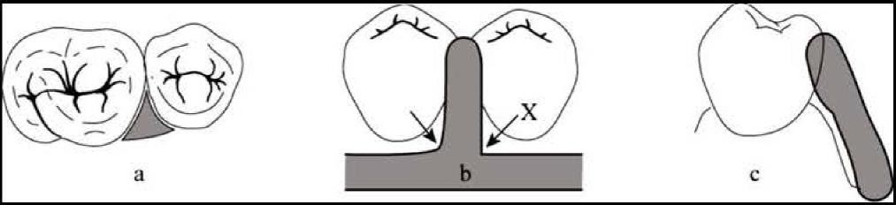
Figure 1: (a). A minor connector should join the major connector at a right angle and cover as small an area of tissue as possible (b). The juncture to the major connector should be rounded (arrow) not sharp
(X) unless the juncture includes an acrylic finish line. Relief should be placed on the master

A minor connector should fill the embrasure space so that a smooth surface is presented to the tongue and so that areas where food can be trapped are minimized. Ideally, a minor connector should not contact the teeth gingival to the height of contour. If a minor connector fits tightly against an abutment below the height of contour, a wedging force may be created during functional movements of the framework. This wedging can result in increased tooth mobility. Alternatively, it may be difficult to seat or unseat the framework.
  - Gridwork minor connectors that connect the denture base and teeth to the major connector.
These minor connectors are adjacent edentulous spaces and usually connect the major connector to a clasp assembly as well. Gridworks can be an open lattice work or mesh type. The mesh type tends to be flatter, with more potential rigidity. Conversely the mesh has been shown provide less retention for the acrylic if the openings are insufficiently large. The lattice type has superior retentive potential, but can interfere with the setting of teeth, if the struts are made too thick or poorly positioned. Both types are acceptable if correctly designed.

Adequate mechanical retention of the denture base resin is gained by providing relief under the minor connector gridwork to allow the acrylic resin to flow under the gridwork. To allow for this space, relief wax is placed on the cast in the edentulous areas prior to making a refractory cast (for fabricating the framework). Usually, one thickness of baseplate wax is sufficient (about 1 mm of relief). After the framework has been waxed and cast on the refractory model and returned to the master cast, the space provided by the relief wax is available for the mechanical retention of the acrylic resin, Figure (2).

Figure 2: Relief under the minor connector
gridwork.

wax relief

Minor connectors originating from the gridwork in an edentulous area usually take the form of vertical metal plates (proximal plates) that make broad contact with prepared guiding planes. These proximal plates may or may not terminate in an occlusal rest, depending on the partial denture design. The plate is shifted slightly towards the lingual to increase rigidity, enhance reciprocation and improve esthetics, Figure (3).
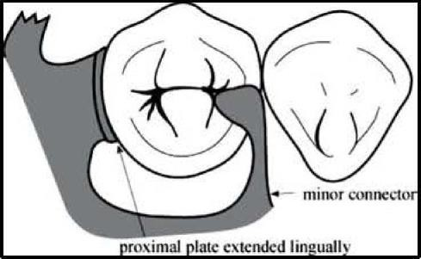
Figure 3: Minor connectors originating from the gridwork in an edentulous area (Proximal plates).

Tissue Stops
Tissue stops are integral parts of minor connectors. Mandibular distal extension gridworks should have a "tissue stop" at their posterior limit. This is an extension of the metal through the relief wax providing direct contact with the ridge. They provide stability to the framework during the stages of transfer and processing. They are particularly useful in preventing distortion of the framework during acrylic-resin processing procedures.
Another integral part of the minor connector is similar to a tissue stop but serves a different purpose. It is located distal to the terminal abutment and is a continuation of the minor connector contacting the guiding plane. Its purpose is to establish a definitive finishing index tissue stop for the acrylic-resin base after processing. Relief under the gridwork should not be started immediately adjacent to the abutment tooth but should begin 1.5 - 2 mm from the abutment tooth. This will create a metal to tissue contact immediately adjacent to the tooth. A metal surface is preferable since it wears less, and is less porous, thus facilitating hygiene, Figure (4).
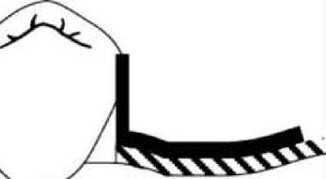
Figure 4: Metal immediately adjacent to tooth on the left, Incorrect (acrylic of base is adjacent tooth) on the right.

Finishing Lines
The finishing line junction with the major connector should take the form of an angle not greater than 90 degrees, therefore being somewhat undercut, Figure (5). This provides for maximum bulk of the acrylic resin denture base at the metal junction, to prevent the creation of thin, weak, feather edges which can easily fracture or distort, Figure (6).

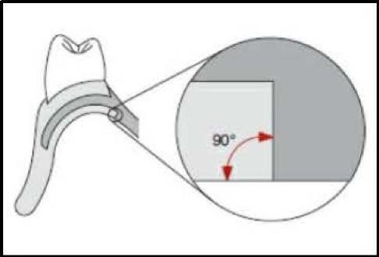
Figure 5: The internal angles of external finish lines should be slightly less than 90 degrees. This results in improved mechanical retention for acrylic resin components.

 |   edentulous rid,,,e  butt joint sligh | t undercut | 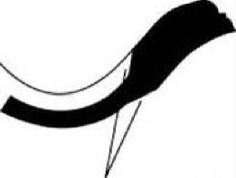  incorrect (>90⁰ joint)
 |  | Figure 6: Finishing line junction.

Therefore, resin metal joints should be created only at the external surfaces. These interfaces are referred to as finish lines. If they are located on the outer surfaces of major connectors, they are called external finish lines. If they are positioned on the inner or tissue surfaces, they are termed internal finish lines, Figure (7).
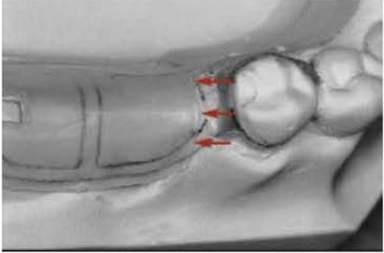
A 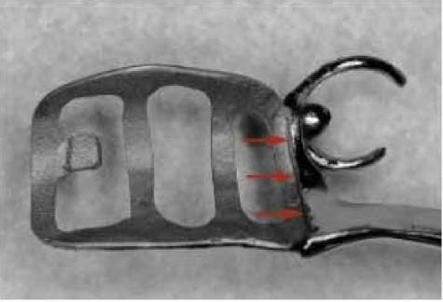 B
Figure 7: A. Internal finish lines result from relief wax placed on the master cast prior to duplication. Arrows indicate the presence of a well-defined vertical wall, which will produce an internal finish line. B. Properly contoured relief wax results in a sharply defined internal

The medial extent of the minor connector depends on the lateral extent of the major palatal connector. If the finishing line is located too far medially, the natural contour of the palate will be altered by the thickness of the junction and the acrylic resin supporting the artificial teeth. If, on the other hand, the finishing line is located too far buccally, it will be most difficult to create a natural contour of the acrylic resin on the lingual surface of the artificial teeth. The location of the finishing line at the junction of the major and minor connectors should be based on restoration of the natural palatal shape, with consideration given to the location of the replacement teeth, Figure (8).

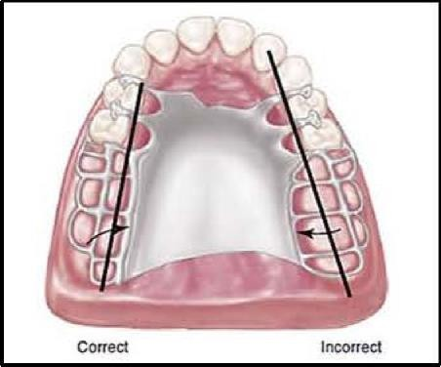
Figure 8: Junction of the major connector and the minor connector at palatal finishing lines should be located 2 mm medial from an imaginary line that would contact the lingual surfaces of missing posterior teeth. The finish line on the right is too far toward midline of the palate. The natural contours of the palate will be altered.

Gridwork Minor Connector Design
The length of the gridwork minor connector for the mandibular distal extension base should extend posteriorly about two-thirds the length of the edentulous ridge of the distal extension in CL I & II cases, Figure (9). For the maxillary distal extension base, gridwork minor connector should extend the entire length of the distal extension in CL I & II cases, Figure (10).
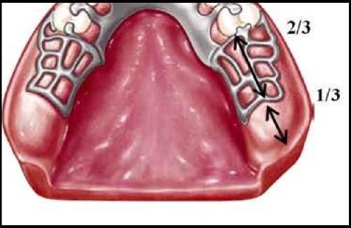
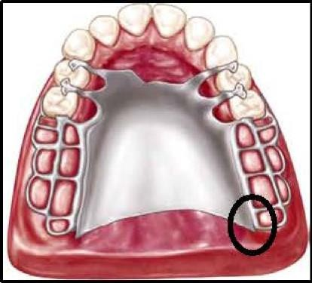
Figure 9: Length of the gridwork minor connector.
Figure 10: Length of the gridwork minor connector. Note the extension of the finishing line to the area of the pterygomaxillary notch provides a butt-type joint for attachment of the border portion of the resin base through the pterygomaxillary notch (Circle).

