Maxillary Major Connectors
Lec. 6
Special Structural Requirements for Maxillary Major Connectors:
Beading: All maxillary major connectors should display minor elevations
at those borders that contact the palatal soft tissues (Fig. 1). The
elevations are termed bead lines and are intended to slightly displace the
adjacent soft tissues. This displacement produces:
- Mechanical seal and prevents food particles from collecting under the major connector.
- These elevations provide excellent visual finish lines for technicians who finish and polish removable partial denture frameworks.
Bead lines are created by carving shallow channels on the surface of a maxillary master cast before duplication in investment material. These lines are best prepared with a small spoon excavator or round bur rotating at slow speed. Each channel should have a width and depth of 0.5 to 1.0 mm. The depth of the beading should be reduced in areas of thin tissue coverage such as the midpalatine raphe or a palatal torus.
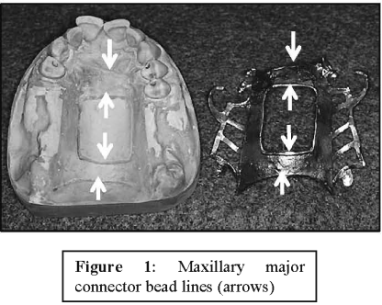

Relief should not be used under a maxillary major connector except in the presence of a palatal torus or a prominent median suture line. The intimate contact between the palatal soft tissues and the metal connector enhances the retention and stability of the denture.
Types of Maxillary Major Connector:
The are six types of maxillary major connectors used in RPD therapy:
1. Single palatal bar
2. Single palatal strap
3. Anterior-posterior palatal bars
4. U-shaped palatal connector
5. Combination anterior and posterior palatal strap-type connector
6. Palatal plate-type connector
1. Single Palatal Bar
The palatal bar is a narrow half oval with its thickest point at the center (Fig. 2). If used, the palatal bar should be limited to short-span Class III applications (replacing one or two teeth on each side of the arch). In addition, the palatal bar should not be placed anterior to the second premolar position; otherwise, its bulk may produce noticeable discomfort and alteration of speech.

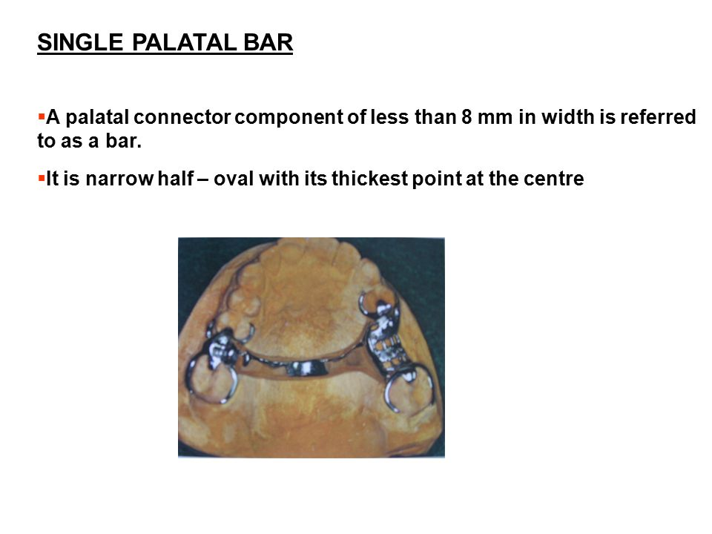
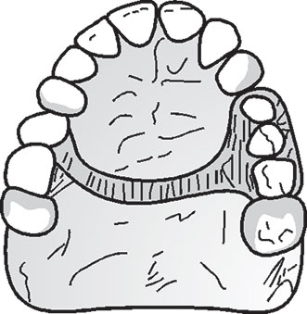
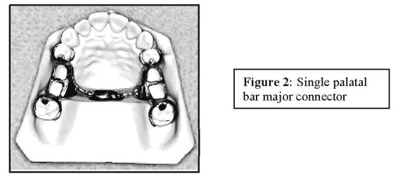

Advantages: -
It's tolerated by tongue.

2. Single Palatal Strap
The palatal strap consists of a wide band of metal with a thin cross- sectional dimension (Fig. 3). The anteroposterior dimension of a palatal strap major connector should not be less than 8 mm to avoid compromise of its rigidity (Fig. 4).
It is a wide palatal strap, it could be made wide to become thinner and helps in the distribution of the mastication forces over a wide area, and it is less objectionable by the patient.
Location and characteristic
- It is located in the middle of the palate
- It does not cover the rugae area which make it more tolerable to the patient.
- Anterior border follows the valleys between rugae
- The posterior border of the major connector should be positioned anterior to the junction of the hard and soft palates.
- Strap should be 8 mm wide or as wide as the combined width of a maxillary premolar and first molar.
- Confined within an area bounded by the four principal rests.
Indications:
Bilateral and unilateral edentulous spaces of short span in a tooth-supported restoration (CL III & CLIII mod 1).
Contraindications:
1. Tooth- tissue supported removable partial denture (RPD).
2. Palatal torus.
3. Extremely long tooth supported edentulous space.
Advantages:
1. Very simple design.
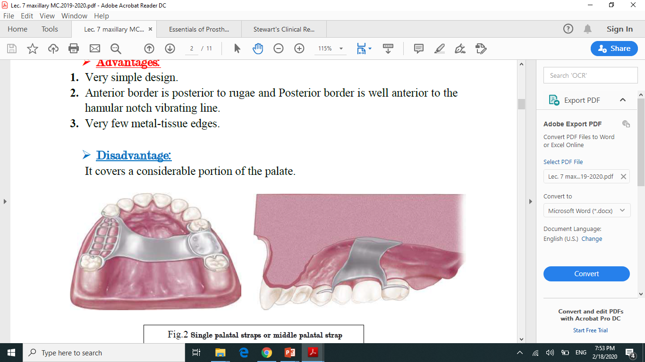
2. Anterior border is posterior to rugae and Posterior border is well anterior to the hamular notch vibrating line.
3. Very few metal-tissue edges.
Disadvantages of the palatal strap:
In some cases, a patient may complain of excessive palatal coverage. Frequently, this complaint can be traced to improper positioning of the strap borders. Therefore, the anterior border of the major connector should be positioned posterior to the palatal rugae if possible. If this is not possible, the anterior border should be terminated on the posterior slopes of prominent rugae.
Note: To differentiate between a palatal bar and a palatal strap, a palatal connector component less than 8 mm in width is referred to as a bar.
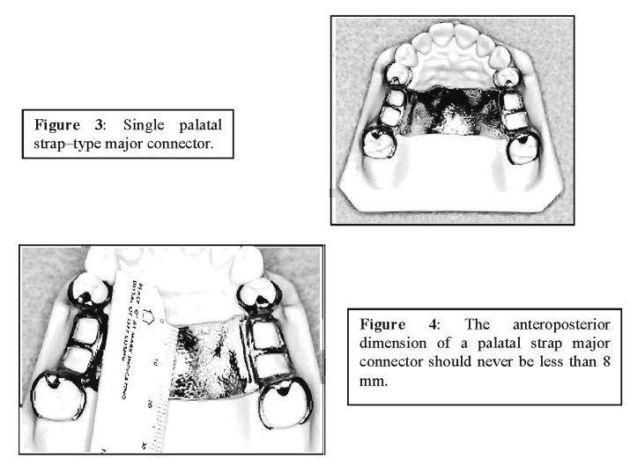3. Combination Anterior and Posterior Palatal Bar-type Connectors
Structurally, this combination of major connectors (Fig. 5) exhibits many
of the same disadvantages as the single palatal bar. To be sufficiently rigid and to provide support and stability, these connectors could be too bulky and could interfere with tongue function.

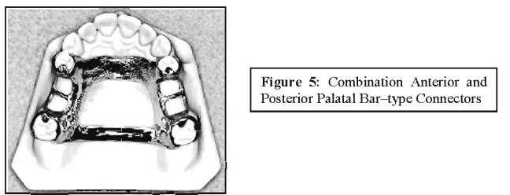
Location and Characteristics
- The anterior component is a flat bar located as far as possible from the rugae area and tongue interference (6 mm away from gingival margins)
- The posterior bar is a half oval in cross section located as far as possible
- The anterior and posterior part are connected by two lingual elements along the lateral slopes of palate giving a circular configuration provides rigidity.
- To be sufficiently rigid and to provide the needed support and stability, these connectors could be too bulky and could interfere with tongue function.
Advantages:
The main advantage of an anteroposterior palatal bar is its rigidity (Strong).
The anteroposterior palatal bar minimizes soft tissue coverage, yet provides exceptional resistance to deformation. (Limited soft tissue coverage).
Disadvantages:
- The disadvantages of the anteroposterior palatal bar is frequently uncomfortable as it has multiple borders.
- The bulk and contour of the connector may be bothersome to the tongue and may interfere with phonetics.
- Limited support from the palate.
As a general rule, the anteroposterior palatal bar should not be considered the first choice for a maxillary major connector. It should be selected only after other choices have been considered and eliminated.

3. Combination Anterior and Posterior Palatal Strap-type Connector
The anterior-posterior palatal strap provides maximum rigidity and minimum bulk. It may be used in almost any maxillary partial denture design. The posterior palatal strap should be flat and a minimum of 8 mm wide (Fig. 6).
Posterior palatal connectors should be located as far posterior as possible to avoid interference with the tongue but anterior to the junction of the hard and soft palates. The only condition that prevents their use is an inoperable maxillary torus that extends posterior to the soft palate.
The strength of this major connector design lies in the fact that the anterior and posterior components are joined together by longitudinal connectors on either side, which form a square or rectangular frame (Fig. 7).
Each component braces the others against possible torque and flexure. Flexure is practically nonexistent in such a design. The open area in the palatal region should be at least 20 x 15 mm. Otherwise, another type of major connector should be chosen.
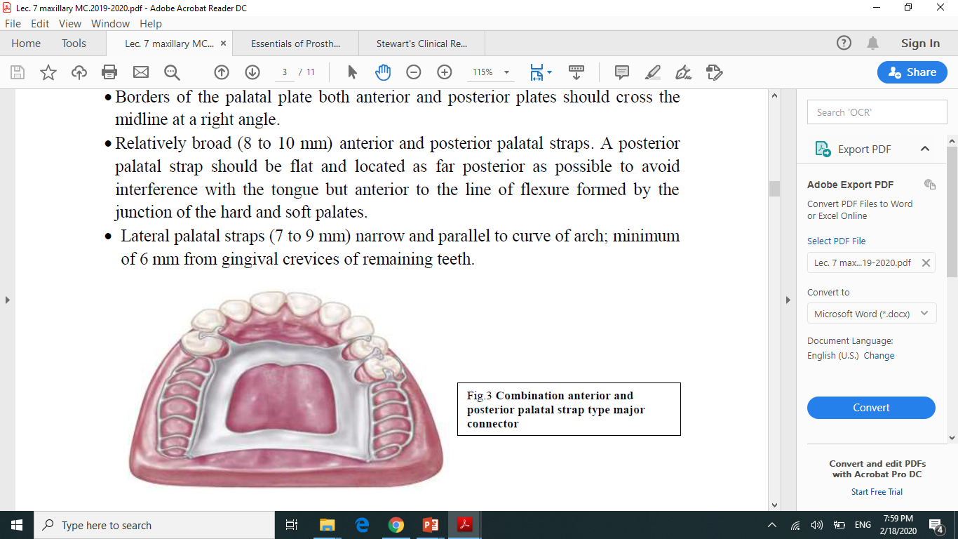
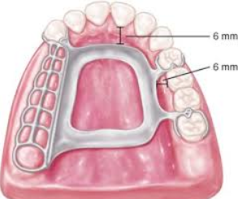

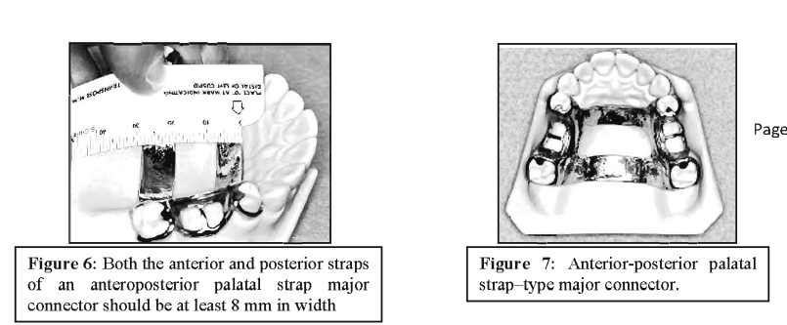

Indications:
The combination anterior-posterior connector design may be used with any Kennedy class of partially edentulous arch. It is used most frequently in Classes II and IV, whereas the single wide palatal strap is used more frequently in Class III situations. The palatal plate-type or complete coverage connector is used most frequently in Class I situations.
- In Class I and II arches in which excellent abutment and residual ridge support exists, and direct retention can be made adequate without the need for indirect retention from palate (palatal plate).
- Long edentulous spans in Class II mod. 1 arch.
- Inoperable palatal tori that do not extend posteriorly to the junction of the hard and soft palates.
All maxillary major connectors should cross the midline at a right angle rather than on a diagonal. It has been suggested that the tongue will accept symmetrically placed components far more readily than those placed without regard for symmetry.
Characteristics and Location:
1. Rectangle shaped and open in center portion.
2. Relatively broad (8 to 10 mm) anterior and posterior palatal straps.
3. Narrow lateral palatal straps (7 to 9 mm) parallel to curve of arch; minimum of 6 mm from gingival crevices of remaining teeth.
4. Anterior palatal strap: anterior border not placed farther anteriorly than anterior rests and never closer than 6 mm to lingual gingival crevices; follows the valleys of the rugae at right angles to the median palatal suture. Posterior border, if in rugae area, follows valleys of rugae at right angles to the median palatal suture.
5. Posterior palatal connector: posterior border located at junction of hard and soft palates and at right angles to median palatal suture and extended to hamular notch area(s) on distal extension side(s).
Contraindications:
The only condition preventing their use is when there is an inoperable maxillary torus that extends posteriorly to the soft palate.
Advantages:
It covers a minimum of palatal tissues.
Disadvantages:
1. Very complex design.
2. A lot of metal-tissue edges.

4. Palatal Plate-type Connector
The complete palatal plate is particularly indicated when maximum tissue support is required. In particular it should be the major connector of choice in long distal extension cases or where six or less anterior teeth remain. It should be selected where the primary abutments are periodontally involved, requiring maximum stress distribution. Where the edentulous areas are covered with flabby tissue or where there is a shallow palatal vault this connector also provides greater stability and stress distributing characteristics. The full palatal plate is usually not used in the presence of torus palatinus.
The word palatal plate is used to designate any thin, broad, contoured palatal coverage used as a maxillary major connector and covering one half or more of the hard palate (Fig. 8). This type is also named anatomic replica palatal major connector.
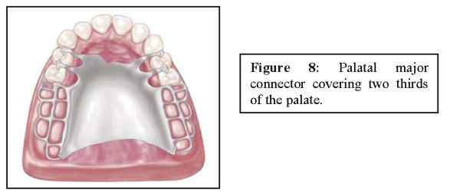
﻿Location and characteristic:
Palatal plate is used to designate any thin, broad, contoured palatal coverage used as a maxillary major connector and covering one half or more of the hard palate.
Anatomic replica form for full palatal metal casting supported anteriorly by positive rest seats.
Palatal linguoplate supported anteriorly and designed for the attachment of acrylic resin extension posteriorly. Contacts all of the teeth remaining in the arch.
Anteriorly it could be with relief or without relief when splinting of anterior teeth is needed.
Posterior border: at the junction of the hard and soft palates;
It covers a wide area of the palate so it contributes in the support and retention of the prosthesis, this coverage permits a wide distribution of the functional load with very little movements from the base during function thus reducing horizontal forces which are highly destructive specially to abutment.
Indications:
The palatal plate may be used:
1) As a plate of varying width that covers the area between two or more edentulous areas, as a partial (Fig. 8) or complete cast plate that extends posterior to the junction of the hard and soft palates (Fig. 9).
2) As an anterior palatal connector with a provision for extending an acrylic resin denture base in a posterior direction and this can be used when future relining is anticipated (Fig. 10).
The palatal plate should be located anterior to the posterior palatal seal area. The maxillary complete denture's typical posterior palatal seal is not necessary with a maxillary partial denture's palatal plate because of the accuracy and stability of the cast metal.
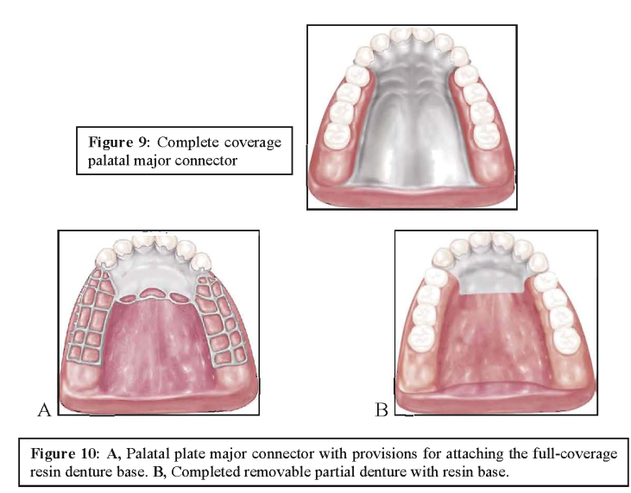
Shape may be used in any one of three ways
- Partial cast plate
- Complete cast plate
- in the form of an anterior palatal connector with a provision for extending an acrylic resin denture base posteriorly.
Indications: -
1. In Class II arch with large posterior modification space and some missing anterior teeth.
2. When relining is anticipated or cost is a factor.
3. In the absence of a pedunculated torus.
4. In most situations in which only some or all anterior teeth remain.
5. When the last remaining abutment tooth on either side of a Class I arch is the canine or first premolar tooth, especially when the residual ridges have undergone excessive vertical resorption.
6. Patient with cleft palate to close any passage nasal and oral cavities.
Contraindications:
When less than complete palatal coverage is necessary and there are sufficient remaining natural teeth to use a palatal plate major connector.
Advantages:
1. It permits the making of a uniformly thin metal plate that reproduces faithfully
the anatomic contours of the patient’s own palate. Its uniform thinness and the thermal conductivity of the metal are designed to make the palatal plate more readily acceptable to the tongue and underlying tissue.
2. The corrugation in the anatomic replica adds strength to the casting; thus a thinner casting with adequate rigidity can be made.
3. Surface irregularities are intentional rather than accidental; therefore electrolytic polishing is all that is needed, the original uniform thickness of the plastic pattern is thus maintained.
4. By virtue of intimate contact, interfacial surface tension between metal and tissue provides the prosthesis with greater retention.
5. Easy to add prosthetic teeth to framework, and Can be easily converted to an interim complete denture.
Disadvantages:
1. Covers more tooth and tissue surface than any other major connector.
2. Design difficulties:
a) The hamular notch vibrating line area must be located on the master cast.
b) Difficult to adjust the metal-tissue contact.
c) Difficult to reline the metal portion of the palatal contact.
﻿
5. U-Shaped Palatal Connector (Horseshoe connector)
From both the patient's standpoint and a mechanical standpoint, the U- shaped palatal connector is the least desirable of maxillary major connectors.
The horseshoe connector consists of a thin band of metal running along the lingual surfaces of the remaining teeth and extending onto the palatal tissues for 6 to 8 mm (Fig.11). The medial borders of this connector should be placed at the junction of the horizontal and vertical slopes of the palate. Rigidity can be increased by extending the borders slightly onto the horizontal surfaces of the hard palate. The connector should display symmetry and should extend to the same height on both sides. All borders of the connector should be gently curved and smooth.
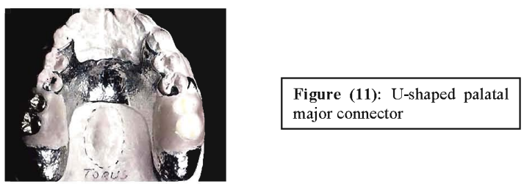
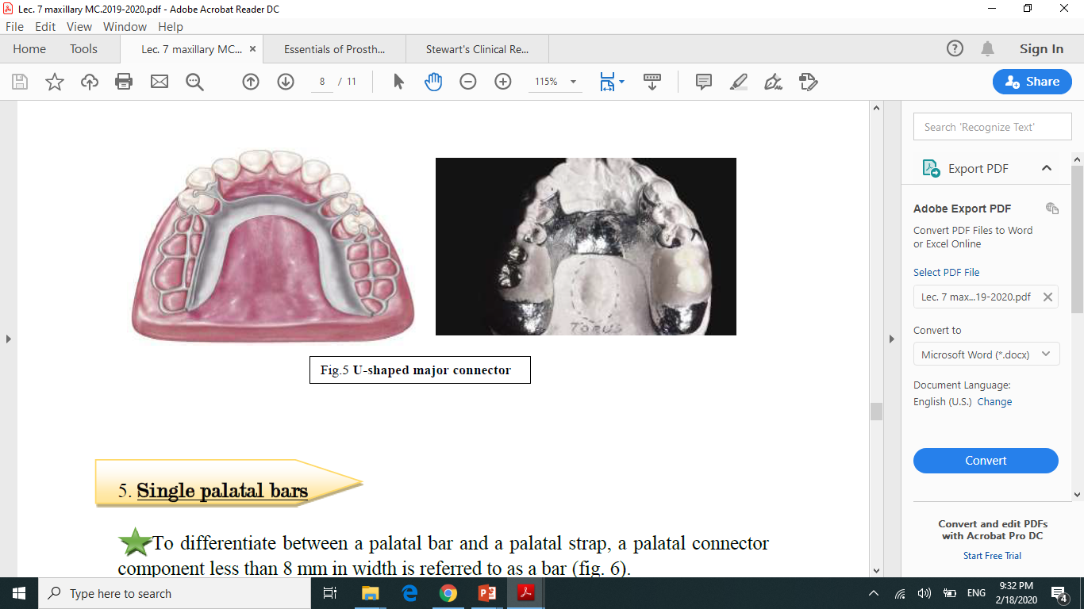

﻿
In the presence of a prominent median suture line or an inoperable torus, this major connector may offer distinct advantages. The horseshoe connector may be designed to avoid bony prominences without sacrificing vertical support.
The U-shaped Palatal Connector (Fig. 11) should never be used arbitrarily and may be indicated when a large inoperable palatal torus exists, and occasionally when several anterior teeth are to be replaced.

The following are the principal objections to use of the U-shaped connector that may lead to failure of many maxillary partial dentures:
1. Its lack of rigidity can allow lateral flexure under occlusal forces, which may induce torque or direct lateral force to abutment teeth. 2. Doesn't provide good support and may impinge underlying tissue when subjected to occlusal loading.
3. Increase in thickness, at the rugae area, to enhance rigidity may interfere with the freedom of the tongue.
A U-shaped major connector may be made more rigid with multiple tooth supported rests and a wider coverage of the major connector.
From both the patient’s standpoint and a mechanical standpoint, the shaped palatal connector is the least desirable of maxillary major connectors. It should never be used arbitrarily.
Indications:-
a- It is indicated when we have a large palatal tours that might be extended posteriorly (in operable tori).
b- Used in Cl I cases but rarely.
c- Class IV partially edentulous arch, a Class III or Class III mod 1 partially edentulous arch with an anterior edentulous space, where cross-arch force distribution is not important.
Contraindications:
1. Where support, retention, bracing, and direct- indirect retention from the palate is necessary
2. Where cross-arch force distribution is necessary.
Advantages:
1. Minimal coverage of the palate and fewer metal-tooth or tissue edges than the AP design
2. Fairly simple design.
The disadvantages of this type:
1. It is flexible and not rigid (allows lateral flexure under occlusal forces, which may induce torque or direct lateral force to abutment teeth).
2. It has the disadvantages of being bulky for the tongue and thus interferes with the phonetics causing this comfort to the patient, so it is objectionable from both, the patients and mechanical stand point.
3. Also (gingival irritation) the design may permit impingement of tissues underline, its palatal border when subjected to occlusal loads (fails to provide good support).
4. Movement may occur at the open ends.

Selection of the type of connector(s) is based on four factors:
- mouth comfort
- rigidity
- location of denture bases
- indirect retention.
- Connectors should be of minimum bulk and should be positioned so that interference with the tongue during speech and mastication is not encountered.
- Connectors must have a maximum of rigidity to distribute stress bilaterally.

