Mandibular Major Connectors

Lec 7

Special Structural Requirements
- In general, mandibular major connectors are long and relatively narrow. Therefore, special consideration must be given to the design of such connectors. Mandibular connectors must be rigid without being so bulky that they compromise patient comfort. Furthermore, mandibular major connectors must not impinge upon the movable floor of the mouth, the associated frena, or mandibular tori
- Unlike maxillary major connectors, for which relief is infrequently required, mandibular major connectors often permit relief between the rigid metal surfaces and the underlying soft tissues. The amount of relief is dependent upon several factors. For an entirely tooth-supported prosthesis, little or no relief is needed because the denture does not tend to move in function. For a distal extension removable partial denture, however, a moderate amount of relief may be indicated because this type of prosthesis tends to rotate during function. Relief prevents the margins of the major connector from lacerating the sensitive lingual mucosa as a result of this movement.
The slope of the anterior ridge also influences the amount of relief needed (Fig. 1). If the soft tissues are vertical, or nearly so, only minimal relief is required. Tissues that slope toward the tongue require the greatest amount of relief because any movement of the connector will bring it into contact with the adjacent soft tissues. If the anterior ridge is undercut, sufficient space may be created when the technician blocks out the undercut area.
- Bead lines are not used in combination with mandibular major connectors. Contact with the mucosa of the mandibular arch may cause irritation, ulceration, and patient discomfort.

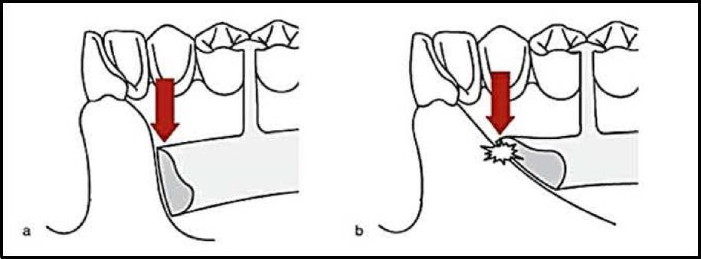

Figure 1: Slope of the anterior ridge also influences the amount of relief needed. (a) If the lingual soft tissues are vertical, or nearly vertical, minimal relief may be used. (b) Tissues that slope toward the tongue requires the greatest amount of relief because any movement of the major connector will bring it into contact with the adjacent soft tissues.

Types of Mandibular major connectors
The following is a list of the different types of mandibular major connectors:

- Lingual bar
- Lingual plate (Linguoplate)
- Sublingual bar.
- Cingulum bar (continuous bar).
- Double lingual bar (Lingual bar with cingulum bar, Kennedy bar)
- Labial bar

Lingual bar and lingual plate major connectors are used in the majority of removable partial denture applications. Double lingual bar and labial bar major connectors are used for special applications in which lingual bars and lingual plates are contraindicated.

Lingual Bar
The lingual bar is possibly the most frequently used mandibular major connector (Fig. 2). Because of its simplicity in and construction, a lingual bar should be used unless one of the other connectors offers a certain advantage. A lingual bar is indicated for all tooth-supported removable partial
dentures unless there is insufficient space between the margin. al gingivae and the floor of the mouth.
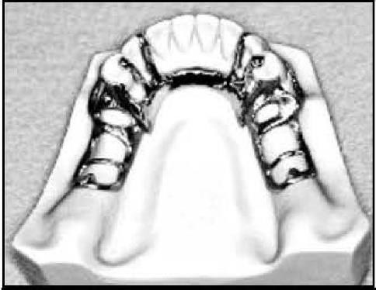

When viewed in cross section, a lingual bar is half-pear shaped. The broadest portion of the bar is located at its inferior border, nearest the floor of the mouth (Fig. 3). The bar should not have sharp margins that irritate the tongue. The superior border should be tapered toward the gingival tissue and the greatest bulk should be at the inferior border which should be slightly rounded, resulting in a contour that has a half-pear shape. A rounded border will not impinge on the lingual tissue when the denture bases rotate inferiorly under occlusal loads. The inferior border of a lingual mandibular major connector must be located free from the floor of the mouth.
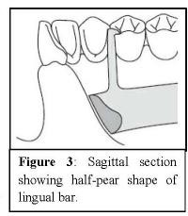

Characteristics and location: -

Half-pear shaped with bulkiest portion inferiorly located.

The superior border should be:

tapered toward the gingival tissue superiorly with its greatest bulk at the inferior border.

at located 3-4mm away from the gingival margin & more if possible to prevent blood constriction.

The inferior border of the lingual bar should be:

1. slightly rounded (A rounded border will not impinge on the lingual tissue when the denture bases rotate inferiorly under occlusal loads).

2. located at the ascertained height of the alveolar lingual sulcus when the patient's tongue is slightly elevated.

3· Frequently, additional bulk is necessary to provide rigidity, particularly when the bar is long or when a less rigid alloy is used.

.

Indication for the Use of lingual Bar.

- The lingual bar should be used for mandibular RPD where sufficient space exists, more than 8mm between the slightly elevated alveolar lingual sulcus and the lingual gingival tissue.
- Diastemas or open cervical embrasures of anterior teeth.
- Overlapped anterior teeth.
Contraindications:
- Less than 8mm between the marginal gingival & the activated lingual frenum & floor of the mouth.
- Only few remaining anterior teeth
- Lingually inclined teeth.
- An undercut lingual alveolar ridge which would result in an excessive space between the bar & the mucosa.
Advantages:
- Covers a minimum of surface area of teeth & tissue
- The potential for caries, periodontal & mucositis caused by plaque
- Esthetic.
Disadvantages:
- Less rigidity compared with other types.
- Difficult to add additional prosthetic teeth to framework.

Methods for Determination the Height of the Floor of the Mouth.
In a clinical situation, the available space may be determined using a periodontal probe. The patient should be instructed to elevate and protrude the tongue so that its tip touches the vermilion border of the upper lip. This activates the floor of the mouth and raises the tissues to the height that occurs during function. While the patient maintains this position, a periodontal probe can be positioned gently in the oral cavity (Fig 4-A). The tip of the probe should rest on the floor of the mouth, and
readings should be taken at the most apical portion of each gingival margin. Then, these readings should be transferred to the diagnostic cast or master cast (Fig 4-B). The lingual bar should be located in the most apical position the movable soft tissues will allow.
Another method may be by the using of a customized impression tray for which lingual borders are 3 mm short of the elevated floor of the mouth, and then use an impression

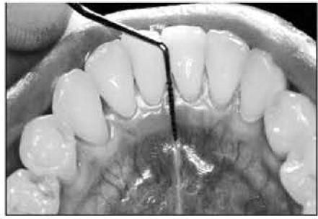
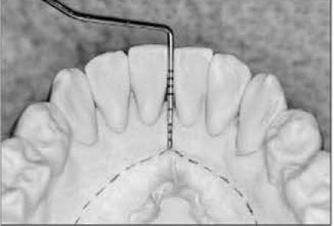
material that will permit the impression to be accurately molded as the patient licks the lips.

B

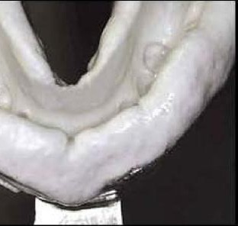
Figure 4: Methods for determination the height of the floor of the mouth. A, Height of floor of the mouth (tongue elevated) in relation to lingual gingival sulci measured with a periodontal probe. B Recorded measurements are transferred to a diagnostic cast and then to a master cast after mouth preparations are completed. C Impression made with functional movement of the tongue to demonstrate maximum shortening of the floor of the mouth.

Linguoplate (lingual plate)
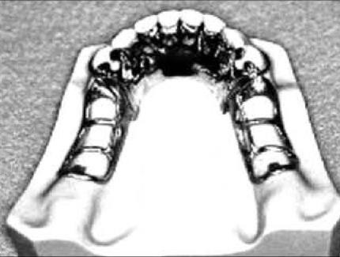
The structure of a lingual plate is basically that of a half pear shaped lingual bar with a thin, solid piece of metal extending from its superior border (Fig.5). This thin projection of metal is carried onto the lingual surfaces of the teeth and p r e s e n t s a s c a l l o p e d appearance.
Figure 5: Lingual plate major
The inferior border of a lingual plate should be positioned as low as possible in
the floor of the mouth, but should not interfere with the functional movements of the tongue and soft tissues. The superior border of a lingual plate must be contoured to intimately contact the lingual surfaces of the teeth above the cingula (Fig. 6).

Figure 6: Sagittal section through the linguoplate demonstrating a basic half-pear—shaped inferior border with the metallic apron extending
superiorly.

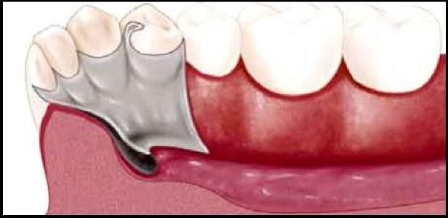
In addition, the lingual plate must completely close the interproximal spaces to the level of the contact points. Sealing these spaces from the lingual aspect prevents food from being packed into these areas. As a result of this contouring, the lingual plate should display a scalloped appearance (Fig.7).
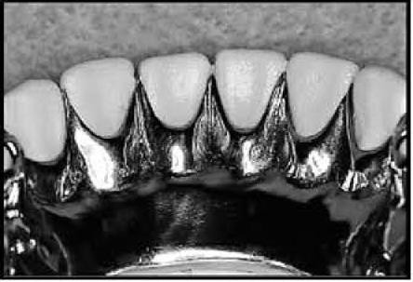
The superior border of a lingual plate should display a scalloped appearance.

Indications for the use of a linguoplate.
- When the lingual frenum is high or the space available for a lingual bar is limited (less than 8 mm).
- In Class I situations in which the residual ridges have undergone excessive vertical resorption.
- For stabilizing periodontally weakened teeth, splinting with a linguoplate can be of some value when used with definite rests on sound adjacent teeth.
- When the future replacement of one or more incisor teeth will be facilitated by the addition of retention loops to an existing linguoplate.
- In the presence of mandibular tori.
The lingual plate has a main disadvantage, because of its extensive coverage, which may contribute to decalcification of enamel surfaces and irritation of the gingival tissues in patients with poor oral hygiene.
Contraindications:-
- Overlapped anterior teeth, that leads to small gaps between the superior edge of the plate and the teeth.
- Lingually inclined teeth.
- Diastemas, unless the lingual plate can have slots in it to avoid the displayed metal (interrupted lingual plate).

The linguoplate does not in itself serve as an indirect retainer. When indirect retention is required, definite rests must be provided for this purpose. Both the linguoplate and the cingulum bar ideally should have a terminal rest at each end, regardless of the need for indirect retention. However, when indirect retainers are necessary, these rests may also serve as terminal rests for the linguoplate.
Sometimes a linguoplate is indicated as the major connector of choice even though the anterior teeth are quite spaced and the patient strenuously objects to metal showing through the spaces. The linguoplate can then be constructed so that the metal will not show through the spaced anterior teeth. This is a modification of the linguoplate and is named "interrupted linguoplate" or "step backs". To accomplish this, the superior border of a lingual plate should cover the cingulum of the individual tooth. The border should extend toward the contact area of the tooth and then turn apically, following the line angle to the level of the gingiva. The rigidity of the major connector is not greatly altered. However, such a design may be as much of a food trap (Fig.8).
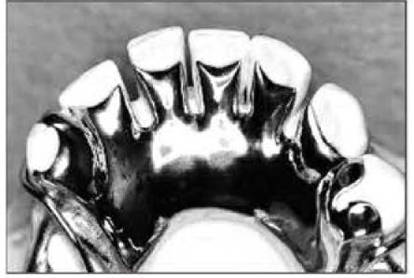
Figur e8: Interrupted linguoplate or
"step backs".

Advantages:

Structurally simple & rigidity more than a lingual bar.

Easy to add additional prosthetic teeth to framework.

Disadvantages:

Covers more tissue surface & teeth than lingual bar.

May be more noticeable to patient than lingual bar.

Sublingual Bar

modification of the lingual bar that has been demonstrated to be useful when the height of the floor of the mouth does not allow placement of the superior border of the bar at least 4 mm below the free gingival margin.

The sublingual bar is essentially the same half-pear shape as a lingual bar, except that the bulkiest portion is located to the lingual and the tapered portion is toward the labial.

Indications:

The sublingual bar should be used for mandibular removable partial dentures when the height of the floor of the mouth in relation to the free gingival margins will be less than 6 mm.

Contraindications:

Interfering with lingual tori.

High attachment of lingual frenum.

Interference with elevation of the floor of the mouth during functional movements.

Advantages:

It doesn't contact anterior teeth or lingual alveolus.

More esthetic than other lingual major connectors because of its location.

More rigid than lingual bar because the metal is bulk horizontally rather than vertically.

Disadvantages:

Require border molded impression of floor of mouth for accurate placement of major connector.

Difficult to add prosthetic teeth.

Most patients prefer a lingual plate to a sublingual bar.

Double lingual bar (Lingual bar with cingulum bar or Kennedy bar).

Double lingual bar (Lingual bar with cingulum bar or Kennedy bar).
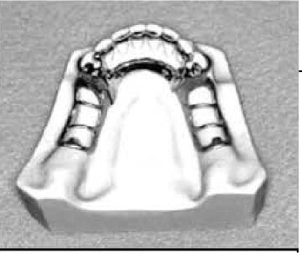
The connector consists of a lingual bar plus a secondary bar resting above the cm. of the anterior teeth. The upper and lower components of a double lingual bar are not joined by a continuous sheet of metal. As a result, the lingual surfaces of the teeth and the of interproximal. soft tissues are largely exposed (Fig. 9).
The lower component of this major connector should display the same

structural characteristics as does a lingual bar. The upper bar should
be half oval in cross section. This bar should be 2 to 3 mm in height and 1 mm thick. The upper bar should not run straight across the lingual surfaces of the teeth but should present a scalloped appearance. The two bars should be joined by rigid minor connectors at each end. Rests should be placed at each end of the upper bar and should be located no farther posterior than the mesial fossae of the first premolars. Placement of these rests is intended to prevent the bar from moving inferiorly and causing orthodontic movement of the remaining anterior teeth.
The secondary bar supposedly acts as an indirect retainer and performs a role in the horizontal stabilization of periodontally involved teeth. The performance of these functions is questionable. Additionally, this major connector can create a food trap between the two bars. The use of this type of connector is not encouraged
Location and characteristic
- Lower part, Conventionally shaped and located same as lingual bar major connector component when possible.
- Upper part, Thin, narrow (3mm) metal strap located on cingula of anterior teeth, scalloped to follow interproximal embrasures with inferior and superior borders tapered to tooth surfaces.
- Originates bilaterally from incisal, lingual, or occlusal rests of adjacent principal abutments.

Indications for Use of Double lingual bar:

- When a linguoplate is indicated but the axial alignment of anterior teeth is such that excessive block out of interproximal. undercuts would be required or open cervical embrasures of anterior teeth
- When wide diastemata exist between mandibular anterior teeth and a linguoplate would objectionably display metal in a frontal view.
- Contraindications:-
- lingually inclined teeth.
- Where a lingual bar or lingual plate will suffice.
- wide diastemata

Advantages:
- More rigid than lingual bar.
- Covers less tooth & tissue surface than lingual plate.
Disadvantages:
The disadvantage of this type of major connector is the tendency of the upper bar to trap debris especially with crowding of the mandibular anterior teeth. This can be minimized by accurate impressions and good adaptation of the upper bar to the anterior teeth. Also, the double lingual bar may irritate the tongue and annoy the patient due to the multiple borders and the thickness of the upper bar. Thus, a modified lingual plate major connector may be preferred.

Labial Bar
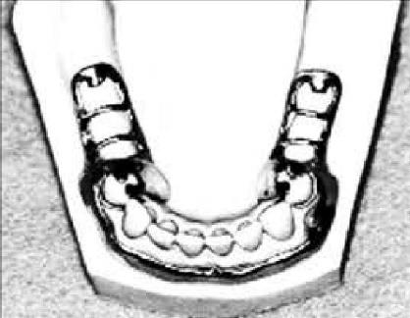
As its name suggests, a labial bar runs across the mucosa on the facial surface of the mandibular arch (Fig. 10 ). Like other mandibular major connectors, a labial bar displays a half-pear shape when viewed in cross section. But, because of its placement on the external curvature of the mandible, a labial

is longer than a corresponding lingual bar, double lingual bar or lingual plate. To ensure rigidity, the height and thickness of a labial bar must be greater than those described for a lingual bar. In only few situations when the extreme lingual inclination of the remaining lower premolar and incisor teeth prevent the use of a lingual bar major connector. With the use of conservative mouth preparations in the form of recontouring and block out, a lingual major connector can almost always be used. Lingually inclined teeth sometimes may have to be reshaped by means of crowns. Although the use of a labial major connector may be necessary in rare instances, this should be avoided by resorting to necessary mouth preparations rather than by accepting a condition that is otherwise correctable.
The same applies to the use of a labial bar when a mandibular torus interferes with placement of a lingual bar. Unless surgery is definitely contraindicated, interfering mandibular tori should be removed so that the use of a labial bar connector may be avoided.

Indications for Use of the Labial Bar.

  - When lingual inclinations of remaining mandibular premolar and incisor teeth cannot be corrected, preventing placement of a conventional lingual bar connector.
  - When severe lingual tori cannot be removed and prevent the use of a lingual bar or lingual plate major connector.
- When severe and abrupt l ingual t issue undercuts make it impractical to use a lingual bar or a lingual plate major connector.

Characteristics and Location of the Labial Bar.
  - Half-pear shaped with bulkiest portion inferiorly located on the labial and buccal aspects of the mandible.
  - Superior border tapered to soft tissue.
  - Superior border located at least 4 mm inferior to labial and buccal gingival margins and farther if possible.

- Contraindications:
- Facial tori.
- The facial alveolar ridge is undercut.
- High facial muscle attachments which would result in less than 3mm of space between the superior edge of the labial bar & the marginal gingival of the teeth.

Inferior border located in the labial-buccal vestibule at the junction of attached (immobile) and unattached (mobile) mucosa.
A labial bar can be used in association with the linguoplate as a modification for the linguoplate. This concept is incorporated in the Swing-Lock design, which consists of a labial or buccal bar that is connected to the linguoplate major connector by a hinge at one end and a latch at the other end, as shown in figure 10.
Support is provided by multiple rests on the remaining natural teeth. Stabilization and reciprocation are provided by a linguoplate that contacts the remaining teeth and are supplemented by the labial bar with its retentive struts. Retention is provided by a bar type of retentive clasp with arms projecting from the labial or buccal bar and contacting the infra-bulge areas on the labial surfaces of the teeth.

Use of the Swing-Lock concept would seem primarily indicated when the following conditions are present:
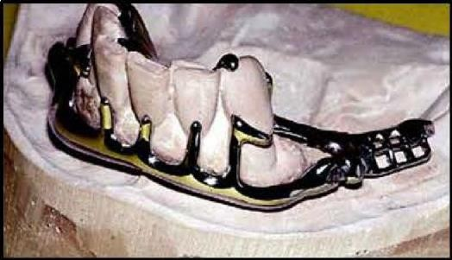
- Missing key abutments,

- Unfavorable tooth contours,

- Unfavorable soft tissue contours, &

- Teeth with questionable prognoses.

Contraindications to the use of this hinged labial bar concept are poor oral hygiene or lack of motivation for plaque control by the patient, the presence of a shallow buccal or labial vestibule, & a high frenal attachment.

Review of Indications for Mandibular Major Connectors

  - For a tooth-supported removable partial denture, the lingual bar generally is the mandibular major connector of choice.
  - When there is insufficient room between the floor of the mouth and the gingival margins (< 8 mm), a lingual plate should be used. This major connector also is indicated for patients with large inoperable tori and patients with high lingual frenum attachments.
  - When the anterior teeth have reduced periodontal support and require stabilization, a lingual plate is recommended.
  - When the anterior teeth exhibit reduced periodontal support and large interproximal spaces, a modified lingual plate (ie, step-back design) or double lingual bar should be used.
  - When a removable partial denture will replace all mandibular posterior teeth, a lingual plate should be used.
  - A labial bar is rarely indicated.
You have to correct the condition by extraction of severely mispositioned teeth, orthodontic correction of lingually inclined teeth, placement of crowns, or surgical intervention to remove tori.

