Component Parts of a Removable Partial Denture
Lec. 5
The removable partial denture consists of seven main components (Fig. 1) and these are essential for the success of the treatment for the partially edentulous patient.
- Major connectors
- Minor connectors
- Rests
- Direct retainers
- Reciprocal components (as parts of a clasp assembly)
- Indirect retainers (if the prosthesis has distal extension bases)
- One or more bases (each supporting one to several replacement teet
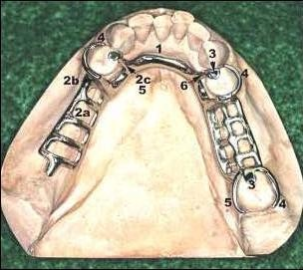
Figure 1: 1, lingual bar major connector; 2a, minor connector by which the resin denture base will be attached; 2b, minor connector, proximal plate, which is part of clasp assembly; 2c, minor connector used to connect rests to major connectors; 3, occlusal rests; 4, direct retainer arm, which is part of the total clasp assembly; 5, stabilizing or reciprocal components of clasp assembly

When using a prosthesis that can be removed from the mouth, the prosthesis must extend to both sides of the arch. This enables transfer of functional forces of occlusion from the denture base to all supporting teeth and tissues within an arch for optimum stability. This is most effective when a rigid major connector joins the portion of the prosthesis receiving the function to selected regions throughout the arch.

Major Connector
It is that part of the R.P.D that joins the components on one side with those of the other side. It is that unit of the partial denture to which all other parts are directly or indirectly attached.
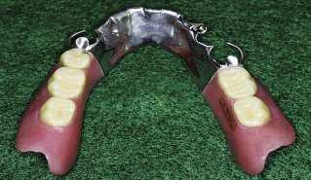
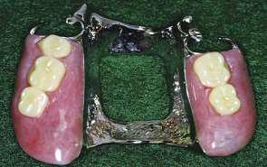

Minor Connectors
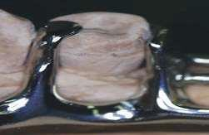
Those are components that serve as the connecting link between the major connector or the base of a removable partial denture and the other components of the prosthesis, such as the clasp assembly, indirect retainers, occlusal rests, or cingulum rests.

Rests
Rest defined as any component of a partial denture on a tooth surface that provides vertical support.
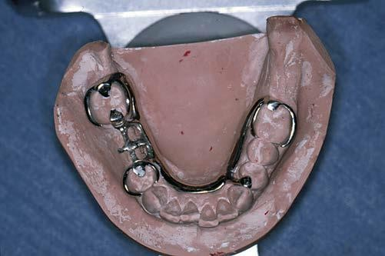

Direct retainer
A direct retainer is any unit of a removable dental prosthesis that engages an abutment tooth or implant to resist displacement of the prosthesis away from basal seat tissue.

Stabilizing or reciprocal clasp
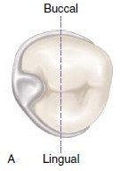
The reciprocal clasp must be in contact during the entire period of retentive clasp deformation. This is best provided with lingual-palatal, guide-plane surfaces.

Indirect Retainers
The rigid components of the partial denture framework, which are located on definite rests on the opposite side of the fulcrum line away from the distal extension base.

Denture base
The denture base supports the artificial teeth and consequently receives the functional forces from occlusion and transfers functional forces to supporting oral structures.
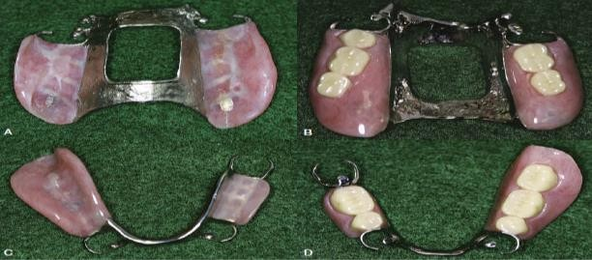

Major connectors
A major connector is the component of the partial denture that connects the parts of the prosthesis located on one side of the arch with those on the opposite side (Fig. 1). There are several designs for the maxillary and mandibular major connector and each serves for certain purposes (Fig. 2 & 3)

- The major connector may be compared with the frame of an automobile or with the foundation of a building. It is through the major connector

that other components of the partial denture become unified and effective.
- The major connector must be rigid so that force applied to any portion of the denture may be effectively distributed over the entire supporting structure, failure to provide rigidity of major connector persist torque force that would be otherwise transmitted to abutment teeth causing traumatic damage to periodontal structure of the abutment teeth, injury to the residual ridges or impingement of underlying tissue.

The chief functions of a major connector include:
- Unification of the major parts of the prosthesis (to act as one unit).
- Distribution of the applied force throughout the arch to selected teeth and tissue.

Major connectors are named by their location and shape.
  - Maxillary major connectors are located on the palate.
  - Mandibular major connectors are usually located on the lingual surface of the ridge and teeth.
  - Rarely, mandibular major connectors are located on the labial alveolar ridge area or under the anterior part of the tongue.
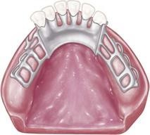
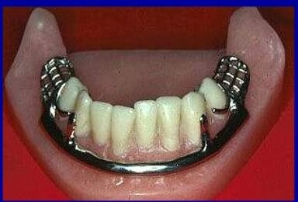
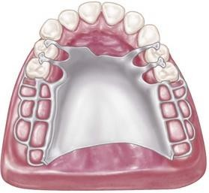

Major connectors are shaped as bars and straps or plates, the difference is the amount of tissue covered. Plates are broad & thin whereas bars are bulky.

A BAR-SHAPED major connector is long, narrow, and thick. In cross section bars are ½ rounds, ½ oval or ½ pears in shape. The thickness of a bar should be at least 6 gauges (4.11 mm) at its greatest dimension. The minimum width of a bar is 4 mm, but they must usually be wider than this for adequate rigidity.
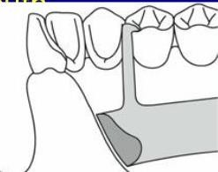

A STRAP or PLATE-SHAPED major connector is long, wide and thin. The width of a strap or plate varies from 6 - 8 mm to the entire length of the palate.
The thickest portion of straps or plates is 22 - 24 gauges (0.64-0.51 mm).
Frequently a strap or plate is added to a bar extending the major connector onto the tooth surfaces. This is sometimes called an APRON
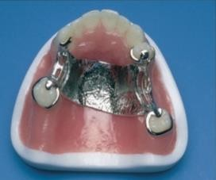
Major connector components resting on unprepared inclined tooth surfaces can lead to slippage of the denture or to orthodontic movement

of the tooth, or to both. Similarly, interproximal projections of the major connector that rest on the gingival third of the tooth and on gingival tissues that are structurally unable to render support may be traumatized. To prevent these sequelae, one should support the major connector with definite rests on the teeth, provide adequate gingival relief, and/or locate the connector far enough away from the gingival margin to avoid any possible restriction of blood supply and entrapment of food debris.

The major connector is that unit of the partial denture to which all other parts are directly or indirectly attached. This component also provides cross arch stability to help resist displacement by functional stresses.
To function effectively and minimize potentially damaging
effects, all major connectors must:

- Be rigid.
A flexible major connector may cause severe damage to the hard and soft tissues of the oral cavity. Flexibility allows forces to be concentrated on individual teeth and segments of the residual ridges. This may lead to tooth mobility or tooth loss. The concentration of forces upon small segments of the residual ridges may cause resorption of the hard and soft tissues. This may result in decreased ridge height and decreased support for the associated denture bases.

- Protect the associated soft tissues.
The Major connector must not gaunt impingement upon the free gingival margins of the remaining teeth. The marginal gingivae are highly vascular and susceptible to injury from sustained pressure.
- Provide a means for obtaining indirect retention where indicated.
Removable partial denture that is not supported at each end of an edentulous space tends to rotate about a fulcrum line. The most common method for controlling this movement is through the use of one or more indirect retainers. For practical purposes, indirect retainers will always take the form of rests. When properly positioned, these rests can minimize the rotational movements of prosthesis.
- Provide a means for placement of one or more denture bases.
Generally, the type of major connector will be dictated by the number and location of edentulous areas. Certain major connectors are indicated for anterior tooth replacement, while others are not. Some major connectors may
be selected for tooth-supported removable partial dentures, but not for tooth-tissue-supported applications. In each instance, a major connector must allow appropriate placement of the associated denture base(s).
- Promote patient comfort.
The edges of a major connector should be contoured to blend with the oral tissues. This is particularly true for major connectors that cross the anterior palate. The anterior border of a maxillary major connector should not end on

the anterior slope of a prominent ruga (Fig 4a). The additional thickness produced by metal coverage will create a noticeable prominence on this section of the palate, and may interfere with the patient's comfort and speech. Instead, the anterior border of the major connector should be terminated on the posterior slope of a prominent ruga (Fig 4b).

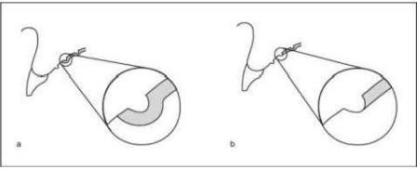
Figure 4: (a) the anterior border of a maxillary major connector should not end on the anterior slope of a prominent ruga (b) The anterior border of the major connector should be terminated on the posterior dope of a prominent raga

The major connector is a component part of the removable partial denture, as mentioned earlier. The chief functions خf a major connect, are to 1) unify the major parts of the prosthesis, 2) distribute the occlusal force throughout the arch to selected teeth and tissue, 3) cross-arch stabilization to minimize the torque to the teeth. It is through the major
connector that other components of the partial denture become unified and effective.

Major connectors should be designed and located with the following guidelines in mind:
- Major connectors should be free of movable tissue.
- Impingement of gingival tissue should be avoided.It is recommended that the borders of the maxillary major connector be located a
minimum of 6 mm away from and parallel to the gingival margins (Fig. 5). As for the mandibular major connector, there should be a minimum of 4 mm below the gingival margin (Fig. 6).
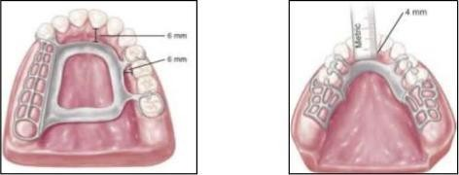
figure 5: borders of a major connector should be positioned at least 6 mm
Figure 6: borders of the major connector should be positioned at least 4

- The borders of the major connector should run parallel to the gingival margins of the remaining teeth (Fig. 7).

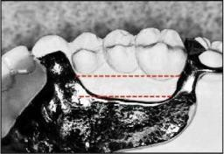
Figure 7: The bonier s of the major connector should run parallel to the gingival margins of the remaining
teeth.

- The major connector should be as a symmetrical as possible. In addition, the borders of a maxillary major connector should cross the palatal midline at right angles not obliquely (Fig. 8).
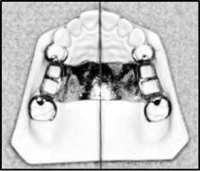
Figure 8: The borders of a maxillary major connector should always cross the palatal midline at 90 degrees.

- Bony and soft tissue prominences should be avoided during placement nd removal (Fig. 9).
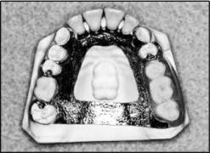
Figure 9: Coverage of tort should be avoided if possible. The tissues covering tort are extremely thin and susceptible to
irritation.

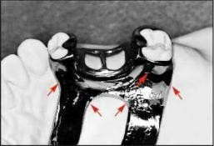
- The major connector should show smooth, rounded contours (Fig. 10). Sharp angles and corners may cause patient discomfort and produce areas of stress concentration within a removable partial denture framework. Areas of stress concentration may lead to structural fatigue and prosthesis
Figure 10: All major connectors should exhibit smooth, rounded contours
(arrows).

- Relief should be provided beneath a major connector to prevent its settling into areas of possible interference, such as an elevated median palatal suture.
- Major connectors should be located and/or relieved to prevent impingement of tissue that occurs because the distal extension denture rotates in function in the mandible.

Characteristics of major connectors that contribute to the maintenance of health of the oral environment and the wellbeing qf the patient may be listed as follows:
- Made from an alloy compatible with oral tissue.
- Rigid and provide cross-arch stability through the principle of broad distribution of stress.
- Do not interfere with and are not irritating to the tongue.
- Do not substantially alter the natural contour of the lingual surface of the mandibular alveolar ridge or of the palatal vault.
- Do not impinge on oral tissue when the restoration is placed, removed, or rotated in function.
- Cover no more tissue than is absolutely necessary.
- Do not contribute to retention or trapping of food particles.
- Have support from other elements of the framework to minimize rotation tendencies in function.
- Contribute to the support of the prosthesis.

The major connector should be designed and located with the following guidelines:
- They should be free from movable tissue (e.g. lingual frenum and soft palate).
- It should never impinge on the gingival tissue. (Margins of the major connector adjacent to gingival tissue should be located far enough from these tissues to avoid any possible impingement, on the other hand the gingival tissues must have unrestricted superficial blood supply to remain healthy, to accomplish this it is recommended that the superior border of mandibular major connector should be located 4 mm below the gingival margin and more if possible. And the borders of the maxillary major connectors should be placed at least 6 mm away from the gingival margin).
- Bony and soft tissue prominences should be avoided.
- Relive should be provided beneath a major connector to prevent its settling into areas of possible interference, such as (inoperable tori or elevated median palatine suture).
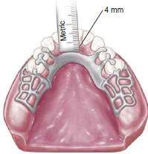
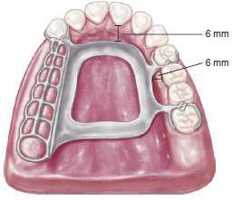
- Major connectors should be located and relieved to prevent impingement of tissue because the distal extension denture rotates in function.

The major connector should be designed for proper shape, thickness and location. Alteration of those dimensions by grinding, considered only as final choice.
Appropriate relief beneath the major connector avoids the need for its adjustment after tissue damage has occurred, Grinding from the major connector has the disadvantages of being:
- Time consuming.
- May seriously weakens the major connector results in flexibility and may lead to fracture.
A useful rule applied to major connectors and throughout partial denture design is to try to avoid adding any part of the denture framework to an already convex surface.

The characteristics and requirements of major connectors: -

- Are made from an alloy compatible with oral tissue
- Are rigid and provide cross-arch stability through the principle of broad distribution
of stress.
- Do not interfere with and are not irritating to the tongue.
- Do not substantially alter the natural contour of the lingual surface of the mandibular alveolar ridge or of the palatal vault.
- Do not impinge on oral tissue when the restoration is placed, is removed, or rotates in function.
- Cover no more tissue than is absolutely necessary.
- Do not contribute to retention or trapping of food particles.
- Have support from other elements of the framework to minimize rotation tendencies in function.
- Contribute to the support of the prosthesis

