Lec2
Prosthodontics

Classification of Partially Edentulous Arches

Classifications are developed to facilitate communication and description between individuals. Universally accepted classification permits people to simplify communications and make them more meaningful.

Any acceptable classification should have the following requirements:
- It should permit immediate visualization of the type of partially edentulous arches.
- It should permit immediate differentiation between tooth borne and tooth tissue borne R.P.D.
- It should be universally accepted.

Need for classification:
  - To formulate a good treatment plan .
  - To anticipate the difficulties common to occur for that particular design.
  - To communicated with a professional about a case.
  - To design the denture according to the occlusal load usually expected for a
  - particular group.

Requirements of an acceptable method of classification:
- It should permit immediate visualization of the type of partially edentulous arch
- that is being considered.
- It should permit immediate differentiation between the tooth- supported and the
- tooth- and tissue supported removable partial denture.
- It should be universally acceptable.
- Serve as a guide to the type of design to be used.

R.P.D. can be classified according to:
- Type of material used.

- Type of treatment.
- Type of support.
- Arch configuration

Type of material used into:
- .Acrylic (Temporary RPDs): is the RPD made of acrylic and artificial teeth ,
retentive wires (clasp) may be used for retention.
- .Cr/Co (Chrome/Cobalt)-metal RPDs (Definitive RPDs): is the RPD made of metal or alloys and artificial teeth, acrylic may be used as a denture base.

The metal based R.P.D. have superior advantages than acrylic type because:
  - Acrylic R.P.D. may produce sensitivity due to the presence of residual monomer.
  - Acrylic is weaker than Cr-Co in structure.
  - Cr-Co R.P.D. is less objectionable to the patient because of its thin base.
  - Cr-Co R.P.D. is less harmful to the underlying tissues as a result to the presence of the occlusal rest which prevents the prosthesis from sinking tissue ward (good load).

Type of treatment:
- Definitive RPDs: Definitive RPDs are constructed after extensive diagnosis, treatment planning ,and through preparation of the teeth and tissue for the prosthesis. The length of service of definitive RPDs is intended to be many years this meaning the cobalt chromium alloy removable partial dentures .
- Interim RPDs: Interim RPDs are usually constructed as part of the preparation of the mouth for definitive RPD, FPD or implant treatment. The length of service of interim RPDs is generally planned to be a year or

less, they are frequently referred to as temporary RPDs example of that is the acrylic removable partial dentures.

Type of support into:
1. Tooth supported prosthesis:
is a prosthesis or part of the prosthesis that depends entirely on the natural teeth (abutments) for support.
For partially edentulous patients the prosthetic options available include:

Natural tooth - supported fixed partial dentures. Natural tooth – supported removable partial dentures. Implant - supported fixed partial dentures.
Retention is derived from direct retainers on the abutment teeth, tooth supported
RPDs do not move appreciably in function.

2 .Tooth - tissue supported prosthesis:
is a prosthesis or part of the prosthesis that depends on the natural teeth (abutment) as well as the residual ridge and tissue for support. Also called true partial denture, it includes a free end extension.
The tooth – tissue supported RPD supported at one end by natural teeth, which essentially do not move, and at the other end by the denture bearing tissues (mucosa overlying bone) which moves because of the resiliency of the mucosa.

Tissue supported prosthesis:
is one which is supported entirely by mucosa and underlying bone.
Tissue supported RPDs are primarily supported by tissues (mucosa overlying bone) of the denture foundation area. Tissue supported RPDs usually have plastic major connectors and are, therefore, usually interim RPDs. Tissue supported RPDs will move in function because of the resiliency of the mucosa.
Retention for tissue supported RPDs is customarily provided by wrought wire retentive clasp arms on selected natural teeth.

Tissue supported RPDs have the potential to cause soft tissue damage and periodontal attachment loss and accordingly should be used for only a short period of time.

Arch configuration:
The most widely accepted system of classification of RPDs and partially
edentulous arches was proposed by Dr. Edward Kennedy in 1923. It is based on the configuration of the remaining natural teeth and edentulous spaces. This system was further defined and expanded upon by Dr. O.C. Applegate and Dr. Jacques Fiset.
The values of the Kennedy – Applegate – Fiset classification system are that:
- .It is relatively simple and easy to remember.
- .Extremely comprehensive and very practical.
- .Universally accepted.
- .It permits logical approach to the problem of design.
- .It permits immediate visualization of the partially edentulous arch or RPDs designed for that arch.
- .It indicates the type of support for the RPD, which suggest certain physiological and mechanical principles of treatment and RPD design.

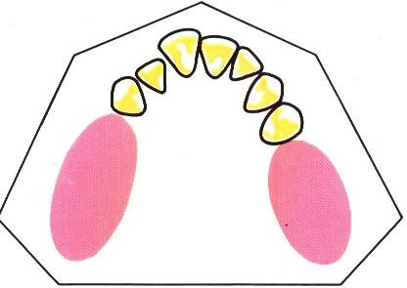
  - CL I: Bilateral edentulous areas located posterior to the remaining natural teeth (bilateral F.E.E).

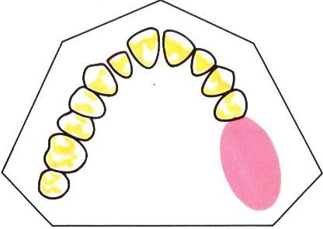
  - CL II: A unilateral edentulous areas located posterior to the remaining natural teeth (unilateral F.E.E).

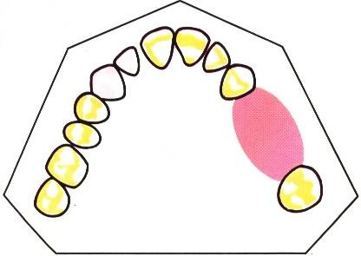
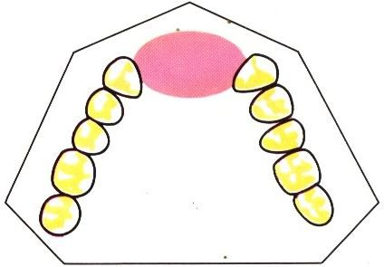
  - CL III: A unilateral edentulous area with natural teeth remaining both anterior and posterior to it.

    - CL IV: A single, but bilateral (crossing the midline), edentulous area located anterior to the remaining natural teeth.

In using Kennedy classification there are certain rules (Applegate’s rules) that
must be followed:
Rule 1: classification should follow rather than precede any extraction of teeth that might alter the classification.
Rule 2: if third molar is missing and not to be replaced, it’s not considered in
classification.
Rule 3: if the third molar is present and to be used as an abutment, it’s
considered in classifications.

Rule 4: if a second molar is missing and not to be replaced, then it’s not
considered in classification.
Rule 5: the most posterior edentulous area (or areas) always determines the classification.
Rule 6: edentulous areas other than those determined the classification are referred to as modifications and are designated by their number.
Rule 7: the extent of modification is not considered, only the number of additional edentulous area.
Rule 8: there can be no modification areas in CL IV arches. (Other edentulous areas lying posterior to the single bilateral areas crossing the midline, would instead determine the classification; see Rule 5).

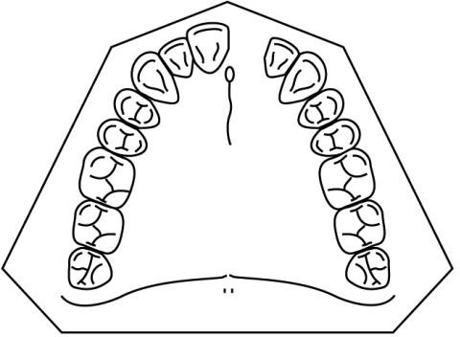
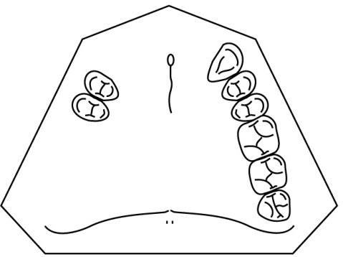
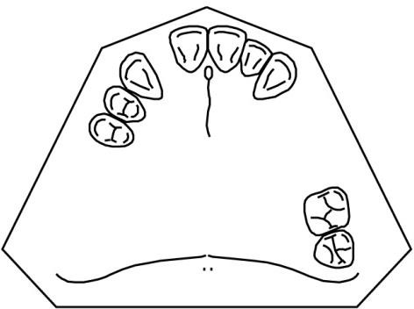
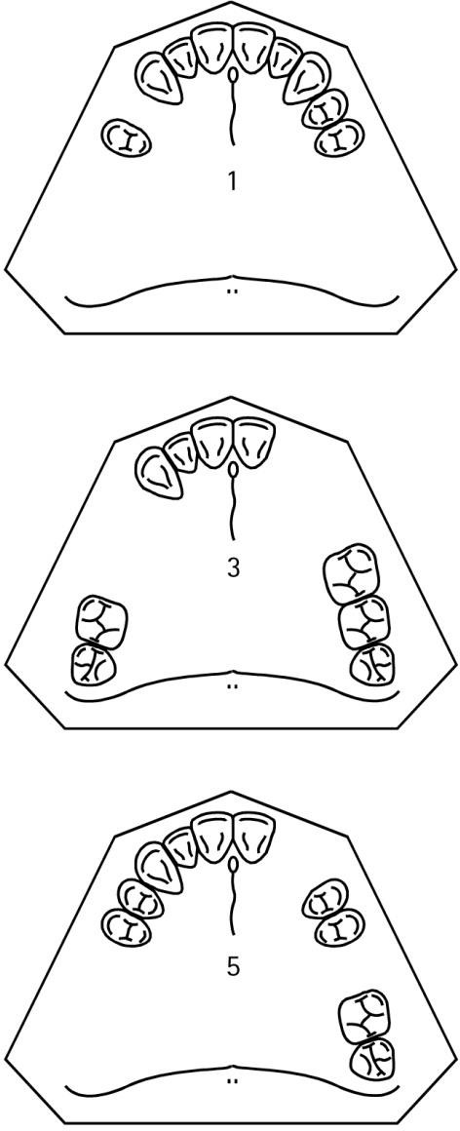
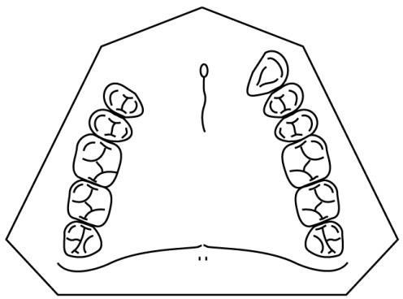
.
Home work
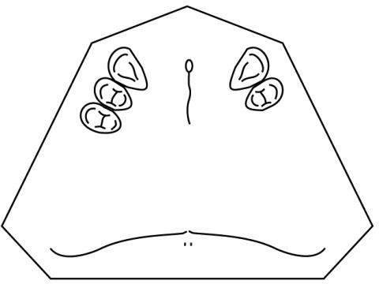
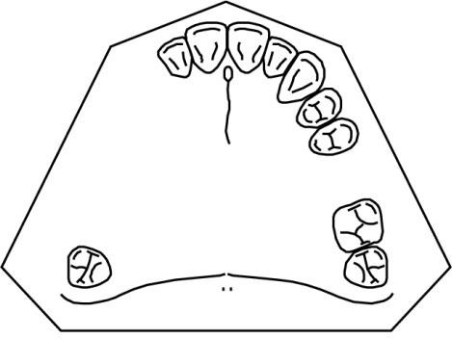

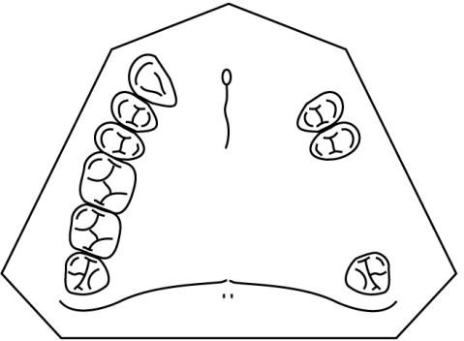
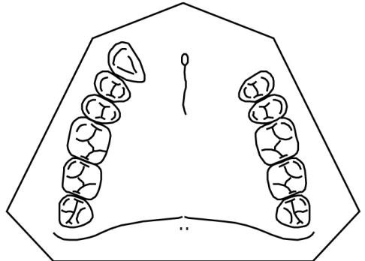
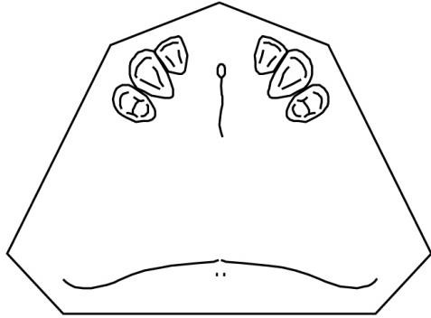

Student name:
Group:

