Prosthodontics

Lec:1
Partial Dentures:
A removable partial denture or a fixed partial denture that restores a partially edentulous arch; a partial denture can be described as a removable partial denture or a fixed partial denture based on the patient’s capability to remove or not remove the prosthesis, respectively.
I. Removable Partial Denture (RPD):
A removable denture that replaces some teeth in a partially edentulous arch; the removable partial denture can be readily inserted and removed from the mouth by the patient.
It is either acrylic type or metallic type (cobalt/chrome).

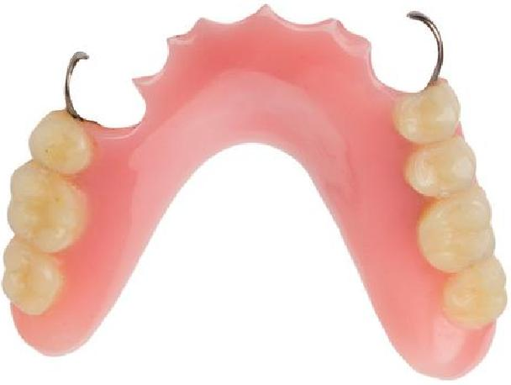
acrylic
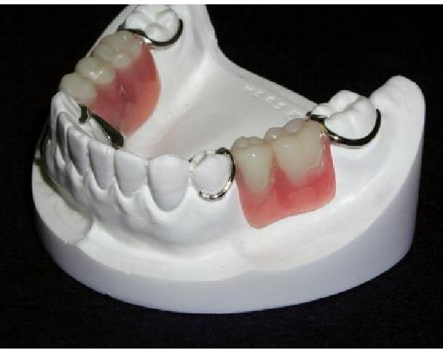
metallic type
(cobalt/chrome)

Partial denture construction: The science and techniques of designing and constructing partial dentures.
Removable prosthodontics:
The branch of prosthodontics concerned with the replacement of teeth and contiguous structures for edentulous or partially edentulous patients by artificial substitutes that are readily removable from the mouth by the patient.
Objectives for RPD construction:
- Restore esthetic (especially for anterior teeth).
- Restore function (phonetic and mastication) for proper speech, proper occlusion and proper food mastication.
- To prevent apposing teeth extrusion or migration and tilting of adjacent teeth.
- To fill empty space or spaces.
- Prevent disease atrophy by a form of stimulation to the underlying tissue and ridge.
- For proper muscular balance.

7. To restore the psychological status of the patient.

Causes of teeth loss:
- Caries (main cause in a young people below 35 years).
- Periodontal diseases (main cause in old people above 35 years).
- Trauma or accident (such as receiving a blow or falling down on them).
- Congenital missing teeth.
Indications of removable partial dentures:
- Distal extension situations (free end situation).
- Long span tooth-bounded edentulous area.
- Need for cross-arch (bilateral) stabilization.
- Excessive loss of the residual ridge.
- Unusually sound abutment teeth.
- If the prognosis of remaining teeth is questionable or reduced periodontal support of remaining teeth (these teeth cannot support fixed prostheses).
- After recent extraction (need immediate replacement of extracted teeth).
- Patient younger than 18 years old.
- Economic consideration.
II. Fixed partial denture:
Any dental prosthesis that is luted, screwed, or mechanically attached or otherwise securely retained to natural teeth, tooth roots, and/or dental implants/abutments that furnish the primary support for the dental prosthesis and restoring teeth in a partially edentulous arch; it cannot be removed by the patient.
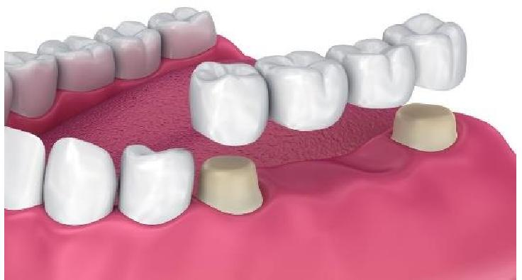
Indications for fixed partial denture:
- Unilateral bounded edentulous short span.
- Class IV Kennedy classification with normal loss of bone.
- Modification area located anteriorly with Class I or with Class II Kennedy
classification for simplifies the design of removable partial denture.
III. Dental implant therapy:
A prosthetic device made of alloplastic material(s) implanted into the oral

tissues beneath the mucosal and/or periosteal layer and on or within the bone to provide retention and support for a fixed or removable dental prosthesis.

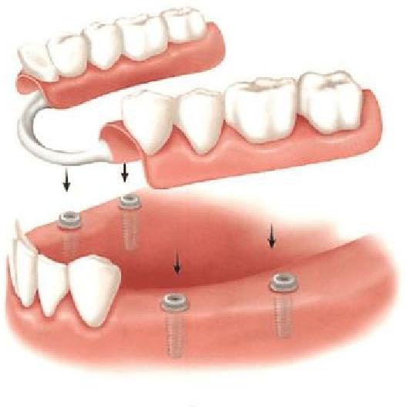
The dental implants are considered adjuncts in fixed and removable therapy.
However, not all patients are candidates for dental implant therapy. Contraindications for dental implant therapy
- Unfavorable regional anatomy.
- Uncontrolled systemic disease.
- Extreme surgical risk.
- High-dose head and neck radiation.
Terminology and definitions
Denture supporting structures: The tissues (teeth and/or residual ridges) that serve as the foundation for removable partial or complete dentures. Diagnostic cast: A life-size reproduction of a part or parts of the oral cavity and/or facial structures for the purpose of study and treatment planning.
Support: The foundation area on which a dental prosthesis rests; with respect to dental prostheses, the resistance to forces directed toward the basal tissue or underlying structures.
Stability: The quality of a complete or removable partial denture to be firm, steady, or constant, to resist displacement by functional horizontal or rotational stresses.
Retention: That quality inherent in the dental prosthesis acting to resist the forces of dislodgment along the path of placement.
(e. g., the force of gravity, the adhesiveness of foods, or the forces associated with the opening of the jaws).
Support, stability, and retention become more meaningful when they are thought of in terms of providing resistance to movement of a removable partial denture.
Interim, or provisional, denture: A fixed or removable dental prosthesis, or maxillofacial prosthesis designed to enhance esthetics, stabilization,

and/or function for a limited period of time, after which it is to be replaced by a definitive dental or maxillofacial prosthesis; often such prostheses are used to assist in determination of the therapeutic effectiveness of a specific treatment plan or the form and function of the planned definitive prosthesis.

Abutment: A tooth, a portion of a tooth, or that portion of a dental implant that serves to support and/or retain a prosthesis.
Height of contour: A line encircling a tooth and designating its greatest circumference at a selected axial position determined by a dental surveyor.
Undercut: The portion of the surface of an object that is below the height of contour in relationship to the path of placement.
When used in reference to an abutment tooth, is that portion of a tooth that lies between the height of contour and the gingiva.
When it is used in reference to other oral structures; the contour of a cross sectional
portion of a residual ridge or dental arch that prevents the insertion of a dental prosthesis.
The angle of gingival (cervical) convergence: The angle of gingival convergence is located apical to the height of contour on the abutment tooth; it can be identified by viewing the angle formed by the tooth surface gingival to the survey line and the analyzing rod or undercut gauge of a surveyor as it contacts the height of contour.
Path of insertion (placement): The specific direction in which a prosthesis is placed on the residual alveolar ridge, abutment teeth, dental implant abutment(s), or attachments.

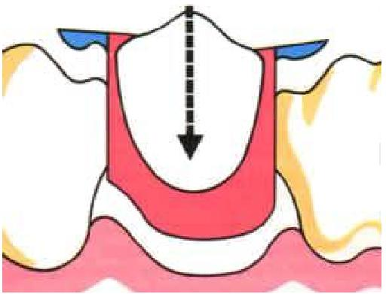
Guiding planes: Two or more vertically parallel surfaces on abutment teeth and/or fixed dental prostheses oriented so as to contribute to the direction of the path of placement and removal of a removable partial denture, maxillofacial prosthesis, and overdenture.
Guiding plane surfaces are parallel to the path of the placement (insertion) and parallel to each other; preferably these surfaces are made parallel to the long axes of abutment teeth.

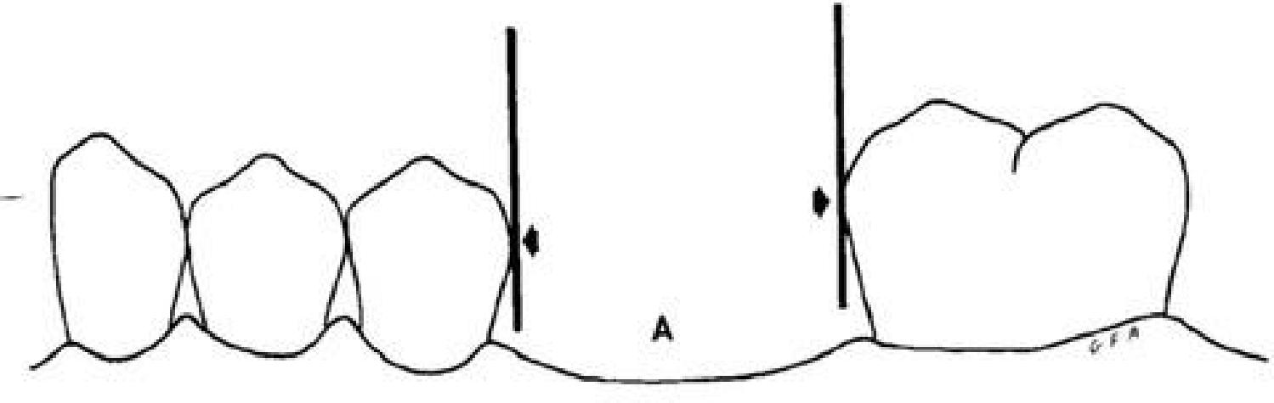
Bounded edentulous area: It is an edentulous area that is bounded and supported by natural teeth at both ends.

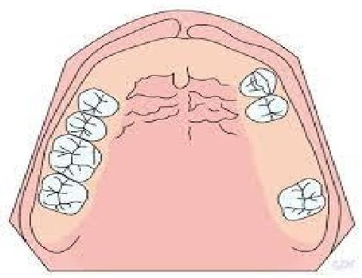
Free-end edentulous area: It is an edentulous area that is bounded and supported by natural teeth at one end.
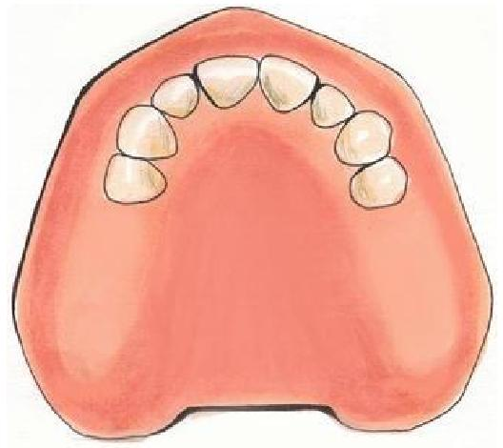
Extension base or free end extension RPD: It is a removable partial denture that is supported and retained by natural teeth only at one end of the denture base segment and in which a portion of the functional load is carried by the residual ridge, it is tooth - tissue - supported RPD. Fulcrum line of rotation of a removable partial denture: A theoretical line around which the RPD tends to rotate.
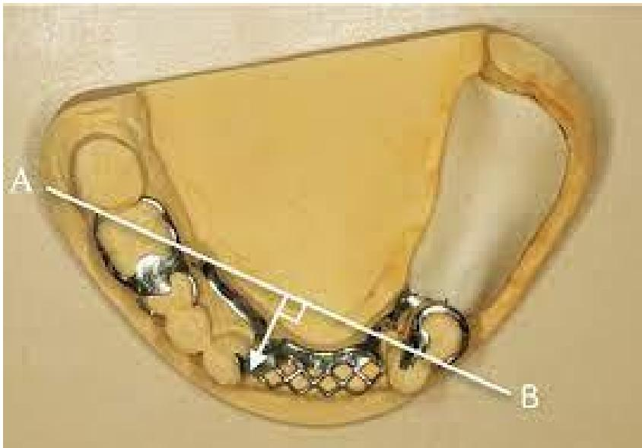
Saddle or denture bases: The part of a denture that rests on the foundation tissues and to which teeth are attached.

Basal seat or denture foundation area: The oral anatomy available to support a denture.
Retainer: Any type of device used for the stabilization or retention of a prosthesis.
Treatment plan: The sequence of procedures planned for the treatment of a patient after diagnosis.
Nesbit prosthesis: Eponym for a unilateral removable partial denture that restores missing teeth on one side of the arch only, without a cross-arch major connector.
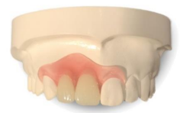

The problems from the lack of partial denture:
- The remaining teeth drift away from their origin position either:
- Mesial drift of tooth posterior to the space.
- Distal drift of a tooth anterior to the space.
- Occlusal drift is over eruption of opposing teeth.
- Separation of the contact point.
- Traumatic gingivitis.
- Exposed cementum led to sensitive teeth.
- Loss of vertical dimension.
- Excessive abrasion of the remaining teeth.
- Carries.
- Periodontal disease.
- Disturbance in T.M.J.
- Aesthetic and speech problem

References:

