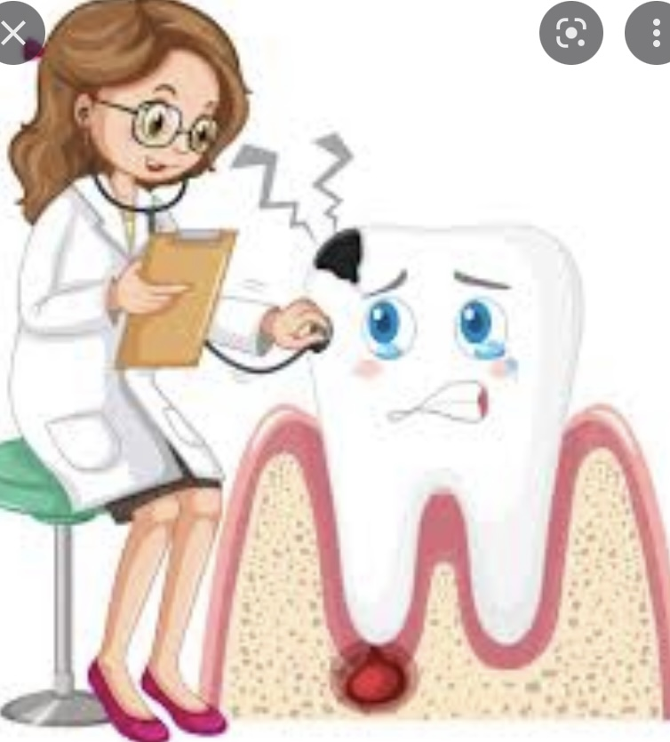
Management of
Trauma to the Teeth and supporting tissues

- Any leakage of straw colored fluid from the nose, bruising, hemorrhage or
laceration of the soft tissues or swelling.
- Type of fracture.
- Discoloration of the tooth.
- Oral hygiene.
- Occlusion.
- Deviation in the path of mandible during mouth opening.

The clinical examination should be conducted after the teeth in the area of injury have been carefully cleaned of debris. A piece of cotton moistened with saline or hydrogen peroxide can be used to clean the teeth and surrounded area .When the in)ury has resulted in a fracture of the crown, the dentist should observe the amount of tooth structure that has been lost and should look for evidence of pulp exposure. With the aid of a good light, the dentist should carefully examine the clinical crown for cracks and craze lines, the presence of which could influence the type of permanent restoration used for the tooth. With light transmitted through the teeth in the urea, the color o1’the injured tooth should be careliilly compared with that of adjacent uninjured teeth.
- Tenderness Of the tooth to gentile percussion.
- Mobility of the tooth.
C. Vitality test of the injured tooth by thermal or electrical pulp tester. Immediately after trauma, it does not give response to vitality test (why?)
reexamine the tooth after 6 weeks and if the child does not give response, this is an indicator that the tooth is non-vital. The injured tooth should be performed, and the teeth in the immediate area, as well as those in the opposing arch, should be tested. When the electric pulp tester is used, the dentist should first determine the normal reading by testing an uninjured tooth on the opposite side of the mouth and recording the lowest number at which the tooth responds. If the injured tooth requires more current than does a normal tooth, the pulp may be undergoing degenerative change, whereas if it required less current, pulpal inflammation is usually indicated. Pulp testing following traumatic injuries is a controversial issue. These procedures require cooperation and a relaxed patient, in order to

avoid false reaction. However, this is often not possible during initial treatment of injured patients, especially children. Furthermore, the electric pulp test is frequently unreliable, even on normal teeth when apices are incompletely formed.
The thermal test is also somewhat helpful in determining the degree of pulpal damage after trauma. Although there are difficulties with the thermal test, it is probably more reliable than the electric pulp test in testing primary incisors in young children. Failure of a tooth to respond to heat indicates pulpal necrosis. The response of a tooth to a lower degree of heat than is necessary to elicit a response in adjacent teeth is an indication of inflammation. Pain occurring when ice is applied to a normal tooth will subside when the ice is removed. A more painful and often lingering reaction to cold indicates a pathologic change within the pulp, the nature of which can be determined when the reaction is correlated with other clinical observations.
Failure of a recently traumatized tooth to respond to the pulp test is not uncommon and may indicate a previous injury with a resulting necrotic pulp. However. The traumatized tooth may be in a state of shock and as a result may fail to respond to the accepted methods of determining pulp vitality. The failure of a pulp to respond immediately after an accident is not an indication for endodontic therapy. Instead, emergency treatment should be completed, and the tooth should be retested at the next follow-up visit.

In children the electric pulp tester is controversy because it needs cooperation and a relaxed child. When the child come from the 1st time because of anxiety the child will give false response.

The examination of traumatized teeth cannot be considered complete without a radiograph of the injured tooth, the adjacent teeth, and sometimes the teeth in the opposing arch. In search of a fractured tooth fragment, it may be necessary to obtain a radiograph o1’ the soft tissue surrounding the injury site.
Radiographs are taken for:
- Baseline evaluation.
- Medico legal record.
- Follow up evaluation (comparison with the records in future). Frequent, periodic radiographs reveal evidence o1’ continued pulp vitality or adverse changes that take place within the pulp or the supporting tissues. In young teeth in which the pulp recovers from the initial trauma, the pulp chamber and canal decrease in size coincident with the normal formation of secondary dentin. After a period of time an

inconsistency in the true size or contour of the pulp chamber or canal compared with that of adjacent teeth may indicate a developing pathologic condition.
- To assess the size of pulp chamber and proximity to the fracture line. The relative sizes of the pulp chamber and canal should be carefully examined. Irregularities or an inconsistency in the size of the chamber or canal compared with that of adjacent teeth may be evidence of a previous injury. This observation is important in determining the immediate course of treatment.
- Determine the stage of root development (the stage of apical development often indicates the type of treatment).
- Presence of root fracture or alveolar bone fracture. A root fracture as a result of the injury or one previously sustained can be detected by a careful examination of the radiograph. However, the presence of a root fracture may not influence the course of treatment, particularly if the fracture line is in the region of the apical third. Teeth with root fractures in this area rarely need stabilization, and a fibrous or calcified union usually results.
- To ascertain the position of traumatized tooth and its relationship to the unerupted teeth in the area (dislocation of the tooth). If teeth have been discernibly dislocated, with or without root fracture, two or three radiographs of the area at different angles may be needed to clearly define the defect and aid the dentist in deciding on a course of treatment.
- Periodontal ligament condition.
- Pre-existing pathological condition.
- Extraoral radiographs help in diagnosis of jaw fractures, complex injuries (to identify the extent and location of all injuries e.g. panoramic, oblique lateral jaw radiograph are useful in addition to the diagnostic process.
- Soft tissue radiographs are helpful in determining displacement of tooth/teeth fragments into adjacent soft tissue.
Injury to the teeth o1 children is often accompanied by:
- Open wounds of the oral tissues,
- Abrasion of the facial tissues,
- Puncture wounds.
The dentist must recognize the possibility o1’ the development o1’ tetanus after the injury and must carry out adequate first-aid measures. Primary immunization is usually a part of medical care during the first 2 years of life. However, primary immunization cannot be assumed—it must be confirmed by examination of the child’s medical record. When the child who has had primary immunization receives an injury

from an object that is likely to have been contaminated, the antibody-forming mechanism may be activated with a booster injection of toxoid. An unimmunized child can be protected through passive immunization or serotherapy with tetanus antitoxin (tetanus immune globulin, or TIG).

The dentist examining the child after an injury should determine the child’s immunization status, carry out adequate debridement of the wound, and, when indicated, refer the child to the family physician. Tetanus is often fatal, and preventive measures must be taken if there is a possibility that an injured child is not adequately immunized.
Debridement, suturing, and\ or hemorrhage control of open soft-tissue wounds should be carried out as indicated.
Working with an oral and maxillofacial surgeon or a plastic surgeon may also be indicated. In extensive injury the child should be hospitalized.

The aim of treatment of any injured tooth is to:
  - Maintain vitality
  - Allow normal development and growth of the jaws and alveolar bone

