Operative Dentistry
Lec.4 &5 Dr Firas Albaaj

Principles of Cavity Preparation

Proper cavity preparation is accomplished through systematic procedures based on definite physical and mechanical principles. These are:

1-Establishing outline form
2-Obtaining resistance form
3- Obtaining retention form
4- Obtaining convenience form
5- Removing remaining caries
6- Finishing cavity walls and margins
7- Performing toilet of the cavity.

I- Outline form:
Means placing the cavity margins in the positions they will occupy in the final preparation.

- The cavity margins should be placed in sound tooth structure. Affected enamel should be removed.
- Extend the cavity margins to include all pits and fissures “Extension for prevention”.

All non-coalesced pits and fissure should be eliminated
Non-coalesced pits and fissure: is imperfect coalescence of enamel, the two end of enamel does not meet and a space remain.

After development of high preventive measures and if the patient with high oral hygiene there is no need to extension for prevention, so we extend our cavity to the limit of caries, then we do saucering to the remaining non carious fissure "enameloplasty"
Enameloplasty: Is the process of reshaping the enamel surface “rounded or saucered" with suitable rotary instruments, so the area becomes cleanable and finishable , and allow conservative placement of the cavity margins. Not more than one third of enamel thickness should be removed.

- The margins should be placed in a cleansable area, ex: in proximal surface the contact area is hard to be cleaned by brushes and cleaning device and this lead to caries so we should extend our margin of the cavity preparation 0.5 mm gingival to the contact area to reach a cleansable area.

- Avoid terminating the margins on extreme eminence such as cusp height or ridge crest.

Naturally the typical outline form varies with the anatomical form of the individual tooth being operated on.
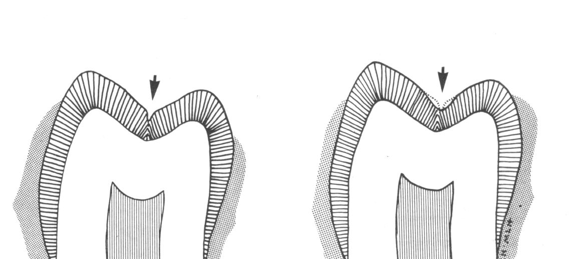

Enameloplasty

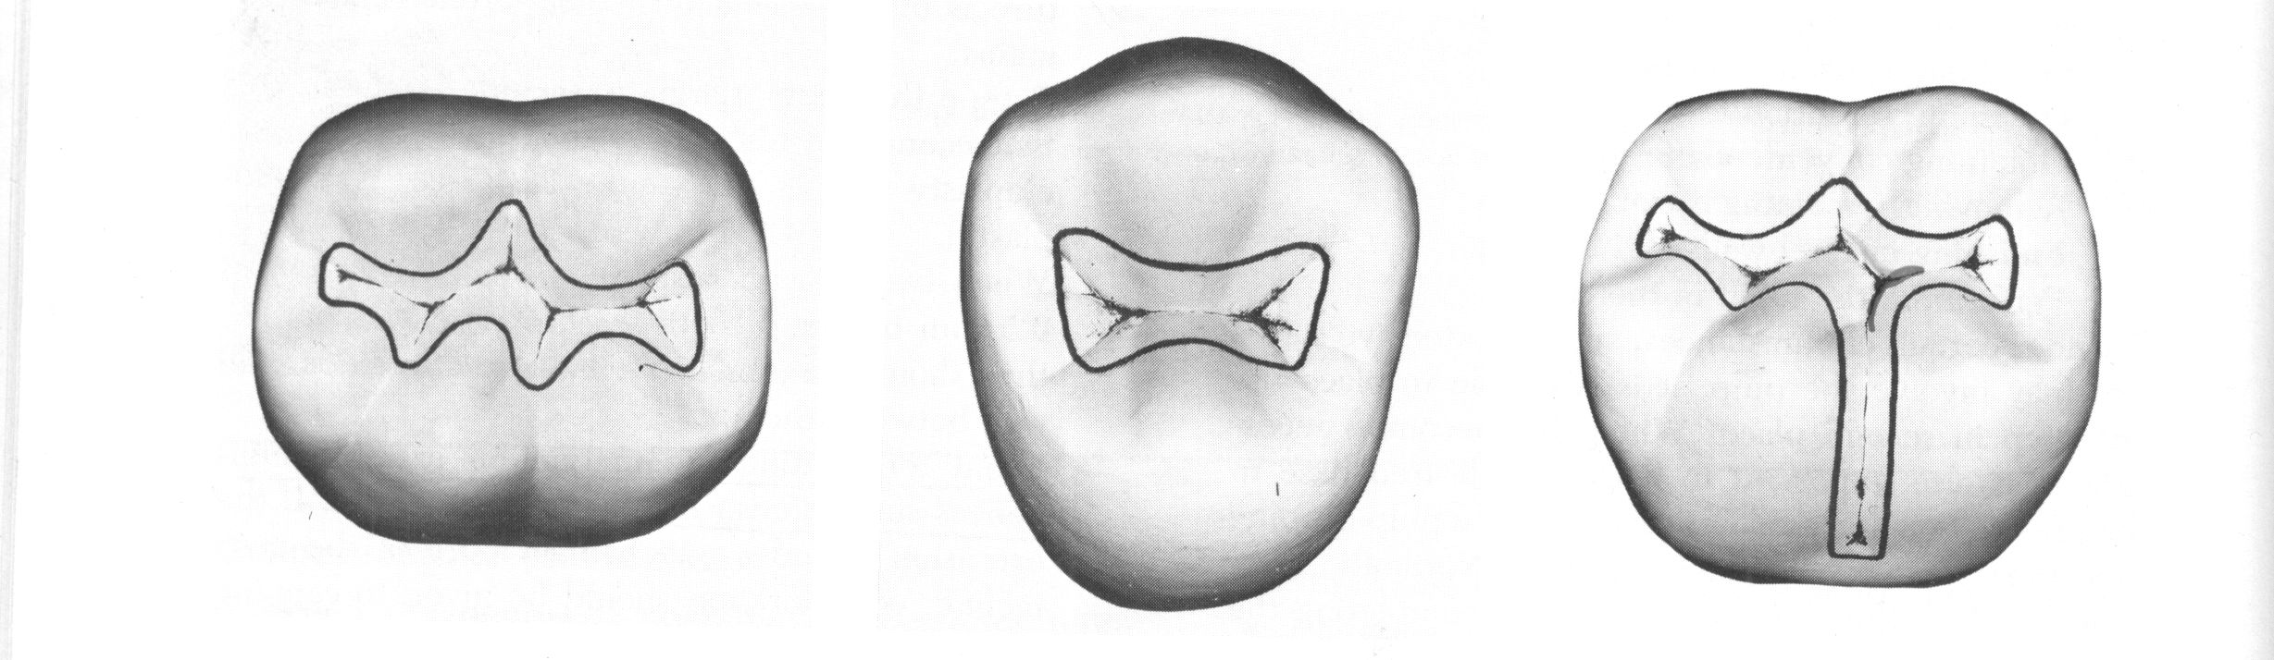
II – Resistance form:
Shaping and placement of the cavity walls that best enable both the restoration and the tooth to withstand the force of mastication without fracture.
- Flat pulpal floor will resist the restoration movement, if pulpal floor is rounded, so any force exerted on the restoration will produce a wedging action on the tooth cause a splitting or shearing of the remaining tooth structure.
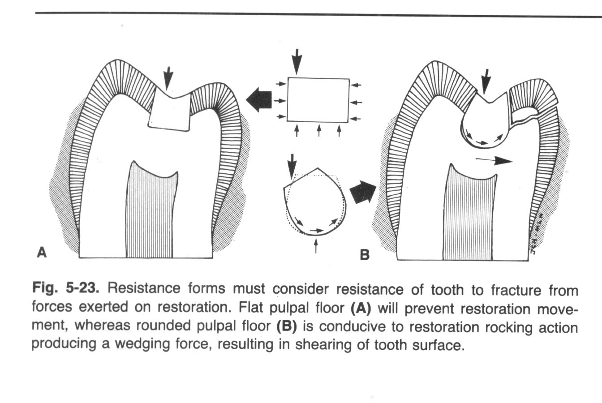

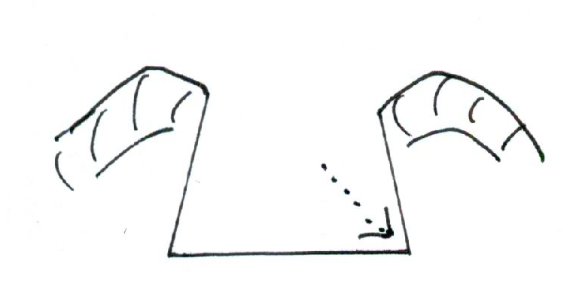
- Internal line angles should be slightly curved (rounded). Sharp internal line angles lead to stress concentration at these areas and fracture of tooth structure.

- Unsupported enamel should be removed because enamel is brittle non vital structure so unsupported enamel will fracture easily when subjected to force of mastication. Caries is spread quickly and widely in dentin than enamel because of the difference in their structure. So during cavity preparation if we remove too much from carious dentin this lead to unsupported enamel that should be removed.
Unsupported
Enamel

- Width of the cavity: restrict the extension of the walls to allow strong cusp and ridge with sufficient dentin support. The width of the cavity should be 1/4 of the intercuspal distance (the distance between the tips of the apposing cusps in the same tooth) this to preserve sound tooth structure. Increasing the width of the cavity lead to weak remaining tooth structure, which will be fractured in the future. Also wide cavity lead to wide surface of the restoration, so the force of mastication on the large surface area of the restoration will be more, this cause fracture of the restoration. Narrow cavity will interfere with convenient form. Nowadays, new instruments were made in some countries enable them to reduce the width of the cavity to 1/6 of the intercuspal distance.
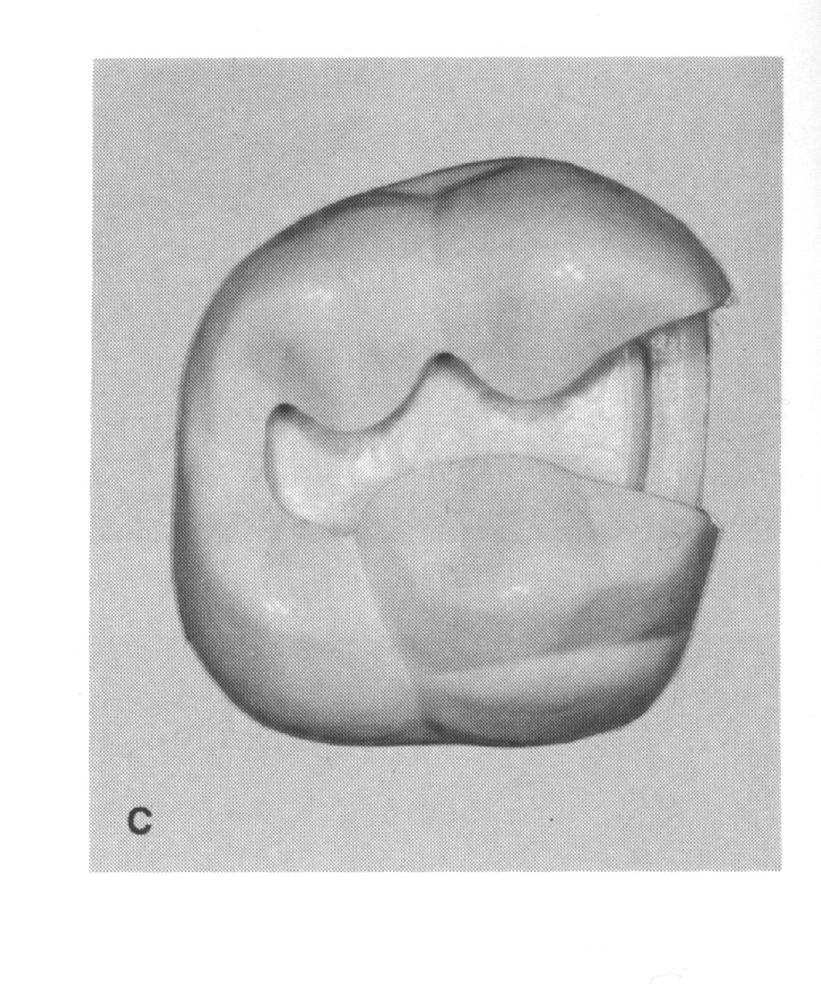

However, when there is an extensive caries that require increasing the width of cavity to remove all caries, there is a chance of weakening of remaining cusp or wall, and in this case there is rule for cusp reduction and coverage. If extension from a primary groove toward the cusp tip is no more than half the distance, no cusp reduction and coverage should be done; if the extension is one half to two thirds of the distance, consider cusp reduction and coverage; if the extension is more than two thirds of the distance, usually reduce the cusp and cover it with restorative material. Cusp reduction and coverage has also been referred to as “cusp capping.”

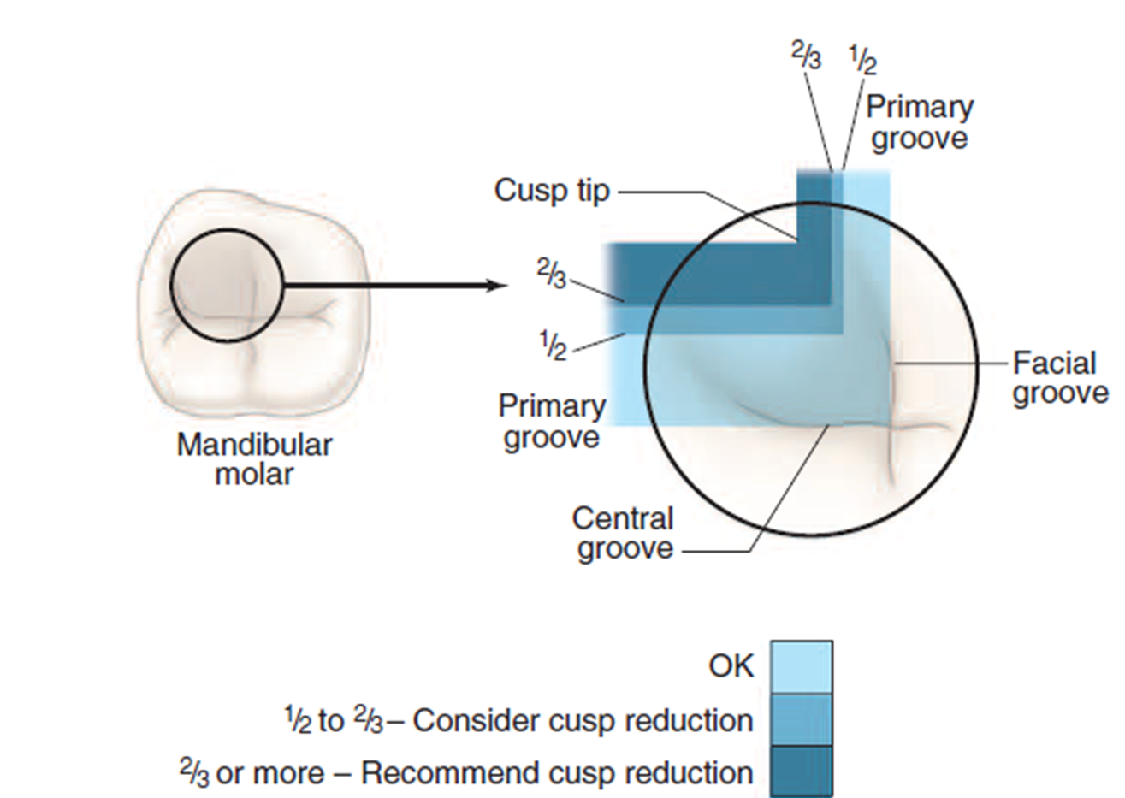

5- Smooth pulpal floor: irregular pulpal floor created by removing caries form areas other than others so the occlusal force that exerted will be concentrated on deepest areas which will cause fracture of the tooth structure. And the forces concentrated on the elevated areas cause fracture of the restoration.

6- Mesial and distal walls should be made parallel or slightly diverge because of little amount of dentin supported enamel so any convergence cause unsupported enamel , that will be fractured if subjected to occlusal load.

7- Axiopulpal line angle should be beveled. If remain sharp this lead to stress concentration at that area which will lead to fracture of the restoration.

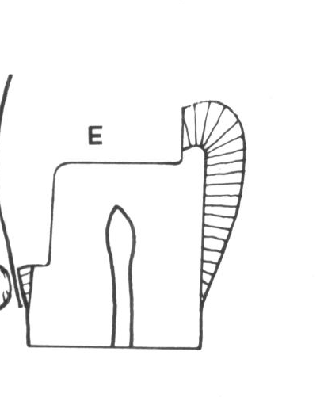
8- Gingival cavosurface line angle should be slightly rounded to prevent the unsupported enamel.

9- Thickness of amalgam: the minimum thickness of amalgam should be 1-1.5 mm. to withstand the load applied without being fractured.

10- Carving of amalgam: over carving lead to reduce thickness of amalgam which will lead to fracture . under carving of amalgam lead to stress concentration on one area other than others which will lead to fracture.

11- Cavosurface line angle should be 90⁰ if beveled, a thin layer of amalgam will be present which will be fractured under occlusal load. Less than 90⁰ cause unsupported enamel and this cause fracture of the tooth surface.

III- Retention Form:

Is that shape or form of the prepared cavity that resists displacement or removal of the restoration against tipping or lifting forces.
The amalgam restorative material cannot adhere to the tooth chemically, so our aim is to place the restoration in the cavity and prevent it form dislocation against the force of mastication and also against the pull of sticky food.

- Convergence of buccal and lingual (palatal) walls about 5⁰, because of good bulk of dentin under the cusp supported enamel. Too much convergence by cutting more from dentinal structure leads to unsupported enamel which may fracture under occlusal load
- Dove tail
- Flat pulpal floor, if rounded this cause displacement of the filling, or movement, which may cause a space between the tooth and the filling, and this lead to secondary caries.
- Extra retention like pins, pinholes, grooves in case of complete destruction of the buccal wall for example.
- Acid etching of enamel and applying bonding agent for resin based restorative materials like composite resin.

IV- Convenience form

Is that shape and form of the cavity that allow adequate observation, accessibility and ease of operation in preparing and restoring the cavity.

The form of the cavity should allow the operator to distinguish all internal line angles to ensure removing of all caries, also allow the operator to use instrument easily in removing caries, shaping of cavity walls and restoring the tooth.

V- Removing of remaining caries

Caries is removed during outline form and the margins should be placed in sound tooth structure , and the typical depth of the cavity is 1.5 mm , if caries is present in pulpal floor or axial wall or both , it should be removed using spoon excavator or handpiece with large round bur. The caries dentin is soft, either has the same color of normal dentin which can be detected using sharp probe or most of the time has a different color from normal dentin. If we have one spot of caries on the pulpal floor we can remove only this area lead to depression , if we remove all pulpal floor this result in
1) Unnecessary cutting tooth structure
2) Increase the possibility of hitting the pulp. This depression is small compared with total surface area and is covered by cement to make flat pulpal floor.

If multiple spots of caries is present we should not remove each one alone this may result in many depressions and if covered with cement and filling , so the stress concentration lead to fracture of the cement , filling and tooth .In this case we should increase the depth of cavity till all caries has been removed.

VI- Finishing of cavity walls:

The objectives of finishing the walls are:
- To have best marginal seal between the restorative material and tooth structure.
- To afford a smooth marginal junction.
- To provide maximum strength of both the tooth and the restorative material at and near the margin.

Several factors must be considered in the finishing of enamel walls and margins:
- Direction of enamel rods
- Support of enamel rods
- Type of the restorative material to be placed in the cavity
- The location of the margins
- Degree of the smoothness desired.

VII- Toilet of the cavity
Toilet of the cavity is cleaning of the cavity from small chips of cutting tooth structure and removing carious lesion, using water – air spray, cotton pellets then dryness with oil free air.

END

