Lab. Packed cell volume (PCV) or Haematocrit (HCT)

Introduction and principle:
PCV: is the volume of RBCs per unit volume of whole blood. To obtain the PCV, a sample of whole blood is anticoagulated and centrifuged for maximum red blood cell packing and the space occupied by the red blood cells is measured and expressed as a percentage of the whole blood volume.
Normal Values for adult:
Male: 40 - 54%
Female: 36 - 48%
Anemia: < normal
Polycythemia: > 60% in males and 56% in females
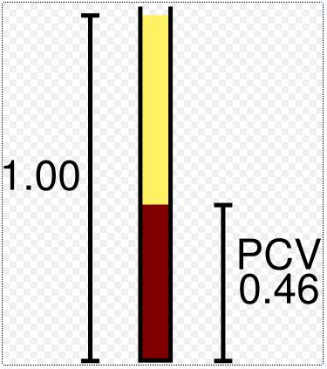
Methods to measure PCV:
- Microhaematocrit
- Electronic cell counting

Microhaematocrit method
Material and instruments
- Microhaematocrit tube (capillary tube): 75mm in length and 1mm in diameter which contains heparin and show a red ring at one end of the tube.
- Microhaematocrit centrifuge device.
- Plastic seal to seal one end of Microhaematocrit capillary tube.
- Microhaematocrit reader.

Procedure:
1- Blood is drawn into the tubes by capillary phenomenon. By holding the tube in a horizontal manner and allow 2/3 to 3/4 to be filled with blood (Air bubbles denote poor technique but do not affect the results of the test).
2- Seal the dry end of the tube by plastic seal.
3- The sealed tube is then placed in the radial grooves of the Microhaematocrit centrifuge and centrifuge for 5 minutes.
4- When looking at a centrifuged haematocrit tube, you can see three distinct layers. A top layer of clear slightly milky plasma, a thin buffy coat layer (consisting of WBC and platelets), and a dark packed RBCs layer
5- Obtain the result using the microhaematocrit tube reading device adjusted over the movable line to touch the top of the RBCs in the tube (We can measure the PCV by a ruler and we find the percentage of packed cells to the whole column of the sample)

Medical considerations:
High PCV (haemoconcentration):
It is either due to reduced plasma volume as occur in cases of dehydration (e.g. alcohol, diuretic therapy, Addison's disease, burns, and diarrhea), or due to increased RBC mass as occur in cases of primary or secondary polycythaemia.
Low PCV (haemodilution):
It is either due to increased plasma volume as occur in cases of anemia, pregnancy, acute renal disease and acute liver disease, or due to reduced RBC mass as occur in cases of bone marrow depression due to malignancies, chronic renal disease and chronic liver disease.

