Medical physics Lecture 1 lec.kawther hussien
Terminology,modeling ,and measurement
Medical physics (also called biomedical physics, medical biophysics, and applied physics in medicine, physics applications in medical science, radiological physics or hospital radio-physics) is, in general, the application of physics concepts, theories, and methods to medicine or healthcare.
As application, the term medical physics refers to two major areas: -
- The applications of physics to the function of the human body in health and disease.
- The applications of physics in the practice of medicine.
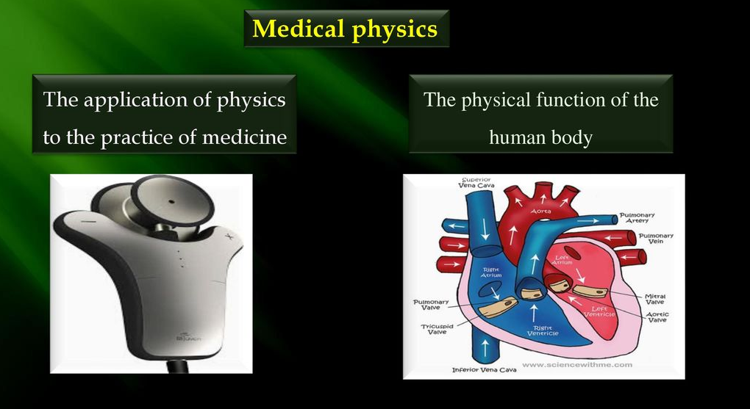

Medical physics is generally split into two major subgroups, specifically
a) Radiation therapy.
b) Radiology.
*Medical physics of radiation therapy can involve work such as:
1-Dosimetry.
(Radiation dosimetry in the fields of health physics and radiation protection is the measurement, calculation and assessment of the ionizing radiation dose absorbed by an object, usually the human body).
2-linac quality assurance.
(A medical linear accelerator (LINAC) is the device most commonly used for external beam radiation treatments for patients with cancer. It delivers high-energy x-rays or electrons to the region of the patient's tumor).
3-brachytherapy.
(Brachytherapy is a procedure that involves placing radioactive material inside your body. Brachytherapy is one type of radiation therapy that's used to treat cancer. Brachytherapy is sometimes called internal radiation).
*Medical physics of radiology involves: medical imaging techniques such as
1-magnetic resonance imaging.
2-ultrasound.
3- computed tomography.
4- positron emission tomography. 5- x-ray.
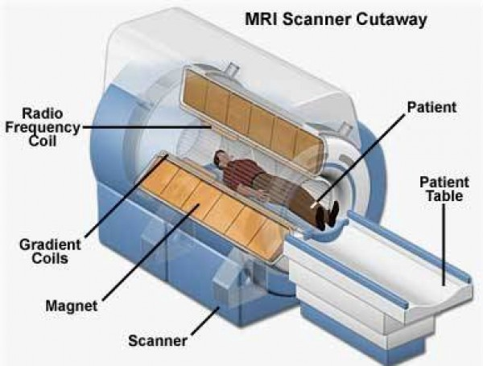

In the case of clinical work, the term medical physicist is the title of a specific healthcare profession, usually working within a hospital or other clinic. Medical physicists are often found in the following healthcare specialties:
# Radiation oncology.
# Diagnostic and interventional radiology (also known as medical imaging).
# Nuclear medicine.
#Radiation protection.

Mission statement of medical physicists.
In the case of hospital medical physics departments, the mission statement for medical physicists as adopted by the European Federation of Organisations for Medical Physics (EFOMP) is the following:
1-Medical Physicists will contribute to maintaining and improving the quality, safety and of healthcare services through patient-oriented activities.

2-control and optimized clinical use of medical devices and regarding patient risks and protection from associated physical agents .Also including the prevention of unintended or accidental exposures.
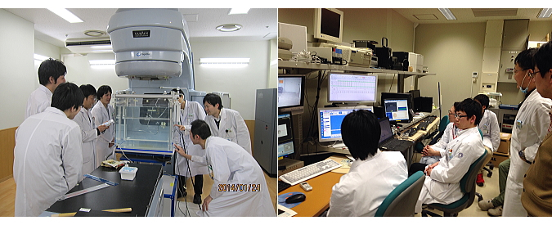

The term "physical agents" refers to
1- Ionizing and non-ionizing electromagnetic radiations.
2- Static electric and magnetic fields.
3- Ultrasound.
4- Laser light.
5- Other physical agents associated with medical e.g.
a-X- rays in computerized (CT).
b- Gamma rays/radionuclides in nuclear medicine.
c- Magnetic fields and radio-frequencies in magnetic resonance imaging (MRI).
d- Ultrasound in ultrasound imaging and Doppler measurements.

Medical imaging physics.
Medical imaging physics is also known as diagnostic and interventional radiology physics.
- Clinical physicists typically deal with diagnostic radiology physics areas such as
- Radiographic X-rays.
An X-ray gives only qualitative information about the inside of the body; a repeat X-ray taken with a different machine may look quite different to the ordinary observer.
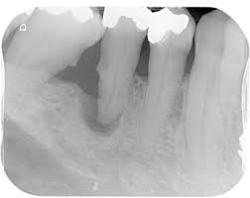
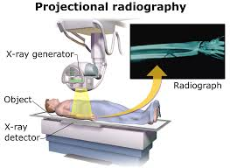

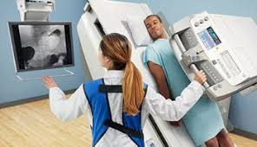
- Fluoroscopy.

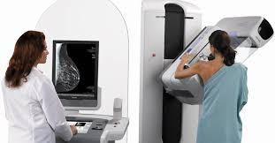
- Mammography.

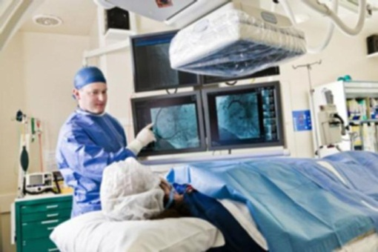
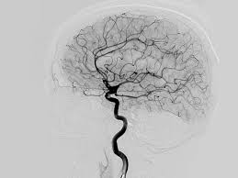
- angiography.

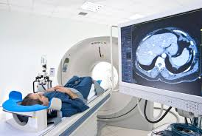
- computed tomography.

- non-ionizing radiation modalities such as ultrasound, and MRI.
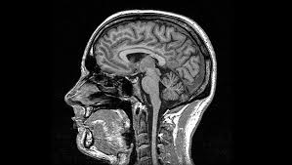
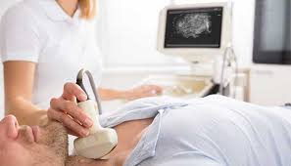

- In addition, many imaging physicists are often also involved with nuclear medicine systems, including
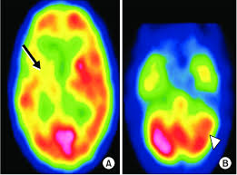
- single photon emission computed tomography (SPECT).

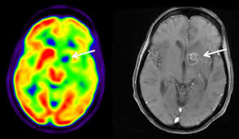
- positron emission tomography (PET).

Radiation therapeutic physics
Radiation therapeutic physics is also known as radiotherapy physics or radiation oncologist physics. A radiation therapy physicist typically deals with
- linear accelerator (Linac) systems
- kilovoltage x-ray treatment units on a daily basis.
c- as well as other modalities such as TomoTherapy, gamma knife, proton therapy, and brachytherapy.

The academic and research side of therapeutic physics may encompass fields such:
1-high-intensity focused ultrasound (including lithotripsy).
2- Optical radiation Lasers .
3-Ultraviolet including photodynamic therapy.
4- Nuclear medicine including unsealed source radiotherapy.
5- Photomedicine, which is the use of light to treat and diagnose disease.
Nuclear medicine physics
Nuclear medicine is a branch of medicine that uses radiation to provide information about the functioning of a person's specific organs or to treat disease. The thyroid, bones, heart, liver and many other organs can be easily imaged, and disorders in their function revealed. In some cases radiation sources can be used to treat diseased organs, or tumors. The most common radioisotope used in diagnosis is technetium-99m, with some 30 million procedures per year, accounting for 80% of all nuclear medicine procedures worldwide.

Health physics
Health physics is also known as radiation safety or radiation protection. Health physics is the applied physics of radiation protection for health and health care purposes. It is the science concerned with the recognition, evaluation, and control of health hazards to permit the safe use and application of ionizing radiation.

Modeling
Scientific modeling, the generation of a physical or mathematical representation of a real phenomenon that is difficult to observe directly. Scientific models are used to explain and predict the behavior of real objects or systems and are used in a variety of scientific disciplines, ranging from medicine, physics and chemistry to ecology and the Earth sciences.
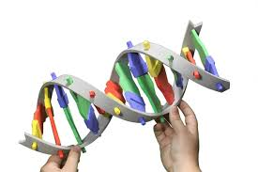
- The purpose of scientific modeling varies. Some models, such as the three-dimensional double-helix model of DNA, are used primarily to visualize an object or system, often being created from experimental data. Other models are intended to describe an abstract or hypothetical behavior or phenomenon.

For Example: -
Three- dimensional models of proteins are used to gain insight into protein function and to assist with drug design.
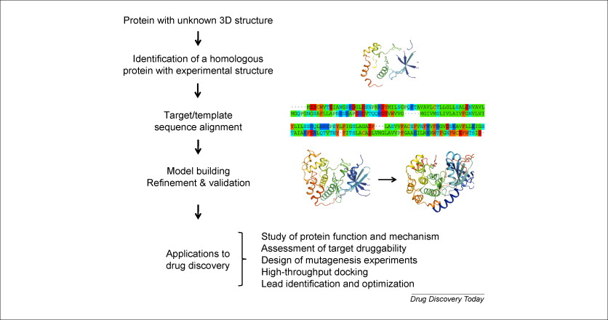

- Even though physicists believe that the physical world obeys the laws of physics, they are also aware that the mathematical descriptions of some physical situations are too complex to permit solutions.
For Example: -
If you tore a small corner off this page and let it fall to the floor, it would go through various gyrations. Its path would be determined by the laws of physics, but it would be almost impossible to write the equation describing this path. Physicists would agree that the force of gravity would cause it to go in the general direction of the floor if some other force did not interfere. Air currents and static electricity would affect its path.

- In trying to understand the physical aspects of the body, we often resort to analogies; physicists often teach and think by analogy. Keep in mind that analogies are never perfect.
For Example: -
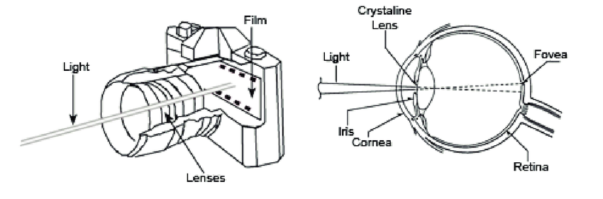
In many ways the eye is analogous to a camera; however, the analogy is poor when the film, which must be developed and replaced, is compared to the retina, the light detector of the eye.

- Some models involve physical phenomena that appear to be completely unrelated to the subject being studied.
For Example: -
A model in which the flow of blood is represented by the flow of electricity is often used in the study of the body's circulatory system. This electrical model can simulate very well many phenomena of the cardiovascular system. Of course, if you do not understand electrical phenomena the model does not help much. Also, as mentioned before, all analogies have their limitations.
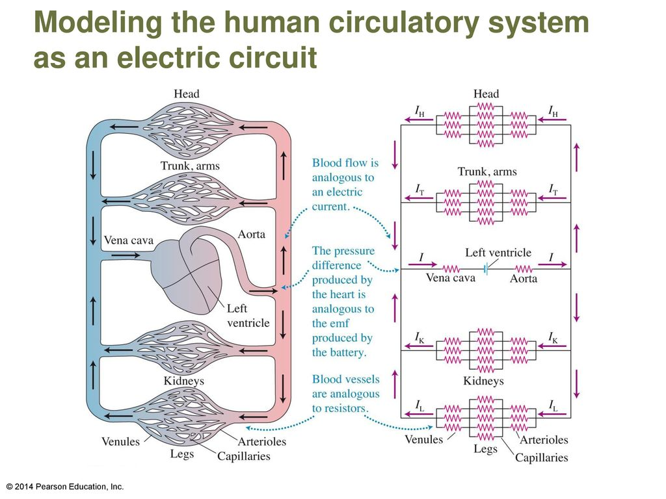
Blood is made up of red blood cells and plasma, and the percentage of the blood occupied by the red blood cells (the hematocrit) changes as the blood flows toward the extremities. This phenomenon is difficult to simulate with the electrical model.

- Other models are mathematical; equations are mathematical models that can be used to describe and predict the physical behavior of some systems. In the everyday world of physics we have many such equations. Some are of such general use that they are referred to as laws.
For Example: -
The relationship between force F, mass m, and acceleration a, usually written as F=ma, is known as Newton's second law. There are other mathematical expressions of this law that may look quite different to a lay person but are recognized by a physicist as other ways of saying the same thing. Newton's second law is used in the form F=∆mv/∆t, where v is the velocity, t is the time, and ∆ indicates a small change of the quantity. The quantity mv is the momentum, and the part of the equation P/∆t means rate of the change (of momentum) with time.

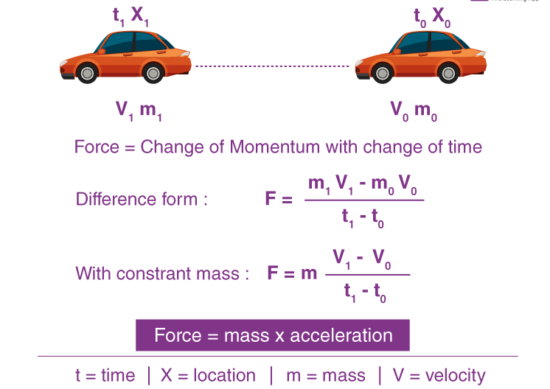

Measurement
Physiological measurements have also been used to monitor and measure various physiological parameters. Many physiological measurement techniques are non-invasive and can be used in conjunction with, or as an alternative to, other invasive methods.
Measurements are central to clinical practice and medical and health research. They form the basis of diagnosis, and evaluation of the results of medical interventions. Technical developments and advances in medical knowledge mean that new measurement instruments are still appearing in all fields of medicine. For example recent developments such as functional MRI and DNA microarrays.

There are many other physical measurements involving the body and time. We can divide them into two groups: -
- Measurements of repetitive processes. It usually involves the number of repetitions per second, minute, hour, and so forth.
For Example: -
- The pulse rate is about 70/min.
- The breathing rate is about 15/min.
2-Measurements of nonrepetitive processes, Nonrepetitive time processes in the body range from the action potential of a nerve cell (1msec) to the lifespan of an individual.
For Example: -
Such as how long it takes the kidneys to remove a foreign substance from the blood

Measurement accuracy: is the closeness of agreement between a measured quantity value and a true quantity value of the measured. A measurement is said to be more accurate when it offers a smaller measurement error.
For example
One may wish to measure a certain chemical’s volume in the experiment.
If the actual volume was 60 ml but the measurement was 75 ml, it would not be a very accurate value due to the fact that it is not close to the ‘true’ value of 60 ml.
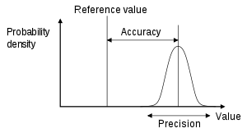

Measurement precision: is the closeness of agreement between measured quantity values obtained by replicate measurements on the same or similar objects under specified conditions.
Examples of Precision
Example 1 –
When you are measuring the value of resistance using a digital multimeter. (A multimeter or a multitester, also known as a VOM (volt-ohm-milliammeter))
The value of resistance is actually 35 Ohms, but multimeter is showing 33 Ohms consistently 10 times. So, Multimeter is Precise but not Accurate.

Example 2 –
Let’s say the temperature of an object is 60-degree celsius. And thermometer is showing 60 degrees for all readings. That means thermometer is Accurate and precise.

Measurement trueness: is the closeness of agreement between the average of an infinite number of replicate measured quantity values and the true or a reference quantity value. The concept trueness is a quality and is not given a numerical value.

One of the main characteristics of science is its ability to reproducibly measure quantities of interest.
Reproducibility is a major principle of the scientific method. It means that a result obtained by an experiment or observational study should be achieved again with a high degree of agreement when the study is replicated with the same methodology by different researchers.

The following are the common measurements used in the practice of medicine. Some of these measurements are more reproducible than others:
- Weight.
- Pulse.
- Temperature.
- Blood pressure.
- X-ray.
- Blood analysis.

Data collection to assessment body health
A) The Physical Examination
During a health assessment, diagnosing an illness, disorder or a condition is like a puzzle. Diagnosis often includes laboratory studies, radiology studies to look at certain organs, and the physical exam itself. This process is called data collection. Before modern technology, it was important for doctor to perfect their physical examination techniques, because x-ray machines, scanners, and echocardiograms were non-existent.
Findings that are present on the physical exam may by themselves diagnose, or be helpful to diagnose, many diseases. The components of a physical exam include:
i) Inspection
Your examiner will look at, or "inspect" specific areas of your body for normal color, shape and consistency. Certain findings on "inspection" may alert your examiner to focus other parts of the physical exam on certain areas of your body. For example, your legs may be swollen.
ii) Palpation
This is when the examiner uses their hands to feel for abnormalities during a health assessment. Things that are commonly palpated during an exam include your lymph nodes, chest wall (to see if your heart is beating harder than normal), and your abdomen. He or she will use palpation to see if there are any masses or lumps, anywhere in your body.
iii) Percussion
This is when the examiner uses their hands to "tap" on an area of your body. The "tapping" produces different sounds. Depending on the kind of sounds that are produced over your abdomen, on your back or chest wall, your examiner may determine anything from fluid in your lungs, or a mass in your stomach. This will provide further clues to a possible diagnosis.
iv) Auscultation
This is an important physical examination technique used by your doctor, where he or she will listen to your heart, lungs, neck or abdomen, to identify if any problems are present. Auscultation is often performed by using a stethoscope. The stethoscope will amplify sounds heard in the area that is being listened to. If there is an abnormal finding on your examination, further testing may be suggested.
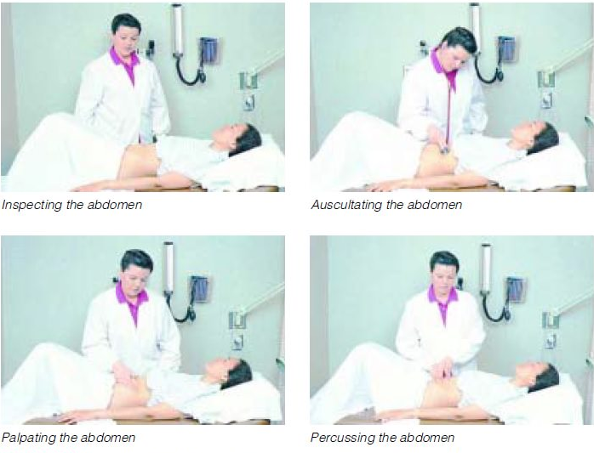

B) The Neurologic Examination:
A neurologic examination may be performed. This can be very brief or more detailed depending on findings. In general the physical examination is divided into 4 parts; cranial nerve assessment, motor function assessment, sensory function assessment, and assessment of reflexes.
C) Analysis of Body Fluids
- Blood
- Urine
- Fluid that surrounds the spinal cord and brain (cerebrospinal fluid(CSF))
- Fluid within a joint (synovial fluid)
Less often, sweat, saliva, and fluid from the digestive tract (such as gastric juices) are analyzed. Sometimes the fluids analyzed are present only if a disorder is present, as when fluid collects in the abdomen, causing ascites, or in the space between the two-layered membrane covering the lungs and lining the chest wall (pleura), causing pleural effusion.
D) Measurement of Body Functions
Often, body functions are measured by recording and analyzing the activity of various organs. For example, electrical activity of the heart is measured with electrocardiography (ECG), and electrical activity of the brain is measured with electroencephalography (EEG). The lungs’ ability to hold air, to move air in and out, and to exchange oxygen and carbon dioxide is measured with pulmonary function tests.

E) Biopsy
Tissue samples are removed and examined, usually with a microscope. The examination often focuses on finding abnormal cells that may provide evidence of inflammation or of a disorder, such as cancer. Tissues that are commonly examined include skin, breast, lung, liver, kidney, and bone.
F) Analysis of Genetic Material (Genetic Testing)
Usually, cells from skin, blood, or bone marrow are analyzed. Cells are examined to check for abnormalities of chromosomes, genes (including DNA), or both.

*When a physician must decide if the patient is ill or not, and what the illness is?
After a physician has reviewed a patient's: -
- Medical history.
- The findings of the physical examination.
- The results of the clinical laboratory measurements.

Measurements of physiological, biochemical, physical, and other patient-related variables produce results; these results from such measurements also provide essential information for critical decision-making in clinical practice, as well as for research and technology development.
Erroneous measurements can jeopardize patient safety and can expose the most critically ill patients to severe hazards.
The decisions are two types: -
- Right decisions.
- Wrong decisions.
It is not surprising that sometimes wrong decisions are made. These wrong decisions are of two types: -
- False Positives.
- False Negatives.
A false positive error occurs when a patient is diagnosed to have a particular disease when he or she does not have it.
A false negative error occurs when a patient is diagnosed to be free of a particular disease when he or she does have it.
Note: -
In some situations a diagnostic error can have a great impact on a patient's life.
For Example: -
A young woman was thought to have a rheumatic heart condition and spent several years in complete bed rest before it was discovered that a false positive diagnosis had been made-she really had arthritis, a disease in which activity should be maintained to avoid joint stiffening.
In the early stages of many types of cancer it is easy to make a false negative diagnostic error because the tumor is small. Since the probability of cure depends on early detection of the cancer, a false negative diagnosis can greatly reduce the patient's chance of survival.

Diagnostic errors (false positives and false negatives) can be reduced by: -
1-Research into the causes of misleading laboratory test values.
2-Development of new clinical tests and better instrumentation.
3-Using care in taking the measurement.
4-Repeating measurements.
5-Using reliable instruments.
6-Properly calibrating the instruments.

