Operative Dentistry
Lec. 1
Dr. Farah Salahaldeen Abbas

Defense mechanism of dentin and pulp against injury

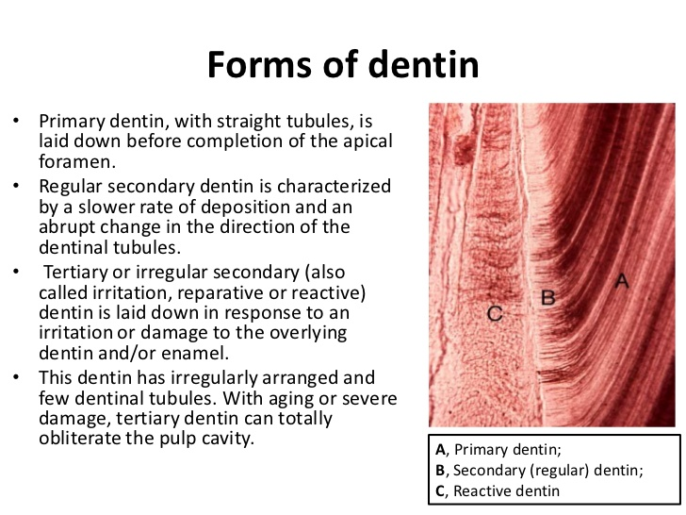

The reaction in dentin mainly due to the activity of odontoblast cells, so that dentin and pulp should be considered as one tissue.
The pulp-dentin complex reacts to caries attack by attempting to initiate remineralization and blocking off the open tubules. These reactions result from odontoblastic activity and the physical process of demineralization and remineralization.

A variety of reactions are seen such as:
Dead tracts:
They are regions of empty tubules in primary dentin that result from degeneration of the odontoblastic processes found under most carious cavities. At the proximal end of the tubules {near the pulp side} the dead tract has been sealed off by a layer of impermeable calcified tissue protecting the pulp.

Three levels of dentinal reaction to caries can be recognized:

(1) Reaction to long-term, low-level acid demineralization associated with a slowly advancing lesion.
(2) Reaction to moderate-intensity attack.
(3) Reaction to sever, rapidly advancing caries characterized by very high acid levels.
In slowly advancing caries: a vital pulp can repair demineralized dentin by remineralization of the intertubular dentin and by apposition of peritubular dentin. Early stages of caries or mild caries attack, produces a long-term low-level acid demineralization of dentin. Dentin responses to a first stimuli of caries demineralization by deposition of crystalline material in the lumen of the tubules and the intertubular dentin of affected dentin in front of the advancing infecting dentin portion of the lesion. Dentin that has more mineral content than normal dentin is termed sclerotic dentin. Sclerotic dentin formation occurs ahead of the demineralization front of a slowly advancing lesion and may be seen under an old restoration and its function is to wall off a lesion by blocking (sealing) the tubules.
Sclerotic dentin is usually shiny and darker in color but feels hard to the explorer tip. By contrast, normal, freshly-cut dentin lacks a shiny, reflected surface and allows some penetration from a sharp explorer tip. Sclerotic dentin that resulted from mild irritation {such as slowly advancing caries} is "reactive dentin sclerosis" which is often seen radiographically in the form of more radio-opaque (lighter area) in the S-shape of tubules.
Sclerosis of dentin can also be resulted from aging is called "physiological dentin sclerosis".

The second level of dentinal response: A response to moderate intensity irritants including pathogenic bacteria and high acid level which can cause degeneration and death of odontoblasts and their extensions below the lesion and a mild inflammation of the pulp resulting in formation of secondary odontoblast cells (from undifferentiated mesenchymal cells) to produce reparative dentin on the affected portion of the pulp chamber wall. This dentin is different from normal dentin which is mostly irregular tubular dentin. Reparative D is a defense reaction to an area of injury.

The third level of dentinal response (Inflammation of pulp): A response to sever irritation. Acute, rapidly advancing caries with high level of acid production that overpowers dentinal defenses and results in infection, abscess, and because the pulp is contained in a sealed chamber, and its blood supply through narrow root canals, any stagnation of blood flow can result in local anoxia and necrosis that rapidly spread involving the entire pulp.

Thus the pulp response determined by:
1) Intensity of the stimulus.
2) Adequacy of blood supply to the pulp.
,,,,,,,,,,,,,,,,,,,,,,,,,,,,,,,,,,,,,,,,,,,,,,,,,,,,,,,,,,,,,,,,,,,,,,,,,,,,,,,,,,,,,,,,,,,,,,,

