Operative Dentistry

Lec. 2 Dr. Farah Salahaldeen

Reaction of the pulp to different operative procedures

Introduction: teeth are vital organs; they should be treated with consideration when subjected to operative procedures. The pulp responds very quickly to external stimuli, and the response depends on the severity of the stimuli. The effects of different operative procedure on the pulp can be subdivided into:

A-Effect during cavity and crown preparation (cutting procedures): pulpal responses to cutting procedure depend on many factors:-

1- Thermal injury (frictional heat)
In spite of low thermal conductivity of dentin, the heat generated by grinding procedures of tooth structure has often been considered as being the greatest single cause of damage, if high temperature is produced in a deep cavity by continuous cutting without proper cooling, the underlying pulp may be severely damage. If damage is extensive and the cell-rich zone of the pulp is destroyed, reparative dentin may not form. Instead a generalized cellular degeneration leading to localized abscess. Permanent damage of pulp may result when the temperature reaches 55 degree C.

Basic factors in rotary instrumentation that cause temperature rise in the pulp:
*Force applied by the operator: is directly proportional with heat generation.
*Revolutions per minute (rpm) (speed of rotation): the development of ultra-speed (300,000 rpm) and more found to be more traumatic to the pulp than low- speed (3000 rpm) because of increase of frictional heat, but this occur in case if inadequate air water coolant is used. So it is essential that the development of these high-speed hand pieces should be accompanied by the development of adequate cooling mechanisms to prevent heat generated by grinding. Water cooling system is better than air-cooling.
The advantages of water cooling system
1-Reduce the temperature
2-Removal of debris
3- Clean vision

*Size, shape and the condition of cutting tools (burs):
-The more the contact between the tooth structure and bur, the more is the heat generation.
- Carbide burs generate less heat than diamond instruments. Diamond instrument has full surface contact with the tooth surface so is more heat generation.
- Bur with longitudinal serration or with cross cut is better because water can get to the cutting blades easily and this will reduces the heat generation.
- Dull burs decrease cutting efficiencies and increase heat and vibration.

*Duration of actual cutting time:
Intermittent cutting at intervals of a few seconds can reduce the heat generation.
Two new methods for tooth preparation are available:
-Laser
-Kinetic cavity preparation (air abrasion)
Laser: is a device, which produces beams of very high intensity light. There are several types available based on the wavelengths. Laser used for soft and hard tissues, for soft tissue they can produce completely blood free incision followed by rapid healing. The use of a variety of lasers, including Co, Er:YAG, and free electron lasers (FEL) on tooth structure has demonstrated minimal pulpal response, comparable to that of high-speed rotary instrumentation.
The effect of laser depend on 1- power of beam 2- extent to which beam absorbed. When we use laser for cutting of enamel and dentin the process would generate heat, which might affect the pulp so it should be used in pulsating manner (not continuously).
Air abrasive cutting: using a stream of aluminium oxide particles generated from compressed air or bottled carbon dioxide or nitrogen gas. The abrasive particles strike the tooth with high velocity and remove small amounts of tooth structure. Efficiency of removal is relative to the hardness of the tissue or material being removed and the operating parameters of the air abrasion device. However, it still generates heat and it is difficult for operator to determine the cutting progress within the cavity preparation.
Air abrasive equipment is being used for stain removal and cleansing pit and fissure before sealing.
2-Transection of the odontoblasts processes:
Amputation of the distal segment of the odontoblasts processes is a consequence of cavity preparation, but this quickly followed by repair of the cell membrane. While if amputation of odontoblasts process occur close to the cell body, this will lead to irreversible injury. Also during cutting procedure there is disturb of tight junction between adjacent odontoblasts, thus increasing the permeability of the odontoblast layer and could increase the potential for entry of toxic substances into the subjacent pulp tissue.
3-Dehydration:
When the surface of freshly cut dentin is dried with a jet of air, there is a rapid out ward movement of fluid through the dentinal tubules. According to theory of dentin sensitivity, this movement result in stimulation of the sensory nerve of the pulp and drawing odontoblasts up into tubules, these displaced odontoblasts soon die and disappear as they undergo autolysis result in an inflammatory response.
4-Remaining dentin thickness (RDT):
The distance between the floor of the cavity preparation and the pulp greatly influences the pulpal response to operative procedures and materials. Conservation of the remaining tooth structure is more important to pulpal health than replacement of lost tooth structure with cavity liner and base.
• In human teeth, dentin is approximately 3 mm thick
• Dentin permeability increases with decreasing RDT due to the differences in size and number of dentinal tubules. Permeability of dentin is of great importance in determining the degree of pulp injury resulting from the restorative procedures and materials.
• RDT of 2 mm or more effectively prevent restorative damage to the pulp
• At RDT of 0.75 mm, effects of bacterial invasion are seen
• When RDT is 0.25 mm, odontoblastic cell death is seen.

Fig.1: As dentin thickness decreases, the pulp response increases

5-Pulpal exposure:
Exposure of the pulp during cavity preparation occurs in the process of removing carious dentin. Accidental mechanical exposure may result during the placement of pins or retention points in dentin (large pulp chamber, extensive pulp horn even with shallow cavity). Injury to the pulp appears to be due to bacterial cavity contamination, so carious exposure result in much more bacterial contamination than does mechanical exposure, occasionally a pulp exposure is made unknown to the dentist because there is no bleeding. The first indication of a problem is the patient complaint of pulpalgia when anesthesia wears off. Radiograph reveals the exposure site and cement force into the pulp.

6-Pin insertion:
Since the advantages of pin placement into dentin is to support amalgam and composite restoration, increase in pulp inflammation and death has been noted. Pin insertion result in:
-Heat generation and this will increase the incidence of pulp damage.
-Pins may have been inadvertently inserted directly into the pulp or so close to it that they acted as sever irritant.
-Craze and stress in dentin during insertion.
B-Effect of lining materials and procedure:
Zinc phosphate cement (ZPC): The initial cement mixture is highly acidic because of phosphoric acid, although the pH approaches neutrality in a short period of time, newly mixed phosphate cement is highly irritant to the pulp and produce irreversible pulpal damage (acidity will decrease of blood flow and cause pulpal death).

Polycarpoxylate cement: less irritant than ZPC, the lower level of irritation may be due to the large molecular size of polyacrylic acid which restricts penetration through dentin and it adapts well to dentin and has bacteriocidal effect.
Zinc oxide eugenol (ZOE): has a sedative effect, pH (7), bacteriostatic and bacteriocidal, and has good marginal seal. Eugenol, a phenol derivative, is known to be toxic; it's capable of producing thrombosis of blood vessels when applied directly to pulp tissue. Because eugenol injures cells, there is a question whether should be used in very deep cavity preparation where there is a risk of pulp exposure.
Glass ionomer cement (GIC): it has been found that GIC has no irritating effect upon living pulp.

Lining procedure:
-Lining materials should not be placed on the walls and margins because it dissolves in oral fluid leaving a wide gap between the restoration and tooth and this consider as a source of irritant.
-Thickness of base materials should be (1-2mm) is an effective barrier against both hot and cold stimuli in deep cavity.
-Force of cementation: the patient complains of pulp pain when an inlay or crown is finally cemented with ZPC due to chemical irritation of the cement liquid as a factor. Insertion and cementation-hydraulic forces may compress fluids in the dentinal tubules resulting in separation of the odontoblastic layer from the dentin.

C-Effect of filling materials and procedure:
-Cleansing agents (Acid etching):
-Drying agents:
*Self-cure resin restoration: the initial toxic shock is so sever, that extensive use of self-curing plastics as filling and temporary crown might be related to great number of pulp death. Besides, the damaging effect of the heat generated as the plastic material self-cures on the freshly cut preparation.
*Composite resins: the composite contains acrylic monemers in their catalyst system and it can be assumed that the monemers could be the cause of damage as in case of self-curing resin. However, they give off irritant component, over a longer time than self-cures.
-Heat of polishing: The pulp damage caused by polishing of restoration must be considered, especially if we use dry powder. Polishing appliances made of rubber create higher temperature than cup brushes. Continuous polishing using high speeds of rotation associated with greater heat than intermittent polishing using low speeds.
* Dental amalgam: High mercury content amalgam may exert a cytotoxic effect on the pulp; the mercury penetrates into the dentin and pulp beneath an amalgam restoration. Patients sometimes report hypersensitivity following insertion of dental amalgam and this may be related to:
1- Force of insertion.
2- Possibility to the expansion of amalgam after insertion.
-The pulp may injured from sever temperature changes induced by thermal energy passing through the metallic restoration. Thus whenever the cavity preparation is deep and an inadequate thickness of dentin is present for thermal isolation, protection by a cement base must be provided.
- In class II, matrix band, retainer and wedge are used to prevent overhang filling and microleakage otherwise a pulpal or periodontal damage will occur.
- Proper carving to remove high spots to prevent pulpal or periodontal damage.

*Microleakage:
No permanent filling material has been shown to provide a perfect marginal seal. So leakage and bacterial contamination are always threat to the integrity of the pulp (Fig. A&B). Bacterial growing beneath restoration will produce toxic products that diffuse through the dentinal tubules and cause inflammatory reactions. Adequate liner or cement base should be employed to seal the dentinal tubules before insertion of the restorative materials, and its better that these cements have the ability to inhibit bacterial growth (e.g.; ZOE, GIC).

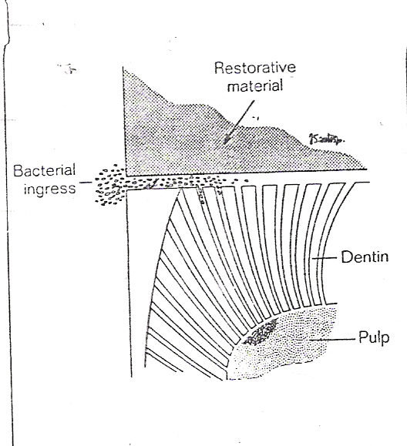
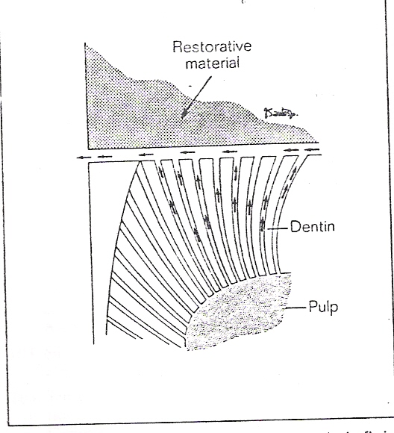

Fig. A and B
Two important factors affecting marginal adaptation;
1- Temperature changes
2- Masticatory forces. If a material has different coefficient of thermal expansion than tooth structure, temperature change is likely to produce gaps between the material and the cavity. In composite filling, marginal seal has been improved by acid etching of beveled enamel and the use of the bonding agent or primer. But it has been shown that the initial marginal seal tends to decrease as the etched composite restoration ages.

D-Accumulative effects:
The whole irritations that subjected to the tooth during the carious process, cavity preparation, lining and filling procedure, and secondary caries. Therefore, the pulp is under a continuous process of irritation and inflammation. If there is a small inflammatory process it may get worse till the whole pulp involved and become necroses. This may occur very fast or slow depending on the severity of irritation, and this may occur without the patient's feeling.

