Physics of Dignostic X-Rays

The X-ray photon is a member of the electromagnetic family that includes light of all
types, radio waves, radar and television signals, and gamma rays. Like many important
scientific breakthroughs, the discovery of X-rays was accidental.
The field of radiology has three major branches: -
1. Diagnostic Radiology.
2. Radiation Therapy.
3. Nuclear Medicine.
Production of X-ray beams
A high-speed electron can convert some or all of its energy into an X-ray photon when it strikes an atom. The main components of a modern X-ray unit are:-
(1) A source of electrons (filament, or cathode).
(2) An evacuated space in which to speed up the electrons.
(3) A high positive potential to accelerate the negative electrons.
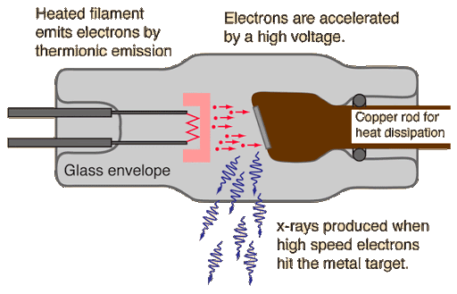
(4) A target, or anode, which the electrons strike to produce X-ray.

Types of X-rays
1- Bremsstrahlung
While the energy of most of the electrons striking the target is dissipated in the form of heat, the
remaining few electrons produce useful X-rays. Many times one of these electrons gets close
enough to the nucleus of a target atom to be diverted from its path and emits an X-ray photon
that has some of its energy. X-rays produced in this way have a fancy German name,
bremsstrahlung, which means "braking radiation".
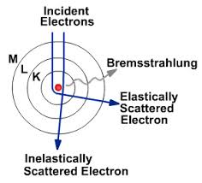

Bremsstrahlung is also called white radiation since it is analogous to white light and has a
range of wavelengths. The amount of bremsstrahlung produced for a given number of electrons
striking the anode depend upon two factors:
1) The Z of the target-the more protons in the nucleus, the greater the acceleration of the
electrons.
2) The kilovolt peak-the faster the electrons, the more likely they will penetrate into the region
of the nucleus.

2- Characteristic X-ray
Sometimes a fast electron strikes a K electron in a target atom and knocks it out of its orbit
and free of the atom. The vacancy in the K shell is filled almost immediately when an electron
from an outer shell of the atom falls into it, and in the process, a characteristic K X-ray
photon is emitted.
An X-ray photon emitted when an electron falls from the L level to the K level is called a
K_{α} characteristic X-ray, and that emitted when an electron falls from the M shell to the K
shell is called a K_{β} characteristic X-ray.
Since the energies of the electrons in the various shells of an atom are precisely
determined by nature, an electron falling from an outer shell to an inner shell will always
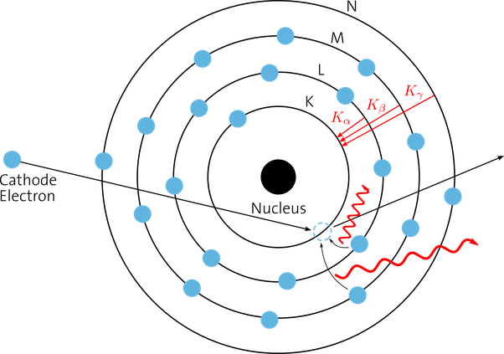
produce an X-ray with an energy characteristic of that atom.

How X-rays are absorbed
X-rays are not absorbed equally well by all materials; if they were, they would not be very
useful in diagnosis. Heavy elements such as calcium are much better absorbers of X-rays than
light elements such as carbon, oxygen, and hydrogen, and as a result, structures containing
heavy elements, like the bones, stand out clearly. The soft tissues-fat, muscles, and tumors-all
absorb about equally well and are thus difficult to distinguish from each other on an X-ray
image. The attenuation of an X-ray beam is its reduction due to the absorption and scattering of
some of the photons out of the beam.
A simple method of measuring the attenuation of an X-ray beam is shown below.
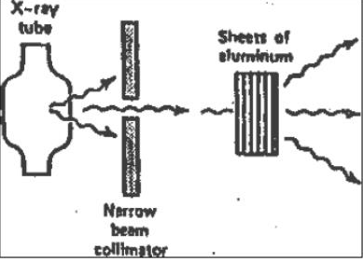

X-ray detector

A narrow beam of X-rays is produced with a collimator-a lead plate with a hole in it-and an Xray detector measures the beam intensity. The unattenuated beam intensity is I_{o}. As sheets of
aluminum are introduced into the beam, the intensity I decrease approximately exponentially.
The lower energy (soft) X-rays are absorbed more readily than the higher energy (hard) X-rays.
The intensity of a monoenergetic X-ray beam would decrease exponentially. The exponential equation describing the attenuation curve for a monoenergetic X-ray beam
is: - I = I_{o} e^{−μ χ}
Where e = 2.718 , x is the thickness of the attenuator, and μ is the linear attenuation coefficient of the attenuator. The linear attenuation coefficient is dependent on the energy of the X-ray photons; as the beam becomes harder, it decreases.
The half-value layer (HVL) for an X-ray beam is the thickness of a given material that
will reduce the beam intensity by one-half.
For a monenergetic X-ray beam, the second half-value layer equals the first half-value
layer. The half-value layer is related to the linear attenuation coefficient by: -
HVL =$\frac{0.693}{µ}$

The mass attenuation coefficient μm is used to remove the effect of density when comparing attenuation in several materials. The mass attenuation coefficient of a material is equal to the linear attenuation coefficient μ divided by the density ρ of the materials.

I=I_{o}e ^{–(μ/ρ) (ρx)} = I_{o}e ^{–μm (ρx)}

The quantity ρx is in grams per square centimeter and is sometimes called the area density; μm is in square centimeters per gram.

Example 1: Calculate the percentage of X-ray beam absorbed by a bone of thickness 3cm and μ/ρ of the bone to that X-ray energy is 0.2cm² /g, and ρ of the bone is 1.9 g/cm³ .

I=I_{o}e ^{–(μ/ρ) (ρx)}
I / I_{o} = e ^{–(μ/ρ) (ρx)}
I / I_{o} = e ^{–(0.2) (1.9×3)} = e^{-1.14} =2.718^{-1.14} = 0.3

There are processes by which X-rays can be absorbed or scattered
- Photoelectric Effect
The Photoelectric Effect is one way X-rays lose energy in the body. It occurs when the incoming X-ray photon transfers all of its energy to an electron which then escapes from the atom. The photoelectron uses some of its energy (the binding energy) to get away from the positive nucleus and spends the remainder ripping electrons off (ionizing) surrounding atoms.
The Photoelectric Effect is more apt to occur in the intense electric field near the nucleus than in the outer levels of the atoms, and it is more common in elements with high Z than in those with low Z. Of course, for a given electron to be liberated its binding energy must be lower than the energy of the X-ray.
When the energy of the X-ray is just slightly greater than the binding energy, the probability that the Photoelectric Effect will occur increases greatly.

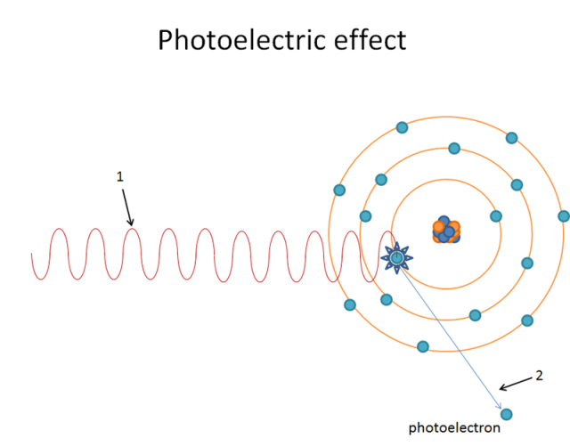

- Compton Effect

Another important way X-rays lose energy in the body is by the Compton Effect. In 1922 A. H. Compton suggested that an X-ray photon can collide with a loosely bound outer electron much like a billiard ball collides with another billiard ball. At the collision, the electron receives part of the energy and the remainder is given to a Compton (scattered) photon, which then travels in a direction different from that of the original X-ray.

The energy transferred to the electron can be calculated in the same way as the energy transferred during a billiard ball collision by using the laws of conservation of energy and momentum. The X-ray has an effective mass m of E/c² (from Einstein's famous equation E=mc² ), and its momentum is E/c. We can calculate the energy equivalent of the electron mass to be 511keV, and the Compton Effect is most likely to occur when the X-ray has this energy.
However, since the Photoelectric Effect is more apt to occur in high Z materials than in low Z materials, the fraction of X-rays that lose energy by the Compton Effect is greatest in low Z elements.
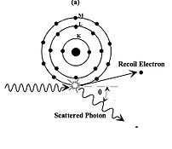

- Pair Production
Pair Production is the third major way X-rays give up energy. When a very energetic photon enters the intense electric field of the nucleus, it may be converted into two particles: an electron and a positron (β ⁺ ), or positive electron.
Providing the mass for the two particles requires a photon with energy of at least 1.02MeV, and the remainder of the energy over 1.02 MeV is given to the particles as kinetic energy. The positron is a piece of antimatter. After it has spent its kinetic energy in ionization it does a death dance with an electron.
Both then vanish, and their mass energy usually appears as two photons of 511keV each called annihilation radiation.

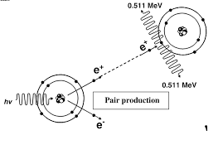

Since a minimum of 1.02MeV is necessary for Pair Production, this type of interaction is only important at very high energies. Because the intense electric field of the nucleus is involved, pair production is more apt to occur in high Z elements than in low Z elements.

How are these interactions related to diagnostic radiology?

You can see that Pair Production is of no use in diagnostic radiology because of the high energies needed and that the Photoelectric Effect is more useful than the Compton Effect because it permits us to see bones and other heavy materials such as bullets in the body. At 30keV bone absorbs X-rays about 8 times better than tissue due to the Photoelectric Effect. To make further use of the Photoelectric Effect radiologists often inject high Z materials, or contrast media, into different parts of the body.
Compounds containing iodine are often injected into the bloodstream to show the arteries, and an oily mist containing iodine is sometimes sprayed into the lungs to make the airways visible. Radiologists give barium compounds orally to see parts of the upper gastrointestinal tract (upper GI) and barium enemas to view the other end of the digestive system (lower GI). Since gases are poorer absorbers of X-rays than liquids and solids, it is possible to use air as a contrast medium. In a double-contrast study, barium and air are used separately to show the same organ.
If the Photoelectric Effect did not exist and radiologists had to rely on the Compton Effect, X-rays would be much less useful because the Compton Effect depends only on the density of the materials.

X-ray film

To obtain a satisfactory X-ray image of thick body parts such as the abdomen and hips, it is necessary to reduce the scattered radiation at the film. The amount of scattered radiation at the film depends somewhat on the energy of the X-rays, but the thickness of the tissue that the X-ray beam passes through is the most important factor-the thicker the tissue, the greater the scatter.
Also, the larger the beam, the greater the scatter, and thus one simple way of reducing scattered radiation is by keeping the X-ray beam as small as possible.

The most significant way of reducing the amount of scattered radiation striking the film is by using a grid consisting of a series of lead and plastic strips. The strips are aligned so that unscattered X-rays from the source will go through the plastic strips and strike the film while most of the scattered radiation will strike the lead strips and be absorbed. The grid was invented by G. Bucky in 1915; H. E. Potter improved it in 1919 by making it move during the exposure so that the lead strips do not produce visible shadows on the image.

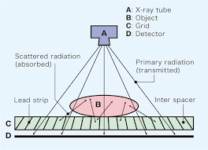

This grid is called a focused grid-it does not focus the X-rays, but its strips are slanted toward the edge so that only unscattered X-rays from an optimum distance (e.g., 1m) can go through unimpeded. When the X-ray source is very far from this optimum distance, many of the unscattered rays will be absorbed in the lead strips. If a focused grid is placed upside down, only the center of the field will be seen on the image.
If two equivalent X-rays are taken, one with and one without a grid, the one taken with the grid will be clearer because of the reduced scatter. However, it will also require a larger exposure to the patient. Since reducing the scatter reduces the darkening of the film, it is necessary to increase the exposure in order to obtain an optimum darkness (optical density) of the film. In addition, a higher exposure must be given because the lead strips absorb some of the unscattered radiation.
When you have a chest X-ray taken, the technologist tells you to hold your breath since reducing motion reduces blurring. However, it is not possible to "hold" your heart motion, and X-rays of the heart are somewhat blurred. This blurring can be reduced by making the exposure as short as possible. The desire for short exposures has led to the development of X-ray tubes with large current capacities that can produce intense X-ray beams.

Most X-ray images are made on a special film sandwiched tightly between two intensifying screenscardboards covered with a thin coating of crystals (e.g., CaWO₄) that absorb X-rays well and give off visible or UV light (fluoresce) when struck by X-rays.
The film is coated on both sides with a light-sensitive emulsion, and each side takes a "picture" of the light from the intensifying screen with which it is in contact. Intensifying screens are much more efficient for making X-ray images than film alone (a dental X-ray taken with film alone requires almost 30 times the X-ray exposure of a chest X-ray taken with intensifying screens). However, since the film records the light emitted by the screen rather than the X-rays striking it, the image is more blurred than when film alone is used.

