كلية طب الأسنان |  | الجامعة المستنصرية
 | The focal length of a convex lens by a graphical method
Medical Physics |  | Lab -11-
While the eye has some striking similarities to a camera, a better analogy exists between the eye and a closed circuit color TV system.
- The lens of the TV camera is the cornea and lens of the eye.
- The signal cable is the optic nerve.
- The viewing monitor is the visual cortex.
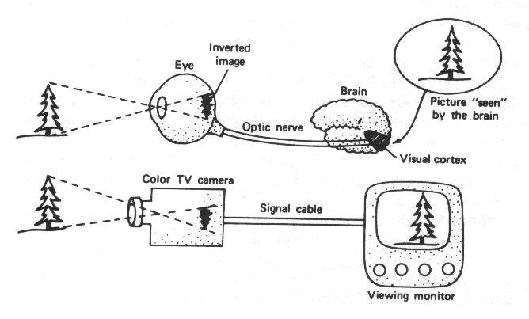

The Refractive Interfaces in the Lens System of the Eye
- The interface between air and the anterior surface of the cornea.
- The interface between the posterior surface of the cornea and the aqueous humor.
- The interface between the aqueous humor and the anterior surface of the crystalline lens of the eye.
- The interface between the posterior surface of the lens and the vitreous humor.

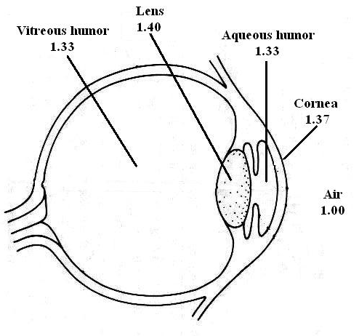

Focal Length of a Lens
The distance beyond a convex lens at which parallel rays converge to a common focal point is called "focal length" of the lens.
$\frac{1}{F}=\frac{1}{u}+\frac{1}{v}$The relation of focal length of the lens F, distance of the point source of light from the lens u, and distance of focus on the other side of the lens v is expressed by the following formula: -

Measurement of the Refractive Power of a Lens
$P=\frac{1}{F}$The more a lens bends light rays, the greater is its "refractive power". This refractive power is measured in terms of "Diopters". The refractive power in diopters of a convex lens is equal to 1 meter divided by its focal length.

Eye Conditions
- For Normal Vision "Emmetropia"
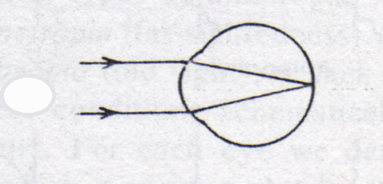
The eye is considered normal, or "emmtropic", if parallel light rays from distance objects are in sharp focus on the retina.

- For Defect Vision "Ametropia"
Is the defective eyesight due to focusing "Refractive" problem.
There are four types of Ametropia: -
- Myopia.
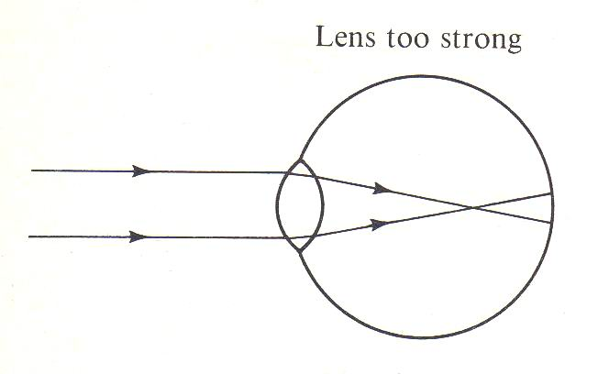
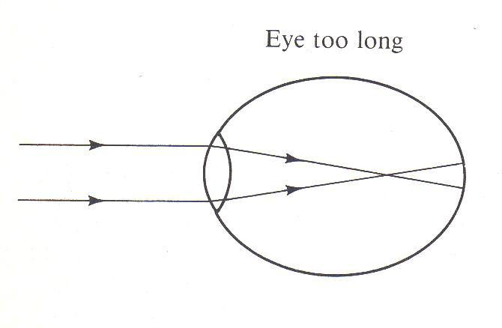
Which is also known as "near-sightedness", is usually due either to an eyeball that is too long, or occasionally, to a lens system that is too strong.

- Hyperopia
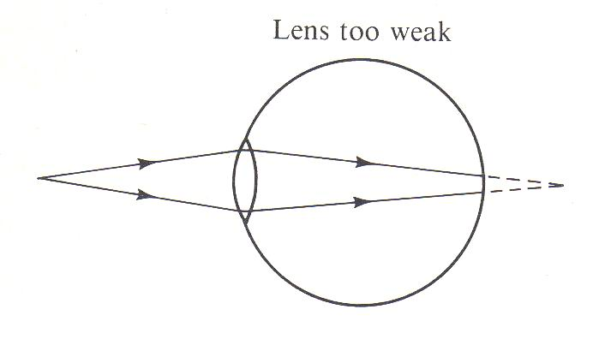
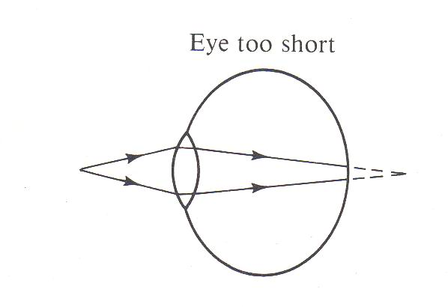
Which is also known as "far-sightedness", is usually due either to an eyeball that is too short, or occasionally, to a lens system that is too week.

- Astigmatism
Is a refractive error of the eye that causes the visual image in one plane to focus at a different distance from that of the plane at right angles. In astigmatism the cornea or lens of the eye is not symmetric.
- Presbyopia
As a person grows older, the lens grows larger and thicker and becomes far less elastic, partially because of progressive denaturation of the lens proteins. Therefore, the ability of the lens to change shape progressively decreases with age.
The Lenses
Lens are used to focus light and form an image in cameras, telescopes, microscopes, eyeglasses an even in our eyes.
Lenses work very much like mirrors. We will discuss two types of lenses.
- Concave Lenses
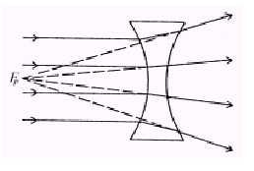
The double concave lens is a diverging lens. When light waves from an infinitely far object passes through the lens, the light waves will diverge as if it originated from a focal point F on the principle axis. The focal length is always a negative value for diverging lenses.

- Convex Lenses
The double convex lens is a converging lens. When light waves parallel to the principle axis from an infinitely far object passes through the lens, it will converge at a focal point F on the principle axis. The distance between the focal point and the lens is the focal length, which is always a positive value for converging lenses.
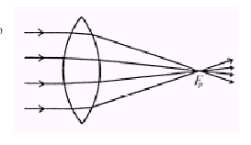

Correction of Eye Defects
- Myopia "near-sightedness"
Concave Lens is used to correct the Myopic persons.
- Hyperopia "far-sightedness"
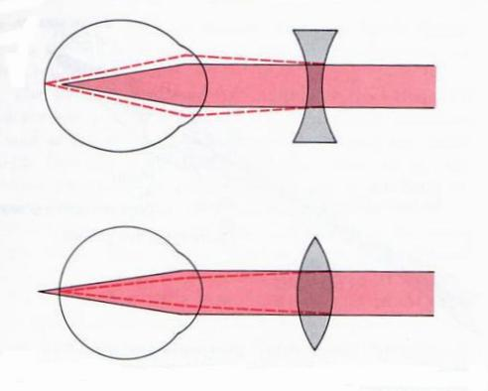
Convex Lens is used to correct the Hyperopic persons.

- Astigmatism
To correct for astigmatism, the usual procedure is to find a spherical lens that corrects the focus in one of the two plans of the astigmatic lens. Then an additional cylindrical lens is used to correct the error in the remaining plane. To do this, both the axis and the strength of the required cylindrical lens must be determined.
The Medical Applications of Lens
- To determine the focal length of the eye and distance between the object and the lens.
- For the treatment of the eye defects like far sight vision, near sight vision, old age vision, and astigmatism.
- It is used in many medical and biological devices like microscope, otoscope, endoscope, ophthalmoscope, and etc.
- In dentistry it is used in many devices and instruments, like dental chairs, mouth mirror, and etc..

