Force on and in the body

Force controls all motion in the world; we are usually unaware of important forces in the body, for example, the muscular forces that cause the blood to circulate and the lungs to take in air.

Forces

Forces in the body Forces on the body
1-Gravitational force 1- Static force
2-Electrical force 2-Dynamic force
3-Nuclear force 3-Frictional force

Forces in the body
1-Gravitational forces:
Newton formulated the law of universal gravitation. This law states that there is a force of attraction between any two objects; our weight is due to the attraction between the earth and our bodies. The gravitational force is much smaller on the moon.
Medical effects of gravitational force
- The formation of varicose veins in the legs as the venous blood travels against the force of gravity on its way to the heart.
- Medical effects of gravitational force on the skeleton (0n the bones), in some way contributes to "healthy bones". If a person becomes "weightless" such as in an orbiting satellite, he may lose some bone mineral, and this may be a serious problem on very long space journeys. Long-term bed rest removes much of the force of the body weight from the bones and can lead to serious bone loss.
2-Electrical forces:
This force more complicated than gravity since it involves attractive and repulsive forces between static electrical charges as well as magnetic force produced by moving electrical charges (electrical current).Electrical forces are immense compared to gravitational force. For example, the electrical force between an electron and a proton in a hydrogen atom is about 10 ³⁹ times greater than the gravitational force between them. Our bodies are basically electrical machines. This forces produced by the muscles are caused by electrical charges attracting or repelling other electrical charges.
Control of the muscles is primary electrical .Each of the billions of living cells in the body has in electrical potential difference across the cell membrane because of the differences in charge between the inside and outside of the cell. This amount to less than 0.1V, but because of the very thin cell wall it may produce a field as large as 10⁵ V/cm.
3-Nuclear forces:
Nuclear force keep the positive charges "proton" together inside the nucleus .we have two types of nuclear forces:
- Strong nuclear force: it is very larger than the other type. it is act as "glue" to hold the nucleus against the repulsive forces that produce by the protons on each other
- Weaker nuclear force: it is involved with electron decay from the nucleus. It may be related to the electrical force.
Forces on the body
1-Statics : When objects are stationary (static) they are in a state of equilibrium. The sum of the forces in any direction is equal to zero, and the sum of the torques about any axis also zero.
Many of the muscle and bone systems act as levers which are classified to:
a-First class levers: They are least common in the body. The fulcrum point (F) is between the muscle forces (M) and the weight (W), for example the head.
b-Second class levers: They are found more than first class levers. Weight (W) is between the fulcrum point (F) and muscle forces (M), for example standing on the toes.
c- Third class levers: They are most common in the body. Muscle forces (M) is between fulcrum point (F) and weight (W).For example, the arm in the elbow joint.

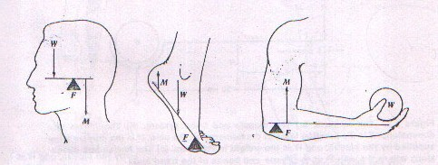
M
W
M
W

W
F
F
M
F

(First class) (Second class) (Third class)
Figure1: The three levers classes and schematic example of each in the body. W is a force that could be the weight, F is a force at the fulcrum point and M is the muscle force.
A simple example of a lever system in the body is the case of the biceps muscle and the radius bone acting to support a weight W in the hand (Figure 2a).Figure 2b show the forces and dimension of a typical arm. We can find the force supplied by the biceps if we sum the torques about the pivot point at the joint. There are only two torques: that due to the weight W, which is equal to 30W acting clockwise, and that produce by the muscle force M which counterclockwise and of magnitude 4M.With the arm in equilibrium we find that:
4M-30W=0 M=7.5W
Or that a muscle force 7.5 times the weight is needed (we neglected the weight of the forearm and hand).Figure 2c show a more corrects representation of the problem with weight of the forearm and hand H included. By summing the torques about the joint we obtain M= 3.5 H+7.5W
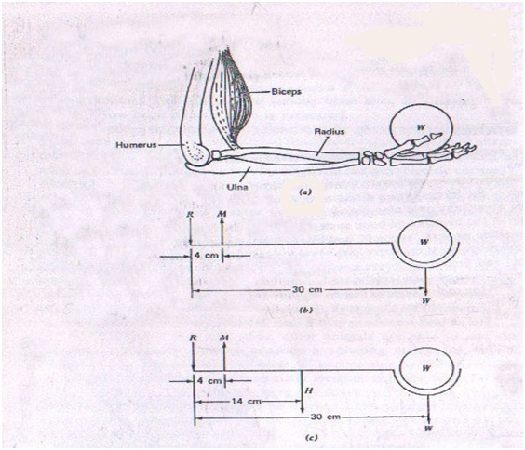

Figure2: The forearm (a) the muscle and bone system.(b) the forces and dimensions, R is the reaction force of the humerus on the ulna. M is the muscle force supplied by the biceps, and W is the weight in the hand.(c) the forces and dimensions where the weight of the tissue and bones of the hand and arm H is included and located at their center of gravity

Let us now consider the effect on the muscle force needed as the arm changes it angle as shown in (figure 3a). Figure 3b shows the forces we must consider for an arbitrary angle $α$. If we take the torques about the joint we find that M remains constant as $α$ changes.
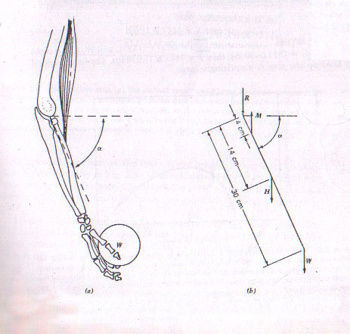
Figure3. The forearm at an angle $α$ to the horizontal.(a) the muscle and bone system.(b) the force and dimensions.
However, the length of the biceps muscle changes with the angle. In general, each muscle has a minimum length to which it can be contracted and a maximum length to which it can be stretched and still function. At these two extremes the force the muscle can exert is essentially zero. At some point in between, the muscle can produce its maximum force (figure 4).
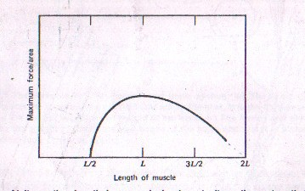
Figure4. At its resting length L a muscle is close to its optimum length for production force. At about half this length it cannot shorten further and the force it can produce drops to (0), whereas at a stretch of about 2L irreversible tearing of the muscle takes place.
If the biceps pulls vertically the angle of the forearm does not affect the force required but it does affect the length of the biceps muscle, which affects the ability of the muscle to provide the needed force.
The arm can be raised and held out horizontally from the shoulder by the deltoid muscle(figure5 a); we can show the forces schematically (figure5 b).By taking the sum of the torques about the shoulder joint ,the tension T can be calculate from
$$T=\frac{2W1+4W2}{sinα}$$
W₁(the weight of the arm),and W₂(the weight in the hand).
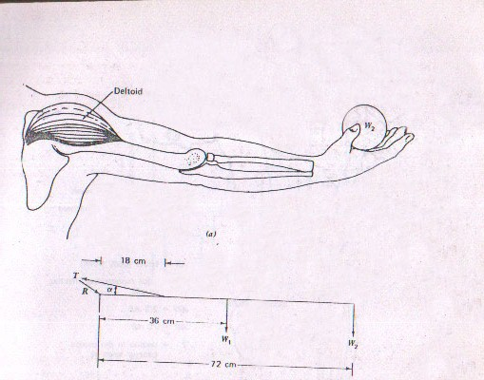

Figure5. Raising the arm.(a) The deltoid muscle and bone structure involved.(b)The forces on the arm. T is the tension in The deltoid muscle fixed at the angle $α,$R is the reaction force on the shoulder joint,W₁ is the weight of the arm located at its center of gravity, and W₂ is the weight in the hand.

2-Dynamic : This force is important when the body is moving and hitting another body. It appears on the body where acceleration or deceleration is involved . The Newton's second law, force equals mass times acceleration.
F=ma
Newton said" force equals the change of momentum ∆(mv) over a short interval
of time ∆t " $F=\frac{∆(mv)}{∆t}$
Example 1: A( 60 kg) person walking at( 1 m/sec )bumps into a wall and stops in a distance of( 2.5 cm )in a about( 0.05sec) .what is the force developed on impact?
∆(mv) = (60 kg)(1m/sec) – (60 kg)(0 m/sec) = 60 kg m/sec
$F=\frac{∆(mv)}{∆t}$ $=\frac{60 kg m/sec}{0.05 sec}$ $=1200 kg m/$ sec² or 1200 N

Example 2: a-A person walking at (1 m/sec) hits his head on a steel beam . Assume his head stops in (0.5 cm) in about 0.01 sec. If the mass of his head is (4kg), what is the force developed?
∆(mv) = (4 kg)(1m/sec) – (4 kg)(0 m/sec) = 4 kg m/sec
$F=\frac{∆(mv)}{∆t}$ $=\frac{4 kg m/sec}{0.01 sec}$ $=400 kg m/$ sec² or 400 N
b- If the steel beam has (2cm) of padding and ∆t is increased to (0.04 sec), what is the force developed?
$F=\frac{∆(mv)}{∆t}$ $=\frac{4 kg m/sec}{0.04 sec}$ $=100 kg m/$ sec² or 100 N

Sedimentation
The tendency of suspended solids of different densities to separate when accelerated is not important in the body but it is utilized in the common laboratory centrifuge. The centrifuge is a way to increase apparent weight. It is especially useful for separating a suspension in a liquid. It speeds up the sedimentation that occurs at a slow rate under the force of gravity. When we drop pebbles into a pond they fall to the bottom at a constant speed much slower than their speed in air. Grains of sand fall through water at a still slower speed. Very fine particles (silt) appear to remain suspended. The speed at which small objects fall through a liquid depends on their size, the viscosity of the liquid, and the acceleration due to gravity g.
We can artificially increase g by spinning the fluid in a centrifuge. This will cause very fine particles to separate from the fluid.
Let us consider first sedimentation of small spherical objects of density p in a solution of density p◌ in a gravitational field g . We know that falling objects reach a maximum (terminal) velocity due to viscosity effects. Stoke has shown that for a spherical object of a radius a , The retarding force F_{d} and terminal velocity v are related by
F_{d} $=6πavŋ$
Where ŋ is the viscosity of the liquid through which the sphere is passing .The SI unit for viscosity is the Pascal second (Pas), The cgs unit for viscosity is the poise (1Pas= 10 poise).

When the particle is moving at a constant speed, the retarding force is in equilibrium with the difference between the downward gravitational force and the upward buoyant force (the weight of the liquid the particle displaces). Thus we have:
- The force of the gravity F_{g}= 4/3$π$ a³ p g
- The buoyant force F_{B}= 4/3$π$ a³ p◌ g
- The retarding force F_{d} $=6πavŋ$
F_{g} acts downward and F_{B} acts upward,and the difference is equal to F_{d}
F_{d}=F_{g}-F_{B}
We obtain the expression for the terminal velocity (sedimentation velocity),
$$v=\frac{{2a}^{2}}{9ŋ}g(p-p)$$

In some forms of disease such as rheumatic fever, rheumatic heart disease, and gout, the red blood cells clump together and the effective radius increases; thus an increased sedimentation velocity occurs. In other diseases such as hemolytic jaundice and sickle cell anemia, the red blood cells change shape or break. The radius decrease; thus the rate of sedimentation of these cells is slower than normal.

3-Frictional forces:
Frictional and the energy loss due to friction appear everywhere in our everyday life. Friction limits the efficiency of most machines such as electrical generators and automobiles. On the other hand, we make use of friction in devices such as rubber tires and automobiles brakes.
Friction must be overcome when joints move, but for normal joints it is very small. The coefficient of friction in bone joints is usually much lower than in engineering-type material.
If a disease of the joint exists, the friction may become large. The synovial fluid in the joint is involved in the lubrication.
The saliva act as lubricant, Most of the large organs in the body are in more or less constant motion .Each time the heart beat its moves, the lungs move inside the chest with each breath, and the intestines have a slow rhythmic motion (peristalsis) as they move food toward its final destination. All of these organs are lubricated by slippery mucus covering to minimize friction.

