Lab. Saliva

In humans, the saliva is secreted by three pairs of major (larger) salivary glands and minor (small) salivary glands (lingual, buccal, labial, and palatal).
Properties of saliva:
Volume: 1000 – 1500 ml/day in rate of 0.5 – 1 ml/min.
Reaction: slightly acidic 6.35 – 6.85 (optimal for enzyme functions)
Specific gravity: 1.002 – 1012
Tonicity: hypotonic to plasma.
Composition: 99.5% water and 0.5% solids(Na, K, Ca, HCO3, Br, Cl, F, PO3, O2, CO2, N2, mucin, albumin, lactoferrin, IgA, Bgr Ag, aminomacids, urea, uric acid, creatinine, xanthine, hypoxanthine, amylase (ptyalin), maltase, lipase, lysozyme, phosphatase, carbonic anhydrase, kallikrein). Glucose normally absent but present in saliva in patient with DM

Functions of saliva:
1. Swallowing: moistening and dissolving food, moistening oral mucosal membrane to facilitate chewing and with facilitated tongue movement, the moistened and masticated food is rolled into a bolus.
2. Taste: saliva dissolves solid food substances to facilitate stimulation of taste buds.
3. Digestion:
Salivary amylase acts on cooked starch and converts it into dextrin and maltose. Starch digestion starts in the mouth but mainly, it occurs in stomach.
Maltase converts maltose into glucose.
Lingual lipase digests milk fats (pre-emulsified fats). It hydrolyzes triglycerides into fatty acids and diacylglycerol.
4. Cleaning and protection
i. The mouth and teeth are rinsed and kept free off food debris, shed epithelial cells and foreign particles. In this way, saliva prevents bacterial growth by removing materials, which may serve as culture media for the bacterial growth.
ii. Enzyme lysozyme kills bacteria like staphylococcus, streptococcus and brucella.
iii. Proline-rich proteins have antimicrobial property and neutralize toxic substances such as food tannin in fruits.
iv. Lactoferrin has antimicrobial property.
v. Proline-rich proteins and lactoferrin protect the teeth by stimulating enamel formation.
vi. Immunoglobulin (IgA) has antibacterial and antiviral actions.
vii. Mucin in the saliva protects the mouth by lubricating oral mucus membrane.
viii. Thiocyanate ions act as antimicrobial.
ix. Thin (0.5 μm) protective diffusion barrier formed on enamel from salivary proteins.
x. Agglutination of bacteria by salivary mucin resulting in accelerated clearance of bacterial cells.
5. Speech: moistening and lubricating mouth and lips to help in pronunciation.
6. Excretion of mercury, potassium iodide, lead, and thiocyanate, and viruses (rabies and mumps) and also glucose in diabetes mellitus. Excess urea is excreted in saliva during nephritis and excess calcium is excreted during hyperparathyroidism.
7. Regulation of body temperature but sweating plays the major role.
8. Regulation of water balance
When dehydration occurs, salivation decreases causing oral dryness and thirst, then information from osmoreceptors are translated by the hypothalamus into decreased urine production and increased drinking to quench thirst and restores body water content.
9. Buffer: Helps to neutralize plaque pH after eating, thus reducing time for demineralization.
10. Propulsion of toxins inadvertently swallowed.
11. Neutralize gastric acid and relieve heartburn when gastric juice is regurgitated into the esophagus.
12. Ion reservoir: solution supersaturated with respect to tooth mineral facilitates dental remineralisation. Salivary statherin and acidic proline-rich proteins inhibit spontaneous precipitation of calcium phosphate salts.

Regulation of salivation through nervous reflex mechanisms:
A. Unconditioned reflex present since birth and does not need previous experience. This reflex induces salivation when any substance is placed in the mouth leading to oral mucosal stimulation of nerve.
B. Conditioned reflex needs previous experience: presence of food in the mouth is not necessary to elicit this reflex. The stimuli for this reflex are the sight, smell, hearing or thinking of food.
The nervous reflex mechanism to control salivation include: stimulation of receptors, afferent nerve fibers, salivary nuclei, and efferent fibers of parasympathetic and sympathetic autonomic nerves that innervate salivary glands:
- Mastication, taste and tactile stimulation of lingual receptors resulting in stimulation of afferent V, VII, IX and X nerves fibers leading to stimulation of superior and inferior salivatory nuclei at the brain stem.
- Higher CNS signals from thinking, sight, and smell stimulation at cerebral cortex and amygdala sent impulses to hypothalamic appetite area to influence parasympathetic centers to control salivation rate (e.g. flavored food induce salivation more than unflavored food).
- Reflex from stomach or upper small intestines during nausea or swallowing an irritant substance (e.g. swallowed saliva neutralizes toxic substance).
- Efferent parasympathetic fibers of VII and IX nerves to salivary glands to induce fluid copious salivation and efferent sympathetic fibers (originate from first and second thoracic segment passing to superior cervical ganglion of sympathetic chain and through the blood vessels reaching the salivary glands) induces secretion of thick viscid salivation.
- Oral vasodilation through parasympathetic stimulation and/or effect of secreted salivary kallikrein enzyme which splits blood alpha 2 globulin protein to bradykinin (local vasodilator).
Also, hormones like androgens, estrogens, and glucocorticoids influence salivary composition.

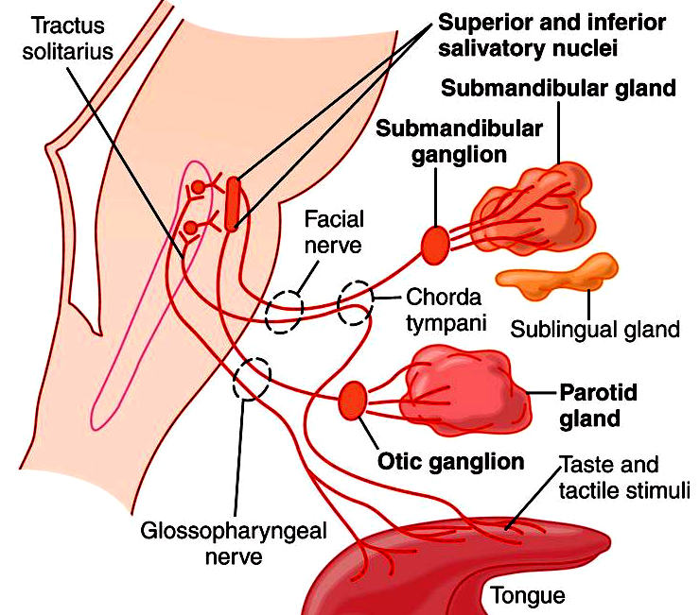

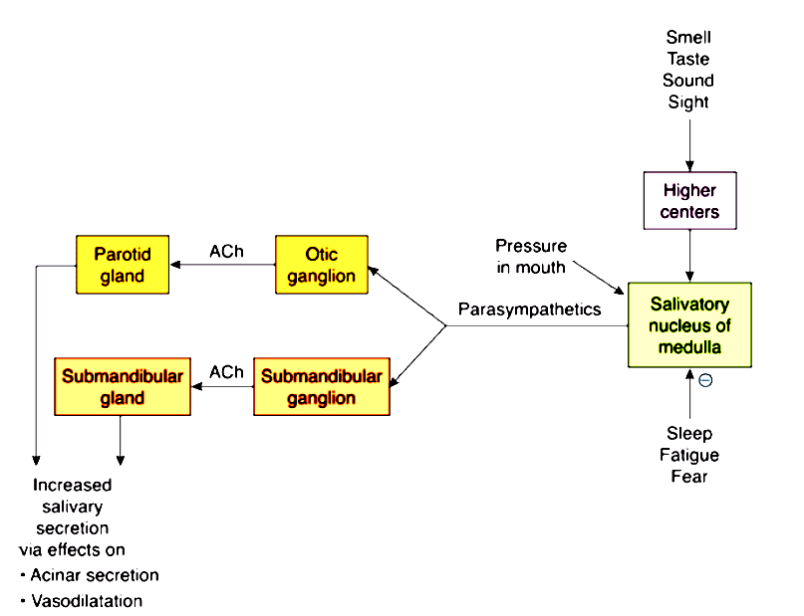
Sympathetic

Clinical conditions
Hyposalivation
Reduced salivary secretion of saliva.
1. Temporary hyposalivation occurs in emotional conditions (fear), fever and dehydration.
2. Permanent hyposalivation occurs in sialolithiasis (obstructed salivary duct), congenital absence of salivary glands and Bell’s palsy (paralysis of facial nerve).
Hypersalivation
Excess secretion of saliva which could be physiological (pregnancy) or pathological sialorrhea or sialosis as occurs in decay of tooth, tumor in mouth or tongue due to continuous irritation of nerve endings in the mouth, disease of esophagus, stomach and intestine, neurological disorders (cerebral palsy, stroke), psychiatric conditions, nausea and vomiting.
Xerostomia
Xerostomia (dry mouth) due to hyposalivation or absent salivary secretion as in dehydration, renal failure, Sjögren syndrome, radiotherapy, trauma to salivary gland, side effect of drugs, shock, and smoking marijuana.
Xerostomia causes difficulties in mastication, swallowing and speech, oral ulceration, infection, dental caries, and halitosis (bad breath: exhalation of unpleasant odors).
Drooling
Uncontrolled excessive flow of saliva outside the mouth due to inability to retain saliva within the mouth as occurs during teeth eruption in children, upper respiratory tract infection, nasal allergies in children, dysphagia (difficulty in swallowing, tonsillitis, and peritonsillar abscess.
Chorda Tympani Syndrome
Condition occurs following facial trauma or surgical procedure when some of parasympathetic nerve fibers to salivary glands are severed and during their regeneration, some of these nerve fibers, which run along with chorda tympani branch of facial nerve may deviate and join with the nerve fibers supplying sweat glands. During eating, when the food is placed in the mouth, salivary secretion is associated with sweating.
Paralytic secretion of saliva
After cutting the parasympathetic nerves to salivary gland, salivary secretion increases for first three weeks and later diminishes, and finally stops at sixth week. The increased salivary secretion after cutting the parasympathetic nerve fibers is called paralytic secretion which is due to hyperactivity of sympathetic nerve fibers to salivary glands which causes release of large amount of catecholamines, which induce paralytic secretion in addition to hypersensitive salivary acinar cells to catecholamines after denervation. This paralytic secretion does not occur after cutting the sympathetic nerve fibers to salivary glands.
Augmented secretion of saliva
If the nerves supplying salivary glands are stimulated twice, the amount of saliva secreted by the second stimulus is more than the amount secreted by the first stimulus. It is because; the first stimulus increases excitability of acinar cells, so that when the second stimulus is applied, the salivary secretion is augmented.
Mumps
It is acute viral infection affecting parotid glands which has features of puffiness of cheeks (from swelling of parotid glands), fever, sore throat and weakness.
Sjögren Syndrome
It is autoimmune disorder in which the immune cells destroy exocrine glands such as lacrimal glands and salivary glands which has symptoms of xerostomia, persistent cough and dryness of eyes.

Gingival crevicular fluid (GCF)
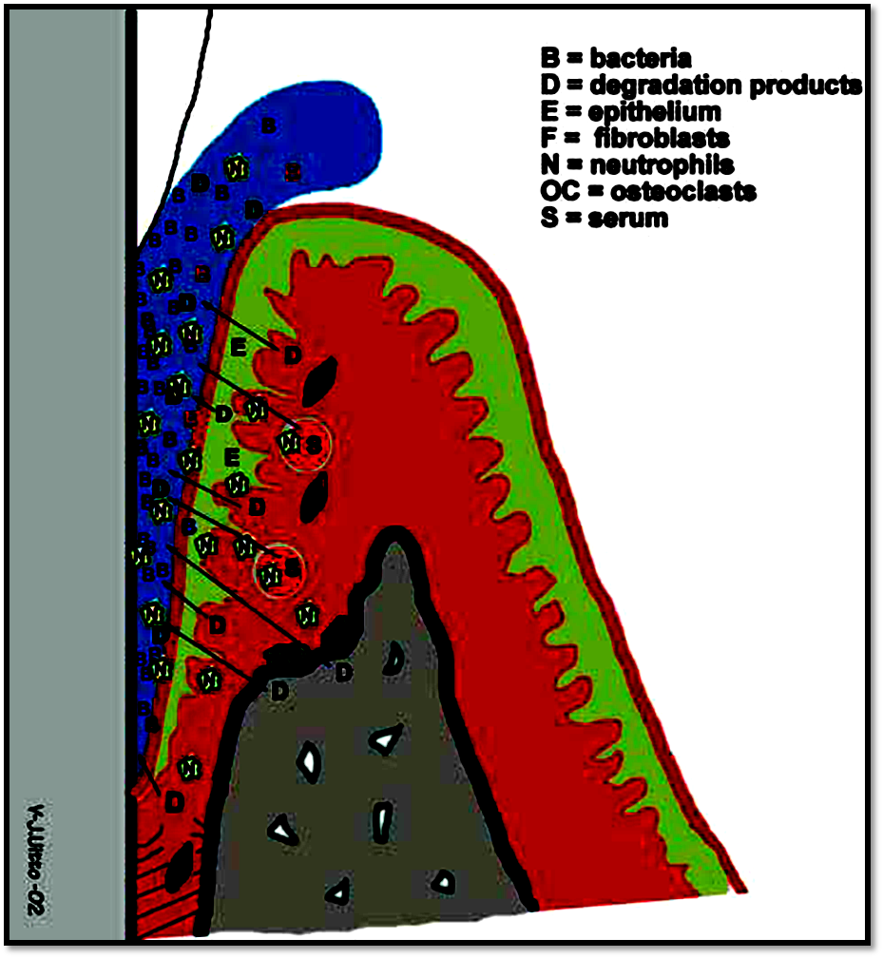
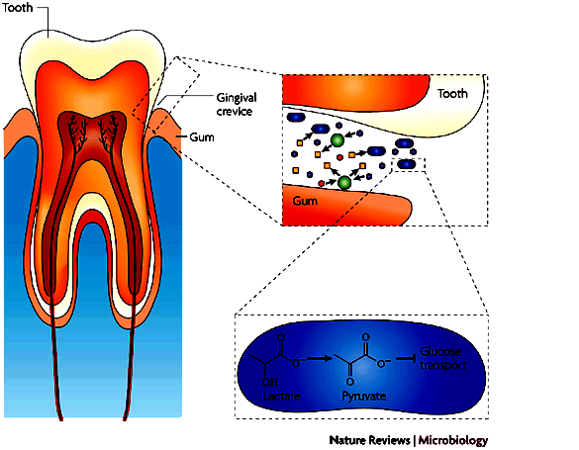
GCF is gingival tissue fluid seeps through crevicular and junctional epithelium. It is derived from serum, leukocytes, structural cells of the periodontium and oral bacteria.
CCF contains electrolytes, enzymes, epithelial cells, bacteria, WBCs, IgG, IgA, IgM, interleukins, complement proteins, carbohydrate, glucose, and drugs.
GCF secreted per day: 0.5 – 2.4 ml
Increased GCF by the following:
Circadian rhythm (6 am – 10 pm), female sex hormones, mechanical stimulation (e.g. tooth brushing, chewing), smoking, periodontal therapy, and gingivitis.
Functions of GCF:
1. Physical cleaning through flushing the pocket from bacteria and any particles (e.g. carbon).
2. Possess antimicrobial properties through its contents (WBCs, immunoglobulins, complement proteins, antibiotic drugs) which enhance gingival resistance.
3. Contain plasma proteins which improve adhesion of the epithelium to the tooth.

Interdental brush

