Lab. 16 Pain physiology

Pain: unpleasant sensation and emotional experience associated with tissue damage. Pain can be classified as fast and slow pain. A painful stimulus causes a sharp, localized sensation (fast pain) followed by a dull, intense, and diffuse feeling (slow pain).
Types of pain presentation: pain could be felt as stabbing, burning, aching, itching, pricking, compressing, etc.
How pain perception happened?
- Excitation of pain receptors by mechanical, thermal (coldness or hotness), or chemical stimuli by ischemia, tissue damage, muscle spasm (due to lactic acid, hypoxia, or pressure on the nerve endings).
- Local release of mediators: bradykinin, serotonin, histamine, potassium ions, acids, acetylcholine, and proteolytic enzymes.
- Enhancement of nerve endings sensitivity (decrease threshold) by prostaglandins and substance P.
- Fast (sharp) pain signals are transmitted by Aδ fibers and slow (chronic) pain signals are transmitted by C fibers. Sometimes, double pain sensation occurs: fast pain followed by slow pain.
- Pain signals enter the spinal cord through dorsal roots then to the neurons in the dorsal horn.
- Fibers cross to the opposite side of the cord and ascend upward through anterolateral column.
- Thalamus directly or through reticular areas of the brain stem and then to the thalamus.
- Signals are transmitted to the somatosensory cortex of the brain (anterior half of the parietal lobe which is concerned with reception and interpretation of somatosensory signals).
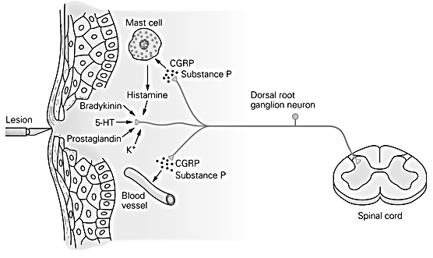

Pathway from painful tooth
- Pain impulse is carried through maxillary or mandibular divisions of V nerve.
- Trigeminal sensory ganglion.
- Pons.
- Descend in the brainstem as the spinal trigeminal tract.
- Synapse in the adjacent V nucleus.
- V nucleus merges with the dorsal gray matter (it resembles the dorsal horn of the spinal cord).
- Axons from V nucleus cross to the opposite side.
- Fibers ascend to the ventral posteromedial nucleus of the thalamus and also project to the reticular area.
- From the thalamus, fibers end at somatosensory cortex (postcentral gyrus).

Position sense (proprioception)
There are two types of position: (1) Static sense: conscious perception of the orientation of the different parts of the body with respect to one another; (2) dynamic sense (kinesthesia).
The followings are examples of position sensation:
- Stimulation of superficial (tactile) and deep receptors near the joints where the exact position is known from degrees of joints angulation in all planes.
- Stimulation of mechanoceptors (muscle spindles) to determine the degree of muscle stretch with joint angulation during motion.

Pathway for such sensation called dorsal column system as follows:
- Signal from above mentioned stimulations pass through large myelinated fibers to dorsal root ganglia.
- Dorsal horn of spinal cord then upward in the dorsal column pathway.
- Dorsal column nuclei (cuneate and gracile nuclei).
- Fibers decussate immediately to the opposite side of the brain stem and continue upward through the medial lemnisci to the thalamus.
- Each medial lemniscus is joined by fibers of sensory V nuclei (carry position sense information from the face).
- Thalamus.
- From the thalamus, fibers end at somatosensory cortex (postcentral gyrus).

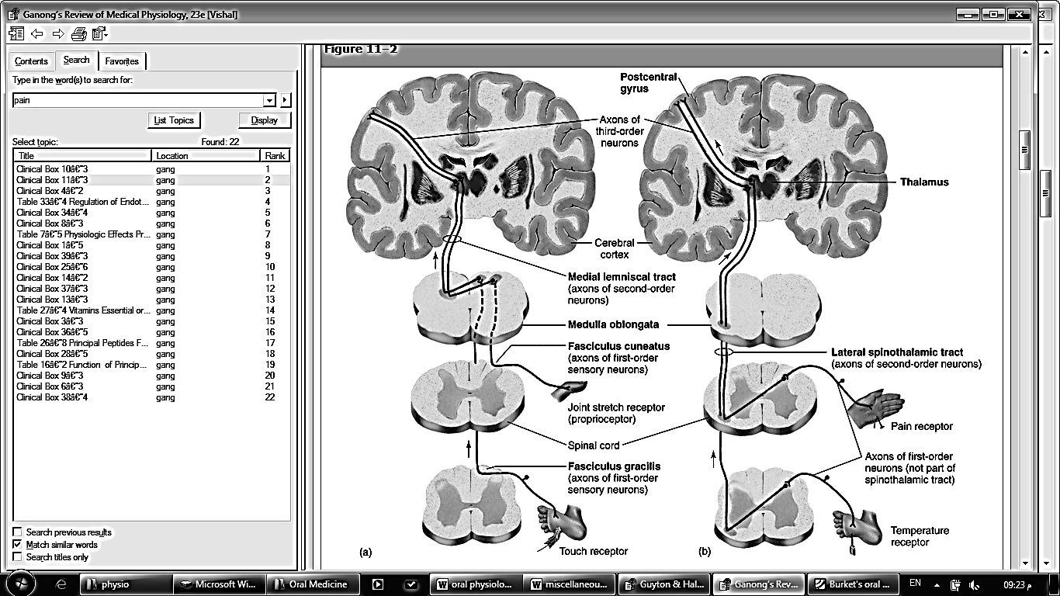
a: Dorsal column pathway (position sense)
b: Spinothalamic pathway (pain pathway)

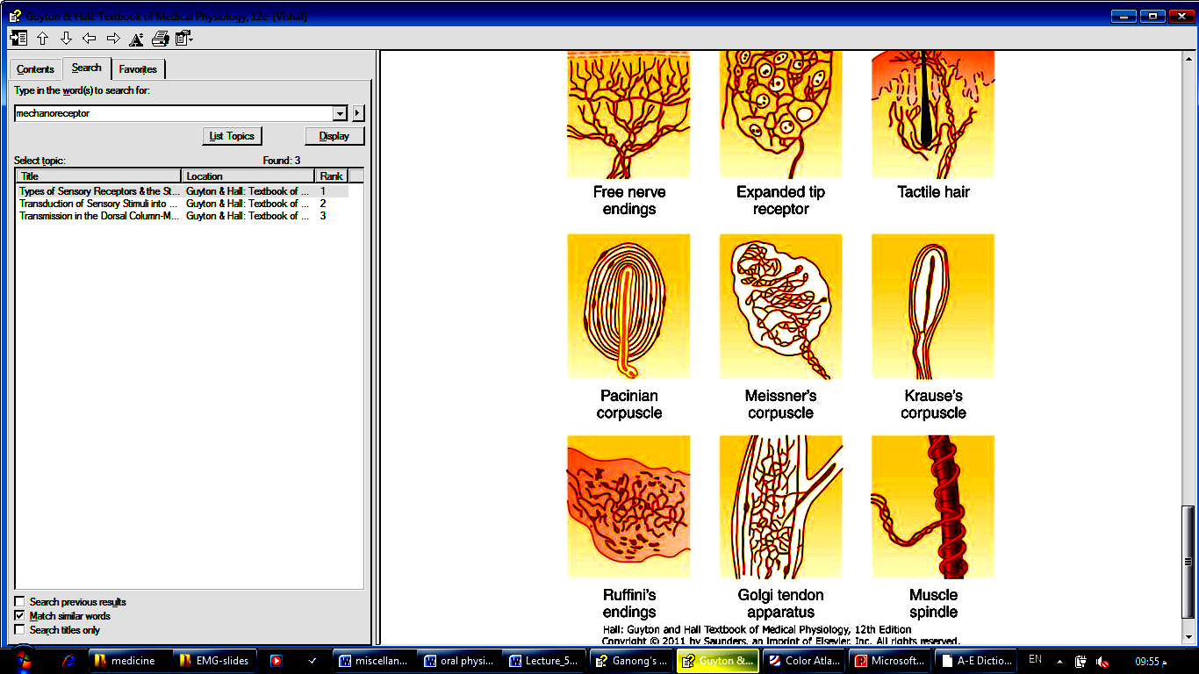
Examples of position receptors

