Lab. 1 Blood collection
Introduction and Principle:
Obtaining blood for laboratory testing from peripheral blood vessel which is either a vein (venipuncture), or capillary, or artery.
Blood is obtained to perform a laboratory tests to diagnose many clinical conditions after doing biochemical tests and to monitor the effects of medications.
Materials and method:
Glove, lancet, heparinized micro-capillary tube, syringe (1, 3, 5, 10 ml) hypodermic needle (18 – 23 gauge) or Vacutainer system, tourniquet, gauze, clean cotton, bandage, Povidone-iodine (Betadine) for venipuncture site in cases of blood culture sample, 70% isopropyl alcohol, tube rack, and blood collection tube.
Types of blood collection tubes:
Tube top color | Reagent (additive) | Usage
White | no additives | Biochemistry, blood typing and cross- matching
Lavender | EDTA (anticoagulant that chelates calcium) | complete blood counts
Dark green | heparin (anticoagulant) | measuring gases and drugs
Light blue | sodium citrate (anticoagulant that removes calcium) | measuring prothrombin time (PT) and partial thromboplastin time (PTT)
Light gray | sodium fluoride and potassium oxylate (antiglycolytics) | measuring glucose
Yellow-black | Culture media | blood culture tube
Red | Clot activator | To obtain serum

Procedure:
- Assess the patient for his name, age, gender, any drugs, and if there is any pregnancy.
- Inform the patient about the ordered test, the procedure and make sure there is no history of bleeding tendency.
- Timing: certain blood tests must be done at specific times.
- Label the container which is drawn into.
- Hand washing (before and after procedure).
- Protection against infection (gloves, masks, gowns, and eyewear).
- Site of venipuncture or prick should be cleaned by Betadine or alcohol.
- Finding vein techniques include:
- Lowering the arm into a dependent position to dilate the veins.
- Applying warm soaks on the arm to improve venous dilation.
- Applying a tourniquet 4 inches above venipuncture site with ends pointing upward away from site.
- The patient open and close the fist many times.
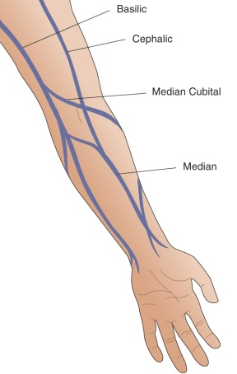
- Palpate a vein where it is expected to be as far as veins can be felt rather to be seen (arteries pulsate and have a thick wall and thrombosed veins feel cord-like, and roll easily).
- There are 3 veins in the antecubital (the front surface of the forearm) for venipuncture: medial, cephalic, and basilic veins. The best is the medial, because it is usually the closest to the skin's surface, the largest, and usually the least painful to puncture. If the antecubital sites cannot be accessed, wrist and hand veins are also acceptable for venipuncture.
- Anchor the vein: with gentle pressure, place your index finger or thumb just below the insertion point.
- Insert the needle with bevel facing up at 15º – 30º angle with the arm to avoid permanent tissue injury).
- Engage the tube and steady. If no blood comes out, do not probe with the needle. A second puncture is less painful for the patient and will likely provide a better sample.
- Aspirate certain volume of blood according to the test (e.g. complete blood count : 1.5 ml).
- Remove the tourniquet when the final tube of blood to be drawn is filling.
- Mix the tube when you remove it from the needle.
- Send the specimen to the laboratory as soon as possible.
- Discard the needle in puncture – proof container.
- Apply pressure for minute or longer if patient has taken an anticoagulant.
- Avoid bending the elbow (else hematoma may be formed).
- Make sure there is no adverse effect and apply a bandage to the site.
- Send the specimen to the laboratory (note: Blood sample could be saved for 7 days ).
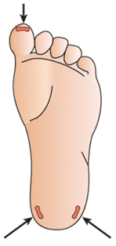
Precautions include:
Avoid the arm which is affected by a stroke when loss of sensation when the patient may not be able to alert you if they experience pain or other problems.
Avoid areas with extensive scarring which is difficult to puncture.
Collect blood specimen from the opposite arm if a patient is receiving intravenous fluids, since fluid may dilute the blood sample.
Avoid sites with swelling, eczema, or infection.
Finger- stick or heelstick
If venipuncture is not possible or appropriate, a finger- stick or heelstick (in babies) may be used for obtaining the specimen as follows
1. Pre-warm the hand if it is cold (Avoid too high temperature).
2. Site is cleaned with alcohol and dried with a dry cotton ball.
3. The hand is held firmly to avoid sudden movements
4. Use 3rd or 4th fingers of non-dominant hand (Avoid the center, tip, or side of the finger).
5. Fingerstick is done with sterile lancet.
6. First blood drop is wiped away (1st drop contains extra fluid from the tissues).
7. Finger is gently massaged to gain drops of blood and avoid squeezing tissue fluid.
8. Avoid areas which is thick, callused, scarred, swollen, cyanotic (blue because of oxygen deficiency).
9. Gauze pad or cotton ball applied for a minute making sure the bleeding is stopped.
Complications:
Bleeding, tissue injury, infection, hematoma formation, pain.
Steps of venipuncture
