Lab. 12 Tests for bleeding disorders
Bleeding time and coagulation time
Hemostasis means prevention of blood loss. Whenever a vessel is severed or ruptured, hemostasis is achieved by several mechanisms: (1) vascular constriction, (2) formation of a platelet plug, (3) formation of a fibrin blood clot as a result of blood coagulation, and (4) eventual growth of fibrous tissue into the blood clot to close the hole in the vessel permanently.
Fibrinolysis: mechanisms that restrict formation of platelet aggregates and fibrin clots to sites of injury to maintain the fluidity of the blood.
Hemorrhage or blood loss can result from trauma, vascular defects (e.g., esophageal varices, peptic ulcer), platelet abnormalities, or deficiencies of one or more of the plasma coagulation factors.
Thrombosis is a pathologic process in which a platelet aggregate and/or a fibrin clot forms in the lumen of an intact blood vessel or in a chamber of the heart.

Bleeding Time is the time taken for a standardized skin wound to stop bleeding.
It is a crude qualitative test of hemostasis. It indicates one or combination of the following:
  - Reduced platelet number (thrombocytopenia).
  - Defected platelets function (thrombosthenia) to interact with blood vessel walls to form blood clots after the wound.
  - Defected blood vessel wall to interact with the platelet.
The bleeding time test is usually used on patients who have a history of prolonged bleeding after cuts, or who have a family history of bleeding disorders. Also, the bleeding time test is sometimes performed as part of preoperative investigation to determine a patient's bleeding response during and after surgery. However, in patients with no history of bleeding problems, or who are not taking anti-inflammatory drugs (e.g.aspirin), the bleeding time test is not usually necessary.

Duke's method for bleeding time:
Introduction and principle: a standardized puncture (5 mm long × 1 mm deep) of the ear lobe or at the lateral aspect of the volar surface of the forearm is made and the time needed for the bleeding to stop is recorded.
The disadvantage of Duke's forearm method is that the pressure on the blood veins in the stab area is not constant and the results are less reliable.

Material &instrument: lancet, stop watch, circular filter paper, alcohol, Sphygmomanometer

Procedure
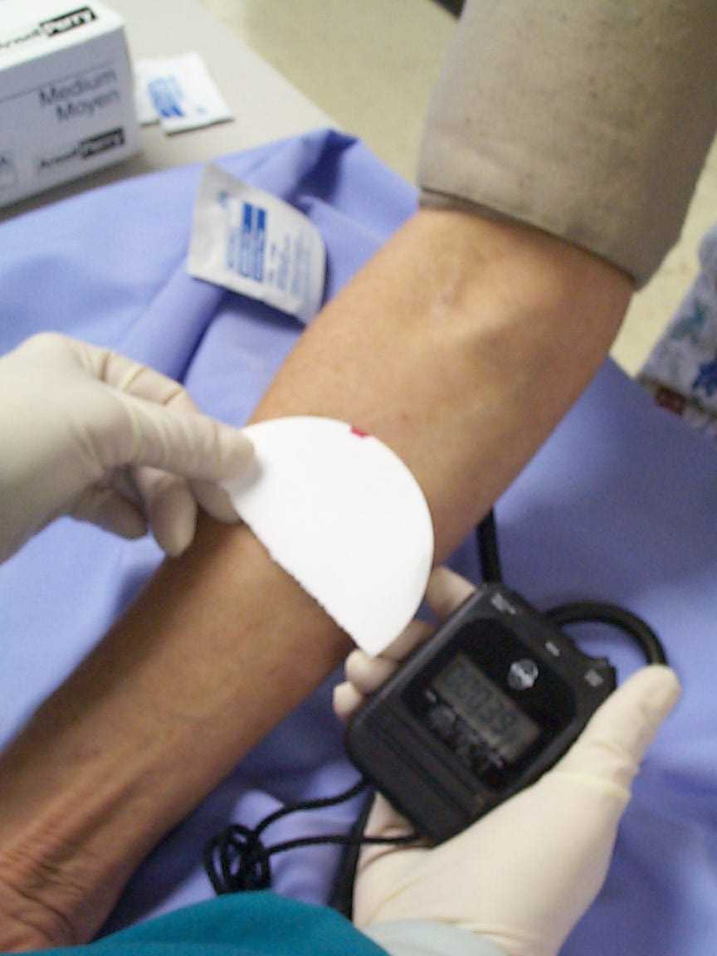
- Ear lobe method: The ear lobe is cleaned with alcohol and is allowed to dry (alcohol should be left on the skin long enough for it to kill bacteria). The alcohol must be removed because alcohol will adversely affect the test due to inhibition of clotting.
- Forearm method: select a site free of veins, bruises, edematous areas, and scars and is approximately 5 cm below the antecubital crease. Place the sphygmomanometer around the patient's arm approximately 5 cm above the elbow and maintain blood pressure at 40 mm Hg.
- A standardized puncture is made using a lancet.
- Time recording is started at the time of puncture.
- Using a circular filter paper the blood is blotted every 30 sec. without allowing the filter paper to touch the wound
- Stop the watch as the bleeding ceases and this is the bleeding time (bleeding stop not due to clotting but due to spasm of the capillaries and formation of platelet plug).

Normal range: (2 - 6 min. if use the ear lobe)
(2 – 9 min. if use the forearm)

Prolonged bleeding time may be due to:
- Decreased platelets number (thrombocytopenia) (< 100,000 platelet /uL).
- Defected platelets function (Thrombosthenia): acquired (aspirin use) and inherited (Von-Willebrand's disease)
- Defected blood vessels (e.g. vitamin C deficiency).

Sources of Error:
False positive (?) due to:  - Too high B.P. (> 40mm Hg.)  - Too deep incision  - Disturbing the clot with the filter paper | False negative (?) due to:  - Too low B.P. (< 40 mm Hg)  - Too shallow incision

Coagulation Time or Whole blood clotting time: the time needed for a measured amount of blood to clot under special conditions.
Capillary tube method
Material and instrument
- Capillary tube (non heparinized)
- Lancet
- Cotton
- Alcohol
- Stop watch

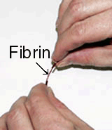
Procedure:
Clean the finger by the cotton and alcohol then prick the finger and note the time using a stop-watch then fill a non heparinized capillary tube (blue colored end) to at least 1/2 full.
After 1 - 5 minutes, take the filled capillary tube between your thumb and forefingers and gently break it in half. Slowly pull the ends apart to view the insoluble fibrin threads. If you don't see any fibrin, wait a little longer and break the tube again every 30 sec. Once the clot is formed we record the time.
Normal clotting time: < 6 min.
Prolonged clotting time may be due to:
- Decreased factor 8 (Hemophilia)
- Decreased factor 9 (Christmas disease)
- Liver failure
- Vitamin K deficiency
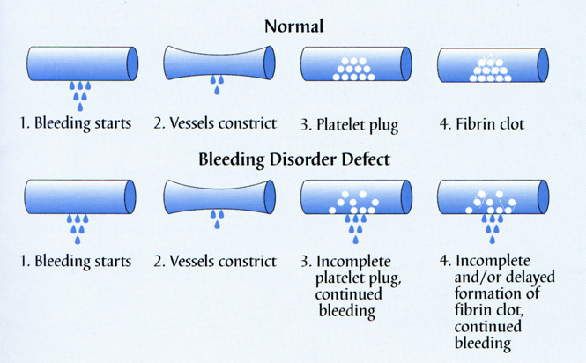

Diagram shows the sequence of major events upon vessel injury and the categories of bleeding disorders accordingly

Approach to patient with bleeding disorder

- History: patient, relatives, medication, substance
- Examination: general and local
- Investigation

Lab. Investigation
- Complete blood count (CBC) (RBCC, WBCC, Hb, PCV)
- Prothrombin time (PT): extrinsic pathway
- Activated Partial thromboplastin time (aPTT): intrinsic pathway
- Thrombin Time (TT): common pathway
- Bleeding Time (BT)
- Platelet function assay (PFA)
- Platelet Aggregation Assays (PAA)
- Coagulation Factor Assays (CFA)
- Platelets count (Normal = 150,000 – 300,000 / uL),
50,000 - 100,000 bleeding occur after major trauma
20,000 - 50,000 bleeding occur after minor trauma
< 20,000 spontaneous bleeding occur
Types of bleeding disorders
- Inherited Disorders:  - Von Willebrand Disease (BT ↑)  - Hemophilia A (factor VIII) (PTT ↑)  - Hemophilia B (factor IX) (PTT ↑)  - Other Deficiencies | - Acquired disorders:  - Vitamin K def. (affect production of 1972 factors)  - Liver failure (affect production of 19721 factors)  - Renal failure  - Massive Transfusion syndrome

(Homework: draw a diagram show the coagulation pathway and differentiate the coagulation factors that were included in PT, PTT, and TT)
(Reference: Guyton and Hall textbook of medical physiology)

Results of screening laboratory tests in bleeding due to von Willebrand disease ?
- A prolonged bleeding time
- A normal platelet count
- A normal PT
- APTT may be prolonged
- Factor VIII levels are often low
- The plasma level of active vWF is reduced
Results of screening laboratory tests in bleeding due to Hemophilia A
- A normal bleeding time.
- A normal platelet count
- A normal PT.
- A prolonged PTT.
Results of screening laboratory tests in bleeding due to Hemophilia B
- normal bleeding time.
- A normal platelet count,
- A normal PT.
- A prolonged PTT.
Results of screening laboratory tests in bleeding due to Disseminated intravascular coagulation: Produces a deficiency of multiple coagulation factors (figure below): DIC presents with signs and symptoms relating to: Tissue hypoxia and infarction caused by the myriad microthrombi or A hemorrhagic disorder related to depletion of the elements required for hemostasis (hence, the term "consumption coagulopathy" is sometimes used to describe DIC). Activation of the fibrinolytic mechanism aggravates the hemorrhagic diathesis.
In a case of bleeding, there are 3 sets of questions to be answered:
- Is there is an emergency? need resuscitation or immediate referral?
  - Is the patient about to lose consciousness (shock or coma)?
  - Is there hypovolaemia (postural hypotension, oliguria)?
  - Is there CNS bleeding (meningism, CNS, and retinal signs)?
- Why is the patient bleeding? Is bleeding normal, given the circumstances (eg. trauma or parturition), or does the patient have a bleeding disorder?
  - Is there unexplained bleeding, bruising, or purpura?
  - Past or family history of bleeding ”trauma, dentistry, surgery? Drugs (warfarin). Alcohol. Liver disease. Recent illness.
  - Is the pattern of bleeding indicative of vascular, platelet, or coagulation problems? Are venepuncture sites bleeding (DIC)? Look for associated conditions (eg. with DIC).
  - Is a clotting screen abnormal? Check FBC, platelets, PT, PTT, CT, thrombin time, bleeding time, FDP, and factor VIII assay.
- In the case of a bleeding disorder, what is the mechanism? Coagulation tests (Sodium citrate tube; false results if under-filled)
  - Prothrombin time (PT): Thromboplastin is added to test the extrinsic system. PT is expressed as a ratio compared to control [International Normalized Ratio (INR), normal range (NR) = 0.9 - 1.2]. Prolonged by: coumarins (eg. warfarin); vitamin K deficiency; liver disease.
  - Thrombin time: Thrombin is added to plasma to convert fibrinogen to fibrin. NR: 10 – 15s, in heparin treatment, DIC, or afibrinogenaemia.
  - PTT = partial thromboplastin time: Kaolin activates the intrinsic system. Normal range 35 - 45s, prolonged in heparin treatment or haemophilia.

Interpretation
Platelet count: If low, do FBC, blood film, and bone marrow biopsy.
INR: If long, look for liver disease, anticoagulant use, or defecinecy of factors VII, X, V, prothrombin, or fibrinogen..
PTT: If long, consider heparin or deficiency of factors VIII, IX, X, XI, XII, V, prothrombin, or fibrinogen.
Bleeding time: If long, consider von Willebrand's disease, or platelet disorders, or drug like aspirin which prolongs the bleeding time.

Disease | INR | aPTT | TT | Plat. count | BT | Other tests
Heparin | ↑ | ↑↑ | ↑↑ | ↔ | ↔
DIC | ↑↑ | ↑↑ | ↑↑ | ↓ | ↑ | FDP ↑
Liver disease | ↑ | ↑ | ↔/↑ | ↔/↓ | ↔/↑ | AST ↑
Platelet defect | ↔ | ↔ | ↔ | ↔ | ↑
Warfarin or  Vit. K deficiency | ↑↑ | ↑ | ↔ | ↔ | ↔
Haemophilia | ↔ | ↑↑ | ↔ | ↔ | ↔ | ↓ factor 8
von Willebrand's | ↔ | ↑↑ | ↔ | ↔ | ↑ | ↓ Factor 8

