**Medical Biology د.اسامة الموسوي**

**Genetics lec(1)**

**Genetics Definitions**

**Genetics:** Study of inheritedvariations.

**Molecular biology**  concerns the molecular basis of [biological](https://en.wikipedia.org/wiki/Biology) activity between the various systems of a [cell](https://en.wikipedia.org/wiki/Cell_(biology)), including the interactions between the different types of [DNA](https://en.wikipedia.org/wiki/DNA), [RNA](https://en.wikipedia.org/wiki/RNA) and [proteins](https://en.wikipedia.org/wiki/Protein) and their [biosynthesis](https://en.wikipedia.org/wiki/Protein_biosynthesis), and studies how these interactions are regulated.

**Gene:** A sequence of DNA that instructs a cell to produce a particular protein.

**Allele**: Alternate forms of a gene that occur at a given locus in chromosome.

**Homozygous:** having two identical alleles of a gene (TT or tt).

**Heterozygous:** having two different alleles of a gene (Tt).

**Phenotype:** The expression of a gene in traits or symptoms.

**Genotype:** The alleles combinations in an individual that cause particular traits or disorders.

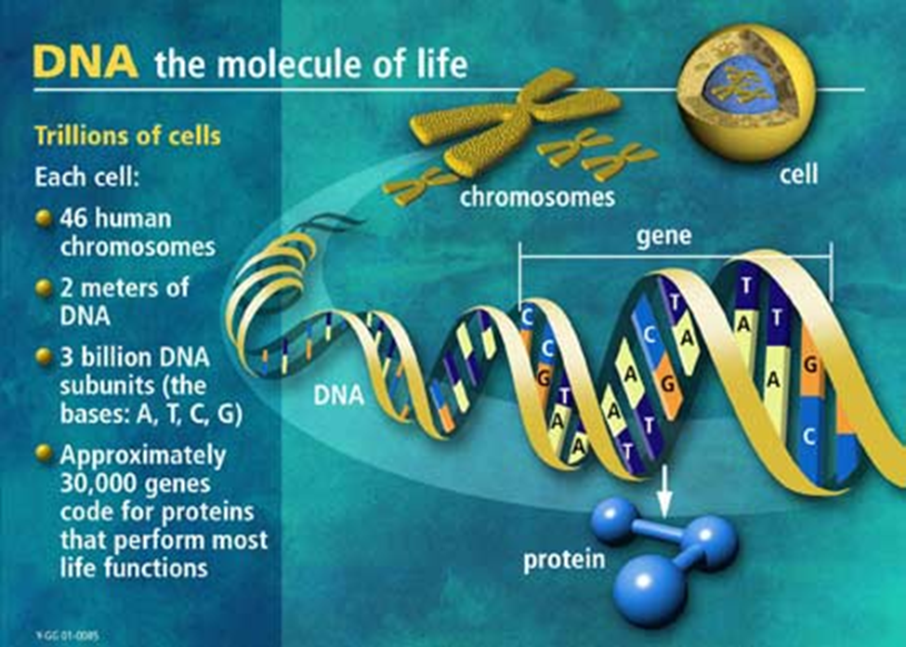

**Human Genome:**

**Genome:** the complete set of chromosomes and genes in an organism.

**Human genome** contained in every cell and consist of :

* 23 chromosome pairs and a small mitochondrial DNA .
* 2 meters of DNA
* 3 billion DNA subunits ( the bases A, T, C, G )
* Approximately 30000 genes code for proteins that perform most life function .
* Genes only make up ( 5 % ) of human genomic DNA and the rest is junk DNA .
* Genes consist of exon ( protein coding portions ) and intron (non coding regions ) .
* ( 99.7 % ) of human genomes are identical .
* ( 0.3 % ) of human genomes are different .

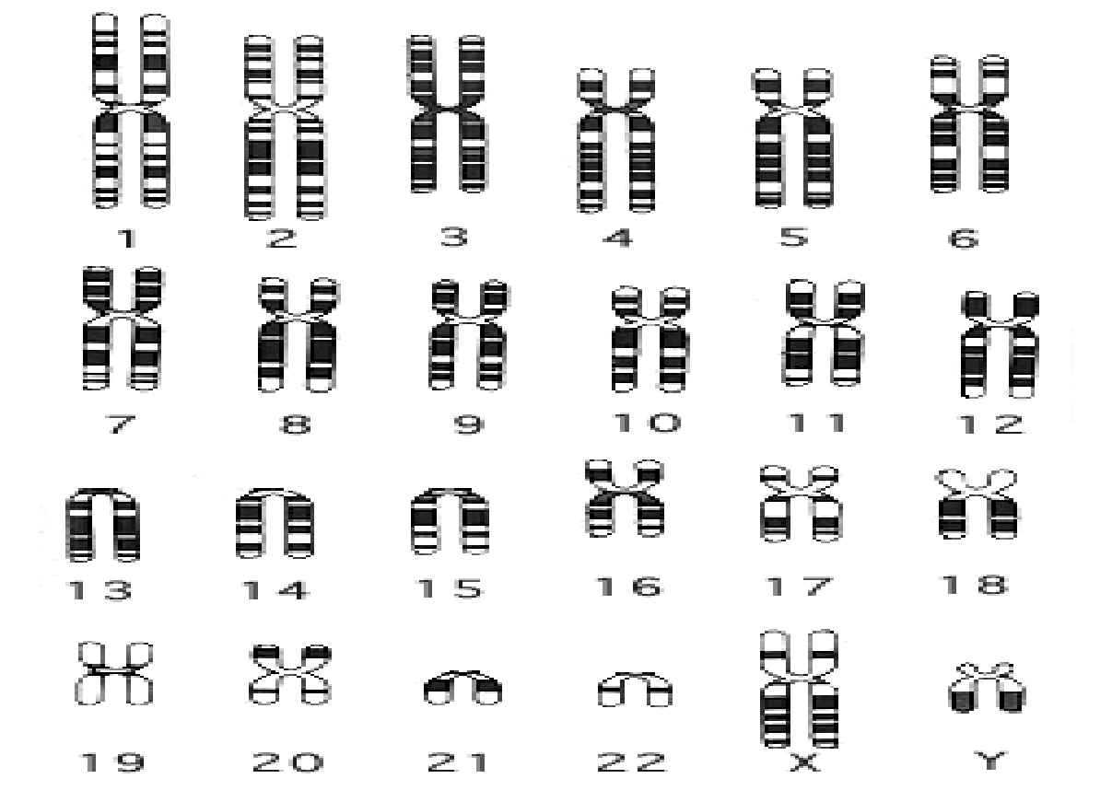

**Chromosome**

The structure by which hereditary information is transmitted from one generation to the next . Located in the nucleus, it is consists of tightly coiled thread of DNA with associated proteins and RNA . The genes are arranged in linear order along the DNA .

Chromosome consist of two chromatids that held together by centromere.

**Chemical Composition of Eukaryotic Chromosomes :**

1- DNA

2- Proteins ( Histones and non Histone Proteins )

3- RNA in small amounts

**Histones** : basic ( positively charged ) proteins , thus facilitating their binding to the negatively charged DNA . Histones H2a , H2b , H3 , H4 are constant from cell to cell with in an organism . They function in the coiling of DNA in chromosomes and in the regulation of gene activity .

**Non Histone Proteins :**

Consist of large number of very heterogeneous acidic proteins , the composition of it varies widely among different cell types of the same organism . Have roles in the regulation of expression of specific genes or sets of genes .It fall into several functional categories : scaffold proteins and chromatin – bound enzymes and transcription factor .

* **Chromatin** : Is the nucleoprotein material of Eukaryotic chromosome . Chromatin is divided into Euchromatin and Heterochromatin .
* **Euchromatin** : is chromatin that stains lightly , it is uncoiled during interphase but becomes condensed during mitosis . Most of genome consists of euchromatin . Genetically active ( that is , it contains genes that are being expressed .
* **Heterochromatin** : is chromatin that remains condensed during interphase , stained darkly and is genetically inactive . It is found at spesific sites in chromosomes, often in centromeric or telomeric regions of chromosomes .

**Nucleosome and Nucleofilament Structure in Eukaryotic DNA**

Nuclear DNA in eukaryotes is found in chromatin associated with histones and nonhistone proteins. The basic packaging unit of chromatin is the nucleosome

• Histones are rich in lysine and arginine, which confer a positive charge on the proteins.

• Two copies each of histones H2A, H2B, H3, and H4 aggregate to form the histone octamer.

• DNA is wound around the outside of this octamer to form a nucleosome (a series of nucleosomes is sometimes called "beads on a string", but is more properly referred to as a 10 nm chromatin fiber).

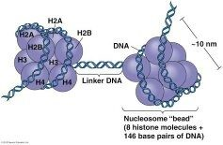

• Histone Hl is associated with the linker DNA found between nucleosomes to help package them into a solenoid-like structure, which is a thick 30-nm fiber.

• Further condensation occurs to eventually form the chromosome. Each eukaryotic chromosome in Go or G 1 contains one linear molecule of double-stranded DNA.

Cells in interphase contain two types of chromatin: **euchromatin** (more opened and available for gene expression) and **heterochromatin** (much more highly condensed and associated with areas of the chromosomes that are not expressed.

Euchromatin generally corresponds to the nucleosomes ( 10-nm fibers) loosely associated with each other (looped 30-nm fibers). Heterochromatin is more highly condensed, producing interphase heterochromatin as well as chromatin characteristic of mitotic chromosomes.

During mitosis, all the DNA is highly condensed to allow separation of the sister chromatids. This is the only time in the cell cycle when the chromosome structure is visible. Chromosome abnormalities may be assessed on mitotic chromosomes by karyotype analysis (metaphase chromosomes) and by banding techniques (prophase or prometaphase), which identify translocations, deletions, inversions, and duplications.

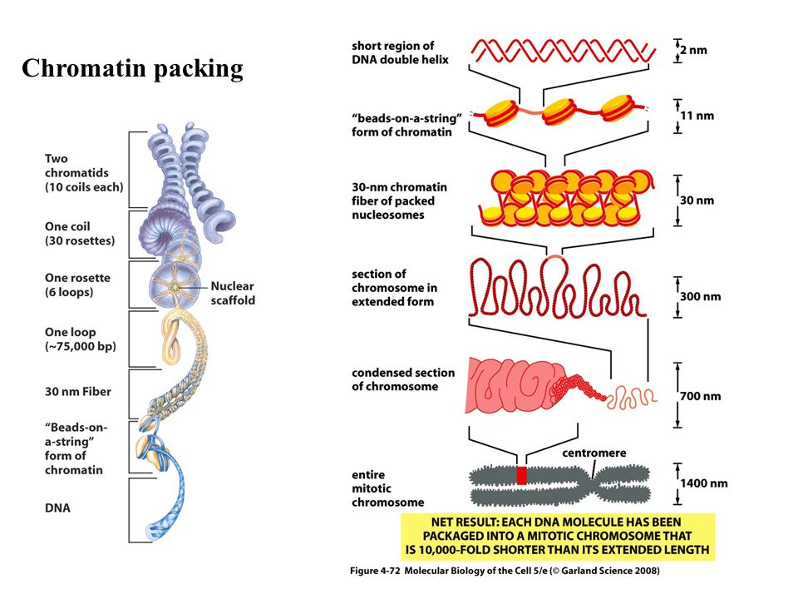

**The structure of DNA and RNA**

In most organisms, the primary genetic material is double-stranded DNA. Nucleic acids are heteropolymers composed of monomers known as **nucleotides**; a nucleic acid chain is therefore often called a **polynucleotide**. The monomers are themselves made up of three components: a sugar, a phosphate group, and a nitrogenous base. The two nucleic acids are polymers composed of nucleotides; DNA is deoxyribonucleic acid, RNA is ribonucleic acid. Types of nucleic acid (DNA and RNA) are named according to the sugar component of the nucleotide, with DNA having 2-deoxyribose as the sugar (hence **D**eoxyribo**N**ucleic**A**cid) and RNA having ribose (hence **R**ibo**N**ucleic**A**cid). The sugar/phosphate components of a nucleotide are important in determining the structural characteristics of polynucleotides, and the nitrogenous bases determine their information storage and transmission characteristics. The nitrogenous bases are the important components of nucleic acids in terms of their coding function. In DNA the bases are as listed in Section 2.4, namely adenine (A), guanine (G), cytosine (C), and thymine (T).

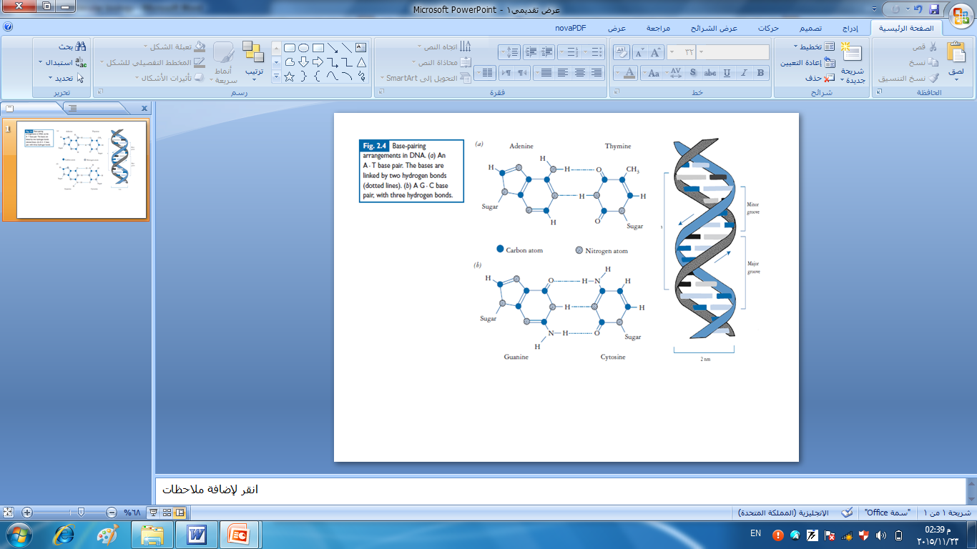

In RNA the base thymine is replaced by uracil (U), which is functionally equivalent. Chemically adenine and guanine are **purines**, which have a double-ring structure, whereas cytosine and thymine (and uracil) are **pyrimidines**, which have a single-ring structure. The bases are held together by hydrogen bonds, two in the case of an A = T base pair and three in the case of a G ≡ C base pair. The structure and base-pairing arrangement of the four DNA bases.

RNA is also most commonly single stranded, although short stretches of double-stranded RNA may be found in self-complementary regions. There are four main types of RNA molecule found in cells: messenger RNA (mRNA), ribosomal RNA (**rRNA**), smallnuclear RNA (**snRNA**) and transfer RNA (**tRNA**). Ribosomal RNA is the most abundant class of RNA molecule, making up some 85% of total cellular RNA. It is associated with **ribosomes**, which are an essential part of the translational machinery. Transfer RNAs make up about 10% of total RNA and provide the essential specificity that enables the insertion of the correct amino acid into the protein that is being synthesized. Messenger RNA, as the name suggests, acts as the carrier of genetic information from the DNA to the translational machinery and usually makes up less than 5% of total cellular RNA.

**The anatomy of gene**

Although there is no such thing as a ‘typical’ gene, there are certain basic requirements for any gene to function. The most obvious is that the gene has to encode the information for the particular protein (or RNA molecule). The double-stranded DNA molecule has the potential to store genetic information in either strand, although in most organisms only one strand is used to encode any particular gene. There is the potential for confusion with the nomenclature of the two DNA strands, which may be called coding/non-coding, sense/antisense, plus/minus, transcribed/non-transcribed, or template/non-template. A site for starting transcription is required, and this encompasses a region that binds RNA polymerase known as the **promoter** (P), and a specific start point for transcription (TC). A stop site for transcription (tC) is also required. From TC start to tC stop is sometimes called the **transcriptional unit**, that is, the DNA region that is copied into RNA. Within this transcriptional unit there may be regulatory sites for translation, namely a start site (TL) and a stop signal (tL). Other sequences involved in the control of gene expression may be present either upstream or downstream from the gene itself.

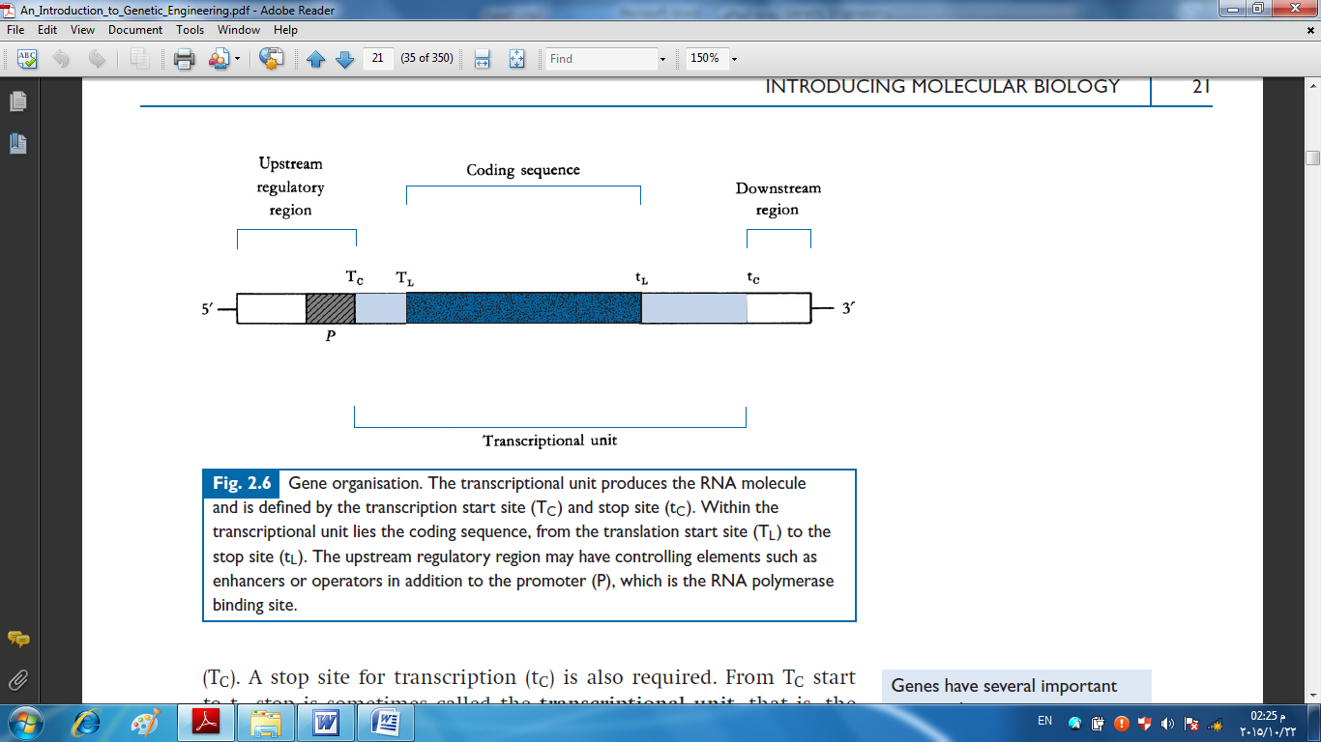

**Gene structure in prokaryotes**

In prokaryotic cells such as bacteria, genes are usually found grouped together in **operons**. The operon is a cluster of genes that are (often coding for enzymes in a metabolic pathway) and that are under the control of a single promoter/regulatory region. Perhaps the best known example of this arrangement is the *lac* operon (Fig. 2.7), which encodes for the enzymes responsible for lactose catabolism. The fact that structural genes in prokaryotes are often grouped together means that the transcribed mRNA may contain information for more than one protein. Such a molecule is known as a **polycistronic** mRNA, with the term **cistron** equating to the ‘gene’ as we have defined it (*i.e*. encoding one protein). Thus, much of the genetic information in bacteria is expressed *via* polycistronic mRNAs whose synthesis is regulated in accordance with the needs of the cell at any given time. This system is flexible and efficient, and it enables the cell to adapt quickly to changing environmental conditions.

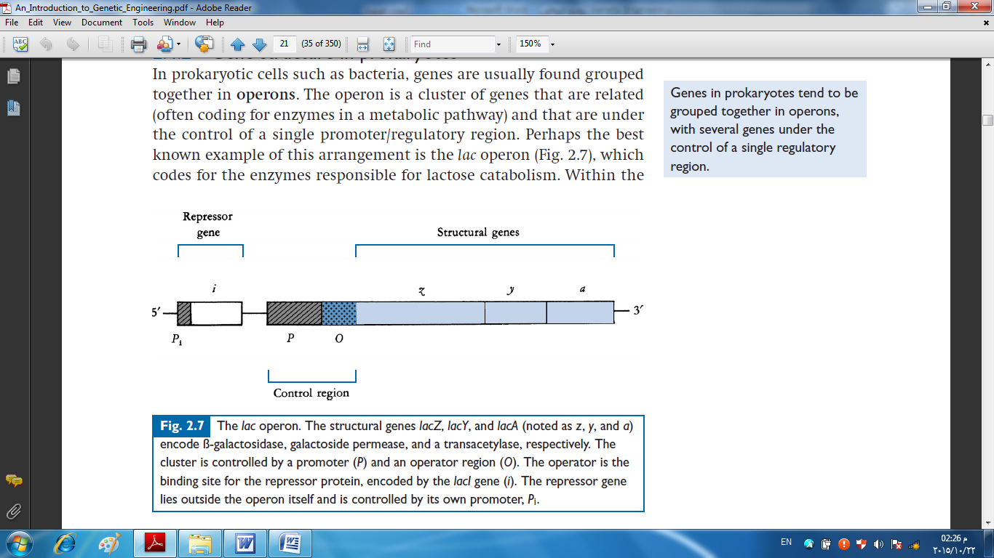

**Gene structure in eukaryotes**

A major defining feature of eukaryotic cells is the presence of a membrane-bound nucleus, within which the DNA is stored in the form of chromosomes. Transcription therefore occurs within the nucleus and is separated from the site of translation, which is in the cytoplasm. Gene structure and function in eukaryotes are more complex than in prokaryotes. Eukaryotic genes contained ‘extra’ pieces of DNA that did not appear in the mRNA that the gene encoded. These sequences are known as intervening sequences or **introns**, with the sequences that will make up the mRNA being called **exons**.

**Characters of DNA**

Some of the features of double-stranded DNA include:

- The two strands are antiparallel (opposite in direction).

- The two strands are complementary. A always pairs with T (two hydrogen

bonds), and G always pairs with C (three hydrogen bonds). Thus, the base sequence on one strand defines the base sequence on the other strand.

- Because of the specific base pairing, the amount of A equals the amount

of T, and the amount of G equals the amount of C. Thus, total purines

equals total pyrimidines. Most DNA occurs in nature as a right-handed double-helical molecule known as.

- DNA carry negative charges because of their phosphate

groups .

-DNA is the same in all nucleated cells of persons body

-Watson-Crick DNA or B-DNA .The hydrophilic sugar-phosphate backbone of each strand is on the outside of the double helix. The hydrogen- bonded base pairs are stacked in the center of the molecule. There are about 10 base pairs per complete turn of the helix. 3-Antiparallel :

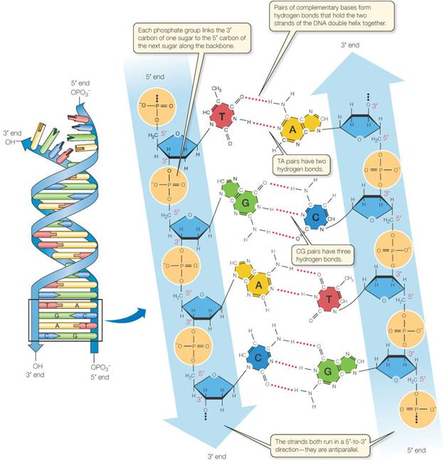

**CENTRAL DOGMA OF MOLECULAR BIOLOGY**

An organism must be able to store and preserve its genetic information, pass that information along to future generations, and express that information as it carries out all the processes of life. The major steps involved in handling genetic information are illustrated by the central dogma of molecular biology .



Genetic information is stored in the base sequence of DNA molecules. Ultimately, during the process of gene expression, this information is used to synthesize all the proteins made by an organism. Classically, a gene is a unit of the DNA that encodes a particular protein or RNA molecule.

**DNA replication**

DNA replication is the process in which each chromosome is duplicated before cell division.



**The Eukaryotic Cell Cycle**

The M phase (mitosis) is the time in which the cell divides to form two daughter cells. Interphase is the term used to describe the time between two cell divisions or mitoses. Gene expression occurs throughout all stages of interphase. Interphase is subdivided as follows:

• G1 phase (gap 1 ) is a period of cellular growth preceding DNA synthesis.

Cells that have stopped cycling, such as muscle and nerve cells, are said to be in a special state called G0•

• S phase (DNA synthesis) is the period of time during which DNA replication

occurs. At the end of S phase, each chromosome has doubled its

DNA content and is composed of two identical sister chromatids linked at the centromere.

• G2 phase (gap 2) is a period of cellular growth after DNA synthesis but

preceding mitosis. Replicated DNA is checked for any errors before cell division.

• Replication of DNA is semiconservative .

• During replication the 2 complementary strand unwind and each single strand serve as template directing the synthesis of a new complementary strand .

• The new result of replication is thus 2 progeny DNA molecules identical to the parental double helix . A site where DNA is locally opened called replication fork .

Enzymes involved in DNA replication and their function :

1. Helicase : unwinds parental double helix .

2. Binding Proteins : stabilize separate strands .

3. Primase : adds short RNA Primer to template strand .

4. DNA Polymerase :

❖ Adding bases to the new DNA chain , added Bases in (5'→3') direction only and DNA is antiparallel, the new strand is synthesized continuously in (5'→3') direction called Leading strand, while the other daughter strand is synthesized discontinuously by short segments of DNA called Okazaki Fragments (5'→3') that are joined together by ligase and called Lagging strand .

❖ Proofreading activity checks and replaces incorrect bases .

❖ Removing RNA primer .

5. Ligase: joins okazaki fragments and seals other nicks in sugar phosphate backbone .

