Endodontics
Lec:13 د. بلند محمد سليم

Root canal filling
The overall function of a root filling is to occupy the instrumented root canal space to allow proper healing of the periapical tissue. Specifically it attempts:
(1) To prevent leakage of bacterial organisms, bacterial elements and nutritional elements from the oral environment to the root canal (coronal leakage).
(2) To restrain growth of any surviving bacteria in dentinal tubules and
uninstrumented parts of the root canal space.
(3) To prevent release of bacterial elements in the other direction, i.e. from the root canal to the apical environment (apical leakage).
(4) To prevent leakage of nutritional elements from the periapical
tissue to the canal space.

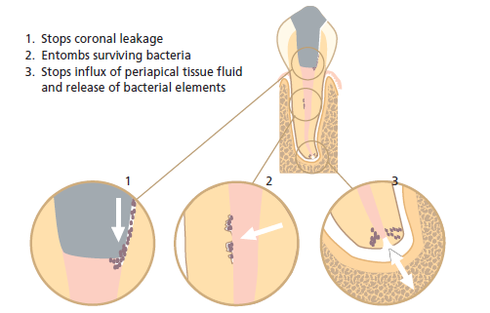

Criteria for obturation:-
It would seem sensible to delay obturation of teeth in the following categories:
1- Teeth with signs of apical periodontitis, e.g. those with tenderness to apical palpation.
2- Teeth associated with radiographic signs of apical periodontitis.
3- Teeth with excessive exudates that cannot be stopped.
4- Teeth with a purulent discharge into the canal.
5- Teeth associated with a procedural accident, e.g. perforation.
Functions of root canal sealer:-
Root canal sealers are used in conjunction with core filling materials for the following purposes:
- Cementing (luting, binding) the core material into the canal.
- Filling the discrepancies between the canal walls and core material.
- Acting as a lubricant to enhance the positioning of the core filling material.
- Acting as a bactericidal agent.
- Acting as a marker for accessory canals, restorative defects, root fractures and other spaces into which the main core material may not penetrate.

The properties of an ideal sealer are:

1-exhibits tackiness when mixed to provide good adhesion between it and the canal wall when set
2-establishes a hermetic seal
3-radiopacity so that it can be seen on the radiograph
4-very fine powder so it can mix easily with the liquid
5-no shrinkage on setting
6-no staining of tooth structure
7-bacteriostatic, or at least dose not encourage bacterial growth
8-exhibits a slow set
9-insoluble in tissue fluids
10-tissue tolerant; that is, nonirritating to periradicular tissue
11-soluble in a common solvent if it is necessary to remove the root canal filling.
Currently used root canal sealers may be divided into:

*Zinc-oxide-eugenol (ZoE) based materials have long been considered the sealer of choice in endodontic therapy. An advantage to this sealer group is its antimicrobial activity. Once set, zinc oxide-eugenol sealers form relatively weak, porous materials which are susceptible to decomposition in tissue fluids particularly when forced into the periradicular tissues. They exhibit a slow setting time, shrinkage on setting , solubility, and they can stain tooth structure. All zinc oxide-eugenol cements are cytotoxic and the response may last longer than those produced by other materials.

Resin-based sealers*
Epoxy resin sealers have comparatively good mechanical and sealing properties. No effects on general health are expected and allergic reactions are apparently rare, also antimicrobial properties are good, especially in a freshly mixed state. Cytotoxicity is moderate to low.
AH26 is an epoxy resin that was initially developed as a single obturation material. Because of its positive handling characteristics, it has been extensively used as a sealer. It has a good flow, seals well to dentin walls, and has sufficient working time. AH Plus is a modified formulation of AH26 in which a formaldehyde is not released. AH Plus is a two-component paste/paste root canal sealer based on epoxy-amine resin, it is an improved modification of its precursor AH26 and shows a high flow. The sealing abilities of AH-26 and AH Plus appear comparable; it exhibits a working time of approximately 4 hours. AH Plus have been shown to have lower solubility than ZoE and calcium hydroxide sealers along with an adequate working time.
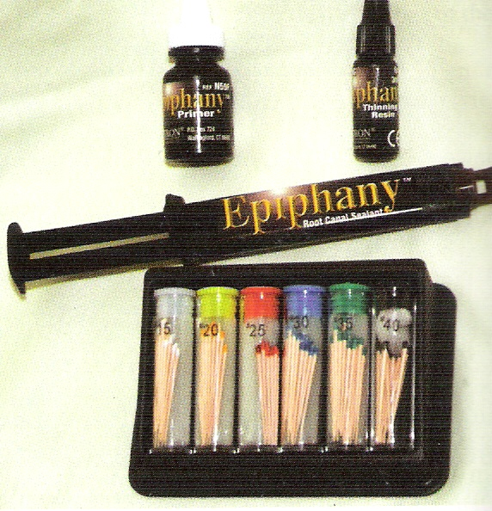
Recently, new dentin-adhesive root canal cements have been introduced to enhance the bond between the core material of gutta-percha and the root canal walls. Example is Epiphany, which are resin based materials with hydrophilic properties. Epiphany may also be combined with a synthetic polymer-based root canal filling material (Resilon) in the Epiphany–Resilon system. Resilon mainly consists of polymers of polyesters (polycaprolacton) and bioactive glass, giving this material physical property similar to those of guttapercha. This means that it can be used cold or plasticized by heat. While a promising development, research documentation has so far primarily been based on in vitro and animal studies observing sealing biocompatibility aspects. Independent clinical research has yet to show superiority of these materials to traditional products with gutta-percha as the core material.

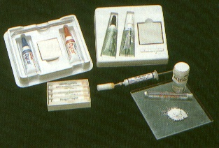
*Calcium hydroxide sealer: Calcium hydroxide sealers were developed for therapeutic activity. It was thought that these would exhibit antimicrobial activity and have osteogenic-cementogenic potential. Solubility is required for release of calcium hydroxide and sustained activity; this is inconsistent with the purpose of a sealer. Examples of these are Calciobiotic root canal sealer, Apexit and Sealapex. Mechanical properties of calcium hydroxide sealers are inferior compared with GIC based sealers. The desired release of OH ions may be associated with degradation of the sealer, enhancing leakage. Degradation of salicylate-based materials is known from their application as pulp capping agents. Studies clearly indicate significant volumetric expansion, disintegration and high solubility of a calcium hydroxide sealer following long-term observations. Apparently, some calcium hydroxide sealers dissolve at a relatively high rate, especially when used in a thick layer.

*Glass ionomer sealers
Pitt Ford in 1979 introduced a glass-ionomer (GI) sealer in a single-cone technique. It is the only self-adhesive material currently available that eliminates the need for a separate adhesive system. Glass ionomer adheres to dentin through physical and chemical interaction; physical interaction is through a micromechanical interlocking of the material to tooth surface irregularities, while chemical interaction occurs when polyacrylate ions of GIC displace existing phosphate ions in the hydroxyapatite crystal and attached to dentin. The sealing ability of GIC sealers have been equivocal; demonstrating both advantages and disadvantages over other sealer types. Dental applications of GI sealers take advantage of their bond to dentin, fluoride release, antimicrobial activity, and biocompatibility. A disadvantage of GI sealer is that they must be removed if retreatment is required. Examples of these are root canal sealer, (Ketac Endo and Activ Gp).
Activ GP is a system which utilizes improved GI technology (both as a sealer and as a special GI coated gutta-percha cone) to create a true single cone monoblock obturation. Activ GP sealer is superior to previous GI-based systems in terms of handling characteristics, working time, radiopacity, and seal, because of the increased of its flowability.
Activ GP Sealer is used in powder and liquid formulation. It is formulated with an extended 15 minute working time. The natural adhesion of GI to dentin (ionic bond) means there’s no need for a bonding agent (primer) and the associated application technique challenges.

*Bioceramic sealer
Bioceramic sealer (BC) has been designed as non-toxic hydraulic calcium silicate cement that is easy to use as an endodontic sealer. Among the attributes of BC Sealer are improved convenience and delivery, and the advantage of utilizing the water inherent in the dentinal tubules to drive the hydration reaction (of the material) thereby shortening the setting time. The calcium silicates in BC Sealer hydrate with water to produce calcium silicate hydrate gel, which forms a chemical bond with the calcium aluminate and calcium silicate compounds on the surface of the coated gutta-percha. Also the BC sealer will bond to dentinal walls; the calcium silicate hydrogel will form a chemical bond with the hydroxyapatite because of the hydroxy-group. Therefore, both of the compounds will form chemical bonding with the dentin hydroxyapatite

The properties of an ideal filling material:
1-easily manipulated and provides ample working time
2-dimensionally stable with no shrinkage once inserted
3-seals the canal laterally and apically, conforming to its complex internal anatomy
4-non irritating to the periapical tissues
5-impervious to moisture and nonporous
6-unaffected by tissue fluids- no corrosion or oxidation
7-inhabits bacterial growth
8-radiopaque and easily discernible on radiographs
9-dose not discolor tooth structure
10-sterile
11-easily removed from the canal if necessary

Gutta – Percha:-
Gutta-percha has been used to fill root canals for over 100 years and is the most widely used and accepted obturation material. Gutta-percha is a form of rubber obtained from a number of tropical trees. It is a trans isomer of polyisoprene which, in its pure form, is hard, brittle and less elastic than cis-poly isoprene, natural rubber. It is exists in two crystalline form (alpha and beta). It is mixed with a variety of other materials to produce a blend which can be used effectively within the root canal. Thus, the points of gutta-percha available commercially contain gutta-percha (20%), zinc oxide (65%) and various waxes, coloring agents, antioxidants and metal salts (10%) to provide radiopacity. The proportions of the constituents vary from brand to brand, with the result that there is considerable variation in the stiffness, brittleness and tensile strength of commercially available gutta-percha points.

Gutta-percha points have many advantages as they are:
1-Inert.
2-Dimensionally stable.
3-Non-allergenic.
4-Antibacterial.
5-Non-staining to dentine.
6-Radiopaque.
7-Compactable.
8-Softened by heat.
9-Softened by organic solvents.
10-Removable from the root canal when necessary.
As with all materials gutta-percha points have some disadvantages as they:
1-Lack rigidity.
2-Do not adhere to dentine.
3-Can be stretched.

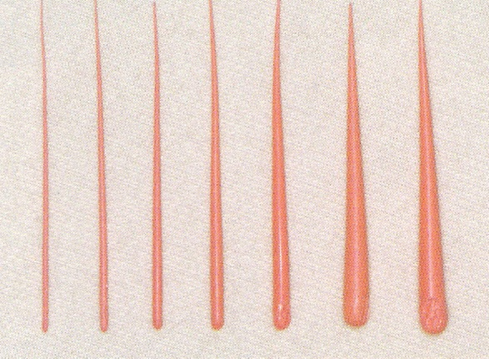
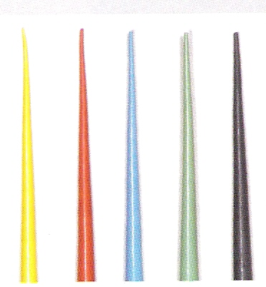
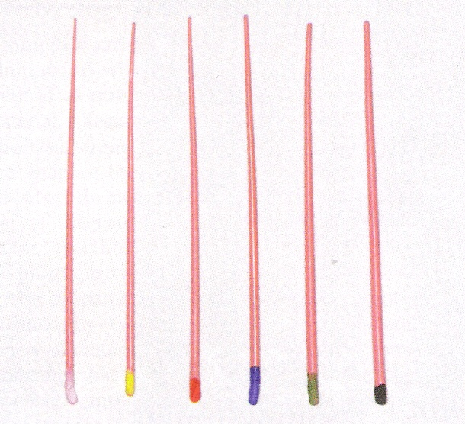
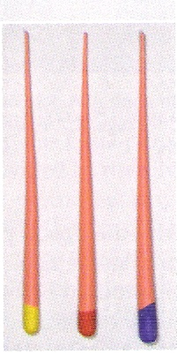
For root canal obturation, gutta-percha is manufactured in the form of cones in both standardized and non standardized sizes. The standardized sizes coordinate with the ISO sizes of the root canal file sizes 15 through 140 and are used primarily as the main core material for obturation. Recently standardize cones are designed to match the taper of nickel titanium instruments (standardized cones# o6, taper, sizes # 15 to #40. , standardized cones protaper S1, S2, S3, S4, S5). The non standardized sizes are more tapered from the tip or point to the top, and they are usually designated as extra-fine, fine-fine, medium-fine, fine-medium, medium, medium-large, large, and extra-large. With some obturation techniques these cones are used as accessory or auxiliary cones during compaction, being matched with the shape of the prepared canal space or the compaction instrument. Although the standardized cones have been popular for years (since the standardization of the file system), non standardized cones have assumed a greater role as the primary core material in the more contemporary obturation techniques. With the development of these techniques, in particular those of vertical compaction with heat softening of gutta-percha, there has been a resurgent interest in the non standardized cones. For injectable thermoplastic obturation techniques, gutta-percha may come in either pellet form or in cannulas. For some thermo mechanical techniques, it is available in heatable syringes.

Coated gutta-percha
1-Resin coated gutta-percha: contain gutta-percha, zinc oxide, barium sulphate and coloring agents and are entirely coated with a thin layer of polymerized urethane dimethacrylate resin (UDMA).
2-Activ GP gutta-percha: consists of gutta-percha cone impregnated in the external surface with glass ionomer (GI).
3-Bioceramic coated gutta-percha: is a new type of coated gutta-percha it is subjected to a patented, proprietary process of impregnating and coating each cone with BC nanoparticles.

Silver points:-
Silver points made to standardized sizes were introduced in the 1930s as a method for filling fine tortuous canals. With the instruments and preparation techniques available at the time, such canals were difficult to enlarge adequately in order to accept gutta-percha pints. The rigidity provided by the silver cones made them easy to place and permitted length control; however, their inability to fill the irregularly shaped root canal system permitted leakage. When silver points contact tissue fluid or saliva they corrode. The corrosion products have been found to cytotoxic and produce pathosis or impeded perapical healing.
With the introduction of the rigid silver cones it became possible to easily place them to length. This resulted in clinicians often failing to properly clean and shape the canal before obturation. The use of silver cones is considered to be below the slandered of care in contemporary endodontics practice.

