Oral Histology Lect.5 أ.م.د.عبد الكريم المحمداوي 2018
Amelogenesis Begins first at cusp tips Then sweeps down crown slopes Stops at CEJ. it involves 2 stages which are:
1- E. matrix deposition,
2- Maturation or mineralization of the E. matrix.

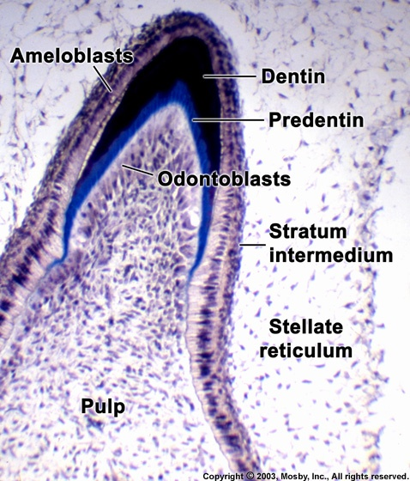
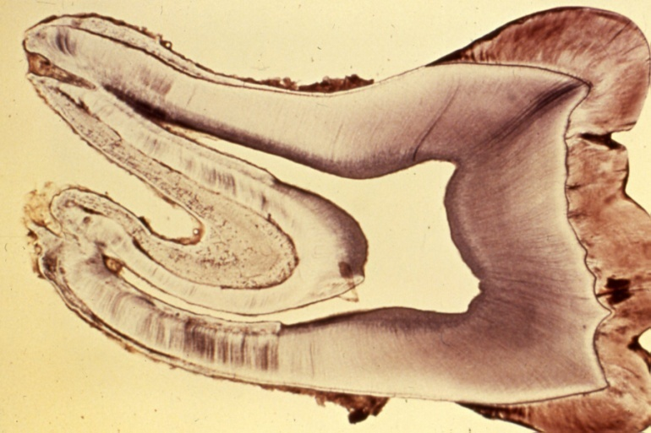
Life Cycle of Ameloblasts
- Morphodifferentiation
- Histodifferentiation
3. Secretory (initial)
4. Secretory (Tomes’ process)
- Maturation (ruffle-ended)
- Maturation (smooth-ended)
- Protective
- Desmolytic

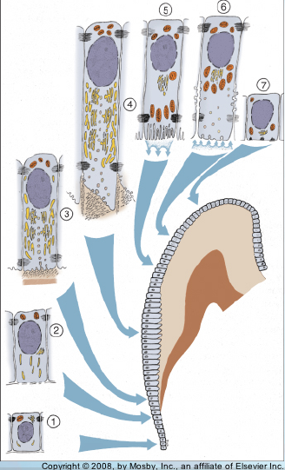
Ameloblast
Ameloblasts are derived from oral epithelium tissue of ectodermal origin. Their differentiation from preameloblasts (whose origin is from inner enamel epithelium) is a result of signaling from the ectomesenchymal cells of the dental papilla.
The ameloblasts will only become fully functional after the first layer of dentin (predentin) has been formed by odontoblasts. Then the cells be part of the reduced enamel epithelium after enamel maturation and then are subsequently lost during tooth eruption
When the first layer of D, is formed, the cells of inner E. epith. will be differentiated into ameloblasts which begins first at cusp tips and the incisal edges and then proceed down the slopes of the tooth crown till all inner E. epith. cells will be differentiated into ameloblasts, so the last E. to form is at the cervical end of the crown.

1.Ameloblast in formative stage
Each ameloblast is a columnar cell approximately 4 micrometers in diameter, 40 micrometers in length and is hexagonal in cross section. The secretory end of the ameloblast ends in a six-sided pyramid-like projection known as the Tomes' process. The angulation of the Tomes' process is significant in the orientation of enamel rods, the basic unit of tooth enamel.
The secretion of the E. matrix by ameloblasts. The freshly secreted E, matrix contain 30% minerals as hydroxy apatite crystals and 70% waters and E. proteins (enameline and amelogenine). These E, proteins which are secreted by ameloblasts
2. Amelogenesis - Maturation Stage
Maturation Process:
- Removal of water & organic material
- Introduction of additional inorganic material
When the full thickness of E. matrix has been deposited, mineralization will be started. This process involved additional minerals with the removal of organic material and water to reach 96% mineral content. This minerals makes the initial E. crystals that formed in first stage to grow wider an thicker due to the deposition of large amount of hydroxy apatite crystals.

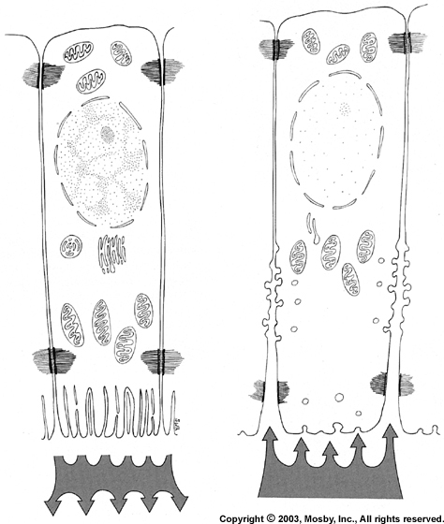
Ruffle-ended
Smooth-ended
Enamel hardens before tooth erupts Results from growth in width, thickness of crystals.
3.Protective Stage
Full thickness of enamel complete, enamel mature
Ameloblast layer & papillary layer form “reduced enamel epithelium”

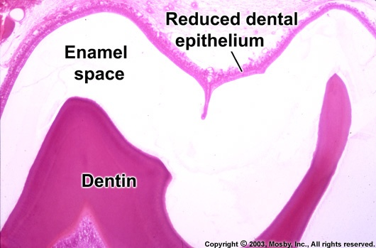

When ameloblasts complete maturation of whole E, matrix , they lose their microvilli and then secretes a thin membrane on the surface of the E. which is called primary E. cuticle. Then ameloblast shorten and arranged with other cells of E, organ (stratum intermedium, stellate reticulum, and outer E. epith.) to form reduce E. epith.
Functions of reduced E. ep.
1- To protect the newly formed mature E. by separating it from the surrounding C.T.comes in contact with E. until the tooth erupt.
2- It elaborate desmolytic enzyme to destroy C.T, fibers to facilate the eruption of the tooth.

4.Desmotytic stage:
Reduce E. epith. proliferates and destroy C.T. around the tooth germ and then fused with oral epith. to form a complete canal of epith. cells called eruptive canal from which tooth will erupt without any bleeding and pain.

