Endodontics
Lec:10

Engine – Driven Instruments
Engine-driven instruments can be used in three types of contra-angle handpieces:
1-A full rotary handpiece, either latch or friction gripe.
2-A reciprocating /quarter-turn handpiece.
3-A special handpiece that imparts a vertical stroke but with an added reciprocating quarter-turn that "cut in" when the instrument is stressed.

Rotary Contra-Angle Handpiece Instruments:-
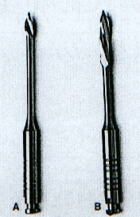
Instrumentation with a full rotary handpiece is by straight-line drilling or side cutting. Mounted with round or tapered burs or diamond points, full rotary contra-angle handpiece can be used to develop coronal access to canal orifices.
Since some of these instruments (stainless) do not readily bend, they should be used in perfectly straight canals. Because they are often misdirected or forced beyond their limits, they notoriously cause perforations or break in the hands of neophytes.
Two of the most historic & popular engine-driven instruments are Gate Glidden drills & Pesso reamers (drills).
Gate Glidden drills are an integral part of new instrumentation techniques for both initial opening of canal orifices & deeper penetration in both straight & curved canals. Gate-Glidden drills are designed to have a weak spot in the part of the shaft closest to the handpiece so that, if the instrument separates, the separated part can be easily removed from the canal. They come in size 1 through 6, although these sizes are being converted to the ISO instrument sizes & colors.

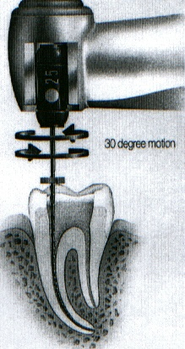
Reciprocating Handpiece:-
A commonly used flat plane reciprocating handpiece is the Giromatic. It accepts only latch-type instruments. In this device, the quarter-turn motion is delivered 3,000 times per minute. More recently, Kerr has introduced the M4 safety handpiece, which has a 30-degree reciprocating motion & a unique chuck that locks regular hand files in place by their handles.

Vertical Stroke Handpiece:-
Levy introduced a handpiece that is driven either by air or electrically that delivers a vertical stroke ranging from 0.3 to 1mm.The more freely the instrument moves in the canal, the longer the stroke. The handpiece also has a quarter-turn reciprocating motion that "kicksin", along with the vertical stroke, when the canal instrument is under bind in a tight canal. If it's too tight, the motion ceases, & the operator returns to a smaller file.

➔Ultrasonic & Sonic Handpiece:-
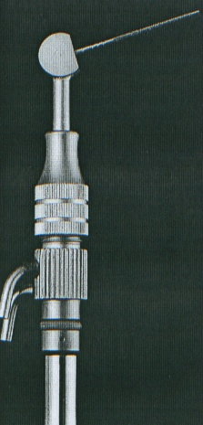
Instruments used in the handpieces that move near or faster than the speed of sound range from standard K-type files to special broach-Like instruments. "Ultrasonic endodontics" is based on a system in which sound as an energy source (at 20 to 25 KHY) activates an endodontic file resulting in three-dimensional activation of the file in the surrounding medium. The main debriding action of ultrasonics was initially thought to be by cavitations, a process by which bubbles formed from the action of file, become unstable, collapse & cause a vacuum-like implosion. A combined shock, shear & vacuum action results. Ultrasonic handpiece use K- files as a canal instrument. Before a size 15 file can fully function, however, the canal must be enlarged with hand instruments to at least a size 20. These instruments all deliver an irrigant / coolant, usually sodium hypochlorite, into the canal space while cleaning & shaping are carried out by a vibrating K- file.

➔Sonic hand pieces:-
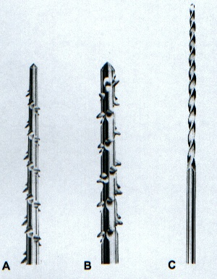
The principal Sonic endodontic handpiece available today is the Micro Mega 1500 Sonic Air Endo System. Like the air rotar handpiece, it attaches to the regular airline at a pressure of 0.4 MPa. The air pressure may be varied with an adjustable ring on the handpiece to give an oscillatory range of 1,500 to 3,000 cycles per second. The three choices of file that are used with the Micro Mega 1500 are the :-
1-Rispisonic which resembles the old rat-tail file.
2-The sharper Sonic resembles a husky barbed broach.
3-The Trio Sonic resembles atriple-helix hedstroem file. All of these instruments have safe-ended non cutting tips.

Laser Endodontics:-
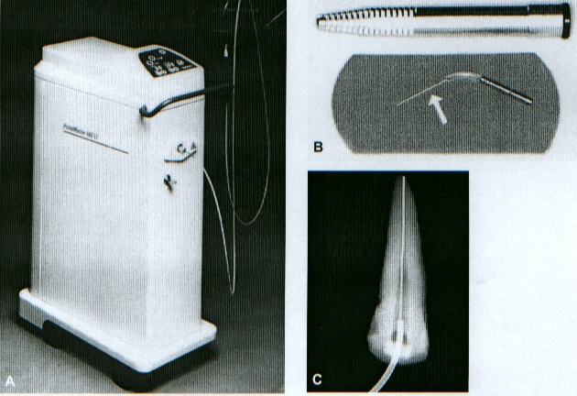
In 1971, at the University of Southern California, Weichman & Johnson were probably the first researchers to suggest the use of lasers in endodontics. A preliminary study was undertaken to attempt to retroseal the apical orifice of the root canal using an Nd: YAG & a carbon-dioxide laser. Although the goal was not achieved, relevant data were obtained. In 1972, Weichman et al. suggested the occurrence of chemical & physical changes of irradiated dentin. The same laser wave lengths were then used, with different materials, in an attempt to seal internally the apical constriction.
Applications of lasers in endodontic therapy have been aggressively investigated over the last two decades. According to Stabholz, there are three main areas in endodontics for the use of lasers: (1) the periapex, (2) the root canal system, & (3) hard tissue, mainly the dentin. One of the major concerns of endodontic therapy is to extensively clean the root canal to achieve necrotic tissue debridement & disinfection. In this sense, lasers are being used as a coadjuvant tool in endodontic therapy: (1) for bacterial reduction, & (2) to modify the root canal surface. The action of different types of laser irradiation on dental root canals "the carbon" dioxide laser, the Nd: YAG laser, the argon laser, the excimer laser, the holmium: YAG, the diode laser & more recently, the erbium: YAG laser has been investigated.
Unlike the carbon-dioxide laser, the Nd:YAG, argon, excimer, holmium,& erbium laser beams can be delivered through an optical fiber that allows for better accessibility to different areas & structures in the oral cavity, including root canals. The technique requires widening the root canal by conventional methods before the laser probe can be placed in the canal. The fibers diameter, used inside the canal space, ranges from 200 to 400mm, equivalent to a No. 20-30 file.


