ENDODONTIC

Lec.9
Preparation of the root canal system
Root canal therapy may be defined as the complete removal of the irreversibly damaged pulp followed by thorough cleaning, shaping and obturation of the root canal system so that the tooth may remain as a functional unit within the dental arch.

Objectives of root canal preparation:-
- To create a tapered funnel shaped canal, widest at the incisal or occlusal part, then tapered gradually toward the apex, and finally it becomes the narrowest at the apical end.
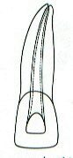
- To retain all the enlarged instrument within the confines of the canal.
- Development of apical constriction “barrier” to prevent extrusion of sealer or overfilling material.
- To retain the original canal shape, at the end of instrumentation we should retain the shape of the canal, and there is no ledge formation.
- To avoid transportation or zipping of the apical part of the canal and create “elbow”.

Methods for using reamers and files:-
Some confusion exists as to the actions for using enlarging instruments and the instruments themselves.
Reaming:-
Reaming involves placement of the instrument toward the apex until some binding is felt and then turning the handle more than a full revolution. Clockwise turning will remove material from the canal by way of the flutes revolution, whereas counterclockwise turning will force material apically. The major effectiveness of hard tissue removal by reaming is in the insertion of the instrument by shaving the dentin walls.
Filing:-
Filing involves placement of the instrument toward the apex until some binding is felt and then removing the instrument by scraping against a side of the dentin wall with little or no revolution of the handle. This dragging against the side of the wall is also referred to as rasping action. The major effectiveness of hard tissue removal by filing is in the outstroke or withdrawal of the instrument by dragging the flutes on the dentin walls.

Circumferential filing:-
Circumferential filing is a method of filing whereby the instrument is moved first toward the buccal (or the labial) side of the canal, then reinserted, and removed slightly mesially. This continues around the preparation to the lingual aspect her then to the distal until all the dentin walls have received planing. This technique enhances preparation when a flaring method is used by widening the orifice of the canal considerably, whereas the apical portion is kept relatively small.
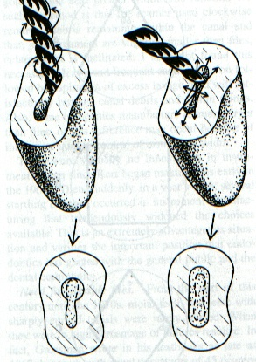
Most roots are oval in cross section and are wider buccolingually than mesiodistally. If such a root contains only one canal, which many but not all do, it will be wider buccolingually as well. In these cases the circumferential filing is emphasized in the buccolingual direction. The oval canal is made into a wider and larger oval. This permits easier placement of precurved instruments, gutta-percha cones, and finger spreaders. Such a preparation is developed solely and specifically for gutta-percha canal filling rather than silver points.

Root canal configuration:-
The shapes of the root canals are divided into:-
Type I | A single canal exist or leaving the pulp chamber which continue as a single canal to the apex of the root to open in a single apical foramen.
Type II | Two canals leaving the pulp chamber, then meet and join each other at eh apical third to be opened in a single apical foramen.
Type III | Two canals leaving pulp chamber and continue as two separated canals to be opened in the root apex into two separated apical foramenae.
Type IV | Single canal leaving the pulp chamber which when reach the apical third, bifurcate into two canals and open into two separated apical foramenae.

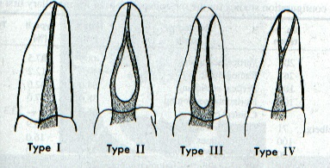

Canal enlargement procedures:-
The principles of root canal preparation are to remove all organic debris and microorganisms and to shape the walls of the root canal so that the entire root canal space may be obturated. Currently, the root canal filling material of choice is gutta-percha, which requires a gradual even funnel-shaped preparation with the widest part coronally and the narrowest part 1.0 mm short of the root apex.
Wide, relatively straight canals are simple to prepare, but fine curved canals can present considerable difficulties. A number of techniques have been described, all of which have been designed to produce a tapered preparation.

- The standardized procedure (conventional technique):-
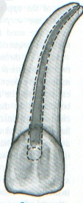
This technique was used for many years and requires each instrument, file or reamer, to be placed to the full working length. The canal was enlarged until clean white dentin shaving were seen on the apical few millimeters of the instrument. The filing was continued for a further 2 or 3 sizes, to complete the preparation. This method was satisfactory in straight canals, but was quite unsuitable for curved canals. As the instrument sizes increase, they become less flexible and cause errors in curved root canals. The common problems are ledging, zipping, elbow formation, perforation and loss of working length owing to impaction of dentin debris.

- Flaring technique:-
The apical portion of the canal is enlarged to a specific degree and then the remainder of the canal is enlarged to even wider sizes to attain an exaggerated funnel shape.
The flared preparation has several physical advantages:-
- The smaller, more flexible files are used in apical portion, and the stiffer files need not be forced but are used short of the apex.
- More apical dentin is available for the dentin matrix, thus if initial files are slightly too long, some dentin can retain gutta-percha within the canal.
- In curved canals, files often bind in the coronal portion and then become ineffective at the apex. With the coronal portion larger, files are more effective and may retain original canal shape better.
- Because the canal is much wider, the intracanal irrigant have more room to gain access to the irritants and necrotic debris.
- The wider coronal portion allows for easier placement for finger spreaders and gutta-percha cones.
- The desired shape of the canal preparation is obtained, as narrow as possible at the apex consistent with cleaning the canal and as wide as possible at the orifice consistent with not gutting the crown.

  - Step-back technique:-
In this technique, we usually prepare the apical part with flexible instruments (i.e. small sizes, 10, 15, 20, 25, 30), but sizes beyond size 30 are considered as a non-flexible instruments.
The first step in this technique is the selection and determination of initial size of instrument according to width of apical third.
Initial size: - is the first instrument, which is inserted inside the canal and goes to the full length and has slight engagement to the walls. Suppose, we had a tooth with initial size 25 file, and working length 20mm…
→File 25 | W.L. = 20mm (initial size).
→File 30 | W.L. = 20 mm→ irrigation.
→File 35 | W.L. = 20 mm → irrigation.
→File 40 | W.L. = 20 mm → (master apical file).
Master apical file:- is the widest instrument that goes to established working length.
→File 45 | W.L. = 19 mm → irrigation.
→File 40 | W.L. = 20 mm (recapitulation).
→File 50 | W.L. = 18 mm → irrigation.
→File 40 | W.L. = 20 mm (recapitulation).
→File 55 | W.L. = 17 mm → irrigation.
→File 40 | W.L. = 20 mm (recapitulation).
→File 60 | W.L. = 16 mm → irrigation.
→File 40 | W.L. = 20 mm (recapitulation).
Recapitulation: - is to ensure that the canal is remained patent.
Note: - due to continuous instrumentation with size 40 file, the file becomes loss inside the canal, so, we select the next larger size (45) as a MAF.
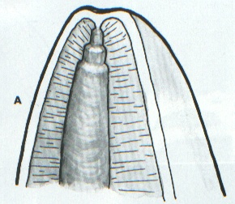
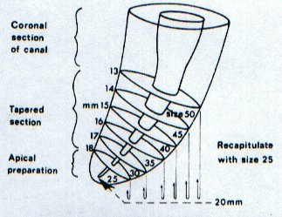

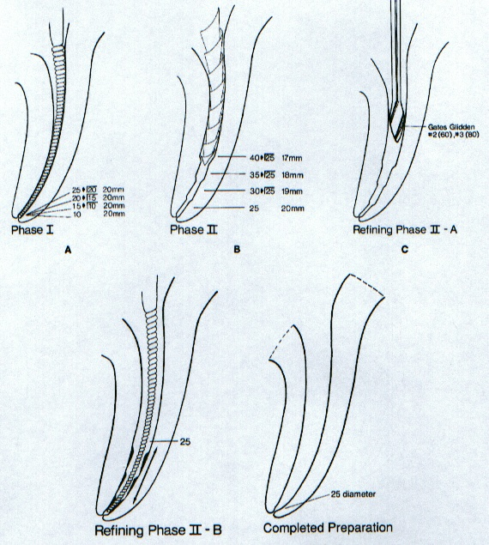

Step down technique (Crown down technique):-
The pulp chamber is first copiously irrigated with irrigant solution. Then, start exploration of the canal with a fine, stainless steel file (No. 0.8, 10, 15, and 20 file). It’s important that the canal be patent to the apical constriction before cleaning and shaping begin.
Gates-Glidden burs are next introduced into the canal, beginning with a size 2 and followed by a size 3. The No. 2 bur is inserted 14-16 mm into the canal from the occlusal reference point. The No.3 bur is placed 11-13 mm into the canal and is directed apically and laterally away from the furcation. Gates-Glidden burs should be rotated with constant medium drill speed form the time they enter the canal until removed. If a bur does break, it usually does so near the hand piece head and may be retrieved easily form the tooth instrumentation with the step-down technique in the radicular access is accomplished using only light pressure directed apically. Preparation of the apical part of the canal is achieved using the step back technique. The instrument should be precurved and only a push-pull motion is used, moving the file clockwise circumferentially. No turning motion is used.
Starting with a file size 20 at the working length, and progressing to sizes 25 and 30, an apical stop is made. Copious irrigation and recapitulation will prevent build up of canal debris. The master apical file (MAF) size is usually 30; larger instruments will start to produce ledging or zipping.
After that we use the step back technique to complete the apical third preparation.

Advantage of step down technique:-
- Most of the microorganisms will be in the coronal third of the root canal system; early removal of these will reduce the possibility of their inoculation into the apical portion of the canal and thence into the periradicular tissues. In addition, hydrostatic pressure can occur within the root canal if working length confirmation or apical preparation is initiated at the start of preparation because the file will act like a piston in a cylinder. This pressure may force pulp debris, dentin chips, irrigant solution and microorganisms through the apical foramen. Extrusion of material is greater when the instrument size is approximately the same as that of the apical section of the root canal.
- Early flaring of the coronal part of the canal system prevents binding of the instruments as they are unencumbered through out most of their length and also gives better access to the apical part of the root canal.
- If removal of interferences at the base of the pulp chamber and in the coronal part of the root canal is undertaken prior to working length determination, the latter is less likely to alter during preparation.
- Early coronal flaring allows better penetration of the irrigant solution.

Balanced force technique:-
The technique can be described as “positioning and pre-loading an instrument through a clockwise rotation and then shaping the canal with a counter clockwise rotation”.

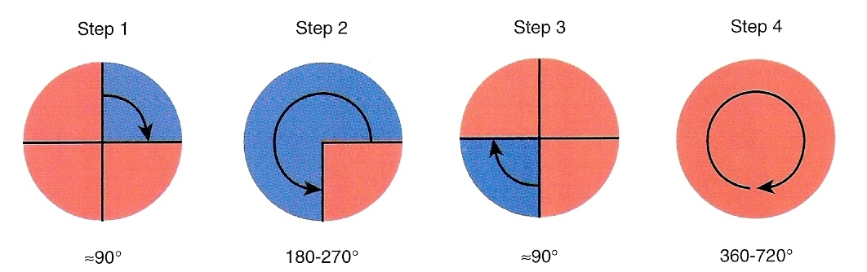

For the best results, preparation is completed in a step-down approach. The coronal and mid thirds of a canal are flared with Gates-Glidden drills, and then instrument shaping is carried into the apical areas. This approach is less difficult than the conventional step-back technique. Increasing the diameter of the coronal and mid-thirds of a canal removes most of the contamination and provides access for a more passive movement of hand instruments into the apical third. After mechanical shaping with Gates-Glidden drills, balanced force hand instrumentation begins, placing, cutting and removing instruments using only rotary motions. Insertion is done with a quarter-turn (90˚) clockwise rotation while slight apical pressure is applied. Cutting is accomplished by making a counter-clockwise rotation. The amount of apical pressure must be adjusted to match the file size (i.e. very light for fine instruments to fairly heavy for large instruments). Pressure should maintain the instrument at or near its clockwise insertion depth. Then counter clockwise rotation and apical pressure act together to enlarge and shape the canal to the diameter of the instrument. Counter clockwise motion must be 120˚ or greater. It must rotate the instrument sufficiently to remove the next larger cutting edge into the location of the blade that preceded it, in order to shape the full circumference of a canal. A greater degree of rotation is preferred and will more completely shape the canal to provide a diameter equal to or greater than that established by the counterclockwise instrument twisting during manufacture.
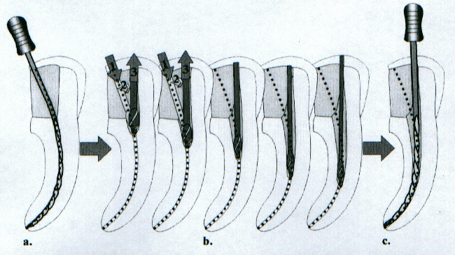
Repeating the previously described steps gradually enlarges the apical third of the canal by advancing to larger and larger instruments.
Thank You

