endodontics

Lec:8
Irrigants and chelating agents

Functions of irrigants:-
Irrigants perform important physical and biologic functions during endodontic therapy. Their action is unquestionably more significant than that supplied by the use of intra-canal medicaments. When there is a wet environment during canal preparation, the dentin shavings are floated to the chamber, where they may be removed by aspiration or paper points. Therefore, they do not pack near the apex to prevent proper canal filling. Files and reamers are much less likely to break when the canal walls are lubricated by the irrigants.
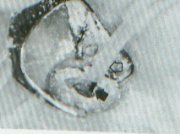
Many liquids would provide these aids, but in addition, the irrigants that are typically used have the function of being necrotic tissue solvents. When used with canal instrumentation, the irrigants loosen debris, pulp tissue, and microorganisms from the irregular dentin walls so that they can be removed from the canal. Because reamers and files are much too small to fit into accessory canals, it is the solvents' action that removes the tissue remaining there so that the subsequently used filling materials may be packed or pushed into these areas.
Most irrigants are germicidal but have further antibacterial effect by ridding the canal of the necrotic debris. With reduced substrate present, the microorganisms have less chance for survival. Irrigants also have a bleaching action to lighten teeth discolored by trauma or extensive silver amalgam restorations and decrease the chance of postoperative darkening.
The commonly used irrigants are capable of causing inflammation of periapical tissue. Therefore, instrumentation must be confined within the canal to limit the forcing of irrigants through the apical foramen. Unquestionably, solution frequently does reach the periapical tissue and some inflammation results. Since the stronger solvents produce greater inflammatory response, the strength of the solutions should be kept to the lowest level that will be effective in debridement.
Useful Irrigants:-
Sodium hypochlorite (NaOCl), NF, is the most widely used irrigant in endodontics and has effectively aided canal preparation procedures for many years. A 5% solution provides excellent solvent action but is dilute enough to cause only mild irritation when contacting periapical tissue. Household liquid bleach (Clorox, Linco) has 5.25% NaOCl and therefore requires slight addition of distilled water to lower the incidence of periapical inflammation.

Hydrogen peroxide solution (H₂O₂), USP, is also widely used in endodontics, with two modes of action. The bubbling of the solution when in contact with tissue and certain chemicals physically foams debris from the canal. In addition, the liberation of oxygen destroys strictly anaerobic microorganisms.
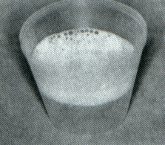
The solvent action of H₂O₂ is much less than that of NaOCl. However, many clinicians use the solutions alternately during treatment. This method is strongly suggested for irrigating canals of teeth that have been left open for drainage, since the effervescence is effective in dislodging food particles as well as other debris that may have packed the canal.

Carbamide peroxide is available in any anhydrous glycerol base (Gly-Oxide) to prevent decomposition and is a useful irrigant. It is better tolerated by periapical tissue than NaOCl yet has greater solvent action and is more germicidal than H₂O₂. Therefore, it is an excellent irrigant for treating canals with normal periapical tissue and wide apices, in which the more irritating solutions would cause severe inflammation when forced out of the canal. The best use for Gly-Oxide is in narrow and/or curved canals, utilizing the slippery effect of the glycerol. Whereas chelating agents react with dentin and may cause root perforation or ledging in softened walls, this action will not occur with Gly-Oxide, where only lubrication is enhanced. Because the canal walls are slippery, they are easier to prepare but are less likely to be gouged or perforated.

Saline:
We use it since it is not irritant to the P.A. tissue area; it has no solvent action just flushing to the canals wall.

Method of irrigation:
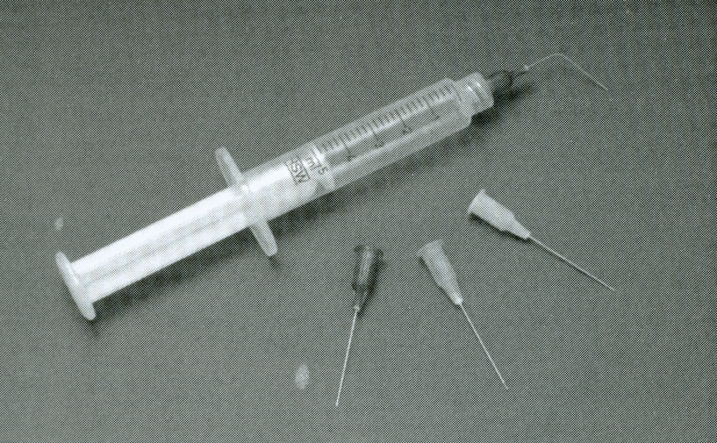
Disposable plastic syringes of 2.5 or 5 ml capacity with 25-gauge blunted needles are useful for endodontic irrigation. Glass syringes with metal tips are also satisfactory but are much more expensive and more easily broken. A bend of approximately 30 degrees is made in the center of the needle so the canals of both anterior and posterior teeth are reachable.
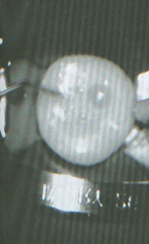
Irrigants must never be forcibly inserted into the periapical tissue but gently placed within the canal. It is the action of the intracanal instruments that distributes the irrigant to the nooks and crannies of the canal rather than the injection syringe. For relatively large canals the tip of the syringe is placed until resistance from the canal walls is felt, then the tip is withdrawn a few millimeters. The solution was expressed very slowly until much of the chamber is filled. In the treatment of posterior teeth and/or small canals, the solution was deposited in the chamber. The files will carry the irrigant into the canal, and the capillary action of the narrow canal diameter will retain much of the solution. Excess irrigant is carried away by aspiration with a small tip, of approximately 16 gauge, if available. Otherwise, a folded gauze pad (2 X 2 inches) is held near the tooth to absorb the excess. To dry a canal in a case where aspiration is not available, the plunger of the irrigating syringe may be withdrawn, and the bulk of the solution will be aspirated in that manner. Paper points are then used to remove residual liquid.

Function of chelating agents:
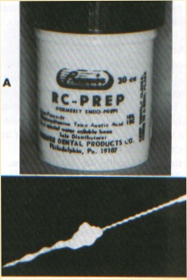
The problems of enlarging very sclerotic canals nagged even the earliest practitioners in endodontics. Chelating agents act on calcified tissues only and have little effect on periapical tissue. Their action is to substitute sodium ions, which combine with the dentin to give soluble salts, for the calcium ions that are bound in less soluble combination. The edges of the canal are thus softer, and canal enlargement is facilitated.
Chelating agents are placed in the orifice of a canal to be enlarged on the tip of the endodontic explorer or on the flutes of the enlarging instrument if the agent is foamy (as is RC-Prep) or by plastic irrigating syringe if liquid (e.g., EDTA). EDTA reacts with glass, so syringes of that material may not be used.
Chelating agents may be useful in the location of a difficult-to-find orifice by sealing in the chamber between appointments. Because the orifices are less calcified than the surrounding dentin, sufficient softening may allow it to be located with the sharp tip of the endodontic explorer at the next appointment.
If misused, chelating agents may cause problems during endodontic therapy. They should not be used in a ledged or blocked canal to aid in reaching the apex. If a sharp instrument is forced or rotated against a wall softened by the chelate, a new but false canal will be started. The operator may erroneously believe that the canal has been located and continue the preparation, thus losing any chance for finding the true canal.
Chelating agents are dangerous in curved canals once the larger-sized instruments (size 30 or greater) are being used. These instruments are not as flexible as the smaller sizes and, with the canal walls softened, may produce an elliptication of the apex or root perforation.
The best use of these agents is to aid and simplify preparation for very sclerotic canals after the apex has already been reached with a fine instrument.
EDTA…
Patterson did much research on the disodium salt of ethylene-diamine tetra acitic acid (EDTA).
EDTA will remain active within the canal for 5 days if not inactivated. If the apical constriction has been opened, the chelate may seep out into the tissue and damage the periapical bone. For this reason, at the completion of the appointment the canal must be irrigated with a sodium hypochlorite-containing solution, a small file being placed into each canal where EDTA was used to ensure penetration of the inactivator.
Some research seems to indicate that the use of EDTA in canal preparation aids in the removal of the smear layer on the dentin wall. This might allow for better surface contact between the canal filling and the dentin wall and better potential penetration of the sealer into the dentinal tubules.
EDTAC…
The addition of Cetavlon, a quaternary ammonium compound, to EDTA produces a solution called EDTAC, which has greater germicidal activity. However, it has greater inflammatory potential to tissue as well. The inactivator for EDTAC is NaOCl.

RC-Prep…
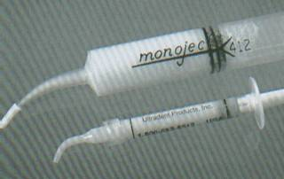
As developed by Stewart, RC-Prep combines the functions of EDTA plus urea peroxide to provide both chelation and irrigation. The foamy solution has a natural effervescence that is increased by irrigation with NaOCl to aid in the removal of debris. RC-Prep may be placed in the canal on the flutes of a file by plastic irrigating syringe.

Intracanal medicaments:-
Originally, endodontics was mainly a therapeutic procedure in which drugs were used to destroy microorganisms, fix or mummify vital tissue, and effect a sealing of the root canal space. The drugs used were generally caustic, such as phenol and its derivatives, and periapical tissues were frequently adversely affected.
Gradually the reliance on drugs has been replaced by emphasis on debridement. It cannot be argued that what is removed from the canal has a greater significance in endodontic success than what is placed in the canal. Even so, drugs are still used as intra treatment dressings, although an ever increasing number of endodontists use them only for symptomatic cases.
Phenol and related volatile compounds…
Phenol was used for many years for its disinfectant and caustic action. However, because it has strongly inflammatory potential, at present it is rarely used as an intracanal medicament.
Eugenol also has been used in endodontics for many years. It is a constituent of most root canal sealers and is used as a part of many temporary sealing agents. Although the compound has high irritating potential when evaluated histologically, it seems to be extremely soothing clinically to vital tissue, probably from some type of caustic action to irritated nerve endings. It is used as an intracanal medicament after partial or complete pulpectomy.
Camphorated monoparachlorophenol (CMCP) is probably the most widely used medicament in endodontics presently, even though its use has decreased considerably in the past few years. It has a wide antibacterial spectrum and is effective against fungi as well. CMCP is much less irritating to periapical tissue than either phenol or eugenol without sacrificing antimicrobial action. It is inexpensive, has a long shelf life, and does not appear to yield false-negative cultures if carried to the medium on a paper point.
Formocresol, a combination of formalin and cresol, is used as a dressing for pulpotomy to fix the retained pulpal tissue. It may also be used as an intratreatment medicament when a pulpotomy is performed as emergency treatment to relieve pain, in situations where pulp inflammation is confined to the pulp chamber.

PBSC…
As mentioned by Grossman, PBSC has enjoyed wide use among dentists trained at eh University of Pennsylvania and those who have participated in postgraduate courses at that institution. The constituents of the paste are as follows:

Penicillin: | Effective against gram-positive microorganisms.
Bacitracin: | Effective against penicillin-resistant microorganisms.
Streptomycin: | Effective against the gram-negative microorganisms.
Caprylate: | As the sodium salt, effective against fungi.

Nystatin replaces sodium caprylate as the antifungal agent in a similar medicament, PBSN. Both are available in a paste form that may be injected into root canals or impregnated on paper points. Because there is no volatility, the drug must be placed in the canal to have effect in that area.

Sulfonamides…
Sulfanilamide and sulfathiazole are used as medicaments by mixing with sterile distilled water or by placing a moistened paper point into a fluffed jar containing the powder. Yellowish tooth discoloration has been reported after use. The medication is suggested for use when closing teeth that had been left open after an acute periapical abscess.

Corticosteroid-antibiotic combinations…
Medications that combine antibiotic and corticosteroid elements are highly effective in the treatment of over instrumentation; they must be placed into the inflamed periapical tissue by a paper point or reamer to be effective.
The corticosteroid constituent reduces the periapical inflammation and gives almost instant relief of pain to the patient who has complained of extreme tenderness to percussion after canal instrumentation. The antibiotic constituents are present so that no overgrowth of microorganisms will occur with the inflammatory response diminished.
Calcium hydroxide as a medicament for "weeping" cases…
One of the most perplexing conditions to treat is the tooth with constant clear or reddish exudation associated with a large apical radiolucency. The tooth often is asymptomatic, but it may be tender to percussion or sensitive to digital pressure over the apex. If cultured, the drainage generally will not support bacterial growth. When opened at the start of the endodontic appointment, a reddish discharge may well up, whereas at a succeeding appointment the exudates will be clear. Some pressure is present, but not nearly as much as with an acute periapical abscess. If the tooth is left open under a rubber dam for 15 to 30 minutes, it may be closed up by absorbing the exudates with an aspirator and paper points; however, a similar condition will still be present at the next appointment. The canal has already been enlarged to a more than acceptable size. This is referred to as a weeping canal.
The exact mechanism for the action of calcium hydroxide in this type of case is an object of much conjecture. I believe that it is closely related to the pH of the periapical tissues, which must be acidic in the weeping stage. The pH is converted by the paste to a more basic environment. Others believe that the calcifying potential of the medicament starts to build up bone in the lesion. Still others suggest that the caustic action of the calcium hydroxide burns residual chronic inflamed tissue.

Chlorhexidine as irrigants and intracanal medicaments:

Chlorhexidine (CHX) is a broad-spectrum antimicrobial agent effective against gram-positive and gram-negative bacteria. It has cationic molecular component that attaches to negatively charged cell membrane areas, causing cell membrane lysis. CHX has been used in periodontal therapy for many years. Its use as an endodontic irrigant is based on it is substantivity long lasting antimicrobial effect.
Recently Chlorhexidine available as gutta-percha point (active point) for temporary root canal filling and for emergency root canal treatment. Active point consists of chlorhexidine diacetate(5%), gutta-percha, ZnO, BaSO4, and coloring agents. Normally, activ point remains in the canal for 1-3 weeks, but in specific clinical cases, it should be replaced every 2-3 days.

Sealing agents for intertreatment dressings:-

Need for sealing agents
Because Endodontic treatment usually takes two or more appointments, some type of temporary sealing agent needed to close the access cavity between visits. The material selected must provide for effective closure against microorganisms and salivary contamination, which would bring irritants to the periapical tissue if allowed free passage. The access-sealing agent must also retain the intracanal medicament, if used, within the tooth to allow effectiveness for the drug.

Types of available sealing agents:
According to radioisotope studies, silver amalgam plus cavity varnish is the most effective sealant available in dentistry. Unfortunately, it would be difficult and time consuming to use those materials at the conclusion of each appointment and then have to drill everything out at the next visit.
Fortunately, zinc oxide powder with eugenol (ZOE) provides an excellent seal and is much easier to place and remove than amalgam. The addition of zinc acetate crystals speeds the set of ZOE without decreasing the sealing properties.
Cavit was introduces for use in Endodontics. Both are easy to apply, and Cavit may be removed with a spoon excavator, not even requiring a bur.
Recently a light-cured material, TERM (Temporary Endodontic Restorative Material), has been introduced. Its major advantages are the ease with which it may be used, since it may be placed with a syringe from sterile prepacked compules, and it is set by exposure to visible light for 20 seconds.

THANK YOU

