ENDODONTICs
Lec:7

Determination of working length:-
- Exploration for the canal orifice:-
Before the canals can be entered, their orifices must be found. In older patients, finding a canal orifice may be the most difficult and time consuming operation.
The endodontic explorer is the greatest aid in finding a minute canal entrance, feeling along the walls and into the floor of the chamber in the area where the orifices are expected to be. Extension of the walls toward these points forms the basic perimeter of the preparation. When we find the orifices, we start to negotiate with small size instrument ex: size 15 to be sure that the canal is patent till the apex. Start extirpation with barbed broach, using the proper size according to the size of the canal. The barbed broach should be loose (no engagement of dentin during rotation). In case of posterior teeth, ex: mesial canal, it's so difficult to use barbed broach, so we use a file instead of barbed broach.
The determination of an accurate working length is one of the most critical steps of Endodontic therapy. The cleaning, shaping and obturation of the root canal system cannot be accomplished accurately unless the working length is determined precisely.
Anatomic consideration and terminology:-
- Working length: - the distance from a coronal reference point to the point of which canal preparation and obturation should terminate, the ideal apical reference point in the canal, the "apical stop", so to speak.
- Anatomic apex: - is the tip or the end of the root determined morphologically, whereas the radiographic apex is the tip or end of the root determined radiographically. Root morphology and radiographic distortion may cause the location of the radiographic apex to vary from the anatomic apex.
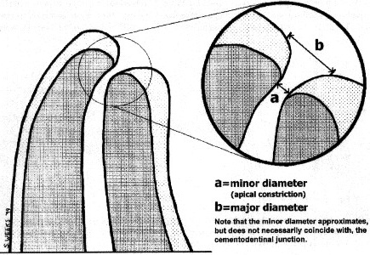

- Apical foramen: - is the main apical opening of the root canal. It's frequently eccentrically located away from the anatomic or radiographic apex.
- Apical constriction:- is the apical portion of the root canal having the narrowest diameter. This position may vary but is usually 0.5 to 1.0 mm short of the center of the apical foramen.
- Cementodentinal junction:- is the region where the dentin and cementum are united, the point of which the cemental surface terminates at or near the apex of the tooth. It must be pointed out, however, that the cementodentinal junction is a histologic landmark that cannot be located clinically or radiographically.

Methods of determining working length:-
- Ideal method:-
To achieve the highest degree of accuracy in working length determination, a combination of several methods should be used. This is most important in canals for which working length determination is difficult. The most common methods are radiographic methods, digital tactile sense, and electronic methods.

- Radiographic methods:-
Radiographic method known as the Ingle method has been compared with three other methods of determining working length. The Ingle method proved to be superior to others in the study. It showed a high percentage of success with a smaller variability. This method, first proposed more than 40 years ago, has withstood the test of time and has become the standard as the most commonly used method of radiographic working length estimation.
Radiographic Apex Location:-
The following items are essential to perform this procedure:-
- Good, undistorted, preoperative radiographs showing the total length and all roots of the involved tooth.
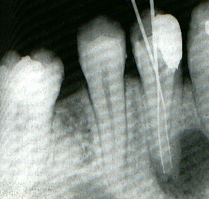
- Adequate coronal access to all canals.
- An endodontic millimeter ruler.
- Working knowledge of the average length of all teeth.
- A definite, repeatable plane of reference to an anatomic landmark on the tooth, a fact that should be noted on the patient's record.

Reference point:- is the site on the occlusal or incisal surface from which measurements are made. This point is used through out canal preparation and obturation. A reference point that will easily visualize during preparation is chosen. Usually this is the highest point on the incisal edge on the anterior teeth and a buccal cusp tip on posterior teeth.
It is imperative that teeth with fractured cusps or cusps severely weakened by caries or restoration be reduced to a flattened surface, supported by dentin. Failure to do so may result in cusps or weak enamel walls being fractured between appointments. Thus, the original site of reference is lost. If this fracture goes unobserved, there is the probability of over instrumentation and overfilling, particularly when anesthesia is used. To establish the length of the tooth, a stainless steel reamer or file with an instrument stop on the shaft is needed. The exploring instrument size must be small enough to negotiate the total length of the canal but large enough not to be loose in the canal. A loose instrument may move in or out of the canal after the radiograph and cause serious error in determining the length of tooth.
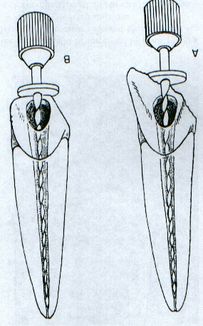

Method:-
  - Measure the tooth on the preoperative radiograph (initial measurement).
  - Subtract at least 1.0 mm "safety allowance" for possible image distortion or magnification.
  - Set the endodontic ruler at this tentative working length and adjust the stop on the instrument at that level.
  - Place the instrument in the canal until the stop is at the plane of reference unless pain is felt, in which case, the instrument is felt at level and the rubber stop readjusted to this new point of reference.
  - Expose, develop, and clear the radiograph.
  - On the radiograph, measure the difference between the end of the instrument and the end of the root and add this amount to the original measured length the instrument extended into the tooth. If, through some oversight, the exploring instrument has gone beyond the apex, subtract this difference.
  - From this adjusted length of tooth, subtract a 1.0 mm "safety factor" to conform to the apical termination of the root canal at the apical constriction.
If, radiographically, there is no resorption of the root end or bone, shorten the length by the standard 1.0mm. If periapical bone resorption is apparent, shorten by 1.5mm, and if both root and bone resorption is apparent, shorten by 2.0 mm. The reasoning behind this suggestion is thoughtful. If there is root resorption, the apical constriction is probably destroyed, hence the shorter move backup the canal. Also, when bone resorption is apparent, there probably is also root resorption, even though it may not be apparent radiographically.
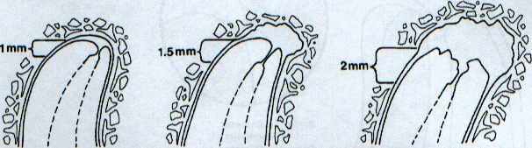

  - Set the endodontic ruler at this new corrected length and readjust the stop on the exploring instrument.

    - Digital Tactile Sense:-
If the coronal portion of the canal is not constricted, an experienced clinician may detect an increase in resistance as the file approaches the apical 2 to 3mm. This detection is by tactile sense. In this region, the canal frequently constricts before exiting the root. There is also a tendency for the canal to deviate from the radiographic apex in this region.
The accuracy of just 64% using digital tactile sense. Another study found that the exact position of the apical constriction could be located accurately by tactile sense in only 25% of canals in their study.
All clinicians should by aware that this method, by itself, is often inexact. It is ineffective in root canals with an immature apex and is highly inaccurate if the canal is constricted throughout its entire length or if the canal has excessive curvature. This method should be considered supplementary to high-quality, carefully aligned, parallel, working length radiographs and/or an apex locator.
A survey found that few general practice dentists and no endodontists trust the digital tactile method of determining working length by itself. Even the most experienced specialist would be prudent to use two or more methods to determine accurate working lengths in every canal.

- Determination of Working Length by Electronics:-
Electronic devices have been designed to determine canal length by “reading” when vital tissue has been reached by the file tip at the apical foramen. The electronic principle is relatively simple and is based on electrical resistance. In 1918, Custer was the first to report the use of electric current to determine working length. The research on dogs using direct current discovered that the electrical resistance between the periodontal ligament and the oral mucosa was a constant value of 6.5 Kilo-ohms. They used a simple direct current ohmmeter to measure a constant resistance of 6.5 kilo-ohms between oral mucous membrane and the periodontium regardless of the size or shape of the teeth. The device used became the basis for most apex locators.
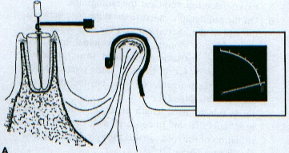
All apex locators function by using the human body to complete an electrical circuit. One side of the apex locator's circuitry is connected to an endodontic instrument. The other side is connected to the patient's body, either by a contact to the patient's lip or by an electrode held in the patient's hand. The electrical circuit is complete when the endodontic instrument is advanced apically inside the root canal until it touches periodontal tissue. The display on the apex locator indicates that the apical area has been reached. According to the device, this event is signaled by a beep, a buzz, flashing light, digital readouts, or a pointer on a dial.

Contraindications:-
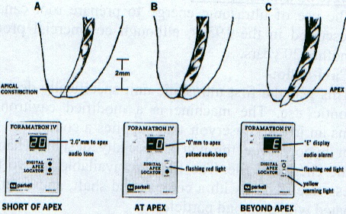
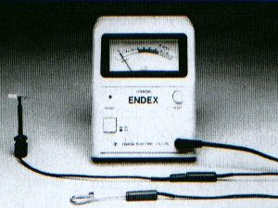
The use of apex locators and other electrical devices such as pulp testers, electrosurgical instruments and desensitizing equipment, is contraindicated for patients who have cardiac pacemakers. Electrical stimulation to the pacemaker patient can interfere with pacemaker function. The severity of the interference depends on the specific type of pacemaker and the patient's dependence on it. In special cases, an apex locator may be used on a patient with a pacemaker when it's done in close consultation with the patient's cardiologist.

Thank you

