endodontics
Lec.6

Access opening of posterior teeth:-
- Maxillary molar teeth:-
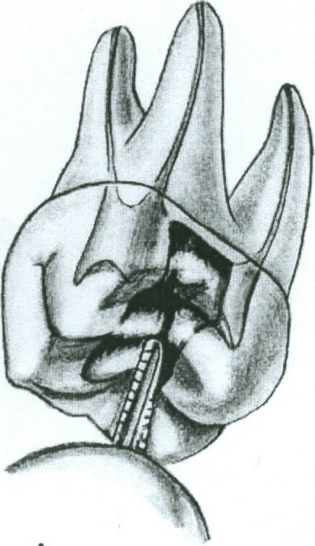
- Entrance is always gained through the occlusal surface of all posterior teeth. Initial penetration is made in the exact center of the mesial pit, with the bur directed toward the lingual. The 702 U tapering fissure bur in an accelerated-speed contra-angle handpiece is ideal for perforating gold casting or virgin enamel surface to the depth of dentin. Amalgam fillings are penetrated with a No.4 or 6 round bur operating in a slow-speed contra-angle handpiece.

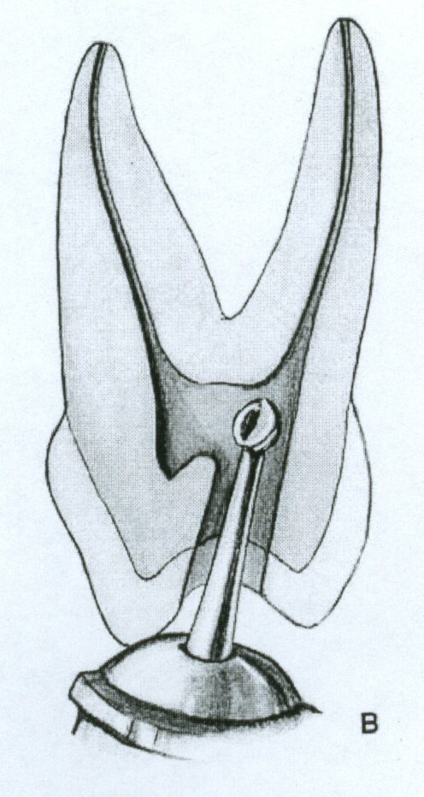
- According to the size of the chamber, a regular-length No.4 round bur is used to open into the pulp chamber. The bur should be directed toward the orifice of the palatal canal or toward the mesiobuccal canal orifice, where the greatest space in the chamber exists. It will be felt to "drop" when the pulp chamber is reached. If the chamber is well calcified, initial penetration is continued until the contra-angle rests against the occlusal surface. This depth of 9mm is the usual position of the floor of the pulp chamber, which lies at the cervical level. Working from inside out, back toward the buccal, the bur removes enough roof of the pulp chamber for exploration.

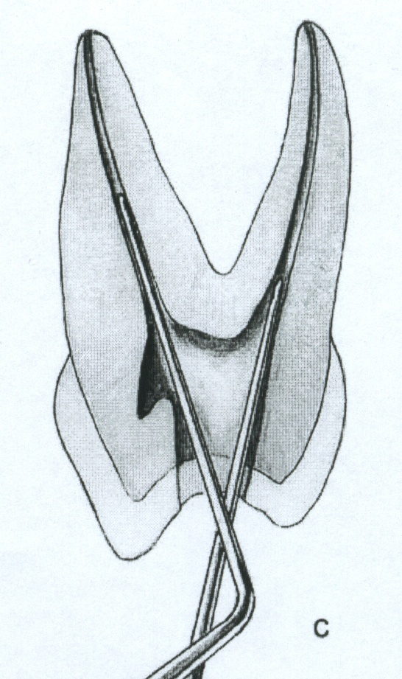
- An endodontic explorer is used to locate orifices of the palatal, mesiobuccal, and distobuccal canals. Tension of the explorer against the walls of preparation will indicate the amount and direction of extension necessary. Orifices of canals form the perimeter of preparation. Special care must be taken to explore for a second canal in the mesiobuccal root.

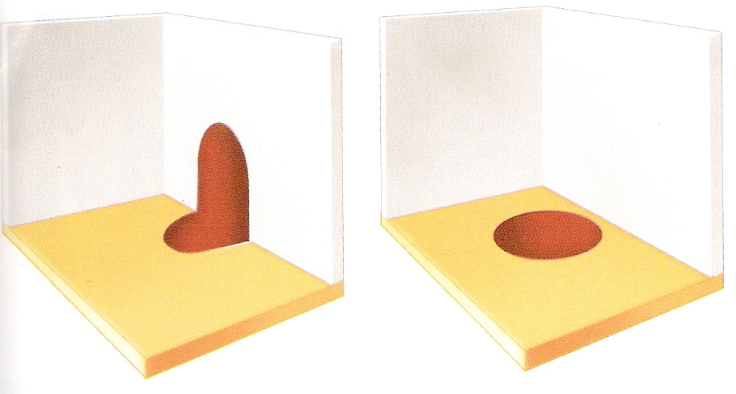
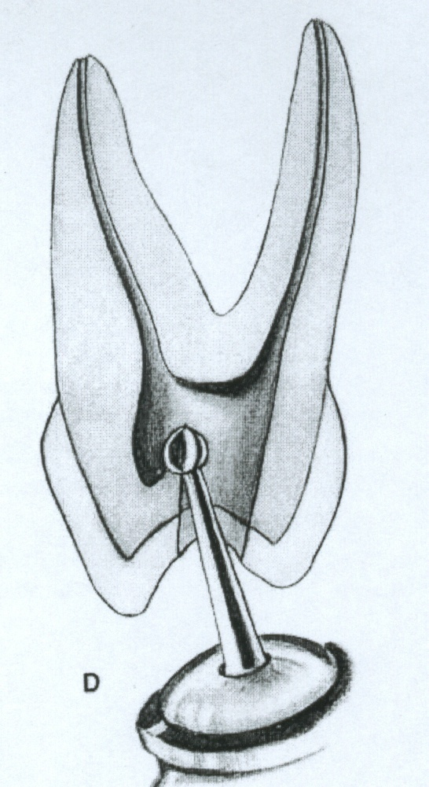
- Again, wording at slow speed from inside to outside, a round bur is used to remove the roof of the pulp chamber. Internal walls and floor of preparation should not be cut into unless difficulty is encountered in locating orifices. In that case, surgical-length No.2 round burs are necessary to explore the floor of the chamber. Internally, the access cavity should have all orifices positioned entirely on the pulp floor and should not extend into an axial wall. Extension of an orifice into the axial wall creates a mouse hole effect, which indicates internal underextension and impedes straight-line access. In such cases the orifice must be repositioned onto the pulp floor without interference from the axial

- In posterior teeth the internal impediments are the cervical dentine bulges and natural coronal canal constriction. The cervical bulges are shelves of dentin that frequently overhang orifices in posterior teeth, restricting access into root canals. These bulges can be removed with safety tip diamond or carbide burs. Final finish and funneling of cavity walls are completed with a 702U fissure bur or tapered diamond points at accelerated speed.
- Final preparation provides unobstructed access to canal orifices and should not impede complete authority of enlarging instruments. Improve ease of access by "leaning" the entire preparation toward the buccal, for all instrumentation is introduced from the buccal. Notice that the preparation extends almost to the length at the buccal cusps. The walls are perfectly smooth, and the orifices are located at the exact pulpal-axial angles of the cavity floor.
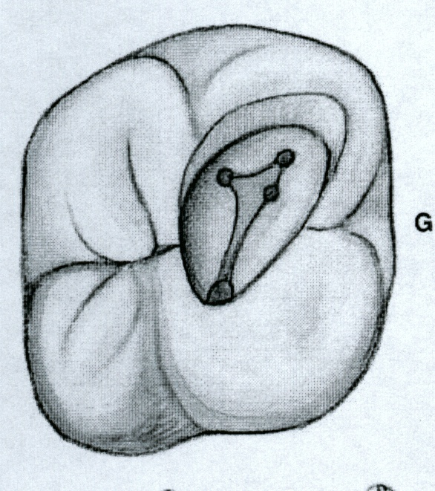
- Extended outline form reflects the anatomy of the pulp chamber. The base is towards the buccal and the apex is to the lingual, with the canal orifice positioned at each angle of the triangle. The cavity is entirely within the mesial half of the tooth and need not invade the transverse ridge but is extensive enough, buccal to lingual, to allow positioning of instruments and filling materials. Outline form of final preparation is identical for both a newly erupted and an "adult" tooth. Note the orifice to the fourth canal. Internally, the access cavity should have all orifices positioned entirely on the pulp floor and should not extend into an axial wall. Extension of an orifice into the axial wall creates a mose hole effect, which indicates internal underextension and impedes straight-line access. In such cases the orifice must be repositioned onto the pulp floor without interference from the axial.
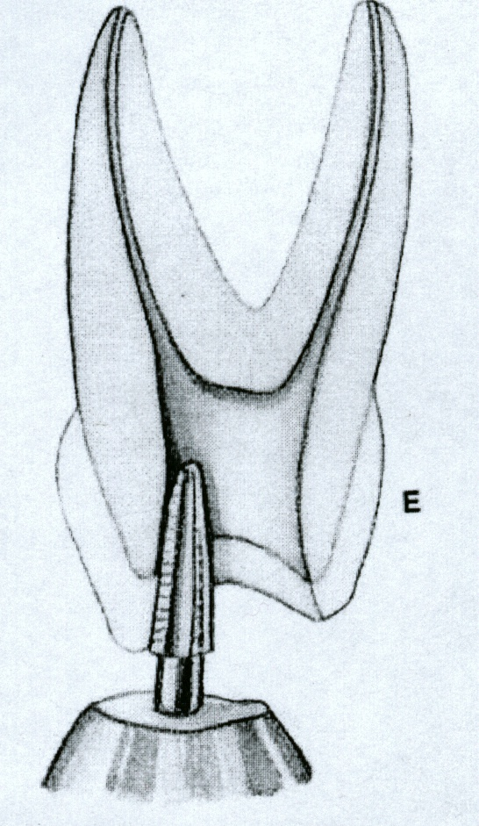
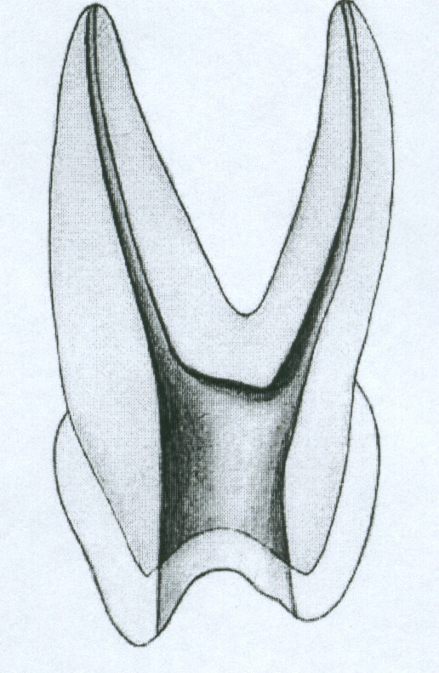

  - Mandibular molar teeth:-
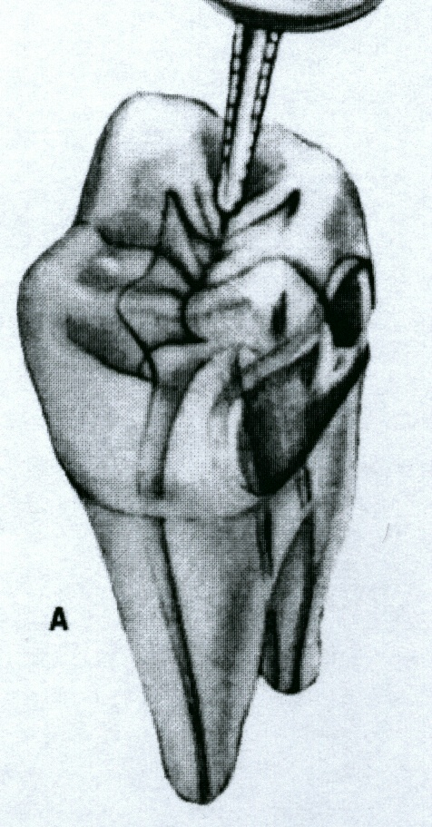
- Entrance is always gained through the occlusal surface of all posterior teeth. Initial penetration is made in the exact center of the mesial pit, with the bur directed toward the distal. The 702U tapering fissure bur is in an accelerated-speed contra-angle handpiece is ideal for perforating gold casting or virgin enamel surface to the depth of dentin. Amalgam fillings are penetrated with a No.4 round bur operating in a high-speed contra-angle handpiece.

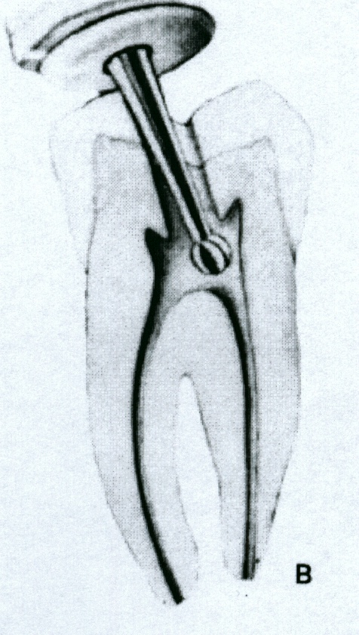
- According to the size of the chamber, a regular-length No.4 or 6 round bur is used to open into the pulp chamber. The bur should be directed toward the orifice of the mesiobuccal or distal canal, where the greatest space in the chamber exists. It will be felt to "drop" when the pulp chamber is reached. If the chamber is well calcifies, initial penetration is continued until the contra-angle handpiece rests against the occlusal surface. This depth of 9mm is the usual position of the floor of the chamber, which lies at the cervical level. Working from inside out, back toward the mesial, the bur removes enough roof of the pulp chamber for exploration.

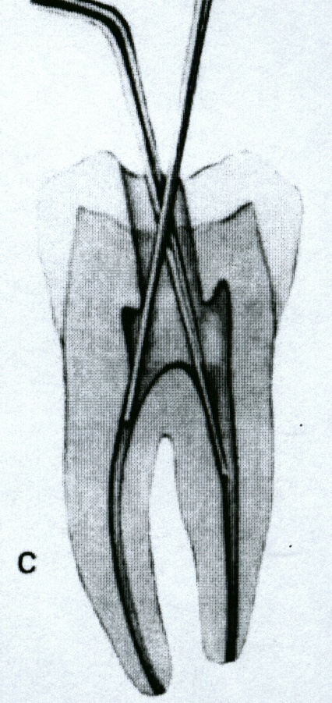
- An endodontic explorer is used to locate orifices of the distal, mesiobuccal, and mesiolingual canals. Tension of the explorer against the walls of preparation indicates the amount and direction of extension necessary. Orifices of the canals form the perimeter of preparation. Special care must be taken to explore for an additional canal in the distal root. The distal canal should form a triangle with two mesial canals. If it is asymmetric, always look for the fourth canal 29% of the time.

- Again, working at slow speed from the inside to outside, a round bur is used to remove the roof of the pulp chamber. Internal walls and floor of preparation should not be cut into unless difficulty is encountered in locating orifices. In that case, surgical-length no.2 or 4 round burs are necessary to explore the floor of the chamber.
- Final finish and funneling of cavity walls are completed with a 702U fissure bur or diamond point at accelerated speed.
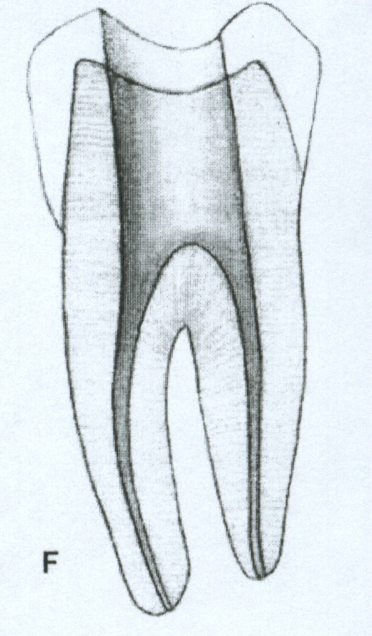
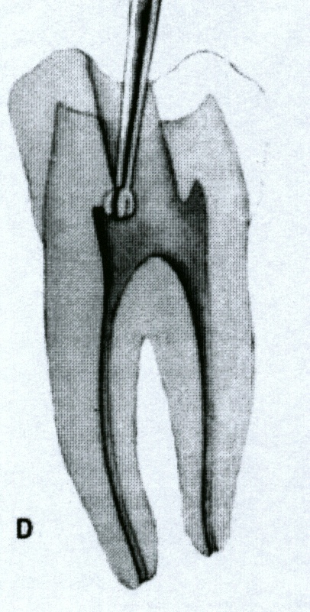
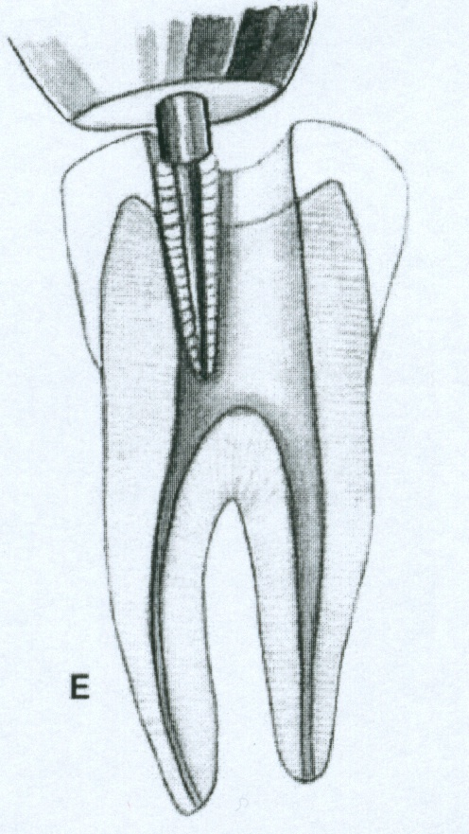

- Final preparation provides unobstructed access to canal orifices and should not impede the complete authority of enlarging instruments. Improve ease of access by "leaning" the entire preparation toward the mesial, for all instrumentation is introduced from the mesial. Notice that the cavity outline extends to the height of the mesial cusps. The walls are perfectly smooth and the orifice located at the exact pulpal-axial angle of the cavity floor.

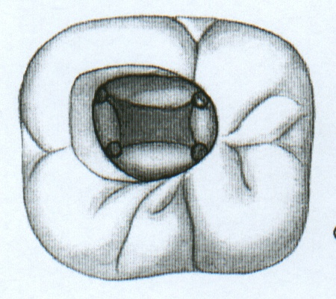
- "Square" outline form reflects the anatomy of the pulp chamber. Both mesial and distal walls slope mesially. The cavity is primarily within the mesial half of the tooth but is extensive enough to allow positioning of the instrument and filling materials. The outline form of the final preparation will be identical for both a newly erupted and an "adult" tooth. Further exploration should determine if a fourth canal can be found in the distal root. If so, the outline is extended in that direction. In that case, an orifice will be positioned at each angle of the square.

Errors in cavity preparation of posterior teeth:-
  - Under extended preparation. Pulp horns have merely been "nicked" and the entire roof of the pulp chamber remains. "White" color dentin of the roof is a clue to under extension.
  - Over extended preparation undermining enamel walls. The crown is badly gouged owing to failure to observe pulp recession in the radiograph.
  - Perforation into furca using a surgical-length bur and failing to realize that the narrow pup chamber had been passed. Operator error in failure to compare the length of the bur to the depth of the pulp canal floor. Length should be marked on the bur shank with dycal.
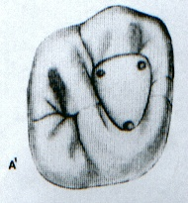
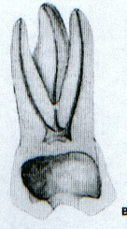
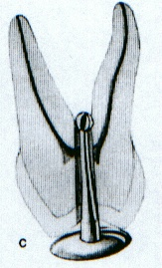

  - Inadequate vertical preparation related to failure to recognize severe buccal inclination of an unopposed molar.
  - Disoriented occlusal outline form exposing only the palatal canal. A faulty cavity has been prepared in full crown, which was placed to "straighten" a rotated molar. Palpating for mesiobuccal root prominence would reveal the severity of the rotation.
  - Perforation at the wall cavity caused by failure to orient the bur with the long axis of the molar severely tipped to the mesial.
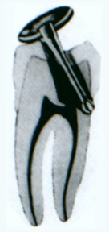
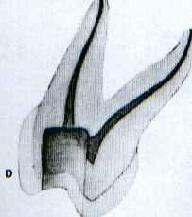
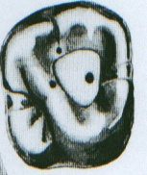

Average length of posterior permanent teeth
Tooth |  |  |  | Average length | Canals | Canals in the mesiobuccal root
 |  |  |  | Mesiobuccal  20mm | 3 canals 41% | One canal/one foramen |  |  |  | 41%
 | 6 | 6 |  | Distobuccal  19.4mm | 4 canals  56.5% | Two canals/one foramen |  |  |  | 40%
 |  |  |  | Palatal  20.6mm | 4 canals  56.5% | Two canals/two foramina |  |  |  | 19%
 |  |  |  | Mesiobuccal  20mm | 3 canals 54% | One canal/one foramen |  |  | 63%
 | 7 | 7 |  | Distobuccal  19.4mm | Fused 46% | Two canals/one foramen |  |  | 13%
 |  |  |  | palatal  20.8mm | Fused 46% | Two canals/two foramina |  |  | 24%
 |  |  |  | Mesial  20.9mm | Two canals  6.7% | Mesial |  | Distal
 | 6 | 6 |  | Distal  20.9mm | 3 canals  64.4% | Two canals/one foramen 40% |  | One canal 71%
 |  |  |  | Distal  20.9mm | 4 canals 29% | Two canals/two foramina 60% |  | Two canals 29%
 |  |  |  | Mesial  20.9mm |  |  | Mesial |  |  |  | Distal
 | 7 | 7 |  | Mesial  20.9mm |  | One canal/one foramen | 13% |  |  |  | 92%
 |  |  |  | Distal  20.8mm |  | Two canals/one foramen | 49% |  |  |  | 5%
 |  |  |  |  |  | Two canals/two foramina | 38% |  |  |  | 3%

