endodontic
Lec:5
Access opening of anterior teeth:-

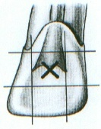
- Entrance is always gained through the lingual surface of all anterior teeth. Initial penetration is made in the exact center of the lingual surface at the position marked "X". A common error is to begin the cavity too far gingivally.

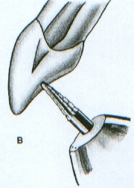
- Initial entrance is prepared with a round- point tapering fissure bur in an accelerated-speed contra-angle handpiece with water coolant, operated at a right angle to the long axis of the tooth. Only enamel is penetrated at this time. Do not force the bur; allow it to cut its own way.

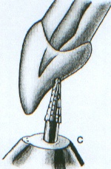
- Convenience extension toward the incisal continues the initial penetrating cavity preparation. Maintain the point of the bur in the central cavity and rotate the handpiece toward the incisal so that the bur parallels the long axis of the tooth. Enamel and dentin are beveled toward the incisal. Entrance into the pulp chamber should not be made with an accelerated-speed instrument. Lack of tactile sensation with these instruments precludes their use inside the tooth.

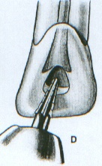
- The preliminary cavity outline is funneled and fanned incisally with a fissure bur. Enamel has a short bevel toward the incisal, and a "nest" is prepared in the dentin to receive the round bur to be used for penetration.

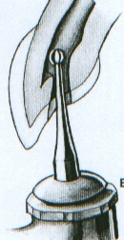
- A surgical length No.2 or 4 round bur in a slow-speed contra-angle handpiece is used to penetrate the pulp chamber. If the pulp has greatly receded, a No.2 round bur is used for initial penetration. Take advantage of convenience extension toward the incisal to allow for the shaft of the penetrating bur, operated nearly parallel to the long axis of the tooth.
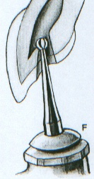
- Once the pulp chamber has been penetrated, the remaining roof is removed by catching the end of a round bur under the lip of the dentine roof and cutting on the burs withdrawal stroke (Working from inside the chamber to outside).

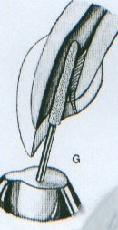
- Once the orifice(s) has been identified and confirmed, the lingual shoulder is removed. This is the lingual shelf of dentin that extends from the cingulum to a point approximately 2mm apical to the orifice. The lingual shoulder can be removed with a tapered safety-tip diamond or carbide bur. The tip of a fine safety-tip diamond bur is placed approximately 2mm apical to the canal orifice and inclined to the lingual during rotation to slope the lingual shoulder. The clinician must be careful when using this bur to avoid placing a bevel on the incisal edge. the lingual "shoulder" is removed to give continuous, smooth-flowing preparation.

- Occasionally, a No.1 or 2 round bur must be used laterally and incisally to eliminate pulpal horn debris and bacteria, this also prevents future discoloration.

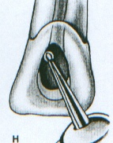
- Final preparation relates to the internal anatomy of the chamber and canal. In a "young" tooth with a large pulp, the outline form reflects a large triangular internal anatomy- an extensive cavity that allows thorough cleansing of the chamber as well as passage of large instruments and filling materials needed to prepare and fill a large canal. Cavity extension toward the incisal allows greater access to the midline of the canal.

- Cavity preparations in "adult" teeth, with the chamber obturated with secondary dentin, are ovoid in shape. Preparation funnels down to the orifice of the canal. The further the pulp has receded, the more difficult it is to reach to this depth with a round bur. Therefore, when the radiograph reveals advanced pulpal recession, convenience extension must be advanced further incisally to allow the bur shaft and instruments to operate in the central axis.
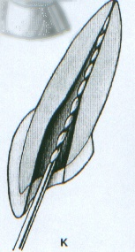
- Final preparation with the reamer in place, the instrument shaft clears the incisal cavity margin and reduced lingual "shoulder", allowing an unrestrained approach to the apical third of the canal. The instrument remains under the complete control of the clinician. An optimal, round, tapered cavity may be prepared in the apical third, tailored to the requirements of round, tapered filling materials to follow. The remaining ovoid part of the canal is cleaned and shaped by circumferential filling or Gates-Glidden drills.

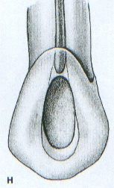
P.S.:- In Maxillary canine, extensive, ovoid, funnel-shaped preparation must be nearly as large as for a young tooth. A beveled incisal extension carries preparation nearer the central axis, allowing better access to the curved apical third. Discovery by exploration of an apical labial curve calls for even greater incisal extension.

Errors in cavity preparation:-
- Perforation at the labiocervical caused by failure to complete convenience extension toward the incisal, prior to the entrance of the shaft of the bur.
- Gouging of the labial or distal wall caused by failure to recognize the lingual- axial or mesial-axial inclination of the tooth.
- Pear-shaped preparation of the apical canal caused by failure to complete convenience extensions. The shaft of the instrument rides on the cavity margin and lingual "shoulder". In adequate debridement and obturation ensure failure.
- Discoloration of the crown caused by failure to remove pulp debris. The access cavity is too far to the gingival with no incisal extension.
- Ledge formation at the apical-labial curve caused by failure to complete the convenience extension. The shaft of the instrument rides on the cavity margin and "shoulder".

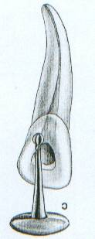
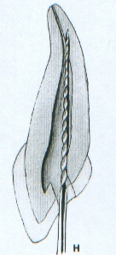
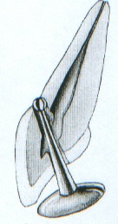
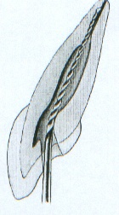
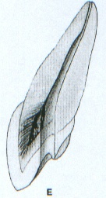

Access opening of premolar teeth:-
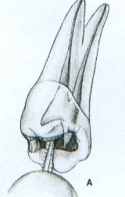
  - Entrance is always gained through the occlusal surface at all posterior teeth. Initial penetration is made parallel to the long axis of the tooth in the exact center of the central groove between the cusp tips of the maxillary premolars. In mandibular first premolars the staring location is halfway up the lingual incline of the buccal cusp on a line connecting the cusp tips mandibular second premolars reguire less of an adjustment because they have less lingual inclination. The 701 U tapering fissure bur in an accelerated-speed contra-angle handpiece is ideal for penetrating gold casting or virgin enamel surface

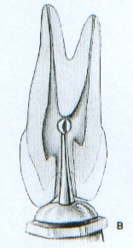
  - A regular-length No.2 or 4 round bur is used to open into the pulp chamber. The bur will be felt to "drop" when the pulp chamber is reached. If the chamber is well calcified and the "drop" is not felt, vertical penetration is made until the contra-angle handpiece rests against the occlusal surface. This depth is approximately 9mm, the position of the floor of the pulp chamber that lies at the cervical level. In removing the bur, the orifice is widened buccolingually to twice the width of the bur to allow room for exploration for canal orifices. If a surgical-length bur is used, care must be exercised not to perforate the furca.

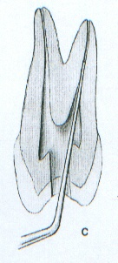
  - An endodontic explorer is used to locate orifices to the buccal and lingual canals in the first premolar or the central canal in the second premolar. Tension of the explorer shaft against the walls of preparation will indicate the amount and direction of extension necessary.
  - Working from inside the pulp chamber to outside, a round bur is used at low speed to extend the cavity buccolingually by removing the roof of the pulp chamber.

  - Buccolingual extension and finish of cavity walls are completed with a 701U fissure bur at accelerated speed.

  - Final preparation should provide unobstructed access to canal orifices. Cavity walls should not impede complete authority over enlarging instruments.

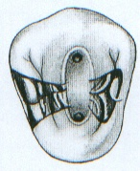
  - Outline form of final preparation will be identical for both newly erupted and "adult" teeth. Buccolingual ovoid preparation reflects the anatomy of the pulp chamber and the position of the buccal and lingual canal orifices. The cavity must be extensive enough to allow for instruments and filling materials needed to enlarge and fill canals. Further exploration at this time is imperative. It may reveal the orifice to an additional canal, a second canal in the second premolar, or a third canal in the first premolar.
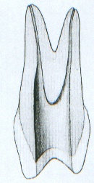
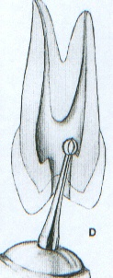
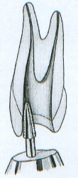

Errors in cavity preparation:-
- Under extended preparation exposing only pulp horns. Control of enlarging instruments is abdicated to cavity walls. The white color of the roof of the chamber is a clue to a shallow cavity.
- Over extended preparation from a fruitless search for a receded pulp. The enamel walls have been completely undermined. Gouging relates to failure to refer to the radiograph, which clearly indicates pulp recession.
- Perforation at the mesiocervical indentation. Failure to observe the distal-axial indentation of the tooth led to bypassing receded pulp and perforation. The maxillary first premolar is one of the most commonly perforated teeth.
- Incomplete preparation and possible instrument breakage caused by total loss of instrument control. Use only occlusal access, never buccal or proximal access.

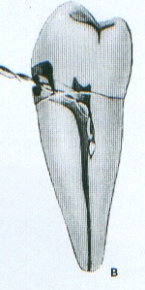
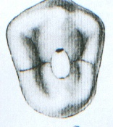
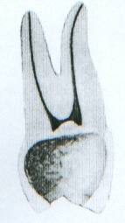
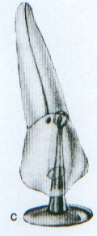

Average length of permanent teeth
Tooth |  |  |  | Average length | Canal | Root curvature
 |  |  |  | 23mm | One canal 100% | Straight 75%
 | 1 | 1
 |  |  |  | 22.8mm | One canal 100% | Distal curve 53%, straight 30%
 | 2 | 2 |  | 22.8mm | One canal 100% | Distal curve 53%, straight 30%
 |  |  |  | 26mm | One canal 100% | Distal curve 32%, straight 39%
 | 3 | 3 |  | 26mm | One canal 100% | Distal curve 32%, straight 39%
 |  |  |  | 21.5mm | One canal/ one foramen 70% | Straight 60%
 | 1 | 1 |  | 21.5mm | two canals/ one foramen 23% | Distal curve 23%
 |  |  |  | 22.4mm | One canal/one foramen 57% | Straight 60%
 | 2 | 2 |  | 22.4mm | Two canals/two foramina 30% | Distal curve 23%
 |  |  |  | 25mm | One canal 94% | Straight 68%, distal curve 20%
 | 3 | 3 |  | 25mm | One canal 94% | Straight 68%, distal curve 20%
 |  |  |  | 21.8mm | Two canals/ two foramina 72% | Straight 38%
 | 4 | 4 |  | 21.8mm | Two canals/one foramen 13% | Distal curve 37%
 |  |  |  | 21mm | One canal/one foramen 75% | Distal curve 27%, buccal curve 12.7%
 | 5 | 5 |  | 21mm | Two canals/two foramina | Bayonet curve 20.6%
 |  |  |  | 22mm | One canal/one foramen 73.5% | Straight 48%
 | 4 | 4 |  | 22mm | Two canals/two foramina 19.5% | Distal curve 35%
 |  |  |  | 21.4mm | One canal/one foramen 85.5% | Straight 39%
 | 5 | 5 |  | 21.4mm | Two canals/two foramina 11.5% | Distal curve 40%

