ENDODONTICS
Lec.2

Basic instrumentation in endodontics:-
It is now widely accepted that success in root canal treatment depends upon the thorough cleaning & shaping of the root canal system & the placement of a three- dimensional root canal filling of gutta-percha & inert sealer. To fulfill these objectives, many different instruments each with a specific purpose, must be available. Some of these instruments have been used for many years, whilst others are newer & highly technical.

- Endodontic Explorer:-
The straight end of the explorer is designed to aid in location of root canal orifices, its tip is sharp & able to negotiate a small opening, the instrument has sufficient rigidity to explore with controlled force. The L-shaped end aids in detection unremoved portions of the pulp chamber root.
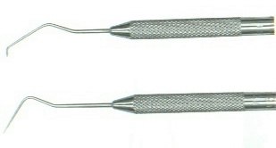

- Plastic Instrument:-
The blade like end of this instrument is used to carry & place the temporary filling materials. The opposite end is used as a plugger to condense filling materials in the pulp chamber.

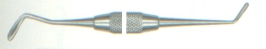

- Endodontic excavator:-
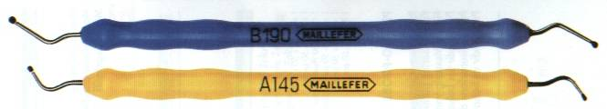
The shape of this instrument allows curettage of the pulp chamber when conventional excavator will not reach the floor of the chamber (had long shank). It’s also part of the surgery kit and is used to curette periapical lesion.

- Endodontic locking plier:-
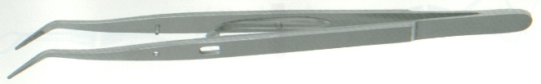
It has a latch that permits materials to be held without continuous finger pressure. The grooved tips facilitate holding absorbent points and gutta-percha cones, which tend to loosen in ungrooved tips.

- Endodontic ruler:-
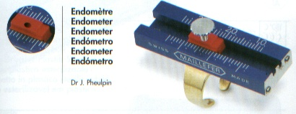
The 0.5 mm ruler is a convenient instrument with which to measure files, gutta-percha cones, and also we have a measuring blocks and special millimeter thumb rulers.
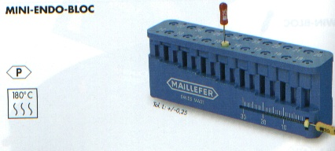

- Endodontic syringe:-
It’s used to carry the irrigants into the root canal. The needle tip is flat to prevent penetration into smaller canal diameter and grooved to allow irrigants that may be under pressure to flow coronolly rather than be forced through the apical foramen. When drying canals, most of the irrigant may be aspirated from the canal by pulling back on the plunger.
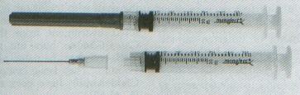

- Instrument organizer:-
A means of organizing endodontic files according to size and length is a necessity. The organizer provides holes for the files, which are held vertically in a sponge allowing them to be grasped easily. The sponge is saturated with disinfectant solutions that maintain instrument sterility.
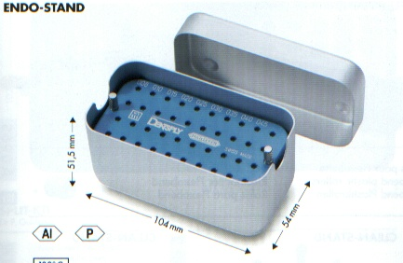
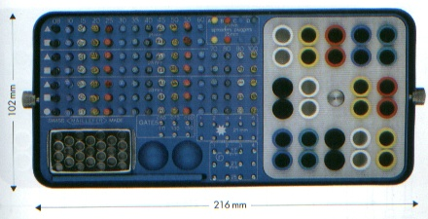

- Transfer sponge:-
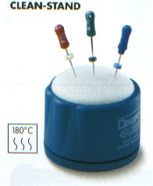
A banker’s sponge is a convenient aid to hold files during root canal preparation. As an assistant or the dentist adjusts the elastic stops on each file. The instruments are placed in the sponge according to size. Each file is then easily grasped, used and replaced in the sponge. The sponge, which is saturated with disinfectant solution, also is useful to debride the instrument. If, during canal preparation, debris and dentin shaving accumulate on the file, they are easily removed by inserting the file into the sponge a few minutes.

- Instrument stop:-
After the canal length is determined, it’s necessary to mark that length on the file. This is accomplished by placing an elastic stop on the instrument shaft. Silicone stops are available commercially, or instrument stops can be made easily by cutting a rubber band into 2 mm squares, which are then centered on the instrument shaft.

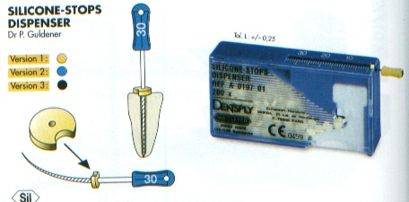

When placing the stop on the instrument, it’s important to avoid angulation which may measure different lengths as the file is rotated. The test handle is an adjustable handle that can be moved on the instrument shaft and locked at a specific length. The assembly consists of a file shaft placed in a handle and nut. Once the correct length is set, the bulky handle provides a mechanical stop that prevents the instrument from extending beyond the measured length. For this reason, the test handle is useful to prevent unintentional instrumentation through the apical foramen.

- Burs:-
Several types of bur will be required to accomplish good access preparation.
  - Round bur: - round burs, normal and extra-long, size 2, 4, and 6, are used to lift the roof off the pulp chamber and eliminate over-hanging dentin. The longer and smaller sizes can be used to find calcified canals.
  - Safe-ended burs:- A safe-ended diamond or tungsten-carbide bur, the Endo-Z bur, both with a non-cutting tip, is used to taper & smooth the access cavity preparation. The non-cutting tip prevents gouging on the floor of the pulp chamber, where important landmarks could be lost in pinpointing the location of root canals.
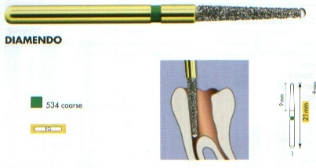
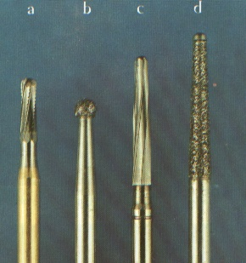

- Hand Spreader:-
Manufactured from stainless steel, land spreaders are designed to facilitate the placement of accessory gutta-percha points around a well-fitting master gutta-percha point during the lateral condensation method. Their diameter & shape are not standardized making it difficult to match spreaders with accessory gutta-percha points.

- Finger spreaders:-
These instruments are color-coded to match either standardized or accessory gutta-percha points. Their short length affords a high degree of tactile sense & allows them to rotate freely around their axis, thus freeing the instrument for easy removal.
The depth of spreader penetration is important for the quality of the find apical seal; spreaders should be capable of reaching to within 1-2 mm of the apical stop alongside its master gutta-percha point.

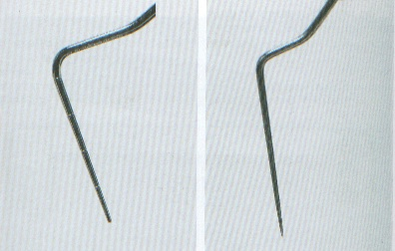
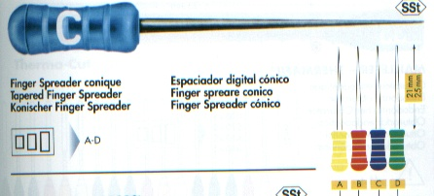
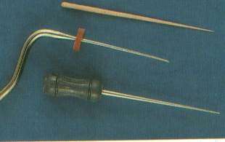

EndodonticPluggers:-
Endodontic pluggers consist of long-handled instruments which are of larger diameter than spreaders & have a blunt end; they are used to pack thermally softened gutta-percha into the root canal. The different-diameter pluggers have reference lines on the tips to allow the assessment of plugger depth. It’s very important to realize when the plugger is engaging a cushion of softened gutta-percha, rather than the resistance of the canal wall. These pluggers may also be used to pack calcium hydroxide into root canals.
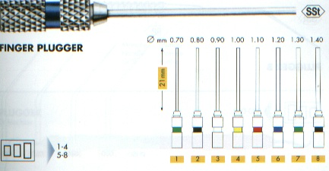

Thank You



