Retroviridae &
AIDS
Retroviruses have many subfamilies in three basic groups.
- Oncoretroviruses (cancer-causing retroviruses) include human T-lymphotropic virus (HTLV) causing a type of leukemia in humans
- Lentiviruses (slow viruses) include HIV-1 and HIV-2, the cause of acquired immune deficiency syndrome (AIDS) in humans.
- Spumaviruses (foamy viruses) are benign and not linked to any disease in humans or animals
Human Immunodeficiency Virus: Human immunodeficiency virus (HIV) ¹ is the cause of acquired immunodeficiency syndrome (AIDS).
Both HIV-1 and HIV-2 cause AIDS, but HIV-1 is found worldwide, whereas HIV-2 is found primarily in West Africa. HIV is one of the two important human T-cell lymphotropic retroviruses (human T-cell leukemia virus is the other). HIV preferentially infects and kills helper (CD4) T lymphocytes, resulting in the loss of cell-mediated immunity and a high probability that the host will develop opportunistic infections. Other cells (e.g., macrophages and monocytes) that have CD4 proteins on their surfaces can be infected also.
HIV belongs to the lentivirus subgroup of retroviruses, which cause "slow" infections with long incubation periods. HIV has a bar-shaped (type D) core surrounded by an envelope containing virus-specific glycoproteins (gp120 and gp41). The genome of HIV consists of two identical molecules of single-stranded, positive-polarity RNA and is said to be diploid. The HIV genome is the most complex of the known retroviruses. In addition to the three typical retroviral genes gag, pol, and env, which encode the structural proteins, the genome RNA has six regulatory genes (Table –1). Two of these regulatory genes, tat and rev, are required for replication, and the other four, nef, vif, vpr, and vpu, are not required for replication and are termed "accessory" genes.

Table –1 Genes and Proteins of Human Immunodeficiency Virus

Gene | Proteins Encoded by Gene | Function of Proteins
I. Structural genes found in all retroviruses
gag | p24, p7 | Nucleocapsid
 | p17 | Matrix
pol | Reverse transcriptase | Transcribes RNA genome into DNA
 | Protease | Cleaves precursor polypeptides
 | Integrase | Integrates viral DNA into host cell DNA
env | Gp120 | Attachment to CD4 protein
 | Gp41 | Fusion with host cell
II. Regulatory genes found in human immunodeficiency virus that are required for replication
tat | Tat | Activation of transcription of viral genes
rev | Rev | Transport of late mRNAs from nucleus to cytoplasm
III. Regulatory genes found in human immunodeficiency virus that are not required for replication (accessory genes)
nef | Nef | Decreases CD4 proteins and class I MHC proteins on surface of infected cells; induces death of uninfected cytotoxic T cells; important for pathogenesis by SIV
vif | Vif | Enhances infectivity by inhibiting the action of APOBEC3G (an enzyme that causes hypermutation in retroviral DNA)
vpr | Vpr | Transports viral core from cytoplasm into nucleus in nondividing cells
Vpu | Vpu | Enhances virion release from cell

The gag gene encodes the internal "core" proteins, the most important of which is p24, an antigen used in serologic tests. The pol gene encodes several proteins, including the virion "reverse transcriptase," which synthesizes DNA by using the genome RNA as a template, an integrase that integrates the viral DNA into the cellular DNA, and a protease that cleaves the various viral precursor proteins. The env gene encodes gp160, a precursor glycoprotein that is cleaved to form the two envelope (surface) glycoproteins, gp120 and gp41.
Three enzymes are located within the nucleocapsid of the virion: reverse transcriptase, integrase, and protease.
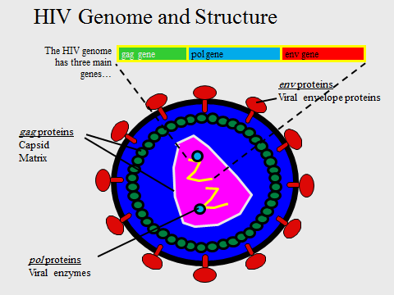

There are several important antigens of HIV:
- gp120 and gp41 are the type-specific envelope glycoproteins. gp120 protrudes from the surface and interacts with the CD4 receptor on the cell surface. gp41 is embedded in the envelope and mediates the fusion of the viral envelope with the cell membrane at the time of infection. Antibody against gp120 neutralizes the infectivity of HIV, but the rapid appearance of gp120 variants will make production of an effective vaccine difficult.
- The group-specific antigen, p24, is located in the core and is not known to vary. Antibodies against p24 do not neutralize HIV infectivity but serve as important serologic markers of infection.
Summary of Replicative Cycle
In general, the replication of HIV follows the typical retroviral cycle .The initial step in the entry of HIV into the cell is the binding of the virion gp120 envelope protein to the CD4 protein on the cell surface. The virion gp120 protein then interacts with a second protein on the cell surface, one of the chemokine receptors. Chemokine receptors, such as CXCR4 and CCR5 proteins, are required for the entry of HIV into CD4-positive cells. The T cell–tropic strains of HIV bind to CXCR4, whereas the macrophage-tropic strains bind to CCR5.Next, the virion gp41 protein mediates fusion of the viral envelope with the cell membrane, and the virion core containing the nucleocapsid, RNA genome, and reverse transcriptase enters the cytoplasm.
In the cytoplasm, reverse transcriptase transcribes the genome RNA into double-stranded DNA, which ``migrates to the nucleus where it integrates into the host cell DNA. The viral DNA can integrate at different sites in the host cell DNA, and multiple copies of viral DNA can integrate. Integration is mediated by a virus-encoded endonuclease (integrase). Viral mRNA is transcribed from the proviral DNA by host cell RNA polymerase and translated into several large polyproteins. The Gag and Pol polyproteins are cleaved by the viral-encoded protease, whereas the Env polyprotein is cleaved by a cellular protease.
The Gag polyprotein is cleaved to form the main core protein (p24), the matrix protein (p17), and several smaller proteins. The Pol polyprotein is cleaved to form the reverse transcriptase, integrase, and protease. The immature virion containing the precursor polyproteins forms in the cytoplasm, and cleavage by the viral protease occurs as the immature virion buds from the cell membrane. It is this cleavage process that results in the mature, infectious virion.
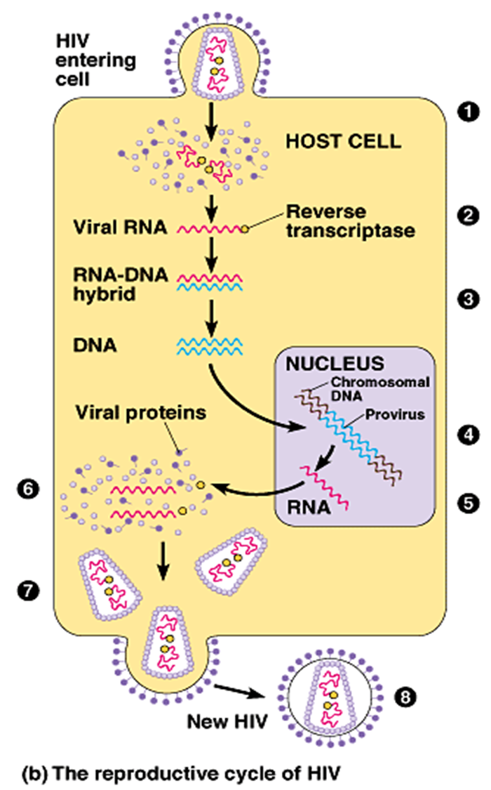

Transmission & Epidemiology
Transmission of HIV occurs primarily by sexual contact and by transfer of infected blood. Perinatal transmission from infected mother to neonate also occurs, either across the placenta, at birth, or via breast milk. Infection occurs by the transfer of either HIV-infected cells or free HIV (i.e., HIV that is not cell-associated). Although small amounts of virus have been found in other fluids, e.g., saliva and tears, there is no evidence that they play a role in infection. In general, transmission of HIV follows the pattern of hepatitis B virus, except that HIV infection is much less efficiently transferred, i.e., the dose of HIV required to cause infection is much higher than that of HBV. People with sexually transmitted diseases, especially those with ulcerative lesions such as syphilis, chancroid, and herpes genitalis, have a significantly higher risk of both transmitting and acquiring HIV. Uncircumcised males have a higher risk of acquiring HIV than do circumcised males.
Transmission of HIV via blood transfusion has been greatly reduced by screening donated blood for the presence of antibody to HIV. However, there is a "window" period early in infection when the blood of an infected person can contain HIV but antibodies are not detectable. Blood banks now test for the presence of p24 antigen in an effort to detect blood that contains HIV.
Pathogenesis & Immunity
HIV infects helper T cells (CD4-positive cells) and kills them, resulting in suppression of cell-mediated immunity. This predisposes the host to various opportunistic infections and certain cancers such as Kaposi's sarcoma and lymphoma. However, HIV does not directly cause these tumors because HIV genes are not found in these cancer cells. The initial infection of the genital tract occurs in dendritic cells that line the mucosa (Langerhans' cells), after which the local CD4-positive helper T cells become infected. HIV is first found in the blood 4 to 11 days after infection.
HIV infection also targets a subset of CD4-positive cells called Th17 cells. These cells are an important mediator of mucosal immunity, especially in the GI tract. Th17 cells produce IL-17, which attracts neutrophils to the site of bacterial infection. The loss of Th17 cells predisposes HIV-infected individuals to blood stream infections by bacteria in the normal flora of the colon, such as E. coli.
HIV also infects brain monocytes and macrophages, producing multinucleated giant cells and significant central nervous system symptoms. The death of HIV-infected cells is result of immunologic attack by cytotoxic CD8 lymphocytes.
Persistent noncytopathic infection of T lymphocytes also occurs. Persistently infected cells continue to produce HIV, which may help sustain the infection in vivo. Lymphoid tissue, e.g., lymph nodes, is the main site of ongoing HIV infection.
A person infected with HIV is considered to be infected for life. This seems likely to be the result of integration of viral DNA into the DNA of infected cells. Although the use of powerful antiviral drugs can significantly reduce the amount of HIV being produced, latent infection in CD4-positive cells and in immature thymocytes serve as a continuing source of virus.

The main immune response to HIV infection.
HIV has three main mechanisms by which it evades the immune system: (1) integration of viral DNA into host cell DNA, resulting in a persistent infection; (2) a high rate of mutation of the env gene; and (3) the production of the Tat and Nef proteins that downregulate class I MHC proteins required for cytotoxic T cells to recognize and kill HIV-infected cells. The ability of HIV to infect and kill CD4-positive helper T cells further enhances its capacity to avoid destruction by the immune system.
Clinical Findings
The clinical picture of HIV infection can be divided into three stages: an early, acute stage; middle, latent stage; and a late, immunodeficiency stage. In the acute stage, which usually begins 2 to 4 weeks after infection, a mononucleosis-like picture of fever, lethargy, sore throat, and generalized lymphadenopathy occurs. A maculopapular rash on the trunk, arms, and legs (but sparing the palms and soles) is also seen. Leukopenia occurs, but the number of CD4 cells is usually normal. A high-level viremia typically occurs, and the infection is readily transmissible during this acute stage. This acute stage typically resolves spontaneously in about 2 weeks.
Antibodies to HIV typically appear 10 to 14 days after infection, and most will have seroconverted by 3 to 4 weeks after infection. Note that the inability to detect antibodies prior to that time can result in "false-negative" serologic tests, i.e., the person is infected, but antibodies are not detectable at the time of the test. This has important implications because HIV can be transmitted to others during this period. If the antibody test is negative but HIV infection is still suspected, then a PCR-based assay for viral RNA in the plasma should be done.
After the initial viremia, a viral set point occurs, which can differ from one person to another. The set point represents the amount of virus produced, i.e., the viral load, and tends to remain "set," or constant, for years. The higher the set point at the end of the initial infection, the more likely the individual is to progress to symptomatic AIDS. It is estimated that an infected person can produce up to 10 billion new virions each day. This viral load can be estimated by using an assay for viral RNA in the patient's plasma. (The assay detects the RNA in free virions in the plasma, not cell-associated virions.)
In the middle stage, a long latent period, measured in years, usually ensues. In untreated patients, the latent period usually lasts for 7 to 11 years. The patient is asymptomatic during this period. Although the patient is asymptomatic and viremia is low or absent, a large amount of HIV is being produced by lymph node cells but remains sequestered within the lymph nodes. This indicates that during this period of clinical latency, the virus itself does not enter a latent state.
A syndrome called AIDS-related complex (ARC) can occur during the latent period. The most frequent manifestations are persistent fevers, fatigue, weight loss, and lymphadenopathy. ARC often progresses to AIDS.
The late stage of HIV infection is AIDS, manifested by a decline in the number of CD4 cells to below 400/µL and an increase in the frequency and severity of opportunistic infections. Table -2 describes some of the common opportunistic infections and their causative organism seen in HIV-infected patients during the late, immunocompromised stage of the infection.

Table –2 Common Opportunistic Infections in AIDS Patients

Site of Infection | Disease or Symptom | Causative Organism
Lung | 1. Pneumonia | Pneumocystis carinii, cytomegalovirus
 | 2. Tuberculosis | Mycobacterium tuberculosis
Mouth | 1. Thrush | Candida albicans
 | 2. Hairy leukoplakia | Epstein-Barr virus
 | 3. Ulcerations | Herpes simplex virus-1, Histoplasma capsulatum
Esophagus | 1. Thrush | Candida albicans
 | 2. Esophagitis | Cytomegalovirus, herpes simplex virus-1
Intestinal tract | Diarrhea | Salmonella sp., Shigella sp, cytomegalovirus, Cryptosporidium parvum, Giardia lamblia
Central nervous system | 1. Meningitis | Cryptococcus neoformans
 | 2. Brain abscess | Toxoplasma gondii
 | 3. Progressive multifocal leukoencephalopathy | JC virus
Eye | Retinitis | Cytomegalovirus
Skin | 1. Kaposi's sarcoma | Human herpesvirus 8
 | 2. Zoster | Varicella-zoster virus
 | 3. Subcutaneous nodules | Cryptococcus neoformans
Reticuloendothelial system | Lymphadenopathy or splenomegaly | Mycobacterium avium complex, Epstein-Barr virus

The two most characteristic manifestations of AIDS are Pneumocystis pneumonia and Kaposi's sarcoma. Many AIDS patients have severe neurologic problems, e.g., dementia and neuropathy, which can be caused by either HIV infection of the brain or by many of these opportunistic organisms.
Laboratory Diagnosis
The presumptive diagnosis of HIV infection is made by the detection of antibodies by ELISA. Because there are some false-positive results with this test, the definitive diagnosis is made by Western blot analysis.
HIV can be grown in culture from clinical specimens, but this procedure is available only at a few medical centers. The polymerase chain reaction (PCR) is a very sensitive and specific technique that can be used to detect HIV DNA within infected cells. Some individuals who do not have detectable antibodies have been shown by this test to be infected. As already mentioned, the amount of viral RNA in the plasma (i.e., the viral load) can also be determined using PCR-based assays.
During the first month after infection, antibody tests may be negative. These false-negative tests are due to insufficient antibody being made early in infection to be detected in the ELISA test. The average time for seroconversion is 10 to 14 days and most, but not all, will have seroconverted by 4 weeks.

Treatment
The treatment of HIV infection has resulted in a remarkable reduction in mortality and improvement in the quality of life of infected individuals. The specific goals of treatment are to restore immunologic function that reduces the incidence of both opportunistic infections and certain malignancies as well as to reduce viral load, which reduces the chance of transmission to others.
Treatment of HIV infection typically involves multiple antiretroviral drugs. The use of a single drug (monotherapy) for treatment is not done because of the high rate of mutation to drug resistance.
The choice of drugs is complex and depends on several factors, e.g., whether it is an initial infection or an established infection, the number of CD4 cells, the viral load, the resistance pattern of the virus, and whether the patient is pregnant or is coinfected with HBV or HCV.
In general, initial antiretroviral therapy consists of one of two regimens, each one of which consists of three drugs. One regimen has two nucleoside reverse transcriptase inhibitors (NRTI), such as lamivudine and zidovudine plus a protease inhibitor, such as fosamprenavir. The second regimen has the same two NRTI plus a nonnucleoside reverse transcriptase inhibitors (NNRTI), such as Nevirapine.
These combinations are known as HAART, which is an acronym for "highly active antiretroviral therapy." It is very effective in prolonging life, improving quality of life, and reducing viral load but does not cure the chronic HIV infection, i.e., replication of HIV within CD4-positive cells continues indefinitely. Discontinuation of HAART almost always results in viremia (a return of the viral load to its pretreatment set point) and a fall in the CD4 count.
Enfuvirtide (Fuzeon) is the first of a new class of anti-HIV drugs known as fusion inhibitors, i.e., they prevent the fusion of the viral envelope with the cell membrane. Enfuvirtide is a synthetic peptide that binds to gp41 on the viral envelope, thereby blocking the entry of HIV into the cell. It must be administered by injection and is quite expensive.
In 2007, the FDA approved the use of maraviroc—a drug that blocks the binding of the gp120 envelope protein of HIV to CCR-5, which is an important coreceptor on the cell surface. It should be used in combination with other antiretroviral drugs in patients infected with CCR-5 tropic strains of HIV.
Also, in 2007, the FDA approved the use of raltegravir (Isentress), the first drug to inhibit the HIV-encoded integrase. It is recommended for use in patients who have been treated with other antiretroviral drugs but continue to produce significant levels of HIV.
"Immune reconstitution syndrome" may occur in HIV-infected patients who are treated with a HAART regimen and who are coinfected with other microbes such as hepatitis B virus, hepatitis C virus, Mycobacterium avium complex, Cryptococcus neoformans, and Toxoplasma gondii. In this syndrome, an exacerbation of clinical symptoms occurs because the antiretroviral drugs enhance the ability to mount an inflammatory response. HIV-infected patients with a low CD4 count have a reduced capacity to produce inflammation, but HAART restores the inflammatory response and, as a result, symptoms become more pronounced. To avoid immune reconstitution syndrome, the coinfection should be treated prior to instituting HAART whenever possible.

Prevention
No vaccine is available. Prevention consists of taking measures to avoid exposure to the virus, e.g., using condoms, not sharing needles, and discarding donated blood that is contaminated with HIV. Postexposure prophylaxis, such as that given after a needle-stick injury or a high-risk nonoccupational exposure, consists of two drugs, e.g., lamivudine and zidovudine for low-risk exposures and the same two drugs plus lopinavir/ritonavir for high-risk exposures. Two steps can be taken to reduce the number of cases of HIV infection in children: ZDV or nevirapine should be given perinatally to HIV-infected mothers and neonates, and HIV-infected mothers should not breast feed. In addition, the risk of neonatal HIV infection is lower if delivery is accomplished by cesarean section rather than by vaginal delivery. Circumcision reduces HIV infection.
Several drugs are commonly taken by patients in the advanced stages of AIDS to prevent certain opportunistic infections. Some examples are trimethoprim-sulfamethoxazole to prevent Pneumocystis pneumonia, fluconazole to prevent recurrences of cryptococcal meningitis, ganciclovir to prevent recurrences of retinitis caused by cytomegalovirus, and oral preparations of antifungal drugs, such as clotrimazole, to prevent thrush caused by Candida albicans.
Why is it difficult to develop a vaccine for HIV and AIDS?
There are many reasons for this, including:
- Nobody has ever recovered from HIV infection, so there is no natural mechanism to imitate
- HIV destroys the immune system cells that are meant to fight against it
- Soon after infection, HIV inserts its genetic material into human cells, where it remains hidden from the immune system .
- HIV occurs in several subtypes, each of which is very different from the others
- Even within each subtype, HIV is highly variable and constantly changing
- There are no good animal models to use in experiments although the use of non human primate (NHP) models could become a more significant model for HIV vaccine design and testing in the future.
Human T-Cell Lymphotropic Virus
Human T-cell lymphotropic virus-1 (HTLV) causes two distinctly different diseases: a cancer called adult T-cell leukemia/lymphoma and a neurologic disease called HTLV-associated myelopathy (also known as tropical spastic paraparesis or chronic progressive myelopathy). HTLV-2 also appears to cause these diseases, but the association is less clearly documented. (All information in this section refers to HTLV-1 unless otherwise stated.)
HTLV and HIV are the two medically important members of the retrovirus family. Both are enveloped viruses with reverse transcriptase in the virion and two copies of a single-stranded, positive-polarity RNA genome. However, HTLV does not kill T cells, whereas HIV does. In fact, HTLV does just the opposite; it causes malignant transformation that "immortalizes" the infected T cells and allows them to proliferate in an uncontrolled manner.

