Dr.maryam VIROLOGY lec.3
Antiviral Drugs
Compared with the number of drugs available to treat bacterial infections, the number of antiviral drugs is very small. The major reason for this difference is the difficulty in obtaining selective toxicity against viruses; their replication is intimately involved with the normal synthetic processes of the cell. Despite the difficulty, several virus-specific replication steps have been identified that are the site of action of effective antiviral drugs (Table –1).
Molecular virology studies are succeeding in identifying virus-speciﬁc functions that can serve as targets for antiviral therapy. Stages during viral infections that could be targeted include attachment of virus to host cells, uncoating of the viral genome, viral nucleic acid synthesis, translation of viral proteins, and assembly and release of progeny virus particles. It has been very diﬃcult to develop antivirals that can distinguish viral from host replicative processes, but there have been successful drugs developed, particularly for chronic infections (eg, HIV, hepatitis C).
Table –1 Potential Sites for Antiviral Chemotherapy

Site of Action | Effective Drugs
1.Early events (entry or uncoating of the virus) | Amantadine, rimantadine, enfuvirtide, maraviroc
2.Nucleic acid synthesis by viral DNA and RNA polymerases | Acyclovir, ganciclovir, cidofovir,, foscarnet, zidovudine (azidothymidine), didanosine (dideoxyinosine), lamivudine (3TC),, nevirapine,, ribavirin
3.Integrase that integrates HIV DNA into cellular DNA | Raltegravir
4.Cleavage of precursor polypeptides | Saquinavir, indinavir, ritonavir, nelfinavir, amprenavir, atazanavir, darunavir, lopinavir, tipranavir
5.Protein synthesis directed by viral mRNA | Interferon, fomivirsen, methisazone
6.Action of viral regulatory proteins | None
7.Assembly of the virus, including the matrix protein | None
8.Release of the virus | Zanamivir, oseltamivir

- Another limitation of antiviral drugs is that they are relatively ineffective because many cycles of viral replication occur during the incubation period when the patient is well. By the time the patient has a recognizable systemic viral disease, the virus has spread throughout the body and it is too late to interdict it. Furthermore, some viruses, e.g., herpesviruses, become latent within cells, and no current antiviral drug can eradicate them.
- Another potential limiting factor is the emergence of drug-resistant viral mutants. At present, this is not of major clinical significance. Mutants of herpesvirus resistant to acyclovir have been recovered from patients, but they do not interfere with recovery. Selective toxicity is the ability of a drug to inhibit viral replication without significantly damaging the host cell. It is difficult to achieve a high degree of selective toxicity with antiviral drugs because the virus can only replicate within cells and uses many cellular functions during replication.
Reasons for continuing search for anti-virals versus vaccines:
1. Antivirals can be used to treat established infections when vaccines would not be eﬀective
2.Rapid mutation (retroviruses)
3. constantly changing virus (influenza)
4.New and emerging diseases - no vaccine available
5.Vaccine development takes many years
6. Antivirals are needed to reduce morbidity and economic loss caused by viral infections and to treat increasing numbers of immunosuppressed patients who are at increased risk of disease.
1.Inhibitors of Early Events
- Amantadine inhibits the uncoating of influenza A virus by blocking "ion channel" activity of the viral matrix protein (M2 protein). The drug has no effect on influenza B or C viruses.
- Maraviroc inhibits the binding of the gp120 of HIV to the CCR-5 receptor on the cell.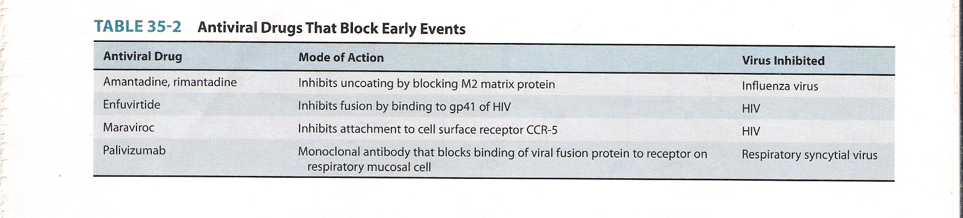

2.Inhibitor of nucleic acid synthesis by viral DNA and RNA polymerases
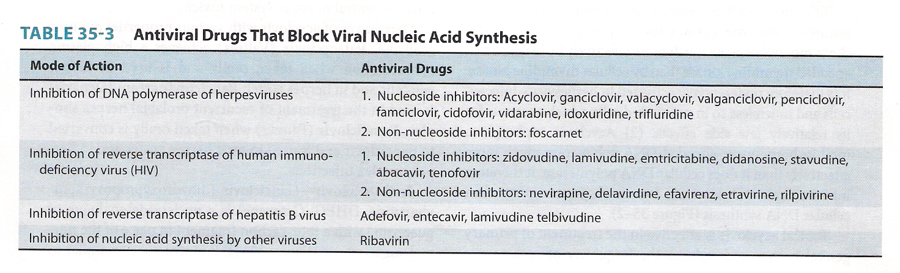

A.Inhibitors of Herpesviruses:
Nucleoside Inhibitors
- Acyclovir inhibits the DNA polymerase of herpes simplex virus (HSV) type-1, HSV-2, and varicella-zoster virus (VZV). Acyclovir must be activated within the infected cell by a virus-encoded thymidine kinase that phosphorylates the drug. Acyclovir is not phosphorylated in uninfected cells and cellular DNA synthesis is not inhibited. Selective toxicity is high and there are very few adverse effects.
- Acyclovir is a chain-terminating drug.
- Acyclovir inhibits viral replication but has no effect on the latency of HSV-1, HSV-2, and VZV.
- Ganciclovir action is very similar to that of acyclovir, but it is effective against cytomegalovirus (CMV), whereas acyclovir is not.

Acyclovir:
- Close to a perfect antiviral drug (specific, nontoxic).
- Highly effective against herpes simplex virus (HSV), less so against varicella-zoster virus (VZV).
- Higly selective and extremely safe.
- Acyclic guanine derivative that inhibits viral DNA synthesis.
Acyclovir very effective against:
  - Herpes simplex keratitis (topical)
  - Latent HSV (iv)
  - Fever blisters – Herpes labialis (topical)
  - Genital herpes (topical, oral, iv)

Nonnucleoside Inhibitors
- Foscarnet inhibits the DNA polymerase of all herpesviruses but is clinically useful against HSV and CMV. It also inhibits the DNA polymerase of the retrovirus HIV. It is a pyrophosphate analogue that inhibits the cleavage of pyrophosphate from the nucleoside triphosphate that has been added to the growing DNA chain.

B.Inhibitors of Retroviruses:
Nucleoside Inhibitors
- Azidothymidine (zidovudine, AZT) inhibits the DNA polymerase (reverse transcriptase) of HIV. It is a chain-terminating drug because it has an azide group in place of the hydroxyl group in the 3' position. Unlike acyclovir, it does not require a viral-encoded kinase to be phosphorylated. Cellular kinases phosphorylate the drug, so it is active in uninfected cells and significant adverse effects can occur.
- Other drugs that have a similar mode of action include didanosine, zalcitabine, stavudine, lamivudine, abacavir, and tenofovir.
Nonnucleoside Inhibitors
- Nevirapine, delavirdine, and efavirenz inhibit the DNA polymerase (reverse transcriptase) of HIV but are not nucleoside analogues.
- The nonnucleoside reverse transcriptase inhibitors (NNRTI) act by binding near the active site of the reverse transcriptase and inducing a conformational change that inhibits the synthesis of viral DNA. NNRTIs should not be used as monotherapy because resistant mutants emerge rapidly. Strains of HIV resistant to one NNRTI are usually resistant to others as well. NNRTIs are typically used in combination with one or two nucleoside analogues.
C. Inhibitors of Hepatitis B Virus
- Adofovir, entecavir, lamivudine, and telbivudine inhibit the DNA polymerase of HBV. These drugs are useful in the treatment of chronic HBV infection.
D.Inhibitors of Other Viruses
- Ribavirin is a guanosine analogue that can inhibit nucleic acid synthesis of several DNA and RNA viruses.
3.Integrase Inhibitors
- Raltegravir inhibits the integrase encoded by HIV, which blocks the integration of HIV DNA into host cell DNA.
4.Protease Inhibitors
- Indinavir and other similar drugs inhibit the virus-encoded protease of HIV. Inhibition of the protease prevents cleavage of precursor polypeptides, which prevents formation of the structural proteins of the virus. Synthesis of infectious virus is inhibited, but the viral DNA integrated into the host cell DNA is unaffected.
- Boceprevir & Telaprevir inhibite the protease of hepatitis C virus

5.Inhibitors of Viral Protein Synthesis
- Interferons inhibit virus replication by blocking the production of viral proteins, primarily by degrading viral mRNA. They induce the synthesis of a ribonuclease that specifically cleaves viral mRNA but not cell mRNA.
- Fomivirsen is an antisense DNA that binds to the mRNA of CMV, which prevents the mRNA from being translated into viral proteins.
6.Inhibitors of Release of Virus
- Zanamir and oseltamivir inhibit the neuraminidase of both influenza A and B viruses. This inhibits the release of progeny virus, which reduces spread of virus to neighboring cells.
- Mechanism: blocking of the active site of neuraminidase; prevents removal of sialic acid residues and results in clumping of viral progeny
- Effective when flu symptoms are < 2 days old.
- Inhibitors reduce disease syndrome by 1 day.
- May decrease influenza secondary complications
- Antiviral resistance can occur, but much less frequently than with the ion channel blockers amantadine or rimantadine
- Neuraminidase inhibitors appear to have similar efficacy to the amantidine & rimantidine ion channel blockers for prevention & treatment of influenza
- Neuraminidase inhibitors have Less Central Nervous System side effects, but more Gastro-Intestinal effects
- Neuraminidase Inhibitors are more expensive, but there is less risk of inducing virus resistance.

