Carbohydrate Metabolism (12)
Dr. Walaa AL - Jedda ( 2022-2023 )

Normal blood sugar level
Fasting blood glucose: (70-100) mg/dL or (3.8 – 5.5) mmol/L
While, after ingestion of carbohydrate meal (100 – 140) mg/dL or
(5.5 – 7.7) mmol/L.

Common problems associated with carbohydrate metabolism:

A-Hypoglycemia:
Low blood sugar is caused by the inability of the liver to maintain blood glucose levels. It can result from excessive insulin, excessive cellular uptake of glucose, or an impairment of glycogenolysis or gluconeogenesis.

Hypoglycemia is characterized by:
1- Central nervous symptoms, including confusion, aberrant behavior, or coma.

2- Blood glucose level equal or less than 40 mg/dL or 2.2 mmol/L.

3- Symptoms being resolved within minutes following the administration of glucose.
Hypoglycemia may be divided according to its causes to:
1-Insulin–induced hypoglycemia: Hypoglycemia occurs frequently in patients with diabetes receiving insulin treatment, or overdosage of insulin treatment of D.M.

2- Postprandial hypoglycemia: This is the second most common forms of hypoglycemia. It is caused by increase insulin release following a meal, causing transit hypoglycemia. The plasma glucose level returns to normal even if the patient is not fed.
The only treatment is that the patient eats frequently small meals rather than the usual three large meals.

3- Fasting hypoglycemia: Fasting hypoglycemia may result from a reduction in the rate of glucose production by the liver. Thus, low blood glucose levels are often seen in patients with hepatocellualr damage or adrenal insufficiency.
Alternately, fasting hypoglycemia may be due to elevated insulin resulting from a pancreatic β cell tumor.

4- Hypoglycemia and alcohol ingestion: Excessive alcohol ingestion also can cause hypoglycemia. Metabolism of alcohol increases levels of NADH in the liver, which inhibit gluconeogenesis.
Alcohol consumption can also increase the risk of hypoglycemia in patients using insulin.

5-Insulin-secreting tumor (Insulinoma) of pancreas produces a severe hypoglycaemia in which blood glucose is very low or may be almost completely absent. It is extremely rare.

Hypoglycemia may be due to severe liver disease, severe exercise, some types of steatorrhoea, and, in childhood an idiopathic hypoglycaemia; due to sensitivity to amino acid leucine has been recognized (Leucine-sensitive hypoglycaemia)
Hypoglycemia is a medical emergency because the central nervous system (CNS) has an absolute requirement for continuous supply of blood glucose to serve as fuel for energy metabolism.
Transient hypoglycemia can cause cerebral dysfunction, whereas severe, prolonged hypoglycemia causes brain death.
It is, therefore, not surprising that the body has multiple overlapping mechanisms to prevent or correct hypoglycemia. The most important hormone changes in hypoglycemia are elevated glucagon and epinephrine, combined with the diminished release of insulin.
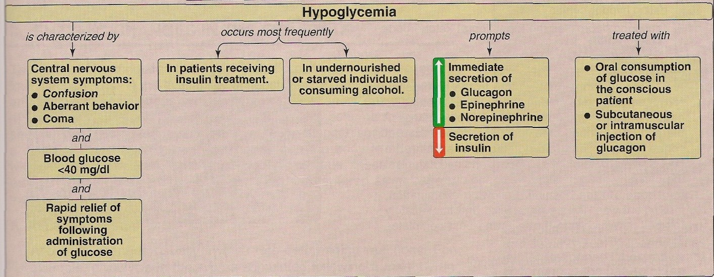

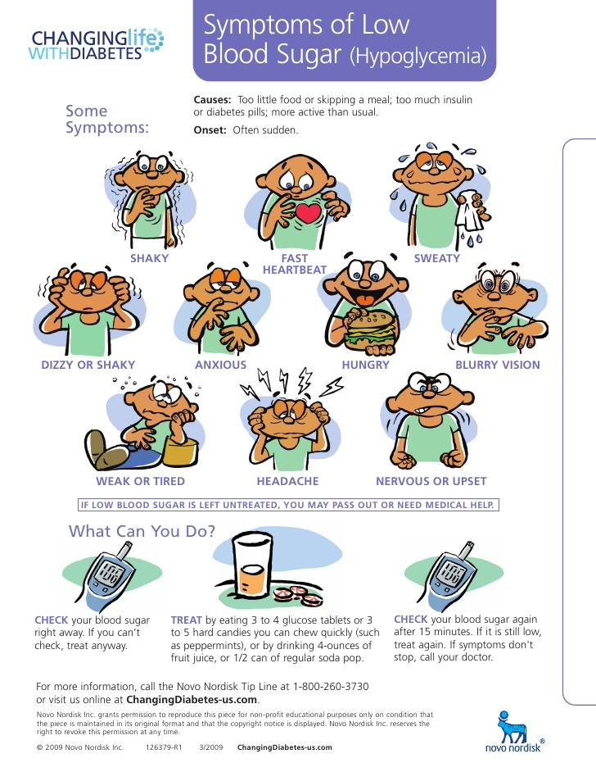
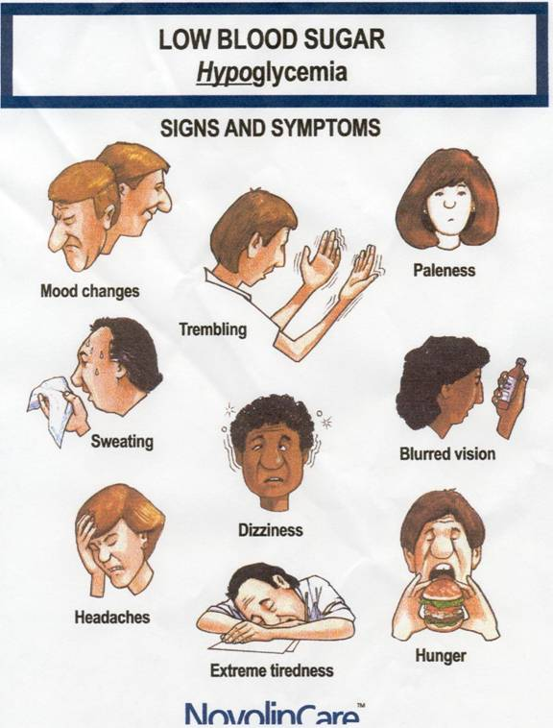

B- Hyperglycemia:
High blood glucose levels may be due to:
1- Diabetes mellitus or impaired regulation.
2- Intravenous infusion of glucose – containing fluids.
3-Sever stress (temporary effect) such as cerebrovascular accidents or myocardial infarction.
4- Hyperactivity of the thyroids, pituitary, and adrenal glands.
5- In diffuse diseases of the pancreas e.g. in pancreatitis and carcinoma of pancreas.
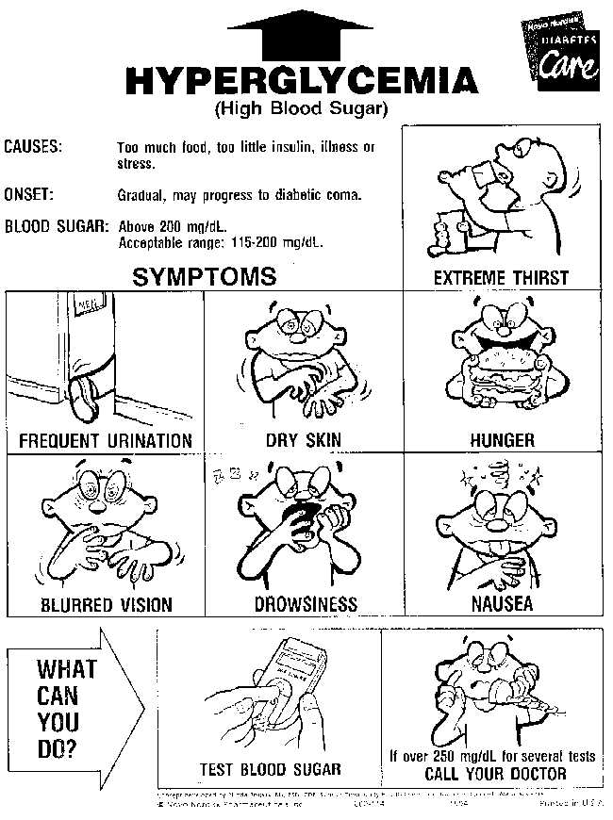
Diabetes Mellitus
Diabetes mellitus is not one disease, but rather is a heterogeneous group of syndromes characterized by an elevation of fasting blood glucose more than or equal (7.0 mmol/L) (126mg/dl) and or more than or equal to (11.1 mmol/L or 200 mg/dl)
2 hours after the oral ingestion of the equivalent of 75 gm of anhydrous glucose, also random plasma glucose concentration more than or equal (11.1 mmol/L), this glucose elevation is caused by a relative or absolute deficiency in insulin.

Diabetes mellitus is the leading cause of adult blindness and amputation, and a major cause of renal failure, heart attacks, and strokes.

Most cases of diabetes mellitus can be separated into two groups:
1- Type1 (Previously called insulin dependent diabetes mellitus IDDM).
2- Type2 (Previously called non-insulin dependent diabetes mellitus NIDDM).
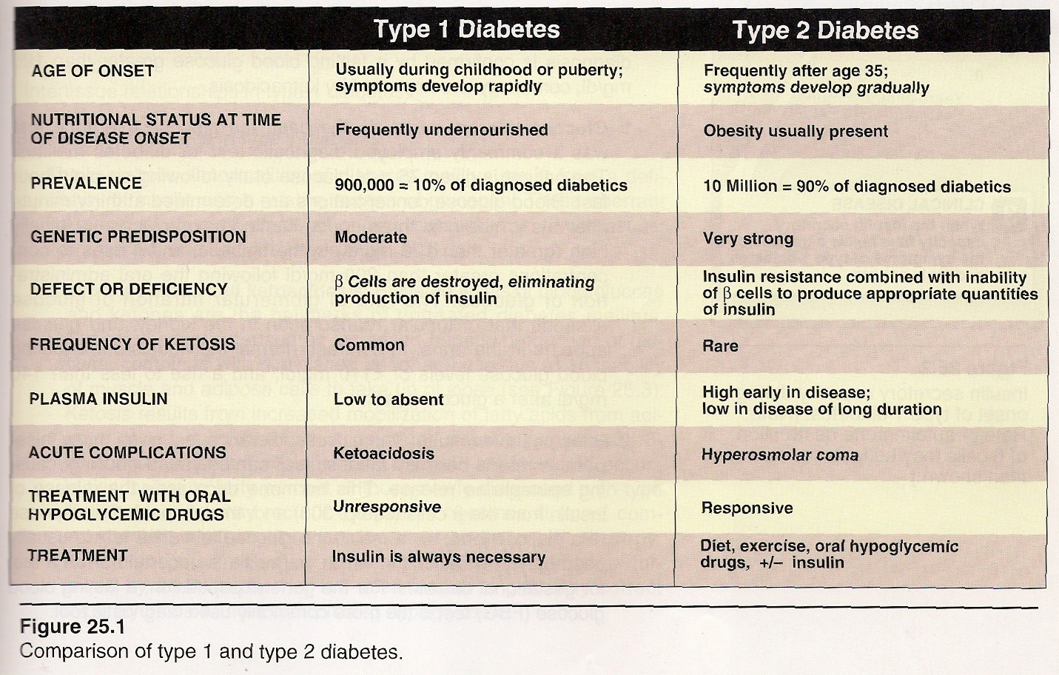
1.

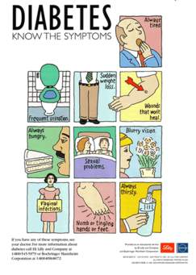

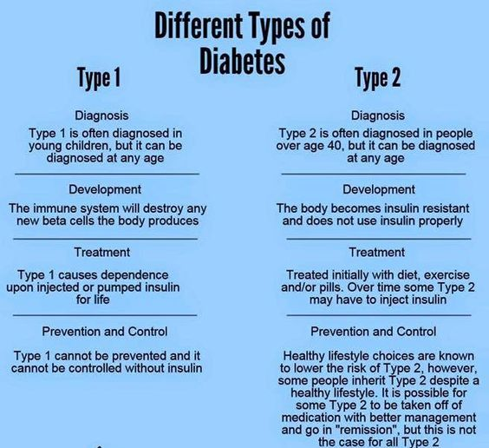
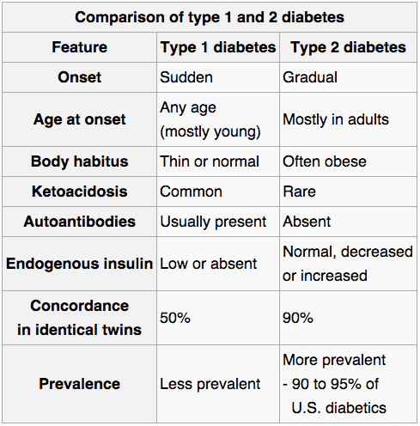

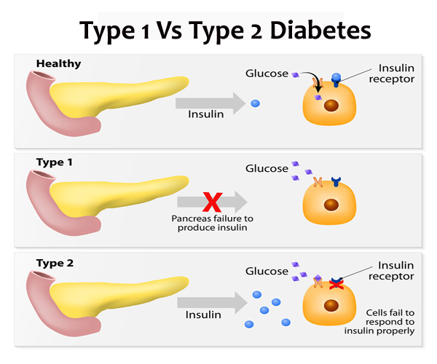
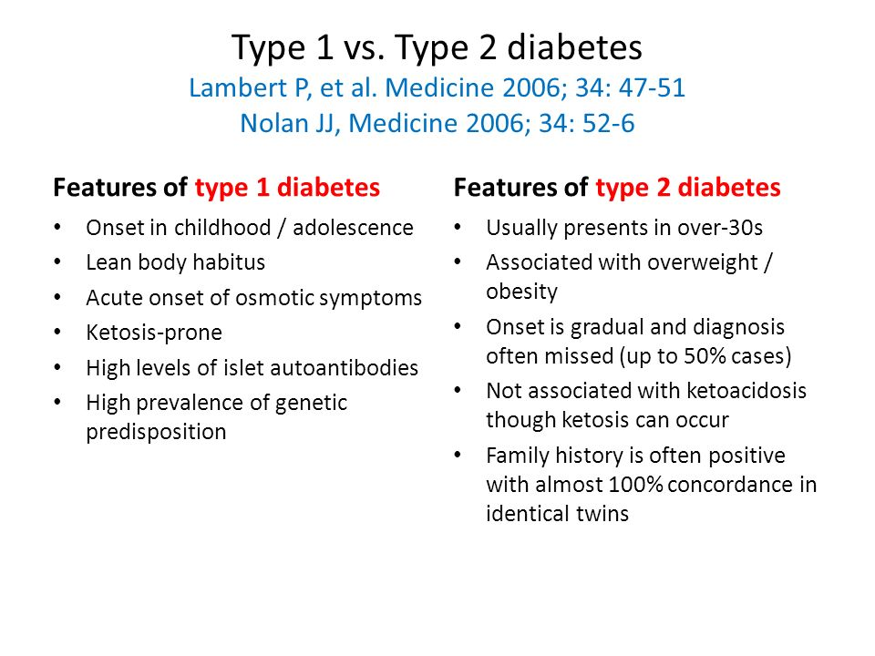
Type 1 Diabetes:
The disease is characterized by an absolute deficiency of insulin caused by autoimmune attack on the β cells of the pancreas. Symptoms appear when eighty to ninety percent of the β cells have been destroyed.
At this point, the pancreas fails to respond adequately to ingestion of glucose, and insulin therapy is required to restore metabolic control and prevent life-threatening ketoacidosis. The onset of type1 diabetes is typically during childhood or puberty and symptoms develop rapidly.

Patients with type 1 recognized by polyuria (frequent urination), polydipsia (excessive thirst), and polyphagia (excessive hunger), often triggered by stress or an illness.
These symptoms are usually accompanied by fatigue, weight loss, and weakness. The diagnosis is confirmed by fasting blood glucose greater than 126 mg/dl, commonly accompanied by ketoacidosis.

Metabolic changes in type 1 diabetes:
The metabolic abnormalities of diabetes mellitus result from a deficiency of insulin and a relative excess of glucagon. These aberrant hormonal levels most profoundly affect metabolism in three tissues: liver, muscle, and adipose tissue. (Fig.2)
- Hyperglycemia and ketoacidosis: Hyperglycemia is caused by increased hepatic production of glucose, combined with diminished peripheral use due to an inability of muscle and adipose cells to take up glucose.
Ketosis results from increased mobilization of fatty acids from adipose tissue, combined with accelerated hepatic synthesis of ketone bodies (3-hydroxybutyrate and acetoacetate). Ketoacidosis is treated by replacing fluid and electrolytes, followed by administration of low –dose insulin to gradually correct hyperglycemia without precipitating hypoglycemia.
2- Hypertriacylglycerolemia: Not all the fatty acids flooding the liver are oxidized or formed ketone bodies, the excess F.A. are converted to triacylglycerol, which is packaged and secreted in VLDL.
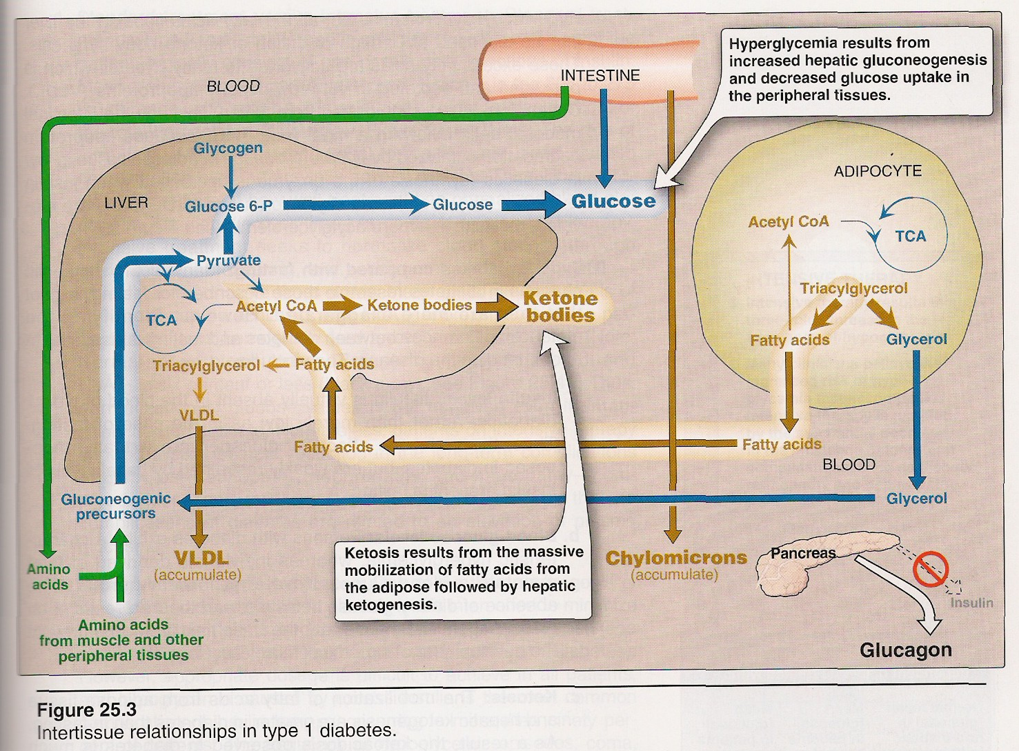
Chylomicrons which synthesized from dietary lipids by the intestinal mucosal cells following a meal. Because lipoprotein degradation catalyzed by lipoprotein lipase in adipose tissue is low in diabetics (synthesis of the enzyme is decreased when insulin levels are low), the plasma chylomicron and VLDL levels are elevated, resulting in hypertriacylglycerolemia.
2.

Type 2 Diabetes:
Type 2 diabetes is the most common form of the disease, (about 90% of all diabetes mellitus cases).
Typically, type 2 diabetes develops gradually without obvious symptoms. The disease is often detected by routine screening tests.

Many individuals with type 2 diabetes have symptoms of polyuria and polydipsia and, polyphagia may be present, but in less common.
Patients with type 2 diabetes have a combination of insulin resistance and dysfunctional β cells, but do not require insulin to sustain life, although insulin may be required to control hyperglycemia in some patients.

Patients are much less likely to develop ketoacidosis than those with type 1 diabetes. Onset is most usual during adult life; there is a familial tendency and an association with obesity.

Insulin resistance: insulin resistance is the decreased ability of target tissues (such as liver, adipose, and muscle), to respond properly to normal circulating concentrations of insulin. For example, insulin resistance is characterized by uncontrolled hepatic glucose production, and decreased glucose uptake by muscle and adipose tissue.
Obesity is the most common cause of insulin resistance, also persons who are physically inactive, or pregnant women, these patients are unable to sufficiently compensate for insulin resistance with increased insulin release.

Metabolic changes in type 2 diabetes:
The metabolic abnormalities of type 2 diabetes mellitus are the result of insulin resistance expressed primarily in liver, muscle and adipose tissue.
1- Hyperglycemia: Hyperglycemia is caused by increased hepatic production of glucose, combined with diminished peripheral use.
Ketosis is usually minimal or absent in type 2 patients because the presence of insulin – even in the presence of insulin resistance – diminishes hepatic ketogenesis.
2- Hypertriacylglycerolemia: in diabetics, the plasma chylomicron and VLDL levels are elevated, resulting in Hypertriacylglycerolemia due to the low levels of lipoprotein lipase enzymes. (Fig.3).
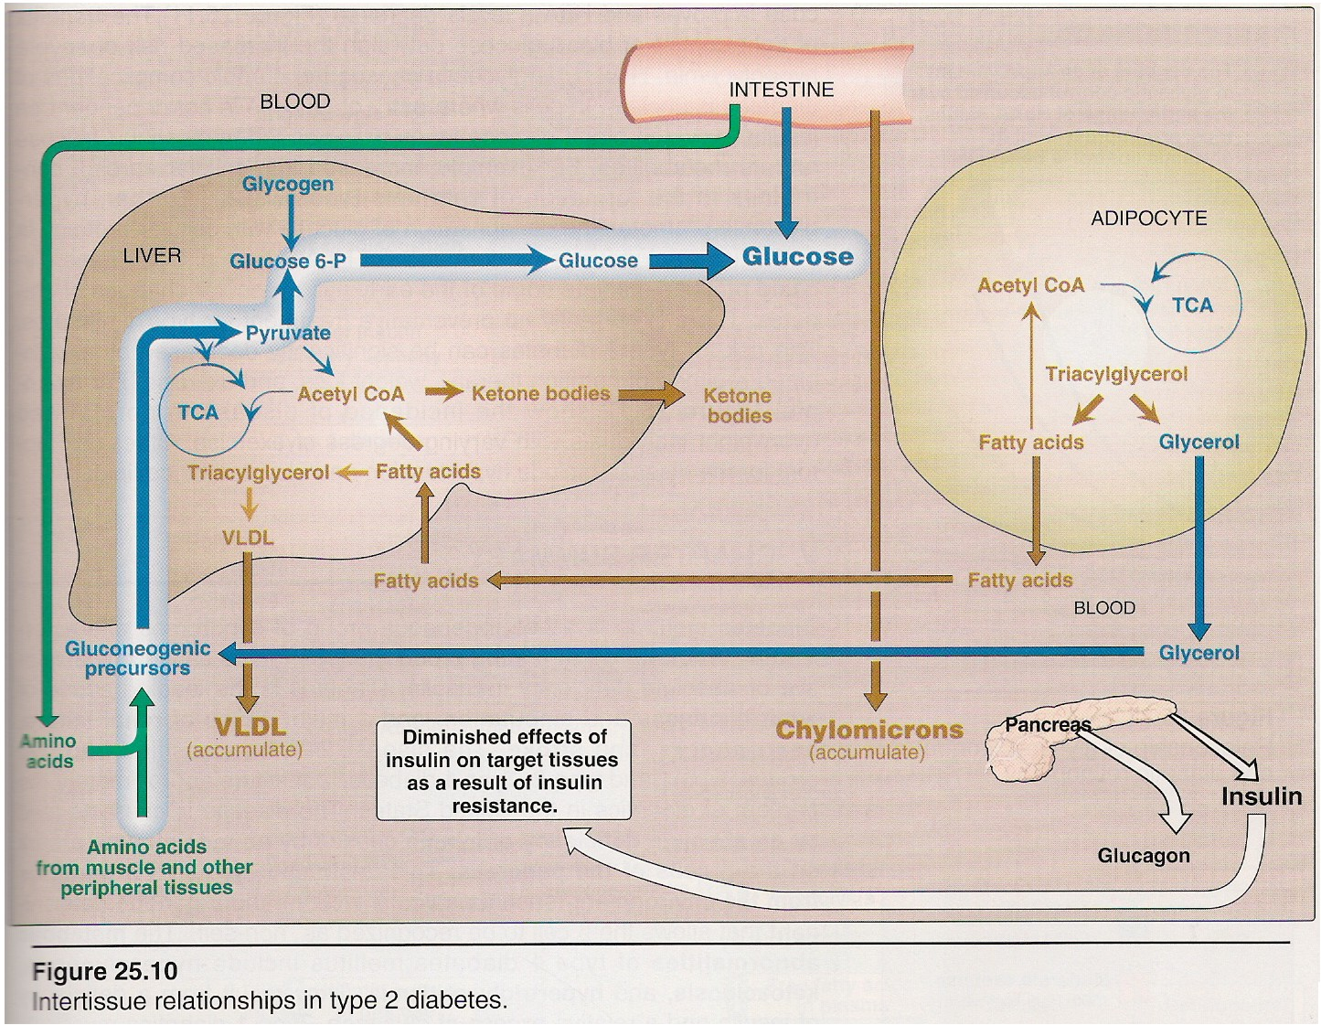
3.

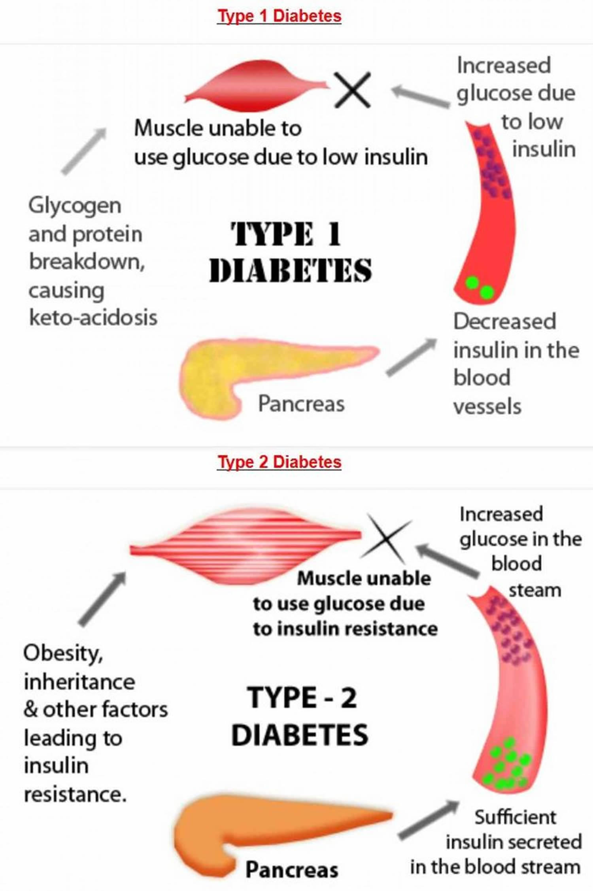

Treatment of type 2 diabetes:
The goal in treating type 2 diabetes is to maintain blood glucose concentrations within normal limits, and to prevent the development of long-term complications. Weight reduction, exercises, and dietary modifications often correct the hyperglycemia of type 2 diabetes. Hypoglycemic agents or insulin therapy may be required to achieve satisfactory plasma glucose levels.

Complication of Diabetes Mellitus
1-Immediate: Diabetic ketoacidosis and coma is one of the most important and dreaded complication especially in Type-1.

2-Late Complication: Other complications are late to appear and are due to changes in blood vessels. These are two types:

(a)-Large Vessels Involvement: Atherosclerosis and its effects:
* Involvement of coronary vessels can produce myocardial infarction.
*Involvement of cerebral vessels can produce "stroke".

(b)-Small Vessels Changes Involve:
* Thickening of basement membrane.
* Microvascular changes.
1. Diabetic retinopathy (70%) 2. Diabetic Cataract
3. Diabetic nephropathy (50%) 4. Peripheral neuritis (neuropathy), 5.Diabetic gangrene 6.Skin Lesions
7. Pulmonary tuberculosis.

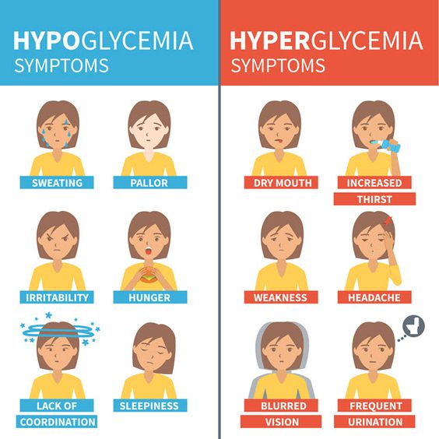
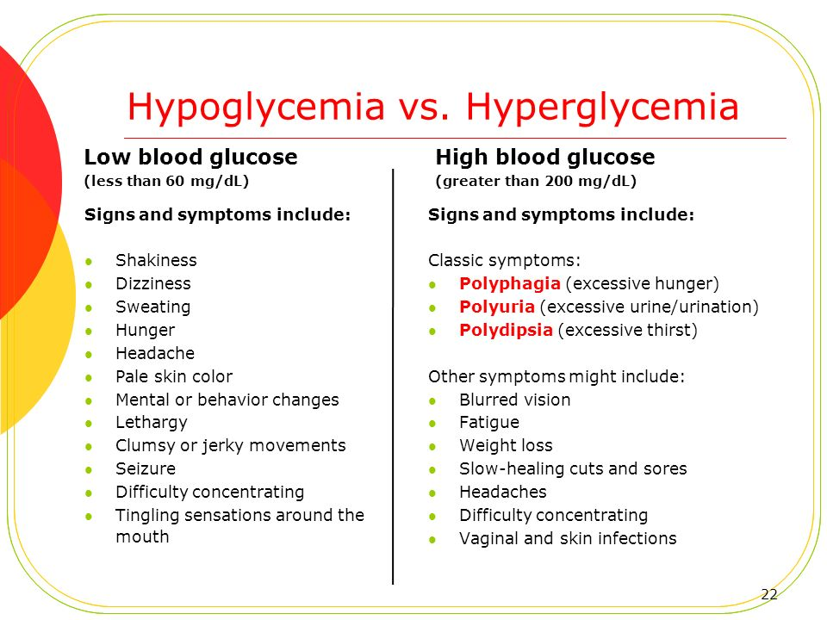
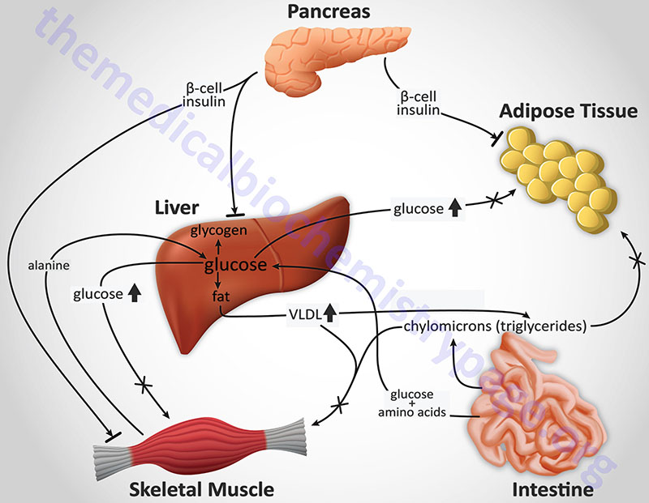

C- Lactic acidosis:
An increase of lactate levels in the blood causes an acidosis.
This condition can result from hypoxia or alcohol ingestion. Lack of oxygen slows the electron transport chain, resulting in increased NADH levels.
High NADH levels cause more than normal amounts of pyruvate to be converted to lactate.
A High NADH level from alcohol metabolism also causes increased conversion of pyruvate to lactate.

Thiamine deficiency, which is common in alcoholics, decreases pyruvate dehydrogenase activity, causing pyruvate to accumulate and form lactate.
Thiamine deficiency also slows the TCA cycle at the α-ketoglutarate dehydrogenase step. This and other conditions that slow the TCA cycle can also produce lactic acidosis.

