Carbohydrate Metabolism
(Lec-9)
Dr. Walaa AL - Jedda ( 2022-2023 )

Metabolism of Monosaccharide
Although many monosaccharides have been identified in nature, only a few sugars appear as metabolic intermediates or as structural components in mammals.
Glucose is the most common monosaccharides consumed by humans. However, two other monosaccharides, fructose and galactose, occur in significant amounts in the diet, and make important contributions to energy metabolism.

Fructose Metabolism
About 10% of the calories contained in the Western diet are supplied by fructose.
Fructose is present in fruit juices and honey, it is also found as a free monosaccharide in high-fructose corn syrup, which is used to sweeten most cola drinks. The major source of fructose is the disaccharides sucrose taken as table sugar which, when cleaved in the intestine, releases equimolar amounts of fructose and glucose by the enzyme sucrase.
Fructose is absorbed by “facilitated transport” and taken by portal blood to liver, where it is mostly converted to glucose.

Entry of fructose into cells is not insulin-dependent (unlike that of glucose into certain tissues), and, in contrast to glucose, fructose doesn’t promote the secretion of insulin.
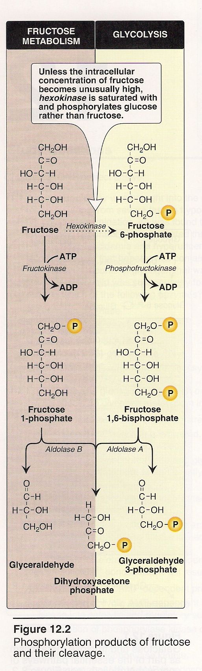
1.
Biomedical Importance of Fructose
- Fructose is easily metabolized and a good source of energy.
- Seminal fluid is rich in fructose and spermatozoa utilize fructose for energy.
- Excess dietary fructose is harmful, leads to increased synthesis of T.G.
- In diabetics, fructose metabolism through “sorbitol” pathway may account for the development of cataract.
- Inherited disorder: “Hereditary fructose intolerance” occurs due to inherited deficiency of the enzyme aldolase – B.

Metabolism of Fructose
1- Conversion of fructose to glycolytic intermediates. (See fig.1)
- Fructose is metabolized mainly in the liver where it is converted to pyruvate or under fasting conditions, to glucose.
A-Phosphorylation of fructose: by the enzyme fructokinase (present in the liver and muscles) and by ATP to form fructose -1- P. (see fig1,2)

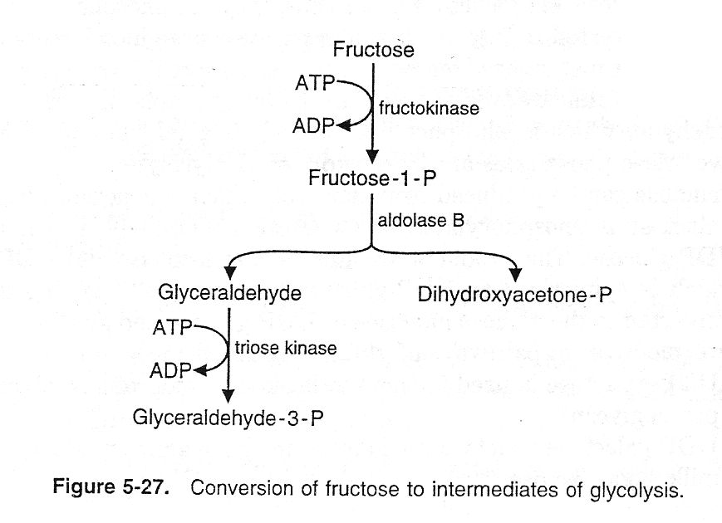
B-Cleavage of fructose - 1- P : F - 1 - P is cleaved by aldolase B to form dihydroxyacetone phosphate (DHAP) and glyceraldehydes.
2.

- In tissues other than liver, the major fate of fructose is phosphorylation by hexokinase to form F-6-P, which enters glycolysis.
Hexokinase has low affinity for glucose (about one – twentieth that of glucose).
Note: Brain and muscle can utilize significant quantities of fructose after its conversion to glucose in liver. Fructose is also metabolized actively by adipose tissue.
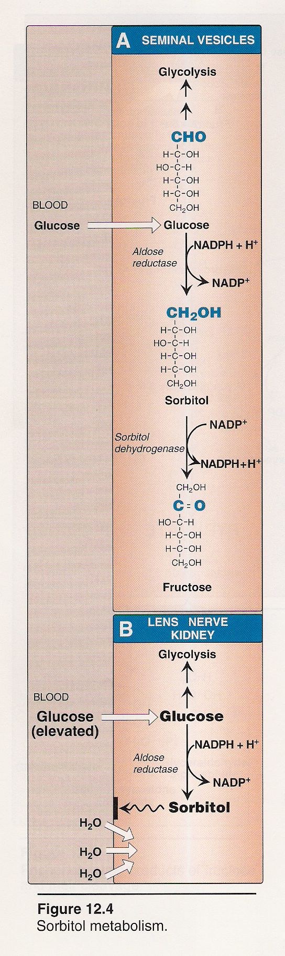
3.
2-Conversion of fructose From glucose. (See fig.3)

- Glucose is reduced to sorbitol by aldose reductase, which reduces an aldehyde group to an alcohol.

b- Sorbitol is then reoxidized by sorbitol dehydrogenase to form fructose.

c- Fructose, derived from glucose in seminal vesicles, is the major energy source for sperm cells.

Clinical significance of sorbitol metabolism in Diabetes Mellitus:
Formation of sorbitol from glucose proceeds rapidly in the lens of the eye and the Schwann cells of the nervous system.

*-Sorbitol cannot pass through the cell membrane and in diabetic individuals, as the rate of oxidation of sorbitol to fructose decreases, sorbitol level in these cells greatly increases.

*-Elevated sorbitol concentration in these cells increase the osmotic pressure which may be responsible for the development of cataracts of Lens of the eye and Diabetic neuropathies.

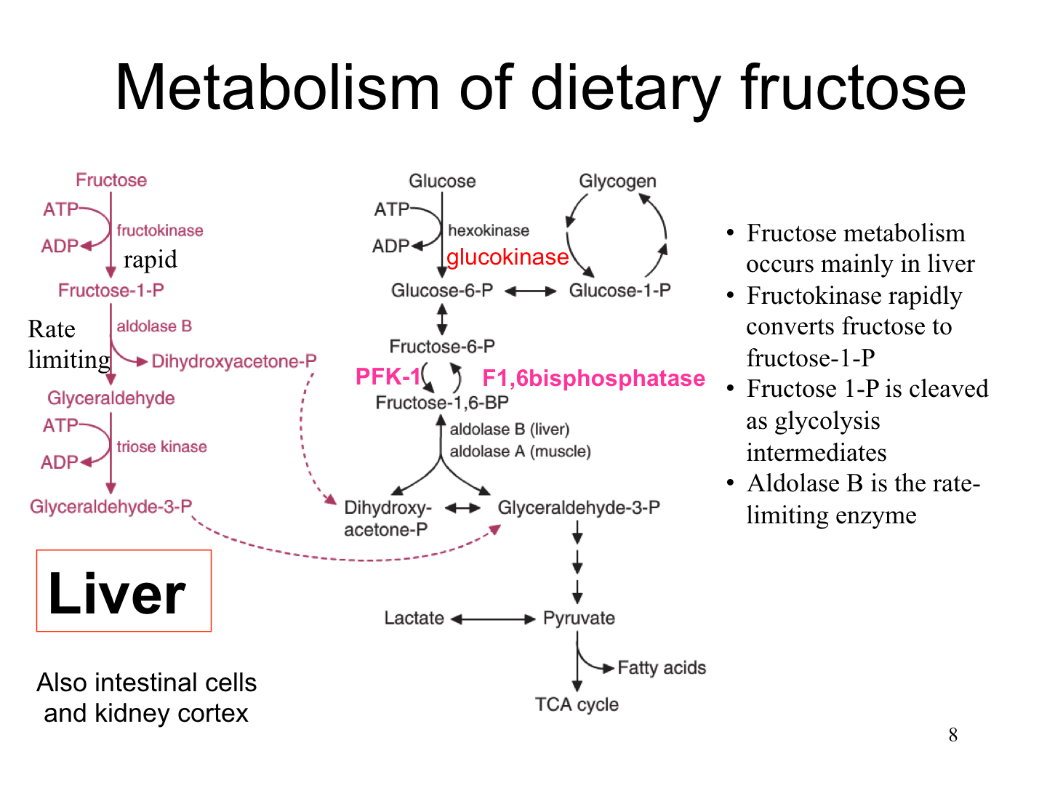
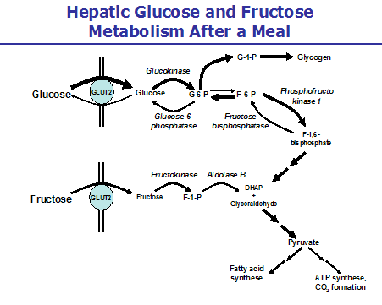

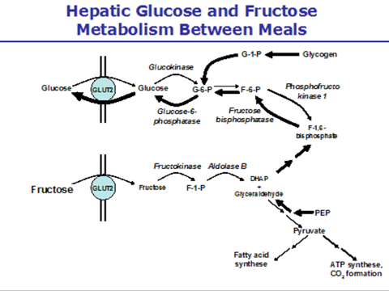
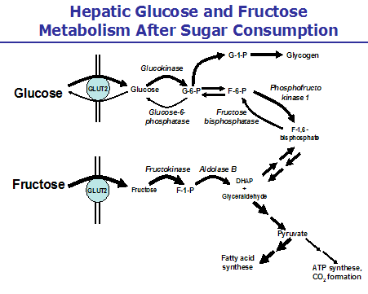
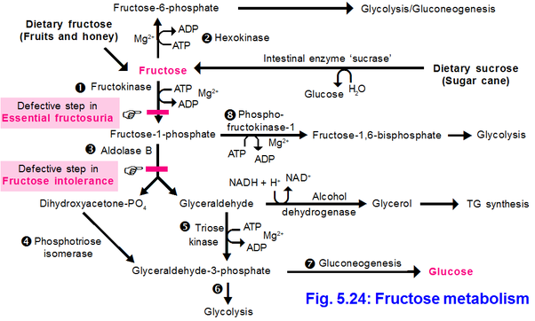
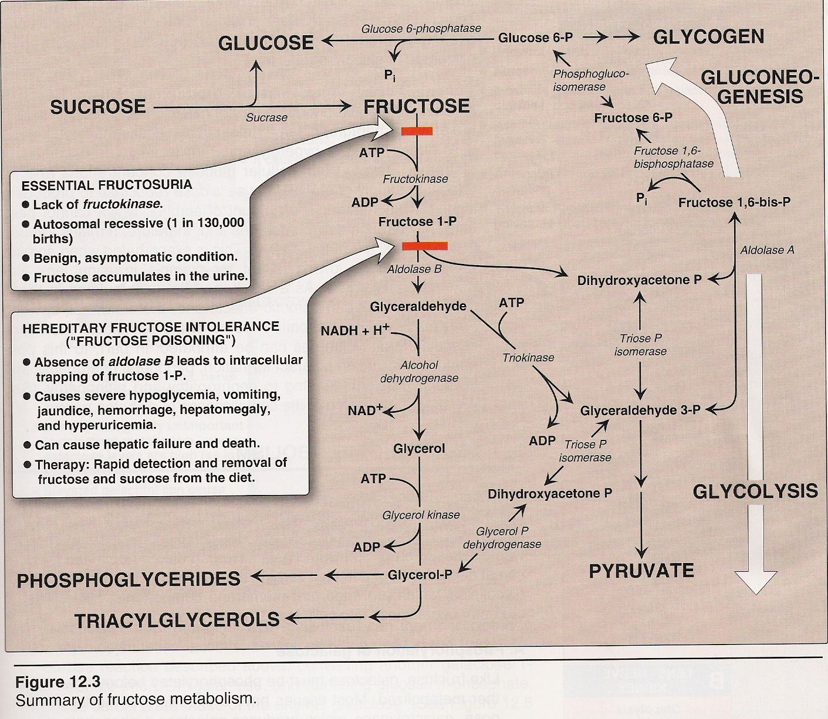

4.

Galactose Metabolism
The major dietary source of galactose is lactose (sugar of milk), obtained from milk and milk products. Lactose is hydrolysed in the intestine by the enzyme lactase. Galactose is actively transported, to portal blood.
Galactose absorption is faster than glucose. Galactose reaches liver by portal blood where it is readily converted to glucose. This property is used as a test of liver function called “galactose tolerance test”.
Most of dietary galactose is converted to glucose and goes to systemic circulation as glucose. Tissues requiring galactose synthesizes it from glucose, taken up by tissues from systemic circulation.

Biomedical Importance of Galactose
- Galactose is required in lactating mammary gland for synthesis of lactose for breast milk.
- Galactose is utilized in Brain and nervous tissues for synthesis of glycolipids – cerebrosides and gangliosides.
- Inherited deficiency of certain enzymes in pathway of galactose metabolism produces inherited disorder “Galactosemia”.

Metabolism of galactose
1- Conversion of galactose to intermediates of glucose pathway (see fig.5)
a- Galactose is phosphorylated by ATP to galactose-1-P by the enzyme galactokinase.
b- Galactose – 1 – P reacts with UDP – glucose and forms glucose – 1-P and
UDP – galactose by the enzyme galactose -1 - phosphate uridyl transferase.

c- UDP – galactose is epimerized to UDP – glucose in a reaction that is readily reversible. The enzyme is epimerase.
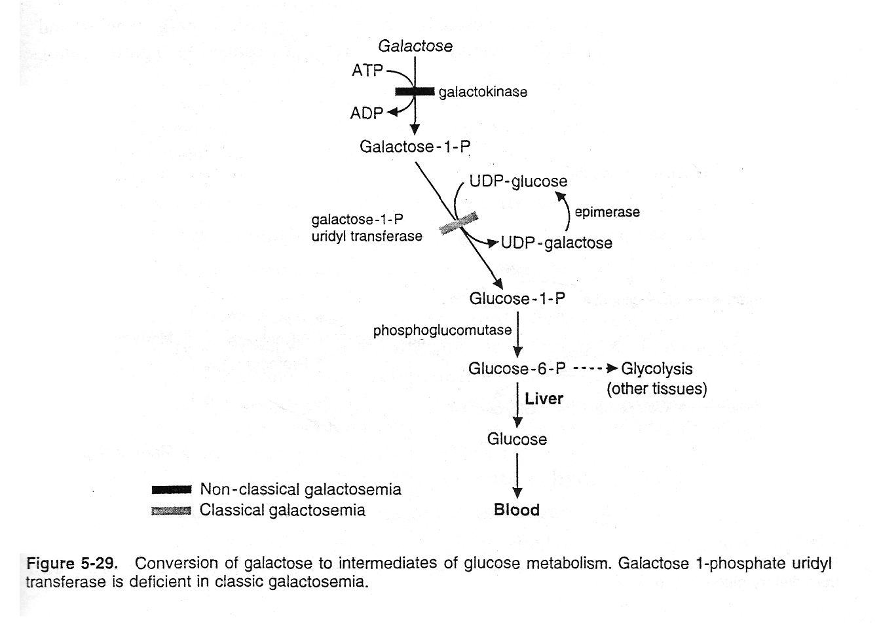
5.
5.

- In the liver, these glucose derivatives are converted to blood glucose during fasting or to glycogen after a meal.
- In various tissues, the glucose -1 -P form glucose -6 – P and feeds into glycolysis.
2- Other fates of UDP – galactose (see figure 6)
-UDP – galactose can be produced either from galactose or from glucose via UDP-galactose and an epimerase.
-UDP-galactose supplies galactose moieties for the synthesis of glycoproteins, glycolipids, and proteoglycans.
-UDP – galactose reacts with glucose in the lactating mammary gland to produce the milk sugar lactose.
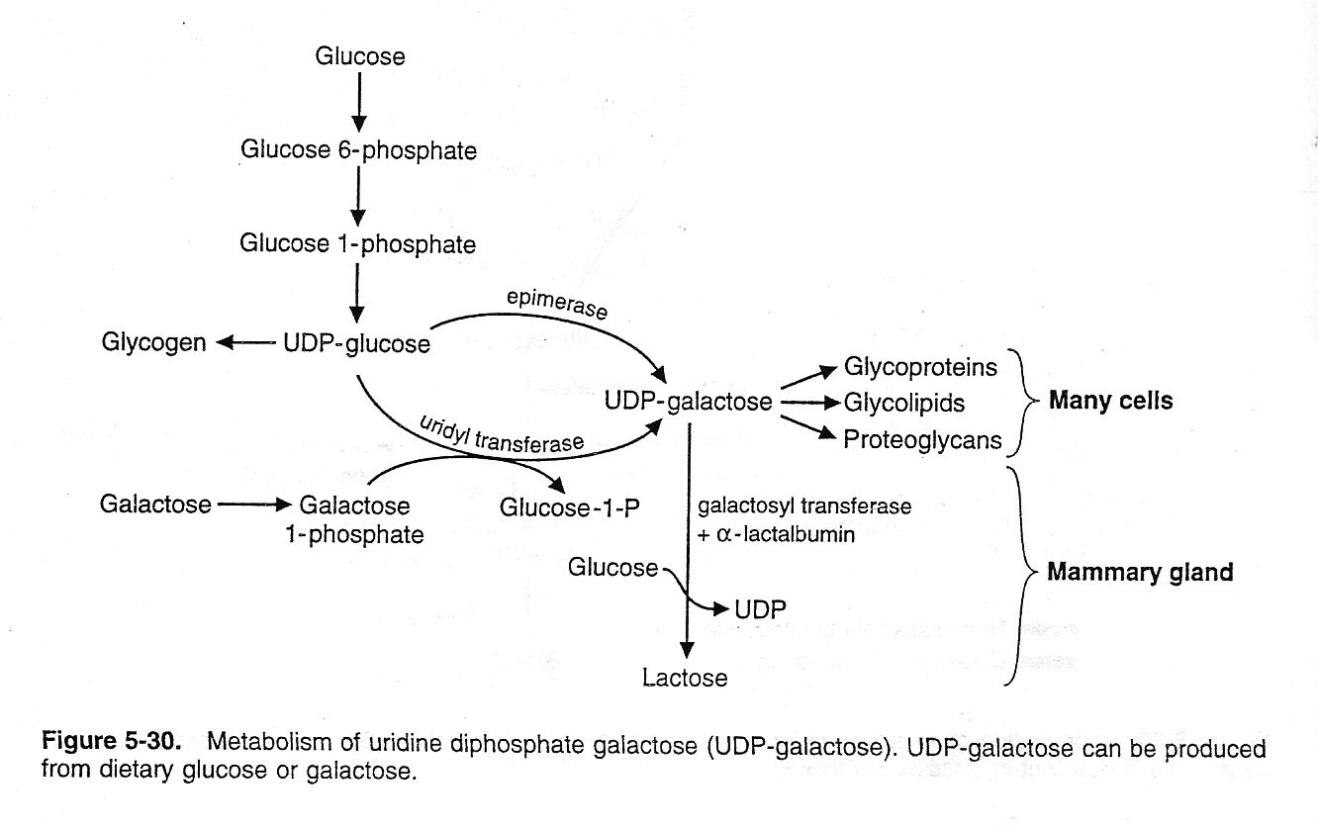
6.

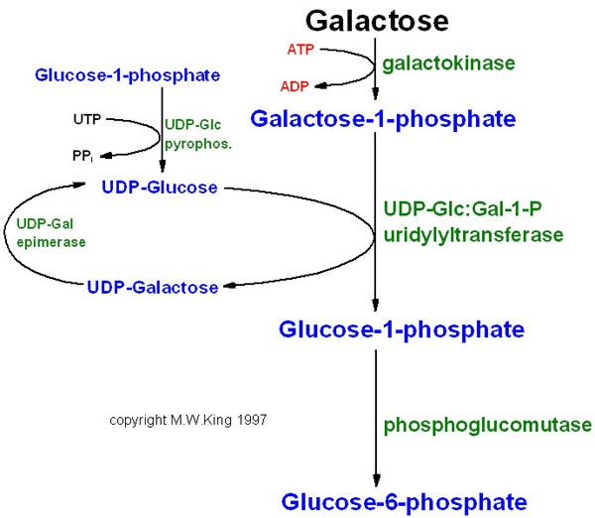
3- Conversion of galactose to galactitol:
Aldose reductase reduces the aldehyde of galactose to an alcohol, forming galactitol.
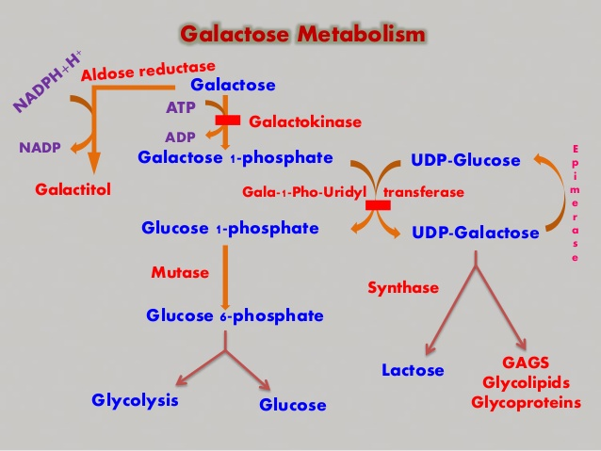
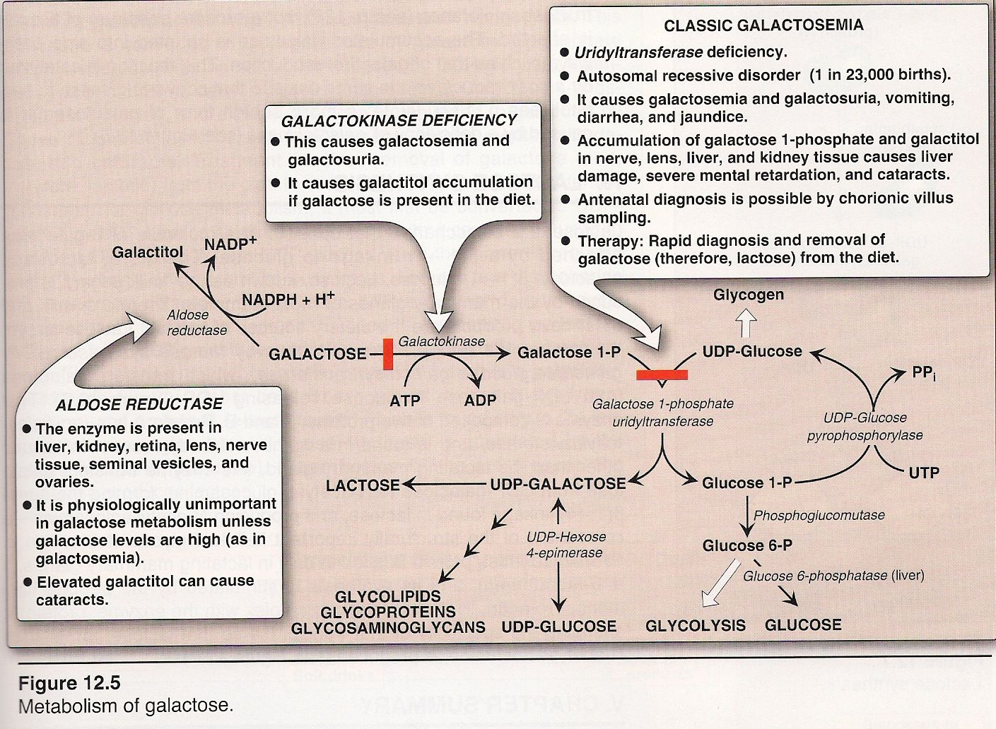
7.

