Carbohydrate Metabolism ( Lec-6 )
Dr. Walaa AL - Jedda (2022-2023)

Metabolism of Glycogen

Glycogen: is the storage form of glucose, which is stored in animal body especially in liver and muscles. It is mobilized to glucose whenever body tissue requires. Glycogen in the skeletal muscles serves as a fuel reserve for the synthesis of ATP during muscle contraction.

Glycogen is a branched polymer of glucose that contains a minor amount of phosphate and glucosamine. In the linear chains, the glucose residues are connected by α-1,4-glycosidic linkages while α-1,6-glycosidic bonds create the branch points. Branches within normal glycogen are distributed at even intervals resulting in a structure with spherical shape. The source and function of phosphate and glucosamine in human glycogen are unclear.
The glycogen particle consists of up to 55.000 glucose residues. In skeletal muscle, glycogen particles have a size of 10–44 nm in diameter while in the liver measure approximately 110–290 nm. Glycogen can be identified by electron microscopy inside the cells.
Glycogen structure
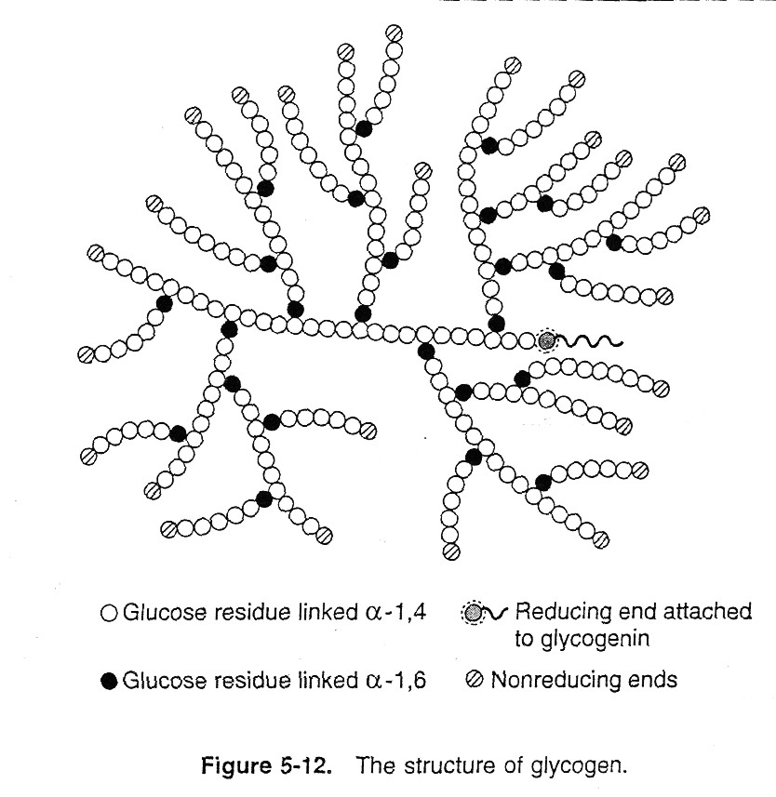
(1)

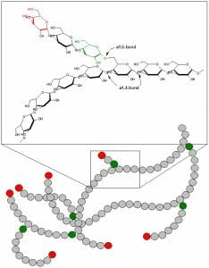
Glycogen is a large branched polymer consist of D– glucose residue.
1. The linkages between glucose residues are α-1, 4 except at branch points where the linkage is α-1, 6.
Branching is more frequent in the interior of the molecule and less frequent at the periphery, the average being an α-1, 6 branch every (8-10) residues.
2. One glucose unit, located at the reducing end of each glycogen molecule, is attached to the protein glycogenin.
3. The glycogen molecule branches like a tree and has many nonreducing ends at which addition and release of glucose residues occur during synthesis and degradation, respectively.

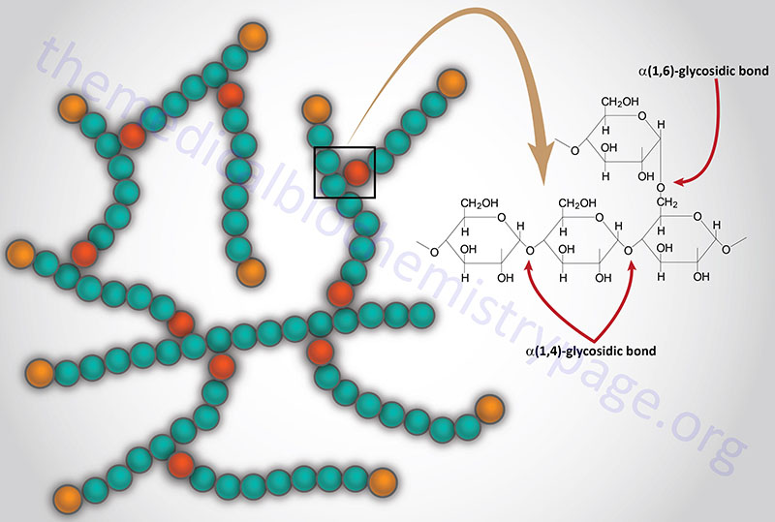
Role of liver glycogen
1 -It is the only immediately available reserve store of blood glucose.
2 -A high liver glycogen level protects the liver cells against the harmful effects of many poisons and chemicals e.g., CCl₄, ethyl alcohol, arsenic, various bacterial toxins.
3 -Certain forms of detoxication, e.g., conjugation with glucuronic acid, and acetylation reactions, are directly influenced by the liver glycogen level.
4 -The rate of deamination of amino acids in the liver is depressed as the glycogen level rises, so that amino acids are preserved longer in that form and so remain available for protein synthesis in the tissues.
5-Similarly, a high level of liver glycogen depresses the rate of ketone bodies formation.

Q) Why body stores glucose as glycogen and not as glucose itself?
Possible reasons:
1-Being insoluble it exerts no osmotic pressure, and so does not disturb the intracellular fluid content and doesn’t diffuse from its storage sites.

2-It has a higher energy level than a corresponding weight of glucose (though energy has to be expended to make it from glucose).

3-It is readily broken down under the influence of hormones and enzymes:
- Into glucose in liver ((to maintain blood glucose level)).
- Into lower intermediates in skeletal muscle and other tissues for energy.

Biomedical importance of glycogen
1-Liver glycogen is largely concerned with storage and supply of glucose -1-P which is converted to glucose, for maintenance of blood glucose, particularly in between meals.

2-Muscle glycogen on the other hand, is to act as readily available source of intermediates of glycolysis for provision of energy within the muscle itself.
Muscle glycogen cannot directly contribute to blood glucose level.

3-Inherited deficiency of enzymes in the pathway of glycogen metabolism produces certain inherited disorders called as “Glycogen storage diseases” (GSDs).

*Glycogenesis and glycogenolysis are finely controlled at substrate level, by end-products and hormones.
* When glycogenesis occurs, glycogenolysis does not take place and vice versa.

Glycogen synthesis (Glycogenesis)
It is the formation of glycogen from glucose. Principally it occurs in liver and skeletal muscles, but it can occur in every tissue to some extent.

Glycogenesis occurs in the cytosol, and requires energy supplied by ATP.
- ((UDP-glucose is the precursor for glycogen synthesis)).
- Sources of glucose:
- A-For liver glycogen:
1. Blood glucose 2. Other hexoses: fructose and galactose 3. Non-carbohydrate sources: “gluconeogenesis”, e. g. amino acids, glycerol and lactate during fed state.
- B-For muscle glycogen: blood glucose only.

1. Synthesis of UDP-glucose (Figure 2)
a. Glucose enters cells and is phosphorylated to glucose 6-phosphate by hexokinase (or by glucokinase in the liver). ATP provides the phosphate group.
b. Phosphoglucomutase converts glucose 6-phosphate to glucose 1-phosphate.
c. Glucose 1-phosphate reacts with UTP, forming UDP-glucose in a reaction catalyzed by UDP- glucose pyrophosphorylase.
Inorganic pyrophosphate (PPi) is released in this reaction.
- PPi , is cleaved by a pyrophosphatase to 2 Pi. This removal of product helps to drive the process in the direction of glycogen synthesis.

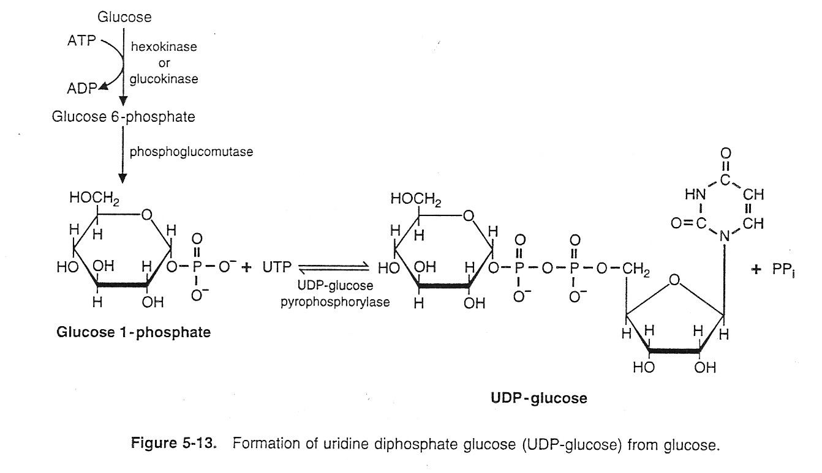
(2)

2. Action of glycogen synthase. (Figure 3A)
a. Glycogen synthase is the key regulatory enzyme for glycogen synthesis.
It transfers glucose residues from UDP-glucose to the nonreducing ends of a glycogen primer.
UDP is released and reconverted to UTP by reaction with ATP.
b. The primers, which are attached to glycogenin, are glycogen molecules that were partially degraded in liver during fasting or in muscle and liver during exercise.
3. Formation of branches (see Figure 3A)
a. When a chain contains (11 or more glucose residues), an oligomer (6-8 residues) in length, is removed from the nonreducing end of the chain.
It is reattached via an α-1, 6 linkage to a glucose residue within an α-l, 4-Iinked chain.
b. These branches are formed by the branching enzyme, a glucosyl 4:6 transferase that breaks an α-1, 4 bond and forms an α-1, 6 bond.
c. The new branch points are at least 4 residues and an average of (7-11 residues) from previously existing branch points.

4. Growth of glycogen chains
a. Glycogen synthase continues to add glucose residues to the nonreducing ends of newly formed branches as well as to the ends of the original chains.
b. As the chains continue to grow, additional branches are produced by the branching enzyme.

Stimulation of Glycogenesis
1- Insulin: Stimulate glycogen synthesis in liver and muscle.
2- Glucocorticoids: effect seen 2-3 hours after administration.
- Enhances gluconeogenesis and glycogen synthesis in liver.
- Increases activity of protein phosphatase -1.
- Increases synthesis of the enzyme “glycogen synthase”.
3- Glucose: high substrate concentration increases synthesis.
Inhibition of glycogenesis
1- Increased concentration of glycogen inhibits Glycogenesis “feedback inhibition”.
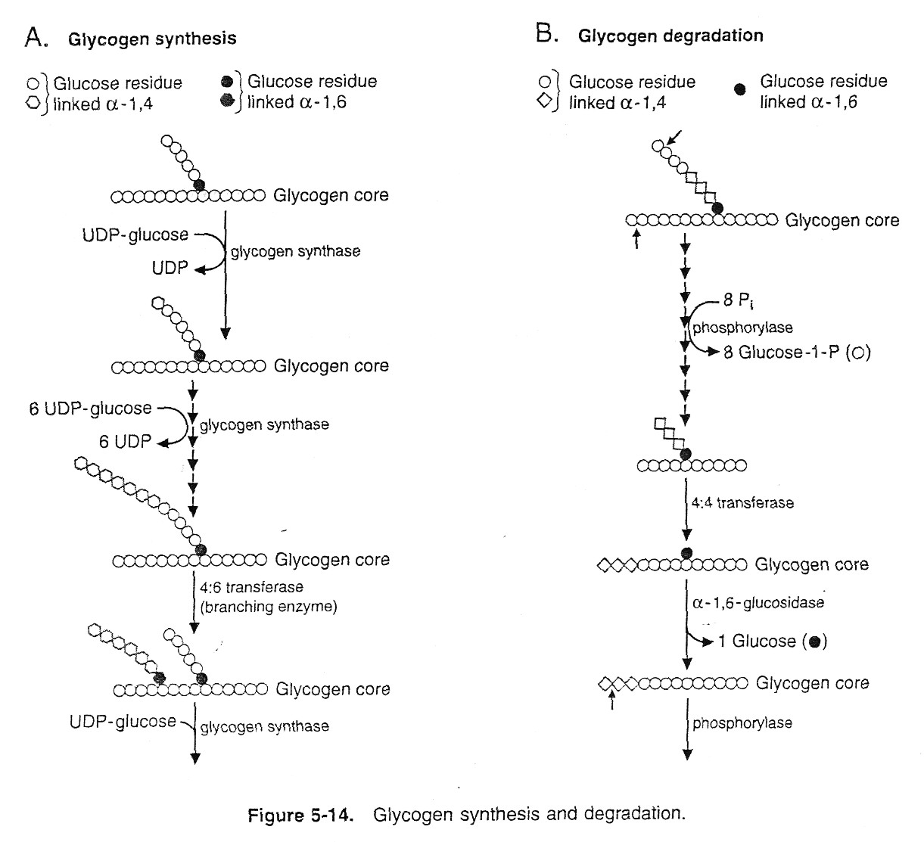
2- Increased concentration of cyclic – AMP which affects protein phosphatase-1
(3)
(Debranching enzyme)
(Debranching enzyme)

Glycogen degradation (Glycogenolysis)
It is the breakdown of glycogen to glucose.
Glycogen degradation produce glucose-1-p as the major product, but free glucose is also formed.
Definition: It is the process of glycogen catabolism (or breakdown) into: Glucose to blood, in the liver. Or, Glucose-6 -phosphate Lactic acid, in the muscles.
Site: Cytosol of all cells but high activity in liver and muscles.

1. Action of glycogen phosphorylase. (See Figure 3B).
a. Glycogen phosphorylase, the key regulatory enzyme for glycogen degradation, removes glucose residues, one at a time, from the nonreducing ends of glycogen molecules.
b. Phosphorylase uses inorganic phosphate (Pi) to cleave α-1, 4 bonds, and producing glucose 1-phosphate.
c. Phosphorylase can act only until it is four glucose units from a branch point

(3)
(Debranching enzyme)
(Debranching enzyme)

2. Removal of branches.
- The four units remaining at a branch are removed by the debranching enzyme, which has glucosyl 4:4 transferase and α-l, 6-glucosidase activity.
a.( Three of the four glucose residues that remain at the branch point are removed as a trisaccharide and attached to the nonreducing end of another chain by a 4:4 transferase, which cleaves an α-1,4 bond and forms a new α-1,4 bond.
b.( The last glucose unit at the branch point, which is linked α-1, 6, is hydrolyzed by α-l, 6-glucosidase, forming free glucose.

3. Degradation of glycogen chains.

- The phosphorylase/debranching process is repeated, generating glucose 1-phosphate and free glucose in about a 10:1 ratio that reflects the length of the chains in the outer region of the glycogen molecule.

4. Fate of glucosyl units released from glycogen.
a. In the liver, glycogen is degraded to maintain blood glucose.
(1) Glucose 1-phosphate is converted "by phosphoglucomutase to glucose 6- phosphate (G-6-P).
(2) Inorganic phosphate is released by glucose 6-phosphatase, and free glucose enters the blood. This enzyme also acts in gluconeogenesis.

b. In muscle, glycogen is degraded to provide energy for contraction.
(1) Phosphoglucomutase converts glucose 1-phosphate to glucose 6-phosphate, which enters the pathway of glycolysis and is converted either to lactate or to C0₂ and H₂O, generating ATP.
(2) Muscle does not contain glucose 6- phosphatase and, therefore, does not contribute to the maintenance of blood glucose.

Regulation of glycogenolysis
The breakdown of glycogen is initiated by action of the enzyme phosphorylase. In the liver it is activated by glucagons, while in the muscle by adrenalin (epinephrine).
- Liver glycogen is used to maintain blood glucose during fasting or exercise, its breakdown is stimulated by glucagon and by epinephrine via a mechanism that involves C-AMP.

- Muscle glycogen is utilized to generate ATP for muscle contraction. Epinephrine, via C-AMP, stimulates muscle glycogen breakdown.

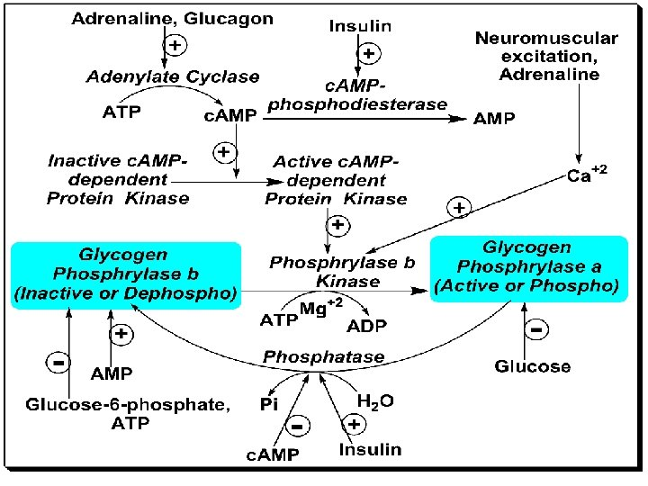
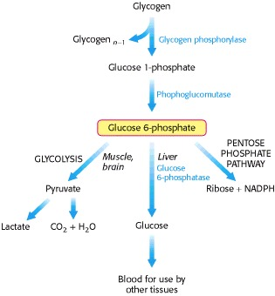
Exercise and Glycogen Depletion

In endurance exercise, athletes may undergo glycogen depletion, in which most of the glycogen is depleted from the muscle. This can result in severe fatigue and difficulty moving. Glycogen depletion can be mitigated by continuously consuming carbohydrates with a high glycemic index (high rate of conversion to blood glucose) during exercise, which will replace some of the glucose using during exercise. Specialized exercise regimens may also be employed that condition muscle to utilize fatty acids as an energy source at a greater rate, thus breaking down less glycogen. Athletes may also use carbohydrate loading, the consumption of large amounts of carbohydrates, to increase the capacity for glycogen storage

Glycogen Storage Diseases (GSDs)
These are group of genetic diseases that result from a defect in an enzyme required for glycogen synthesis or degradation. They result either in formation of glycogen that has an abnormal structure, or in the accumulation of excessive amounts of normal glycogen in specific tissues as a result of impaired degradation.
A particular enzyme may be defective in a single tissue, such as liver, or the defect may be more generalized, affecting liver, muscle, kidney, intestine, and myocardium.
The severity of the glycogen storage diseases (GSDs) ranges from fatal in infancy to mild disorders that are not life – threatening.

1 -Type I: Von Gierke’s disease
2 -Type II: (Pompe’s disease)
3 -Type III: (Limit Dextrinosis, Forbe's disease)
4 -Type IV: (Andersen’s disease)
5 -Type V: (Mc. Ardle’s disease)
6 -Type VI: (Hers' disease)
7 -Type VII: (Tarui’s disease)
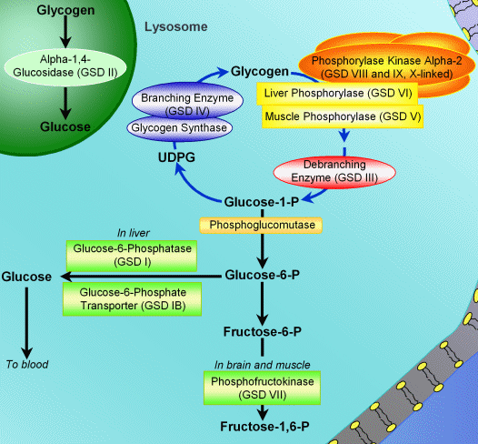

Type I : Von Gierke's Disease
- Most common type of glycogen storage disease.
- Incidence is 1 in 100,000 live births.
- G-6-phosphatase is deficient.
- Fasting hypoglycemia that does not respond to stimulation by adrenaline.
The glucose cannot be released from liver during overnight fasting.
- Hyperlipidemia, lactic acidosis and ketosis.
- G-6-P is accumulated, so it is channeled to HMP shunt pathway producing more ribose and more nucleotides.
- Purines are then catabolized to uric acid, leading to hyperuricemia.
- Glycogen gets deposited in liver. Massive liver enlargement may lead to cirrhosis.
- Children usually die in early childhood.
- Treatment is to give small quantity of food at frequent intervals.

Type III: limit dextrinosis (Forbe's Disease)
- It is due to a genetic deficiency of the debranching enzyme.
- Individuals with this disease cannot degrade glycogen beyond the first encountered α-1, 6 branch points.
- They usually show an enlarged liver and growth retardation; the spleen may also be moderately enlarged.
-Partially degraded glycogen structures (limit dextrin) accumulate in muscle, liver, and sometimes the heart.
-Hypoglycemia and convulsions occur in some patients, and muscle wasting and weakness in others, indicating an inability to meet tissue glucose needs.
- The treatment of type III glycogen storage diseases is aimed at increasing the supply of free glucose available to the tissues. Current recommendations are frequent meals in order to maintain a more constant influx of dietary glucose, and a high-protein diet, which allows enhanced conversions of amino acids to glucose via gluconeogenesis.

Type-V: McArdle"s Disease
- Enzyme deficiency: Muscle phosphorylase
Glycogen deposited in normal structure; organs involved skeletal muscles (excess of normal glycogen).
- Clinically: Muscle cramps on exercise, pain, weakness and stiffness of muscles. No lactate is formed.
Muscles recover on rest, due to utilization of FA for energy.
- Epinephrine test: after administration of epinephrine/ or glucagon, rise in blood glucose occurs which shows that hepatic phosphorylase activity is normal.
- Note: Affects children and adults.

- 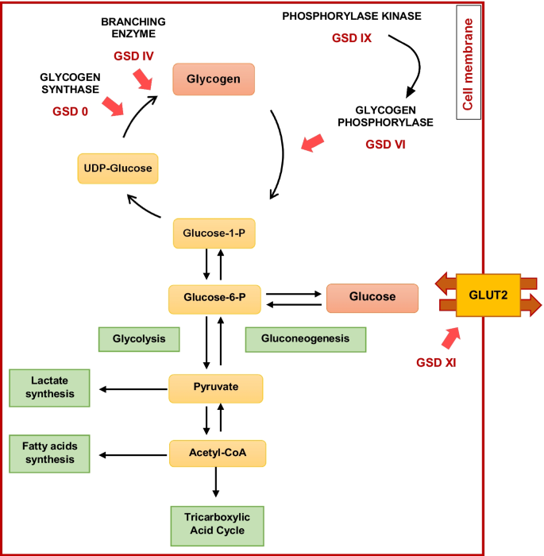
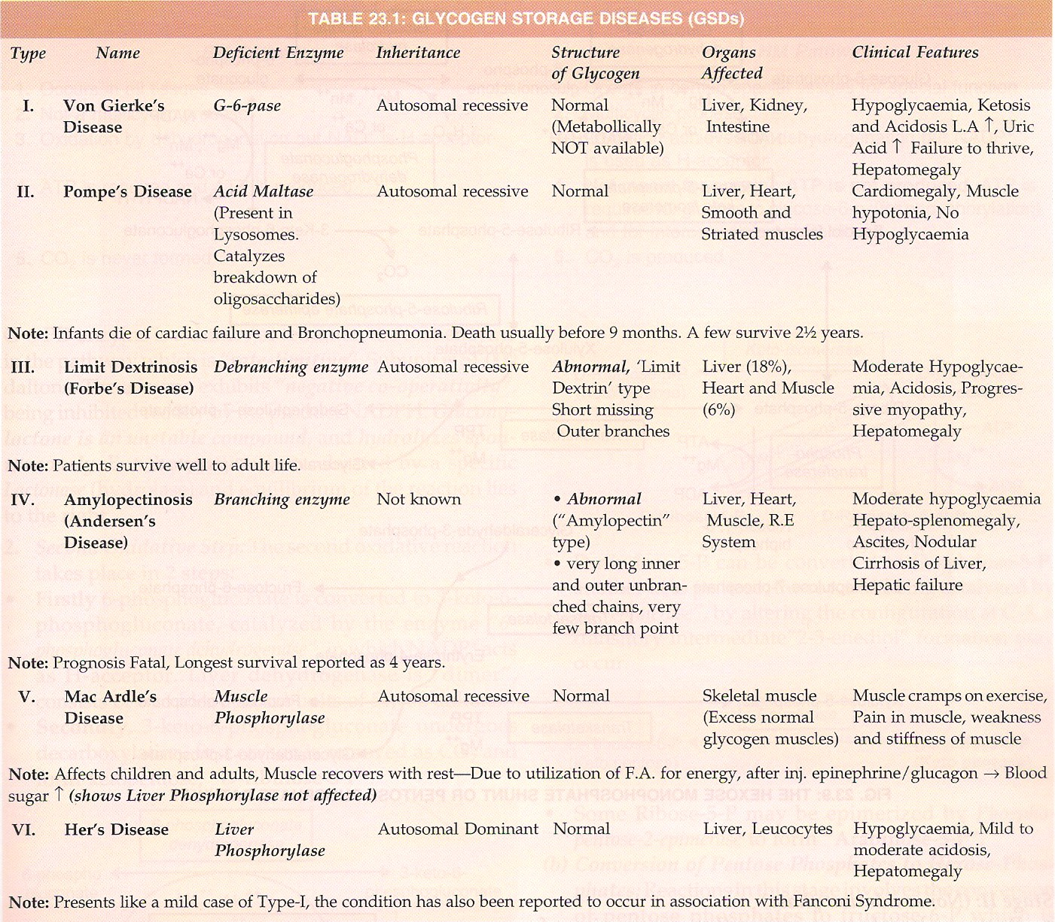

sss

