Carbohydrate Metabolism (5)
Dr. Walaa AL-Jedda (2022-2023)
Hexose Monophosphate Shunt (HMP)
An alternate pathway for oxidation of glucose.
It is also called HMP pathway or Pentose–phosphate pathway
(pp-pathway) or called Pentose cycle and finally may called phosphogluconate pathway.
Biomedical Importance
- Though it is oxidation of glucose, but it is not meant for energy.
- Provides NADPH which is required for various reductive synthesis in metabolic pathways.
- Provides pentoses required for nucleic acid synthesis.
- Deficiency of a particular enzyme leads to hemolytic anemia, which is of great clinical importance.

Major differences with EM pathway
1- This pathway occurs in certain specialized tissues only to serve specific functions. e.g. liver, adipose tissue, RB cells, tests and ovary, adrenal cortex and lactating mammary glands, also lens and cornea of eyes. It is unimportant for skeletal muscle.
2- It is a multicyclic process, 3 molecules of G-6-P enter the cycle, producing 3 mols of CO₂ and 3 mols of 5-C residues, which rearrange to give 2 mols of G-6-P and one mol of glyceraldehyde-3-P.
3- Oxidation is achieved by dehydrogenation, but NADP⁺ is used as hydrogen acceptor and not NAD⁺.
4- CO₂ is produced in this pathway which is never produced in E.M. pathway.
Similarity: The only similarity is that enzymes are extra mitochondrial (Cytosolic) and it operates in cytosol.
NOTE: NADP: Nicotinamide adenine dinucleotide phosphate.
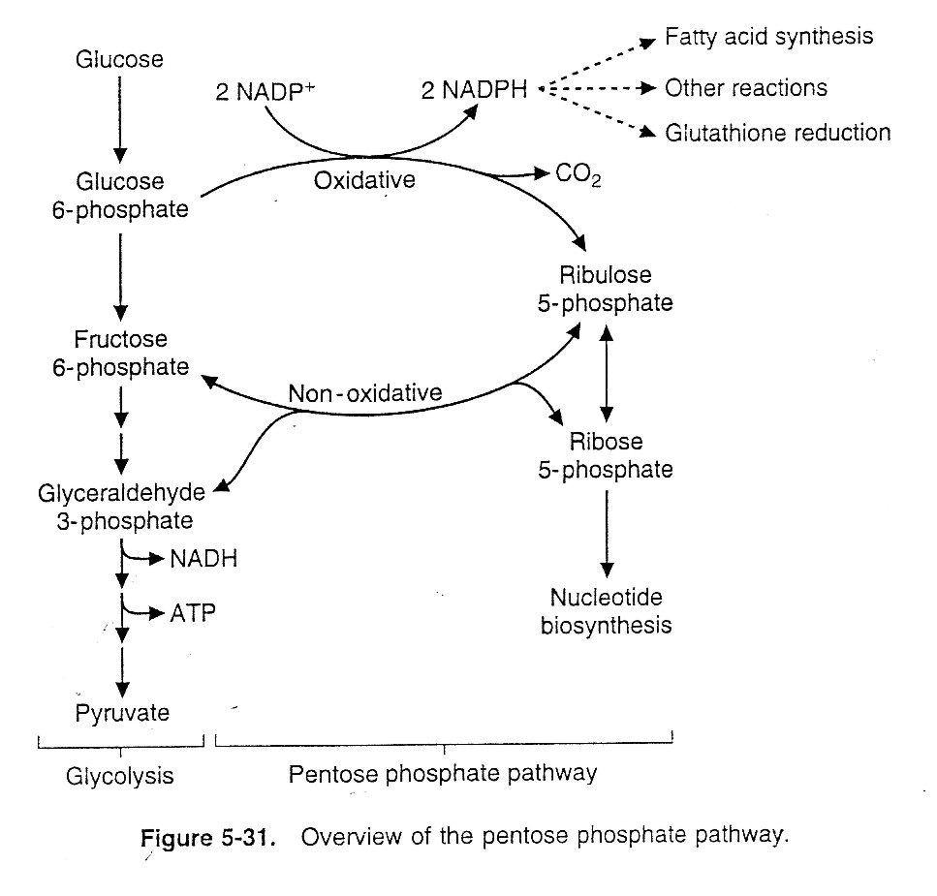
NAD: Nicotinamide adenine dinucleotide.
1.

Reactions of the HMP shunt
1- The oxidative reactions (or oxidative phase)
Oxidation of glucose and formation of pentose phosphate.
a) G-6-P is converted to 6-phosphogluconolactone and NADP⁺ is reduced to NADPH + H⁺ by the enzyme glucose-6-phosphate dehydrogenase (G6PD).
b) 6-phosphogluconolactone is hydrolyzed to 6-phosphogluconate which is oxidatively decarboxylated. CO₂ is released, and a second NADPH+H⁺ is generated from NADP⁺. The remaining carbons form ribulose 5-phosphate.
The oxidative phase has irreversible reactions.
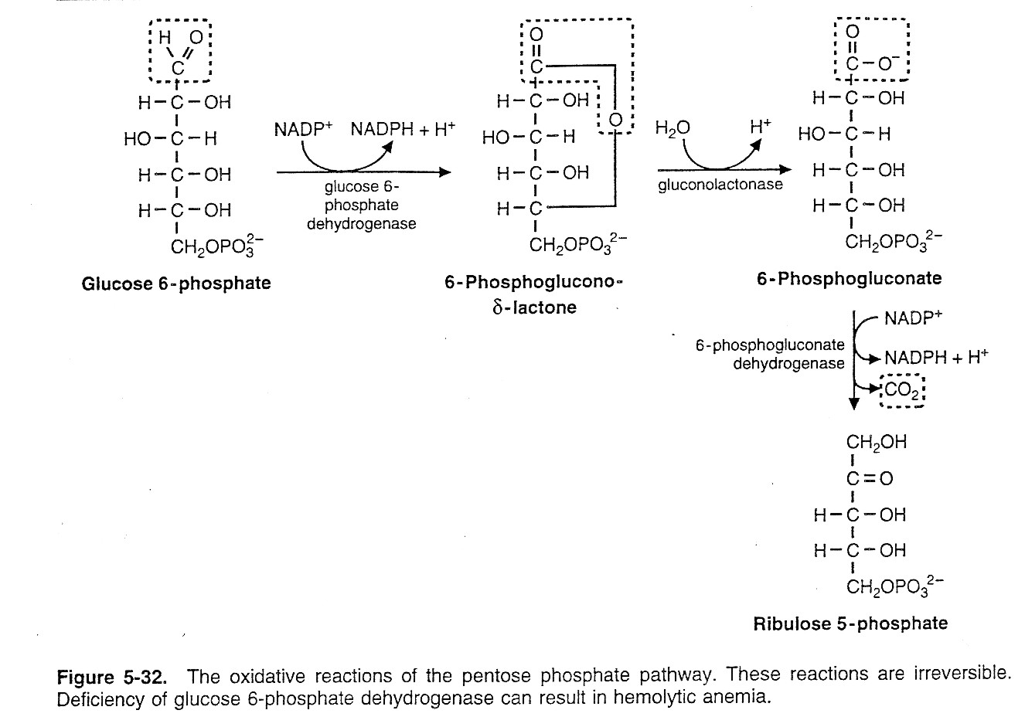
2.

** G-6-PD is the regulating enzyme of the oxidative phase.
2-The non-oxidative reactions (non-oxidative phase)
a- These reactions are reversible.
b- Pentose phosphates produced from ribulose 5-phosphate, are converted to the glycolytic intermediates fructose 6-P and glyceraldehyde 3-P.
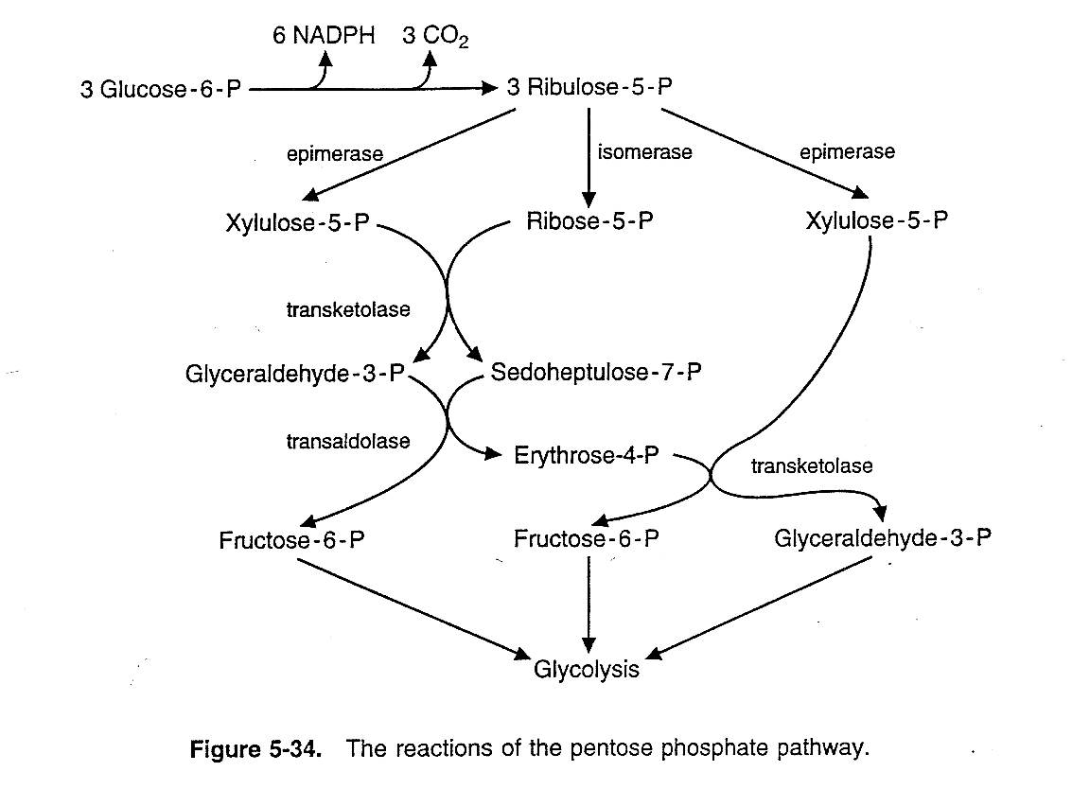
3.

c- Because the non oxidative reactions are reversible, they can be used to generate ribose-5-P for nucleotide synthesis from intermediates of glycolysis.

- The overall reaction of PP-pathway is:
3 glucose -6-P + 6NADP⁺ 3CO2↑ + 2 fructose-6-p + glyceraldehyde- 3-p +6 NADPH + 6H⁺

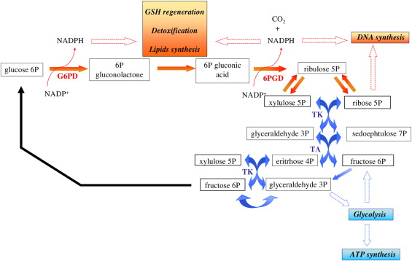

Regulation of HMP shunt:
1) G-6-P D, the first reaction enzyme is the “rate-limiting” step. It is primarily regulated by cytoplasmic levels of NADP⁺ and NADPH, thus the ratio of the two [NADP⁺] / [NADPH]. If the cytoplasmic ratio is high (rise in NADP⁺), enhances the “rate-limiting” reaction as well as the shunt pathway.
A decrease in the ratio (rise in NADPH level), inhibits both G-6-PD and 6-phosphogluconate dehydrogenase by making less NADP⁺ available for their catalytic reactions.

2) The activities of both dehydrogenases and the rate of the pathway are enhanced on feeding high Carbohydrate diets and are reduced in starvation and diabetes mellitus.
3) Increase in F.A. synthesis and steroid synthesis, enhances the shunt pathway.
4) Hormones:
- Insulin: induces the synthesis of both the dehydrogenases and thus enhances the activity of the pathway.
- Thyroid hormones: enhance the activity of G-6-PD and thus the shunt pathway.

Metabolic Significance of HMP shunt
1- Formation of NADPH: This is used as electron donor in many reductive synthesis in the body, like:
- Extra mitochondrial F.A. synthesis.
- In synthesis of cholesterol.
- In synthesis of steroids.
- In conversion of oxidized glutathione G-S-S-G to reduced glutathione G-SH.
- In synthesis of sphingolipids.
- Cytoplasmic synthesis of L-glutamate by L-glutamate dehydrogenase.
- Conversion of phenylalanine to tyrosine.
- As a coenzyme for methaemoglobin reductase for conversion of methaemoglobin to Hb.
- In uronic acid pathway.

2- Provision of pentose's: for nucleotide and nucleic acid synthesis.

3- Supply of arabinose -5-P: used in glycoprotein.

4- Role in R.B. Cells Fragility:
HMP shunt in erythrocytes provides NADPH for:
- Reduction of oxidized glutathione (G-S-S-G) to reduced glutathione (2G-SH) catalyzed by the enzyme glutathione reductase.
- Reduced glutathione (G-SH) removes H₂O₂ from the erythrocytes in a reaction catalyzed by glutathione peroxidase (Se-containing enzyme).

NADPH + H⁺ G-S-S-G H₂O₂
Oxidized
Glutathione glutathione Glutathione
Reductase Peroxidase

NADP⁺ 2G – SH 2 H₂O
Reduced
glutathione

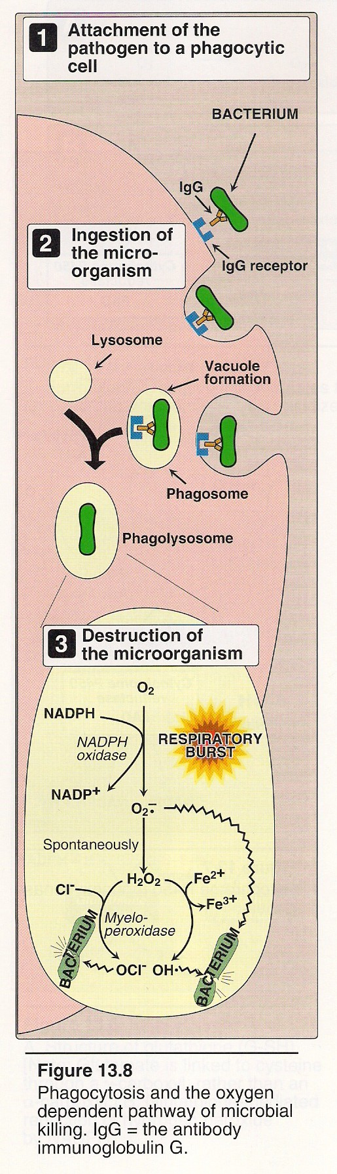
4.
This reaction is important, since accumulation of H₂O₂ may decrease the life span of RB cells by increasing the rate of oxidation of Hb to methaemoglobin. An inverse correlation exists between the activity of G-6-PD enzyme and the fragility of red cells (susceptibility to haemolysis).

5- Role in Lens Metabolism: At least 10% of glucose is metabolized by shunt pathway and provides NADPH, to convert G-S-S-G → 2G-SH which is necessary for maintenance of lens proteins.

6- Role in phagocytosis.
(See fig.4)

7- Oxidation of glucose and production of CO₂ and NADPH.

Glucose 6-P dehydrogenase deficiency diseases
It is an inherited disease characterized by hemolytic anemia, by the inability to detoxify oxidizing agents. This deficiency has the highest prevalence in the Middle East, tropical Africa and Asia, and parts of the Mediterranean.
A family of deficiencies caused by more than 400 different mutations in the gene coding for G6PD. Only some of these mutations cause clinical symptoms. The life span of many individuals with G6PD deficiency is somewhat shortened as a result of complication arising from chronic hemolysis.

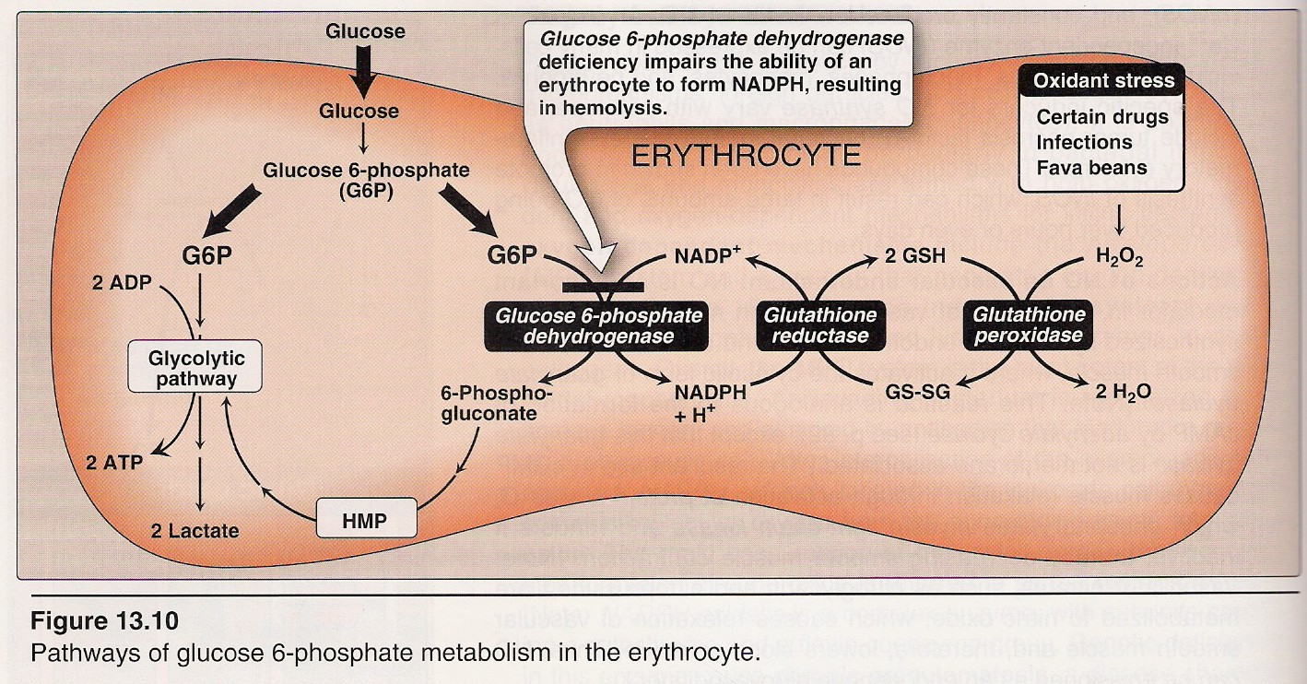
5.

Most individuals who have inherited one of the many G6PD mutations do not show clinical manifestations.
Class | Clinical  Symptoms | Residual enzyme  activity
I | Very severe | < 2%
II | Severe | < 10%
III | Moderate | 10-50%
IV | None | ≥ 60 %

Diminished G6PD activity impairs the ability of the cell to form the NADPH that is essential for the maintenance of the reduced glutathione pool.

These results in a decrease in the cellular detoxification of free radicals and peroxides formed within the cell. Although G6PD deficiency occurs in all cells of the affected individual, it is most severe in erythrocytes, where the pentose phosphate pathway provides the only means of generating NADPH.

Other tissues have alternative sources for NADPH production.

The erythrocyte has no nucleus or ribosomes and cannot renew its supply of the enzyme. Thus, red blood cells are particularly vulnerable to enzyme variants with diminished stability.

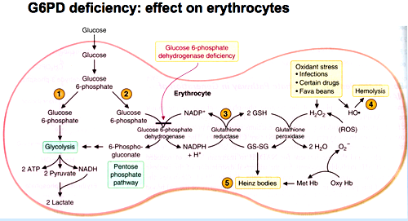
However, some patients with G6PD deficiency develop hemolytic anemia if they are treated with:

1- An oxidant drugs: Commonly used drugs that produce hemolytic anemia in patients with G6PD deficiency are: Antibiotics, Antimalarials, and Antipyretics
2- Favism: In G6PD deficient subjects, a disorder characterized by an acute hemolytic anemia of sudden onset, often with haemoglubinuria, occurs in persons' sensitive to the “Fava beans” either:
- on ingestion of uncooked or lightly cooked beans, or
- In inhalation of pollens from the blossom of the plant.
Favism, the hemolytic effect of ingesting fava beans, fava beans produce oxygen radicals which is going to attack RBC.
Fauvism is not observed in all individuals with G6PD deficiency, but all patients with Favism have G6PD deficiency.

3- Infection: is the most common precipitating factor of hemolysis in G6PD deficiency. The inflammatory response to infection results in the generation of free radicals in macrophages, which can diffuse into the red blood cells and cause oxidative damage.

4- Neonatal Jaundice: Babies with G6PD deficiency may experience neonatal jaundice appearing one to four days after birth. The jaundice which may be sever, results from impaired hepatic catabolism of heme or increased production of bilirubin.

