Carbohydrate Metabolism (1)
Dr. Walaa AL-Jedda – (2022-2023)
Intermediary Metabolism
Intermediary metabolism: the intracellular process by which nutritive material is converted into cellular components.
Metabolism: is the entire network of chemical reactions carried out by living cells. It is also refer to the intermediate steps within the cells in which the nutrient molecules or foodstuffs are metabolized and converted into cellular components catalysed by enzymes.
The fate of dietary components after digestion and absorption constitutes metabolism the metabolic pathways taken by individual molecules, their interrelationships and the mechanisms that regulate the flow of metabolites through the pathways.
However, in cells, these reactions rarely occur in isolation, but rather are organized into multistep sequences called pathways, where the product of one reaction becomes the substrate for the next reaction, such as glycolysis.
Different pathways can also intersect, forming an integrated and purposeful network of chemical reactions. These are collectively called metabolism, which is the sum of all the chemical changes occurring in a cell, a tissue, or the body.
Most pathways can be classified as either catabolic (degradative) or anabolic (synthetic).
- Catabolic pathways: involve reactions that breakdown complex molecules, such as proteins, polysaccharides, and lipids, to a few simple molecules, like, CO₂, NH₃ (ammonia) and water. Catabolic reactions serve to capture chemical energy in the form of ATP from the degradation of energy – rich fuel molecules. Catabolism also allows molecules in the diet (or nutrient molecules stored in cells) to be converted into building blocks needed for the synthesis of molecules energy generation by degradation of complex molecules occurs in three stages:
1- Hydrolysis of complex molecules.
2- Conversion of building blocks to simple intermediates.
3- Oxidation of acetyl CoA.
- Anabolic pathways: form complex end products from simple precursors, like synthesis of glycogen, polysaccharides from glucose. Anabolic reaction required energy, which is generally provided by the breakdown of ATP to ADP and Pi. Also anabolic reactions involve chemical reductions in which the reducing power is most frequently provided by the electron donor NADPH.
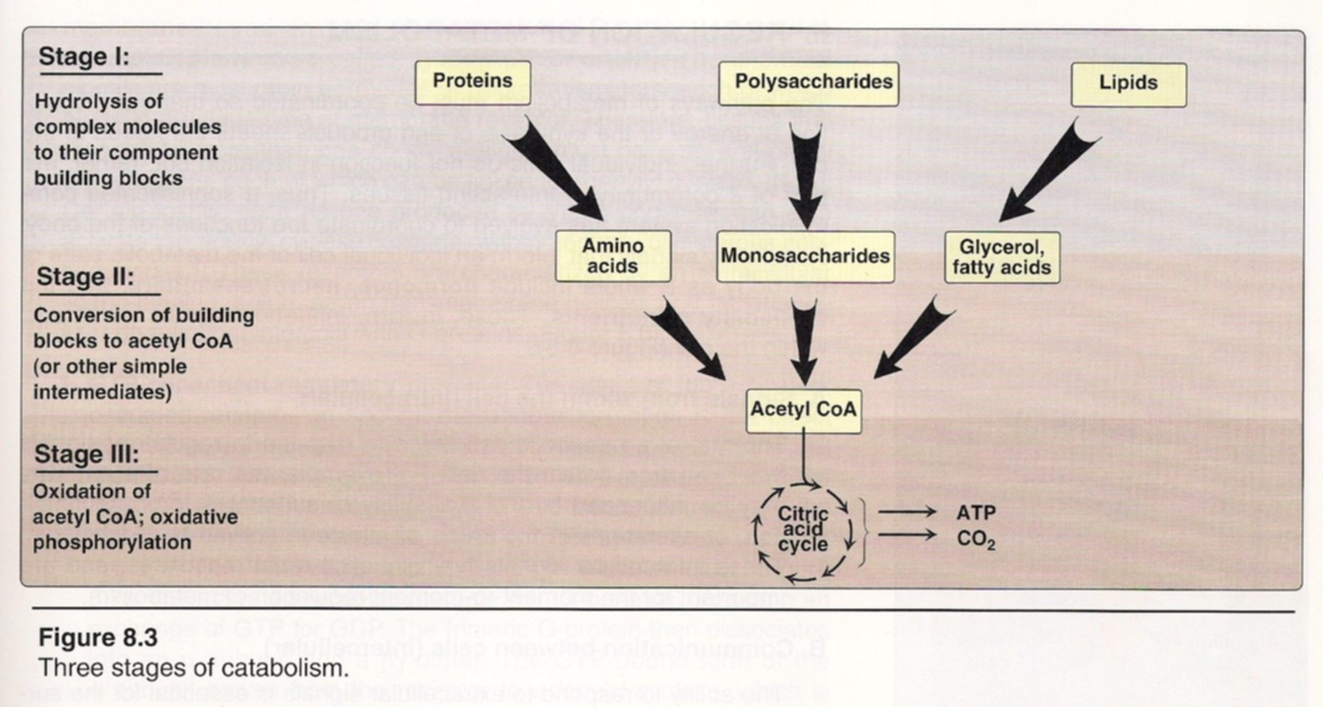
3

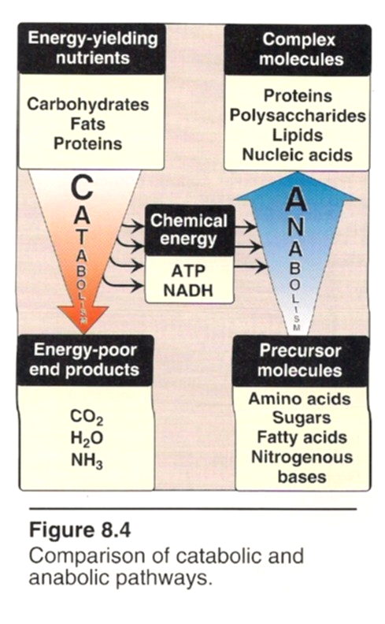

- Metabolic pathways may have a third category called Amphibolic pathway occur at the “crossroads” of metabolism, acting as links between the anabolic and catabolic pathways, e.g., citric acid cycle.
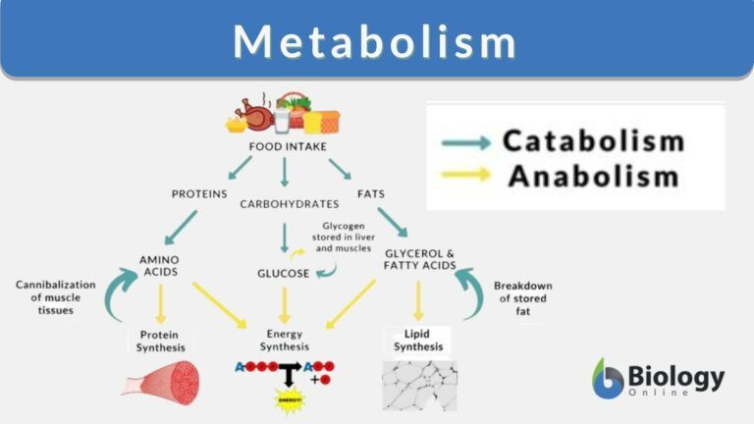
Cellular Regulation of Metabolic Pathways:
The regulation of metabolic pathways may occur at several levels.
1- The reaction rate is a function of pH, intracellular concentration of substrates, products and cofactors.
2- Control of metabolic sequence through the action of regulatory enzymes.
3- Regulation through the genetic control of the rate of enzyme synthesis.
4- Regulatory signals that inform an individual cell of the metabolic state of the body as a whole include hormones, neurotransmitters and the availability of nutrients.

Carbohydrate Metabolism
Introduction
Carbohydrates are polyhydroxy aldehydes or ketones, with the formula (CH₂O) _{n}. They may contain phosphate, amino, or sulfate group.

Carbohydrates are divided into four major groups:
1) Monosaccharides: or called simple sugars with general formula CnH2nOn, these sugars don’t hydrolysis to smaller units. They can be subdivided further:
a) Depending upon the number of carbon atoms, as trioses, tetroses, pentoses, hexoses…
b) Depending upon whether aldehyde (-CHO) or ketone (-C=O) groups are present as aldoses or ketoses.
General formula | Aldosugars | Ketosugars
Trioses (C₃H₆O₃) | Glyceraldehyde | Dihydroxyactone
Tetroses (C₄H₈O₄) | Erthrose | Erythrulose
Pentoses (C₅H₁₀O₅) | Ribose | Ribulose
Hexoses (C₆H₁₂O₆) | Glucose | Fructose

2) Disaccharides: are those sugars which yield two monosaccharide's on hydrolysis. General formula C_{n} (H₂O) _{n-1}
Like: Maltose → glucose + glucose
Lactose → glucose + galactose
Sucrose → glucose + fructose
3) Oligosaccharides: are those which yield 3-10 monosaccharide units on hydrolysis like Maltotriose.

4) Polysaccharides (Glycan's): are those which yield more than ten molecules of monosaccharide on hydrolysis, with general formula (C₆H₁₀O₅) _{n}. Like: starch, glycogen, cellulose, dextrin's…

Biomedical importance of Carbohydrates
- Chief source of energy. Glucose is the preferred source of energy for most of the body tissues. Brain cells derive the energy mainly from glucose.
- Constituents of compound lipid and conjugated proteins.
- Degradation products act as “promoters” or “catalysts”.
- Certain carbohydrates derivatives are used as drugs like glycosides/antibiotics.
- Lactose principle sugar of milk, in lactating mammary gland.
- Degradation products utilized for synthesis of other substances such as fatty acids, cholesterol, amino acid…
- Constituents of mucocpolysaccharides which form the ground substances of mesenchymal tissues.
- Inherited deficiency of certain enzymes in metabolic pathways of different carbohydrates can cause diseases, e.g. galactosemia, glycogen storage diseases (GSDs), lactose intolerance…
- Derangement of glucose metabolism is seen in diabetes mellitus.

Digestion of carbohydrates:
- The major dietary carbohydrates are starch, sucrose, and lactose.
- Human can digest only polysaccharides consisting of α(1→ 4) glycosidic linkage or α (1→ 4) linkage with α (1→ 6) branch points.
- Liquid food materials like milk, soup, fruit juice escape digestion in the mouth as they swallowed, but solid foodstuffs are masticated thoroughly before they swallowed.
- Digestion in Mouth: Salivary α - amylase (ptyalin) (which requires Cl⁻ ion for activation, pH about 6.7) will hydrolyzes α-(1→ 4) glycosidic linkage, molecules like starch, glycogen, and dextrin will produce smaller molecules: maltose, glucose and maltotriose.
- There is no digestion for carbohydrates in stomach, but some dietary sucrose may be hydrolyzed to glucose and fructose by HCl.

- Digestion in the intestine: food bolus reaches the duodenum from stomach where it meets the pancreatic juice. Pancreatic juice contain bicarbonate (HCO₃⁻) neutralizes the stomach acid, raising the pH into the optimal range for the action of the intestinal enzymes.

1) Digestion of pancreatic enzymes:
a- The pancreas secretes an α - amylase also called amylopsin, it is similar to salivary amylase, the enzyme hydrolyze α - (1→ 4) glycosidic linkages between glucose residues.
b- The products of pancreatic α - amylase are the disaccharides maltose, maltotriose, and small oligosaccharides containing α - (1→ 4) and α - (1→ 6) linkages.

2) Digestion by enzymes of intestinal cells:
Action of intestinal juice:
a- intestinal amylase: This hydrolyzes terminal α - (1→ 4) glycosidic linkage in polysaccharides and oligosaccharide molecules liberating free glucose molecule.
b- Isomaltase: It catalyze the hydrolysis of α-(1→ 6) glycosidic linkage, producing maltose & glucose.
c- Maltase: hydrolyze the α - (1→ 4) glycosidic linkage, producing two glucose molecules.
d- Lactase: It is a β - galactosidase. Lactose is hydrolyzed to glucose and galactose.
e- Sucrase: This enzyme converts sucrose to glucose and fructose.

- Carbohydrates that cannot be digested: indigestible polysaccharides are part of dietary fiber that passes through the intestine into the feces.
For example, because enzymes produced by human cells cannot cleave the (β-1, 4) bonds of carbohydrates, these polysaccharides (like cellulose) are indigestible.
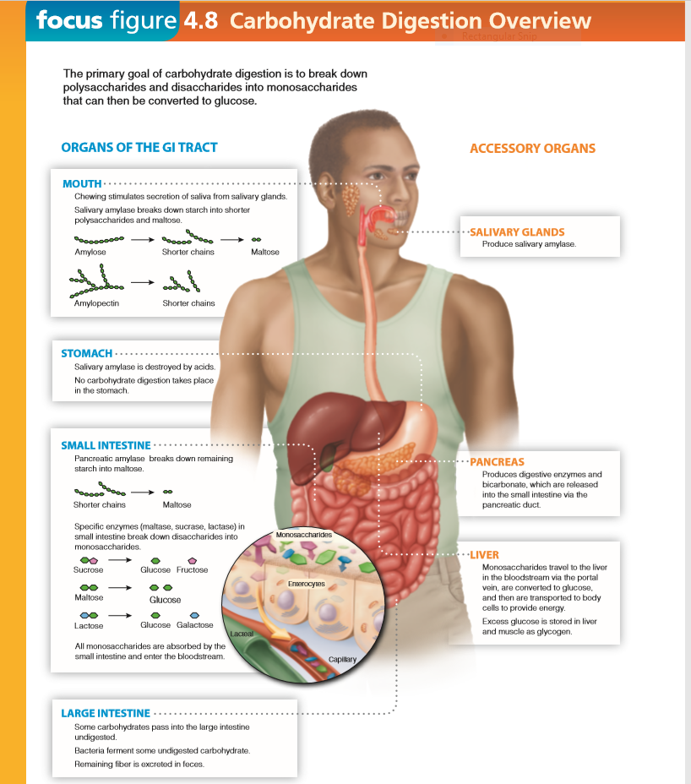
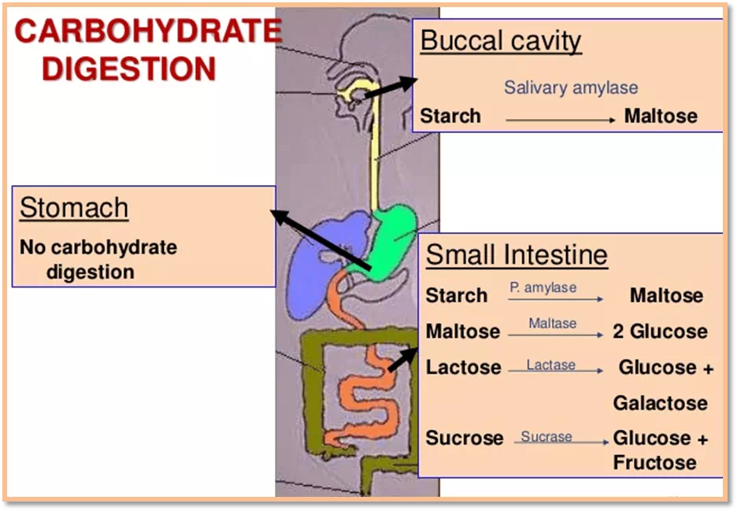

Absorption of glucose, fructose and galactose:
Only monosaccharides are absorbed by the intestine. Absorption rate is maximum for galactose, moderate for glucose and minimum for fructose. Pentoses are absorbed slowly
Mechanisms of absorption:
1-Simple Diffusion: This is dependent on sugar concentration gradients between the intestinal lumen, mucosal cells and blood plasma. All the monosaccharaides are probably absorbed to some extent by simple "passive" diffusion.
2- Active Transport Mechanisms:
- Glucose, fructose and Galactose, the final products generated by digestion of dietary carbohydrates, are absorbed by intestinal epithelial cells.
- Glucose has specific transporters, which are transmembrane proteins
- Co-transport from lumen to intestinal cell, this process is mediated by Sodium Dependent Glucose Transporter-1(SGluT-1)
- The carrier protein has two binding sites one for Na and another for the glucose. The carrier protein is specific for sugar and it is mobile, a Na dependent and energy dependent.
- The transporter in the intestine is named as SGluT-1 and the transporter in the kidney is called SGluT-2. The first one is involved in glucose-galactose malabsorption. The SGluT-2 is defective in congenital renal glycosuria.
B- Another uniport system releases glucose into blood are also called Glucose Transporters (GluT), it is a uniport, facilitated diffusion system.
- Glucose Transporters (Glu-T) are several (Glu-T-1 to 7). The most important are GluT-2 and GluT-4
- GluT-2: Operates in intestinal epithelial cells; it is not Na dependent.
- GluT-4: Operates principally in muscles and adipose tissue.
The GluT-4 is under control of insulin and moves between cytoplasm and membrane.
* ((Note: Other "GluT" molecules are not under control of insulin)).

- GluT-1: is present mainly in RB cells and brain. Also present in retina, colon and placenta.

Absorption of other sugars:
- Sugars like D-fructose and D-mannose are probably absorbed by "facilitated transport" which requires the presence of carrier protein but does not require energy.
- Other sugars like pentoses and L-isomers of glucose and galactose are absorbed passively by simple diffusion.

Factors influencing rate of absorption:
1- State of mucous membrane and length of time of contact.

2- Hormones: thyroid hormones increase hexoses absorption, while adrenal cortex hormones deficiency decrease the hexoses absorption due to decreased Na concentration in body fluids. Insulin has no effect on absorption of glucose.

3- Vitamins: deficiency of B-vitamins decreased hexose absorption.

4- Inherited enzyme deficiencies like sucrase and lactase can interfere with hydrolysis of corresponding disaccharides and their absorption

1 .
Utilization of Glucose in the Body
General outline:
After absorption of monosaccharide into the portal blood, it passes through the liver before entering the systemic circulation. In liver two mechanisms operate:

1- Withdrawal of carbohydrates from blood: This includes:
- Uptake of hexoses by liver cells: such as galactose and fructose and their conversion to glucose by liver cells.
- Conversion of glucose to glycogen for storage (glycogenesis).
- Utilization of glucose, by oxidation (glycolysis) for energy production.
- Utilization of glucose for synthesis of other compounds like fatty acids and certain amino acids.

2- Release of glucose by liver to the blood: This includes:
- Formation of blood glucose from hexoses other than glucose by liver and its release from liver cells.
- Conversion of liver glycogen to blood glucose (glycogenolysis).
- Formation of blood glucose by the liver from non carbohydrate sources, like amino acids (glycogenic), pyruvates and lactates, glycerol and propionly CoA (gluconeogenesis).

Utilization of Glucose:
- Oxidation:
a- For provision of energy: In response to physiological needs, human body requires energy, oxidation of glucose or glycogen to pyruvate and lactate by EM pathways is called “glycolysis”. Glycolysis occurs in all tissues.
b- HMP shunt: An alternative pathway for oxidation of glucose. It is not meant for energy. The pathway provides:
(1) NADPH which is used for reductive synthesis.
(2) Pentoses which is used for nucleic acids synthesis.
This pathway operates only in certain special tissues and not all tissues.
c- Uronic acid pathway: An alternative pathway for oxidation of glucose.
It provides D-glucuronic acid which is used for synthesis of mucopolysaccharides and conjugation reactions.

2- Storage: Excess of glucose taken is converted to glycogen in various tissues (glycogenesis) especially liver and skeletal muscle and stored there for future needs.

3-Conversion to Fats: Excess of glucose is converted to FA and stored as “triacylglycerol” (TG) in Fat depots (lipogenesis).

4- Conversion to other carbohydrates: small amounts of glucose are used directly or indirectly in synthesis other carbohydrates or derivatives, which play important role in the body.
- Formation of ribose and deoxyribose.
- Formation of fructose from glucose.
- Mannose, fucose, glucosamine and Neuraminic acid.
- Galactose.
- D – Glucuronic acid.

5- Conversion to Amino acids

Carbohydrate Metabolism (2)
Glycolysis

Definition: Oxidation of glucose or glycogen to pyruvate and lactate is called glycolysis. It is called also EM pathway "Embden Meyerhof pathway".
- It is the only pathway that is taking place in all the cells of the body.
-Erythrocytes and nervous tissues drive its energy mainly from glycolysis.
-Glycolysis occurs in the cytosol of all cells of the body.

There are two phases of glycolysis:
- Aerobic phase (with oxygen): This series of ten reactions is called aerobic glycolysis because oxygen is required to reoxidize the NADH formed during the oxidation of glyceraldehydes – 3 – phosphate. Aerobic glycolysis sets the stage for the oxidative phosphorylation of pyruvate to acetyl CoA, a major fuel of the citric acid cycle.

- Anaerobic phase (without oxygen): Glucose can be converted to pyruvate which is reduced by NADH to form lactate. This conversion of glucose to lactate is called anaerobic pathway because it can occur without the participation of oxygen. Anaerobic glycolysis allows the continued production of ATP in tissues that lack mitochondria, like red blood cells, or in cells deprived of sufficient oxygen.

The anaerobic phase of glucose metabolism occurs whether O₂ is present or not.
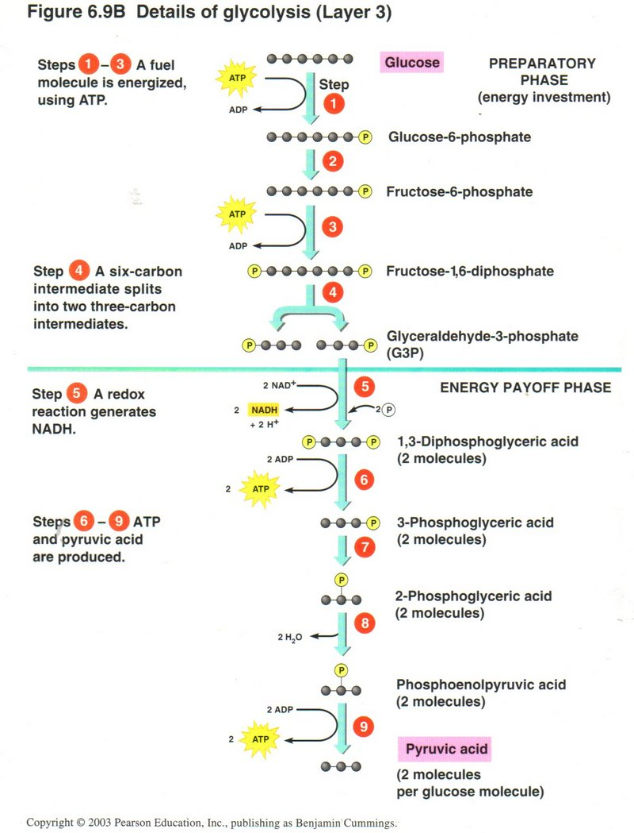
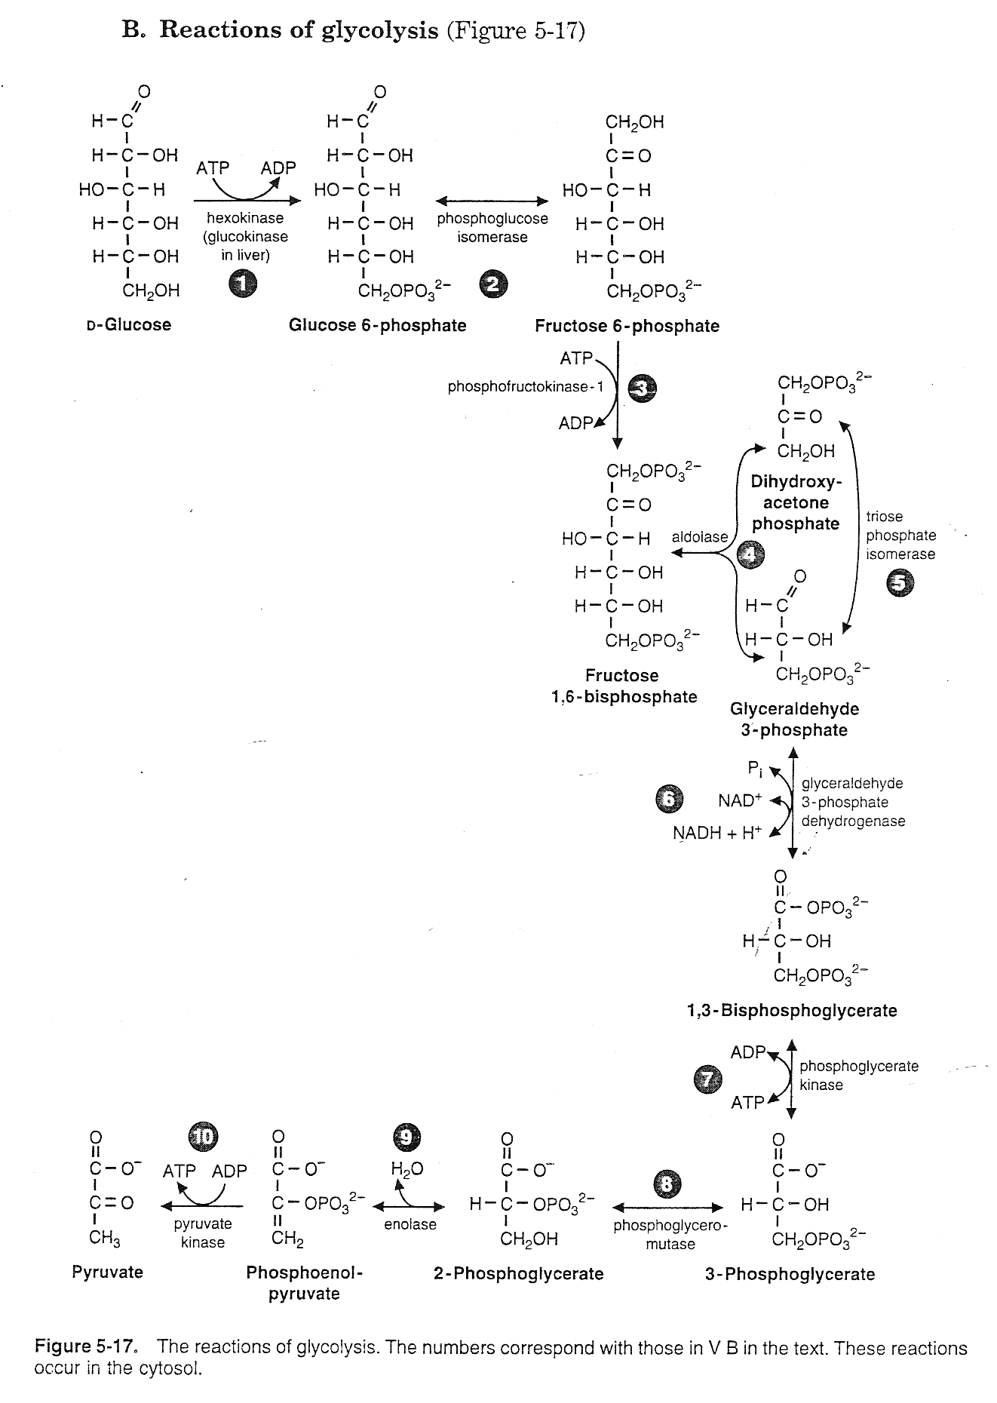

Reactions of glycolysis:
..4
1- Phosphorylation of glucose: glucose is converted to glucose – 6 – phosphate in a reaction that uses ATP and produce ADP. The reaction is catalyzed by specific enzyme (glucokinase) in liver cells and by non – specific (hexokinase) in liver and extra hepatic tissues. Both of these enzymes are subject to regulatory mechanisms.

Differences between hexokinase and glucokinase:
Hexokinase | Glucokinase
- 1-Non – specific, can phosphorylate any of  - the hexoses. | 1- S 1- specific, can phosphorylated glucose only.
2- Found almost in all tissues. | 2- Found only in liver.
3- Found in fetal as well as in adult liver. | 3- Found in adult liver, not in foetal liver.
4- More stable. | 4- Physiologically more labile.
5- Allosteric inhibition by G-6-P. | 5- Not inhibited by G-6-P.
6-Km is low = 0.1mM, hence high affinity  for glucose. | 6- Km is high = 10Mm, low affinity for glucose.
7-Not very much influenced by diabetic state  or fasting. | 7-Depressed in fasting and in diabetes.  Glucokinase is deficient in patients of DM.
8- No change with glucose feeding. | 8- Increased by feeding of glucose after fasting.
9- Inhibited by glucocorticoids and GH,  insulin doesn't affect it. | 9- Inhibited by glucocorticoids and GH.  Synthesis is induced by insulin.
10- Main function to make available  glucose to tissues for oxidation at lower  blood glucose level. | 10- Main function is to clear glucose from  blood after meals and at blood levels greater  than 100 mg/dl.

2- Isomerization of glucose-6- phosphate to fructose–6 – phosphate.
3- Phosphorylation of fructose – 6 – phosphate to fructose 1,6 – bis – phosphate: This reaction is phosphorylated by ATP by the enzyme phosphofructokinase – 1 (PFK-1) is the most important control point and the rate – limiting step of glycolysis. This enzyme is activated by AMP and F-2, 6 – P and inhibited by ATP and citrate.
4- Cleavage of fructose 1, 6 – bisphosphate, to form the triose phosphate: glyceraldehyde 3 – phosphate and dihydroxyacetone phosphate (DHAP).
5- Isomerization of DHAP and formation of glyceraldehydes-3-P.
6- Oxidation of glyceraldehydes – 3 – phosphate to 1, 3 – Bisphosphoglycerate.
7- Synthesis of 3-phospoglycerate producing ATP
8- Shift of the phosphate group from carbon 3 to carbon 2 and form 2- phosphoglycerate.
9- Dehydration of 2 – phosphoglycerate and form (PEP) phosphoenol pyruvate.
10- Formation of pyruvate producing ATP: The conversion of PEP to pyruvate is catalyzed by pyruvate kinase, the third irreversible reaction of glycolysis, pyruvate kinase is activated by F-1,6-p and inhibited by alanine and by phosphorylation in the liver during fasting.

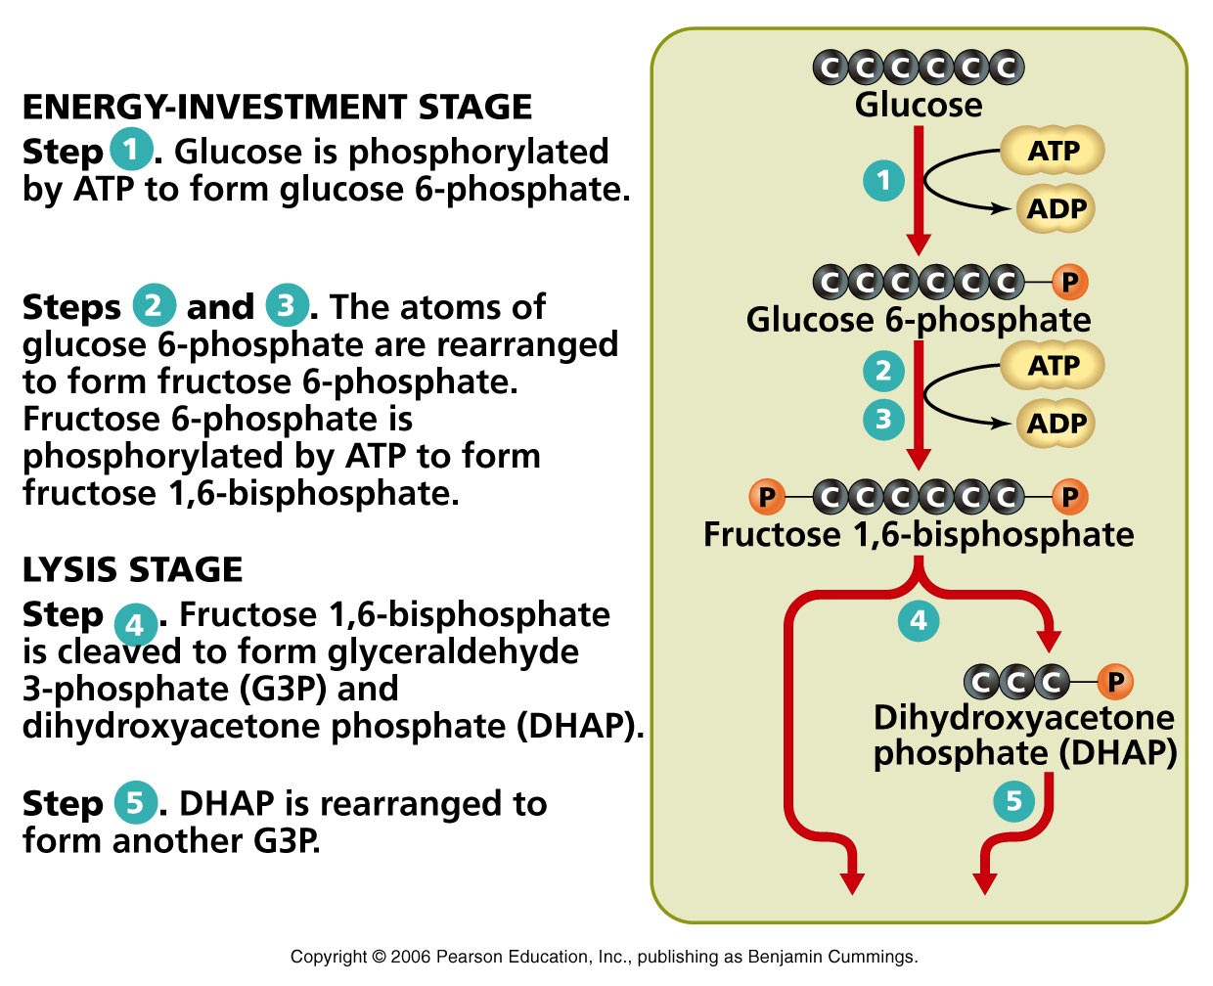

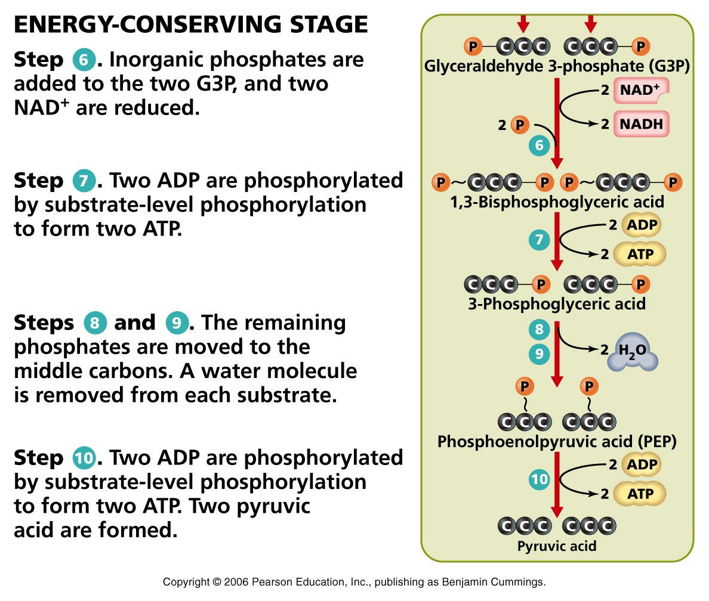
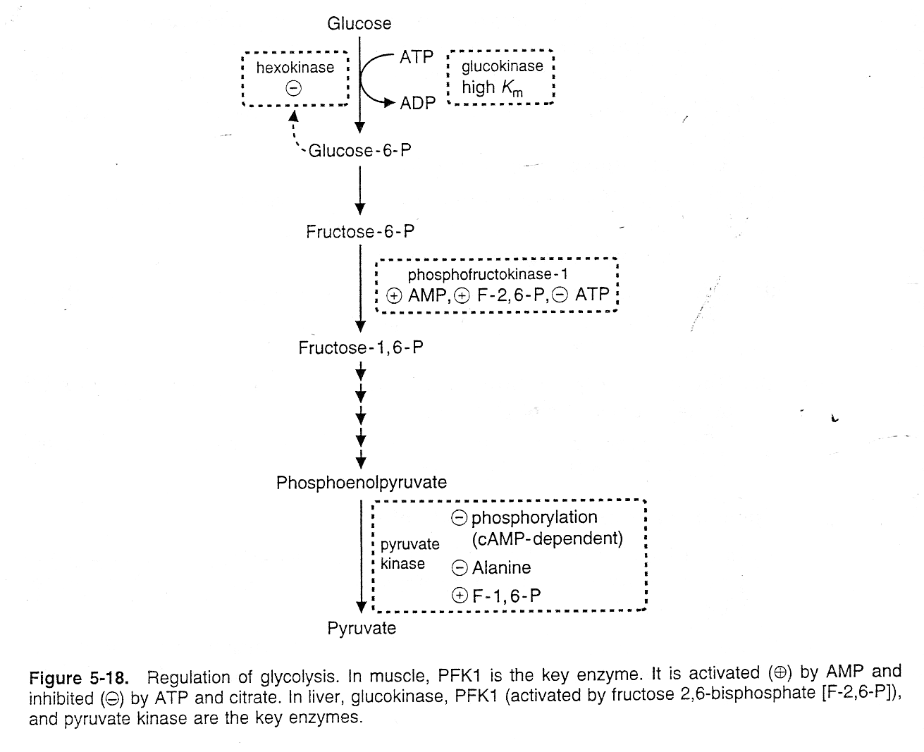

Energy yield per glucose molecule oxidation
A – In Glycolysis in presence of O₂ (Aerobic phase).

Reaction Catalyzed by | ATP production
(phosphorylation)
1- Hexokinase/Glucokinase reaction | - 1 ATP
2- Phosphofructokinase | - 1 ATP
(Oxidation of 2 NADH in electron transport chain)
3- Glyceraldehyde - 3 - P dehydrogenase | + 6 ATP
(Substrate level phosphorylation)
4- Phosphoglycerate kinase | + 2 ATP
5- Pyruvate kinase | + 2 ATP
* (1 NADH → 3 ATP) Net gain | = 10 – 2
 | = 8 ATP

B-In Glycolysis in the absence of O₂ (Anaerobic phase)
This is achieved by re-oxidation of NADH by conversion of pyruvate to lactate (without producing ATP) by the enzyme lactate dehydrogenase.

COOH COOH
C = O lactate dehydrogenase CHOH
CH₃ NADH + H⁺ NAD⁺ CH₃
Pyruvate (keto) lactic acid
In anaerobic phase per molecule of glucose oxidation
4 – 2 = 2 ATP will be produced
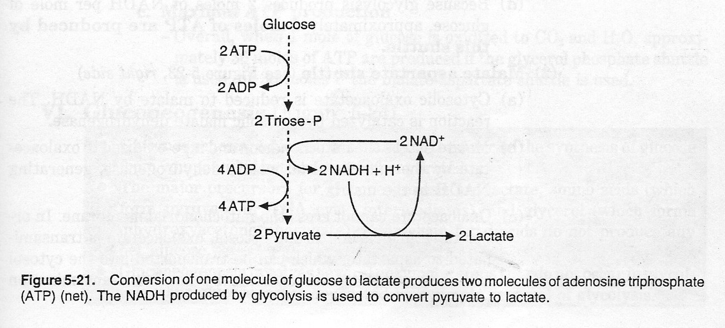

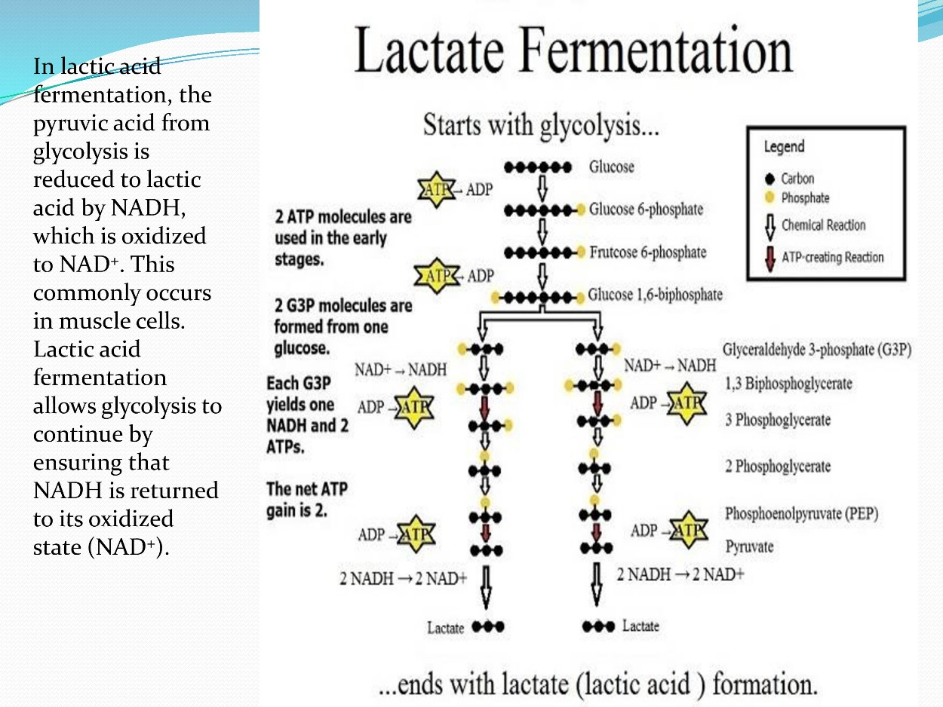
Clinical Importance of anaerobic glycolysis:
- Tissues that function under hypoxic circumstances will produce lactic acid from glucose oxidation, producing local acidosis. If lactate production is more it can produce metabolic acidosis.
- Whether O₂ is present or not, glycolysis in erythrocytes always terminates in pyruvate and lactate.
- Vigorously contracting skeletal muscle will produce relative anaerobiosis and glycolysis will produce lactic acid.
- Inhibitor of Lactate Dehydrogenase (LDH) is Oxamate: it competitively inhibits lactate dehydrogenase and prevents the reoxidation of NADH.

The Biomedical Importance of Glycolysis

- This pathway is meant for provision of energy.
- It has importance in skeletal muscle as glycolysis provides ATP even in absence of O₂.
- Muscle can survive anoxic episodes.
- Insulin favors glycolysis by activating the three key glycolytic enzymes.
- Glucagon and glucocorticoid inhibit glycolysis and favor gluconeogenesis.

- Heart muscle: as compared to skeletal muscle, heart muscle is adapted
for aerobic performance.
It has relatively poor glycolytic activity and poor survival under conditions
of ischemia.

- Role in cancer therapy: In fast- growing cancer cells, rate of glycolysis is very high. Producing more pyruvic acid than TCA cycle can handle. Accumulation of pyruvic acids leads to excessive formation of lactic acid producing local lactic acidosis.

- Hemolytic anemia: inherited enzyme deficiencies like hexokinase deficiency and pyruvate kinase deficiency in glycolytic pathway enzymes, can produce hemolytic anemia.

