PRIMARY AMENORRHEA

Objectives
- Learn the definition of this gynecological problems
- Explain the etiology and pathophysiology
- Gain the ability to diagnose and treat according to different clinical presentation

PRIMARY AMENORRHEA

DEFINITION: The failure to menstruate by the age of 16 years in the presence of normal secondary sexual characteristics, or 14 years in the absence of other evidence of puberty.
The causes can be related to
1-the outflow tract (congenital malformation or receptor insensitivity),
2-the ovary (abnormal or absent germ cells and abnormal folliculogenesis),
3-the anterior pituitary (disrupted gonadotrophin production or secretion) and
4-the central nervous system (CNS) (disrupted hypothalamic factors affecting pituitary signalling). The commonest diagnoses are highlighted in Table 1.
Overall it is estimated that endocrine disorders account for approximately 40% of the causes of primary amenorrhoea, with the remaining 60% having developmental (genetic or structural) origins. It must not be forgotten that amenorrhoea is also frequently physiological; in this age group, pregnancy must be ruled out and constitutionally delayed puberty identified as a diagnosis of exclusion.
Evaluation of the adolescent
History, examination and baseline investigation A thorough history should include
enquiry about growth and development, and signs of puberty. Evidence of psychological dysfunction or emotional stress should be borne in mind through verbal and non-verbal cues, and in relation to enquiry about the family and social (educational) history.

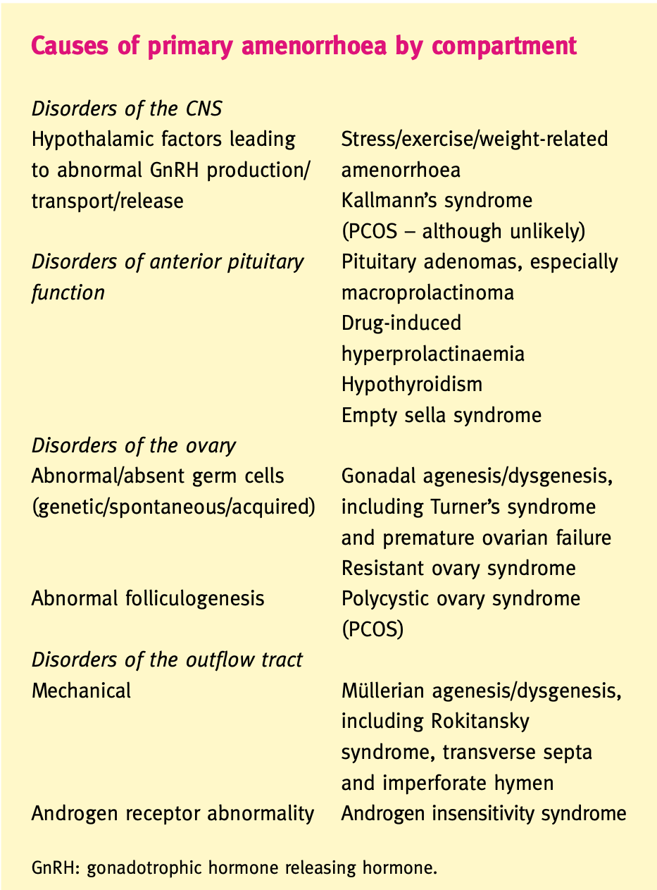

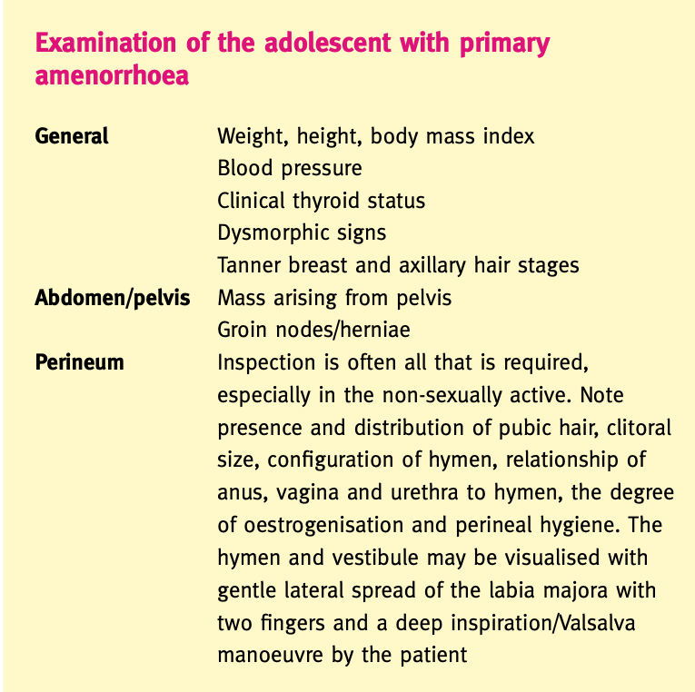

Amenorrhoea of hypothalamic/CNS origin

Weight-related amenorrhoea
The hypothalamus is central to the normal functioning of the reproductive axis. The transition of puberty is driven by of gradually increasing pulse amplitude and frequency of GnRH. Between the ages of 8 and 13 years, pituitary gonadotrophin release occurs, initially nocturnally and then also by day, culminating in the adult pattern of 90-min pulses. The precise mechanism driving the hypothalamus is not yet fully clear but there is a close relationship to body weight and in par- ticular to body fat proportion. White fat produces hormone leptin, which has hypothalamic receptors. Its action is mediated through the inhibition of neuropeptide Y, which in turn reduces GnRH pulsatility. This has been interpreted as a signal from the fat stores to the brain that adequate levels of body fat have been reached for successful reproduction. The balance is then struck by reduced food intake, leading to reduced thermo- genesis, increased insulin output (­liberating biologically active sex steroids from insulin-like growth factor binding protein-1 and sex hormone binding globulin suppression) and increased GnRH pulsatility.
There has been some evidence that a critical fat mass of 22% is required for this sequence of events to occur. This theory explains the earlier onset of menarche observed in affluent societies over the past 100 years, and the absence of menarche in malnourished girls, particularly anorexic girls and those undertaking significant exercise (­ballet dancers, gymnasts and especially competitive endurance sportswomen). Treating the problem requires the cause to be addressed, which can uncover major conflicts of psychological disturbance and distorted body image in the case of eating disorders, and may be perceived to compromise sporting or artistic success in the case of excessive exercise. sometimes a relatively minor reduction in exercise intensity and/or increased caloric intake may suffice to trigger resumption of hypothalamic activity. Delayed puberty becomes medically significant when there is a risk of poor bone mineralization and osteoporosis. If osteoporosis is a concern, puberty may be induced with gradually increasing oral oestrogen therapy (­2 mcg ethinyloestradiol daily, increasing by 5 mcg every 6 months to 20 mcg, then conversion to the combined oral contraceptive pill [COCP]).

Constitutionally delayed puberty is characterised by a positive family history, short stature, delayed secondary sexual characteristics and delayed epiphyseal maturation (­identified by hand X-ray bone aging). Final height prognosis remains in the appropriate range for the parental centiles. Other causes should be ruled out and puberty induced as described above. Note that hypogonadotrophic hypogonadism is difficult to distinguish from constitutional delay and may only manifest on withdrawal of oestrogen support in due course.
Add pic of bone

Chronic illness
Many types of chronic childhood illnesses may cause sufficient general debilitation as to compromise hypothalamic function by similar central mechanisms. A good history should also identify malabsorption syndromes (­coeliac disease and inflammatory bowel disease) which warrant specific treatments. Childhood cancer requiring cranial irradiation invariably causes pubertal failure which should be proactively managed to optimise growth and development.

Space-occupying lesions
Space-occupying lesions of the hypothalamus (­craniopharyngiomas, germinomas, gliomas, dermoid cysts) are rare but when they do occur, they tend to exhibit clinical effects around the time of puberty. They cause amenorrhoea by disrupting the tonic inhibition of dopamine on prolactin release and/or compress and destroy hypothalamic and pituitary tissue. They are likely to present with other concerning symptoms of a neurological nature (­headache, visual field defects) and evidence of other pituitary hormone dysfunction, including galactorrhoea. Diagnosis will involve cranial imaging and neurological/neurosurgical input. Invariably destructive therapy in the form of surgery and/or radiotherapy is required. Subsequent hormone replacement will depend on the resulting deficiencies.

Kallmann’s syndrome
This is the rare (­1:50 000) congenital absence of GnRH neurons whose cell bodies have failed to migrate from the olfactory area to the arcuate nucleus of the hypothalamus through the cribriform plate at the base of the skull. It may be sporadic or inherited (­autosomal dominant or X-linked recessive) and is associated with anosmia and colour blindness.
Add pic of anatomy and women with kallman
Therapy
Where possible, therapy should be directed at the cause of the problem. puberty induction can be accomplished with oestrogen and until fertility is required, hormone replacement with the COCP are satisfactory in the medium to long term. The onset of breast development associated with a growth spurt rapidly solves the problem. Many young women also welcome the option of minimising menses to three to four times per year by taking COCP cycles back to back. This also minimises periods of oestrogen deficiency which can be unpleasantly symptomatic. In isolated hypothalamic dysfunction, fertility can be restored either with GnRH administered through a subcutaneous needle and pump device, delivering physiological pulses to an intact pituitary, or with daily bolus exogenous follicle stimulating hormone (­FSH) and LH by subcutaneous injection. Gonadotrophin ovulation induction requires careful monitoring to guard against the risk of multiple pregnancy and ovarian hyperstimulation syndrome.

Amenorrhoea of pituitary origin
Hyperprolactinaemia
Hyperprolactinaemia is the commonest pituitary cause of amenorrhoea, although it is not a common presentation in adolescents with primary amenorrhoea. It can arise due to the development of a tumour which can be a micro (­<10 mm) or macro (­>10 mm) adenoma, of the functioning or non-functioning variety, either by the cells over-producing prolactin or the mass effect disrupting the inhibition exerted by hypothalamicopamine. When amenorrhoea is the consequence of hyperprolactinaemia, presenting symptoms are more commonly related to oestrogen deficiency. Up to 30% may have galactorrhoea but this bears no correlation with prolactin levels or the presence of a tumour. Only 5% will display visual field defects. Persistently elevated prolactin (­>1500 mU/L) associated with amenorrhoea warrants pituitary Magnetic resonance imaging .
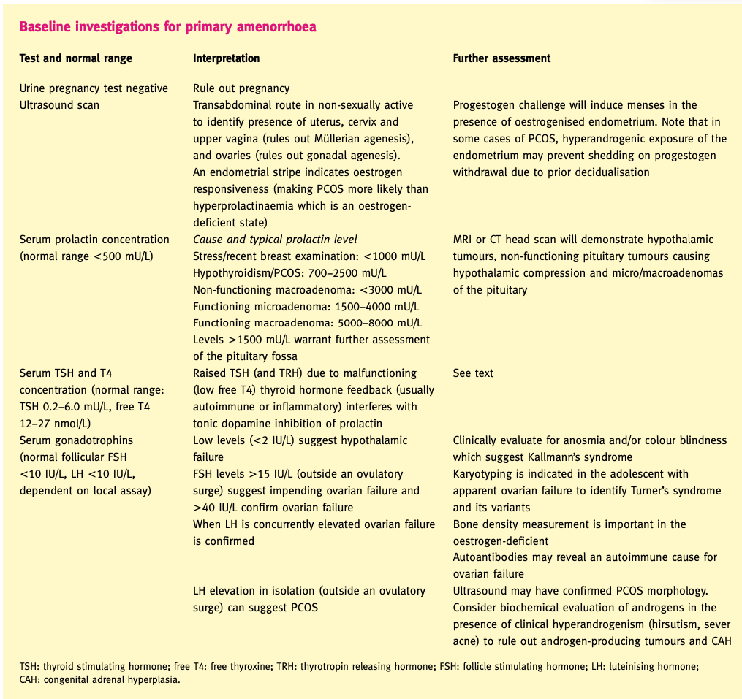

Therapy: Dopamine-agonist treatment is favoured for prolactin- secreting tumours displaying rapid growth or those that are large at diagnosis. Bromocriptine is started at a dose of 1.25 mg per night for 5 nights, and is gradually titrated up to 7.5 mg daily in two or three divided doses over about 3 weeks. Common side-effects include nausea, vomiting, headache and postural hypotension, and are minimised by initiating therapy at night and then taking tablets with food. Longer-term adverse effects include Raynaud’s syndrome, constipation and psychiatric changes, especially aggression, which can occur at the start of therapy. Carbergoline (­0.25–1 mg twice-weekly up to 1 mg daily) is longer acting and better tolerated by many patients who experience unacceptable side-effects on bromocriptine. However, it also can have psychiatric side-effects and therefore should remain second-line. Surgery (­transsphenoidal resection of the adenoma) is reserved for those with intolerable side-effects to medication, non-functioning macroadenomas or suprasellar extension that has not resolved with medical therapy. Pituitary irradiation is seldom required with the availability of modern neurosurgical skills
Asymptomatic, incidentally-detected microadenomas of the pituitary are common (­up to 10% of the population). They rarely grow, and if they do, progression is slow. They should be imaged at 1, 2 and 5 years and if there has been no change, no further follow-up is required.
Iatrogenic causes of hyperprolactinaemia include the use of dopaminergic antagonist drugs such as antipsychotic phenothiazines, domperidone and metoclopramide.
Empty sella syndrome
This is a benign condition arising due to congenital absence of the sellar diaphragm. It can also occur following surgery, radiotherapy or the development of a tumour.

Amenorrhoea of ovarian origin
Chromosomal abnormality
Unlike the testes, ovaries devoid of gametes are unable to produce normal amounts of steroid hormones, leading to elevated concentrations of serum gonadotrophins. Several chromosomal abnormalities result in gonadal dysgenesis, the commonest being 45XO or Turner’s syndrome. Others include Turner’s mosaics and XY mosaics (­Swyer’s syndrome). Most girls with Turner’s syndrome are diagnosed in the neonatal period or in infancy due to phenotypic abnormalities. All will experience primary amenorrhoea and should undergo artificial induction of puberty in conjunction with specialised optimisation of growth through the care of the paediatric endocrinologist. Some with a mosaic karyotype will begin to go through puberty but fail to menstruate, or may suffer early secondary amenorrhoea. Any evidence of Y chromosomal material warrants surgical excision of the gonads to remove any risk of malignant change (­gonadoblastoma) within them. During adolescence, the goal is to optimise pubertal development in respect of appropriate body image and also to promote uterine growth in anticipation of potential pregnancy achieved in due course through oocyte donation and intravenous fertilisation (­IVF) techniques. Until that time, cyclical menses may be achieved with the COCP or hormone replacement as previously described.
Premature ovarian failure (­POF) may also result from polyglandular autoimmune syndromes (­in conjunction with combinations of hypothyroidism, hypoparathyroidism, hypoad- renalism/Addison’s disease and type 1 diabetes). It can be difficult to detect ovarian autoantibodies due to the poor sensitivity of current assays. An increasingly common cause of POF in adolescence is childhood cancer that has required gonadotoxic chemotherapy (­e.g. alkylating agents like cyclophosphamide) and/or pelvic irradiation (­e.g. Hodgkin’s disease or Wilm’s tumour).

Resistant ovary syndrome: Rarely, the ovary may contain a normal complement of primordial follicles yet fail to respond to the gonadotrophin stimulus. Most cases remain unexplained. The same advice applies with respect to the induction and support of puberty and menstrual function, and counselling with respect to fertility prospects with donated oocytes.

Polycystic ovary syndrome
PCOS is the commonest endocrinopathy to affect women of reproductive age and is also one of the commonest causes of primary (­and secondary) amenorrhoea. Gonadotrophin concentrations are normal/low normal and oestrogen concentrations satisfactory. An underlying hypothalamic abnormality of increased GnRH pulsatility has been suggested to contribute to the pathogenesis of the condition, such that the pituitary responds with inappropriate and excessive luteinising hormone (­LH) secretion, leading to the premature arrest of ovarian follicle development, ovarian hyperandrogenism and amenorrhoea. This might come about due to earlier attainment of the critical body fat mass in an individual who has an intrinsic/genetic predisposition to insulin resistance.PCOS is frequently associated with clinical or biochemical evidence of hyperandrogenism and/or obesity. Indeed according to the most recent international consensus definition(­Rotterdam ESHRE/ASRM Workshop, 2003), two to three criteria of (­oligo-) amenorrhoea, hyperandrogenism, or polycystic ovary morphology (­after the exclusion of other causes of hyperandrogenism, e.g. late onset congenital adrenal hyperplasia [CAH], Cushing’s syndrome and androgen-producing tumours) suffice to make the PCOS diagnosis.

Therapy:that active management of lifestyle issues aimed at normalising body weight is important. Weight gain permits the condition to manifest more severely, and sets up a ‘slippery slope’ towards worsening insulin resistance which has profound implications for lifelong health (­especially type 2 diabetes) and fertility. Weight loss of just 5–10% is often sufficient to shift metabolically active visceral fat and restore normal menstrual regularity. Good diet and increased exercise should continue to be encouraged until a normal weight for height is achieved. Amenorrhoea may be overcome during the weight loss programme by inducing regular withdrawal bleeds either with progestogens (­e.g. medroxyprogesterone acetate 10 mg daily for 5 days every 3 months) or a COCP with a non-androgenic progestogen, antiandrogen (­e.g. cyproterone acetate) or the newly marketed spironolactone derivative drosperinone. This is important to prevent endometrial accumulation and the risk of hyperplasia. Clinical hyperandrogenism is often best managed cosmetically, but some find benefit in the topical preparation Vaniqa for unsightly facial hair. If ovulation has not been spontaneously restored by the time fertility becomes important, the common sequence of therapies entails ovulation induction with clomifene citrate (­with/without metformin), followed if unsuccessful by daily gonadotrophins. Ultimately IVF techniques may be employed with good success but increased risk of complications in the form of ovarian hyperstimulation syndrome.

Amenorrhoea due to outflow tract abnormalities
Abnormalities of the uterus or outflow tract are rare causes of amenorrhoea overall but are relatively commoner causes of primary amenorrhoea. Congenital abnormalities can arise from embryological failure of canalisation or complete lack of development of the Müllerian duct, or due to the correct regression of Müllerian structures but the evolution of the female phenotype due to androgen insensitivity syndrome (­46XY).
Müllerian abnormalities
Complete Müllerian agenesis is the second commonest cause of primary amenorrhoea (­10%) after gonadal dysgenesis (­40%). Also known as Mayer–Rokitansky–Kuster–Hauser syndrome, or Rokitansky syndrome for short, it occurs in approximately 1:5000 pregnancies. The vagina is absent or hypoplastic. The uterus is usually absent although there may be a small non-communicating rudimentary remnant, which may or may not contain endometrium. There are frequently concurrent abnormalities of the urological tract (­e.g. unilateral renal agenesis, pelvic kidney, horseshoe kidney, hydronephrosis, ureteric duplication). Ovarian development and function is normal.
Imperforate hymen (relatively common 1:1000) and transverse vaginal septum ( rare 1:80,000) are outflow tract malformations that typically present with acute cyclic pelvic or abdominal pain in a patient soon after the age of expected menarche and may cause painful haematocolpos, haematometra and haemoperitoneum. The patient will often have age- appropriate secondary development. Examination of an imperforate hymen reveals no obvious vaginal orifice and often a bulging, thin perineal membrane. In a patient with a transverse septum, physical exam will reveal a normal vaginal orifice but no visible cervix. In some cases, an MRI may be required to distinguish an imperforate hymen from a transverse septum.

Therapy
In all cases, surgery is required to establish patency of the tract or to remove the rudimentary structure if it has no prospect of ever functioning normally. Without surgery, proximal menstrual build-up may cause serious damage to a potentially functional reproductive system. Cruciate incision of an imperforate hymen is straightforward and does not require subsequent dilatation. Transverse septa can arise at different levels in the vagina and may be quite thick. Ovarian integrity means that IVF surrogacy is very successful with a surrogate carrying the pregnancy following embryo transfer.

Androgen insensitivity syndrome
Androgen insensitivity syndrome is rare (­1:60,000) but represents 5% those presenting in adolescence with primary amenorrhoea. The karyotype is 46XY with a female phenotype. The gonads are testes which exhibit failure of spermatogenesis but maintain testosterone production. Normal secretion of testicular Müllerian inhibitory factor in utero leads to regression of internal Müllerian structures. The gonads may be abdominally located or in the inguinal canals. Pubic and axillary hair are absent. The labia minora tend to be juvenile and the vagina is short and blind-ending. Breast development occurs due to peripheral aromatisation of testosterone to oestrogen.

Therapy
There is a risk of malignant change in the malpositioned gonads but this is rare prior to the completion of puberty, and endogenous hormone production produces a smother pubertal transition and more normal early breast development. They may be removed on completion of the growth spurt. Hormone replacement must follow to complete breast development, and to maintain bone health. Sadly these young women are unable to conceive by any of the assisted reproductive technologies and coming to terms with this profound news requires specialist counselling support.

