ANTEPARTUM HAEMORRHAGE

Objectives
- Learn the definition of antepartum hemorrhage
- Identifying the possible causes
- Describe the clinical features and diagnostic criteria for placenta previa, placental abruption and placenta previa accreta
- Describing the most important points in resuscitation of theses cases
- Describe the appropriate management plan based on the cause

Antepartum haemorrhage
This is defined as vaginal bleeding after 20 weeks’ gestation. It complicates 2–5% of pregnancies and most cases involve relatively small amounts of blood loss. However, significant blood loss poses a risk of mortality and morbidity to both mother and baby. The causes can be classified into placental, fetal and maternal:
• Placental causes: placental abruption, placenta praevia.
• Fetal cause: vasa praevia.
• Maternal causes: vaginal trauma; cervical ectropion; cervical carcinoma; vaginal infection and cervicitis.
Placental causes are the most worrying, as potentially the mother’s and/or fetus’s life is in danger and often the bleeding may be more severe than with other causes such as cervical ectropion. However, any antepartum haemorrhage must always be taken seriously, and any woman presenting with a history of fresh vaginal bleeding must be investigated promptly and properly. The key question is whether the bleeding is placental and is compromising the mother and/or fetus, or whether it has a less significant cause.
History
• How much bleeding?
• Triggering factors (e.g. postcoital bleed).
• Associated with pain or contractions?
• Is the baby moving?
• Last cervical smear (date/normal or abnormal)?
Examination
- Pulse, blood pressure.
- Is the uterus soft or tender and firm?
- Fetal heart auscultation/CTG.
- Speculum vaginal examination, with particular importance placed on visualizing the cervix (hav- ing established that placenta is not a praevia, pref- erably using a portable ultrasound machine).
Investigations
• Depending on the degree of bleeding, full blood count, clotting and, if suspected praevia/ abruption, cross-match 6 units of blood.
• Ultrasound (fetal size, presentation, amniotic fluid, placental position and morphology).

Immediate management
• An intravenous line should be inserted with a wide bore needle and infusion of normal saline or colloids should be started.
• Blood sample should be drawn for hematocrit, cross-matching, and other tests depending on initial diagnosis .
• The bladder should be catheterized and hourly urine output monitored.
• Blood should be transfused as required.
• Once the patient is stabilized hemodynamically, ultrasonography should be performed to diagnose the cause of bleeding and assess fetal status.
• Subsequent management depends on the cause of bleeding.

Placental abruption
Placental abruption is the premature separation of the placenta from the uterine wall. The bleeding is maternal and/or fetal and abruption is acutely dangerous for both the mother and fetus (Figure 14.4).
Classification is made as follows:
- mild abruption, vaginal bleeding is minimal with no fetal monitor abnormality. Localized uterine pain and tenderness is noted, with incomplete relaxation between contractions.

- moderate abruption, symptoms of uterine pain and moderate vaginal bleeding can be gradual or abrupt in onset. From 25–50% of placental surface is separated. Fetal monitoring may show tachycardia, decreased variability, or mild late decelerations.

- severe abruption, symptoms are usually abrupt with a continuous knife-like uterine pain. More than 50% of placental separation occurs. Fetal monitor shows severe late decelerations, bradycardia, or even fetal death. Severe disseminated intravascular coagulation (DIC) may occur. Ultrasound visualization of a retroplacental hematoma may be seen.

Clinical presentation
The characteristic presentation of placental abruption is that of painful bleeding associated with a tense rigid abdomen. The absence of a tense abdomen does not rule out a placental abruption. Placental abruption may be diagnosed on ultra- sound but the absence of any ultrasound changes does not rule it out and patients should be managed on the basis of their clinical findings. Maternal signs and symptoms may include vaginal bleeding, abdominal pain, sweating, shock, hypotension, tachycardia, absence or reduced fetal movements and tense painful abdomen. CTG may reveal evi- dence of fetal distress.
The degree of vaginal bleeding does not necessarily correlate with the degree of abrup- tion as abruptions may be concealed (i.e. sig- nificant separation between placenta and uterus but blood is concealed between the placenta and uterus so there is little vaginal bleeding seen [Figure 14.4B]).

Risk factors: Abruptio placentae is seen more commonly with previous abruption, hypertension, and maternal blunt trauma. Other risk factors are smoking, maternal cocaine abuse, and premature membrane rupture.
Laboratory Findings
Blood type and Rh status, hemoglobin, hematocrit, platelet count, coagulation studies, and fibrinogen level should be sent. A Kleihauer-Betke test should be sent for all women who are Rh negative.
Imaging Studies
Ultrasound has become important in the diagnosis and characterization of placental abruption. More than 50% of patients with confirmed abruption will have evidence of hemorrhage on ultrasound. Echogenicity, size, and location of the hemorrhage can be described, allowing the clinician to better understand the timing and severity of the abruption. If the ultrasound is performed during the early phases of the abruption, the area of hemorrhage will appear isoechoic or hyperechoic compared with the echogenicity of the placenta. The hematoma becomes hypoechoic within 1 week and sonolucent within 2 weeks of the initial hemorrhage.

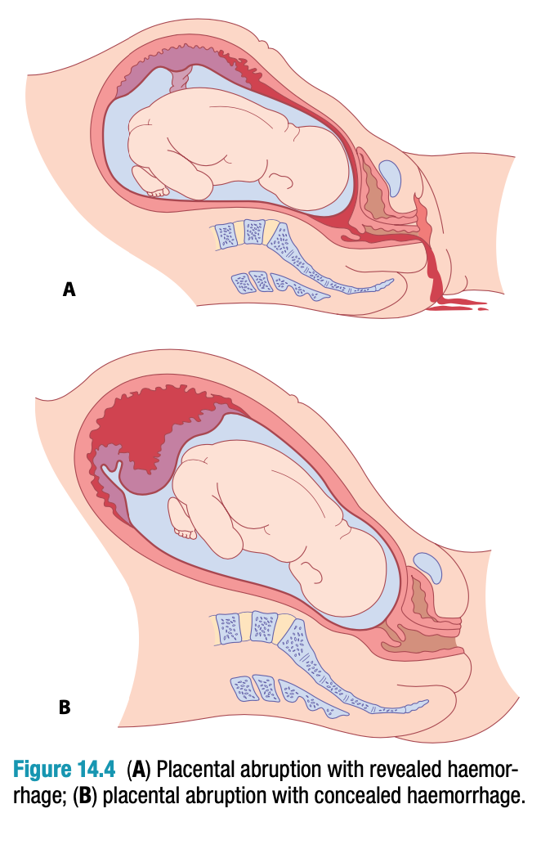

A larger hematoma is associated with a worse prognosis than a smaller hematoma. A retroplacental hemorrhage has a worse prognosis than a subchorionic hemorrhage, which is defined as a collection of blood between the chorion and the decidua. A retroplacental hemorrhage that is >60 mL in volume has at least a 50% morality rate associated with it.
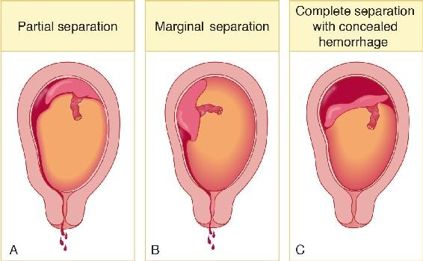
Management of placental abruption is variable
Emergency cesarean delivery is performed if maternal or fetal jeopardy is present as soon as the mother is stabilized.
Vaginal delivery is performed if bleeding is heavy but controlled or pregnancy is >36 weeks. Perform amniotomy and induce labor. Place external monitors to assess fetal heart rate pattern and contractions. Avoid cesarean delivery if the fetus is dead.
Conservative in-hospital observation is performed if mother and fetus are stable and remote from term, bleeding is minimal or decreasing, and contractions are subsiding. Confirm normal placental implantation with sonogram and replace blood loss with crystalloid and blood products as needed.
Complications include the following: Severe abruption can result in hemorrhagic shock with acute tubular necrosis from profound hypotension and DIC from release of tissue thromboplastin into the general circulation from the disrupted placenta. Couvelaire uterus refers to blood extravasating between the myometrial fibers, appearing like bruises on the serosal surface.
Placenta praevia
Usually the lower implanted placenta atrophies and the upper placenta hypertrophies, resulting in migration of the placenta. At term, placenta previa is found in only 0.5% of pregnancies.
A placenta covering or encroaching on the cervical os may be associated with bleeding, either provoked or spontaneous. The bleeding is from the maternal not fetal circulation and is more likely to compromise the mother than the fetus.
Symptomatic placenta previa occurs when painless vaginal bleeding develops through avulsion of the anchoring villi of an abnormally implanted placenta as lower uterine segment stretching occurs in the latter part of pregnancy.
Classification is made as follows:
Total, complete, or central previa is found when the placenta completely covers the internal cervical os. This is the most dangerous location because of its potential for hemorrhage.
Partial previa exists when the placenta partially covers the internal os. Marginal or low-lying previa exists when the placental edge is near but not over the internal os.
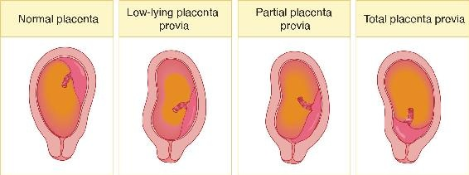

Clinical Presentation. The classic picture is painless late-pregnancy bleeding, which can occur during rest or activity, suddenly and without warning. It may be preceded by trauma, coitus, or pelvic examination. The uterus is nontender and nonirritable.
Risk Factors. Placenta previa is seen more commonly with previous placenta previa and multiple gestation. Other risk factors are multiparity and advanced maternal age.
Laboratory Findings
Baseline admission labs including blood type and Rh status, hemoglobin, hematocrit, and platelet count should be sent. Coagulation studies and fibrinogen concentration are not as important in patients with previa as in patients with abruption; however, if there is any doubt of the diagnosis, these should also be sent. A Kleihauer-Betke test should be sent for all women who are Rh negative.
Imaging Studies
Prior to the advent of routine second-trimester ultrasound, patients with placenta previa were diagnosed at the onset of bleeding. Currently, most cases are diagnosed by ultrasound in the second trimester, although most of these will resolve. Five to fifteen percent of all patients will have placenta previa at 17 weeks. Ninety percent of these will resolve by 37 weeks. This occurs because as the lower uterine segment develops, more distance is created between the placenta and the cervix. Complete previa and marginal or partial previa diagnosed in the second trimester will persist in 26% and 2.5% of patients, respectively. All patients who have placenta previa diagnosed before 24 weeks should have a sonogram between 28 and 32 weeks to reassess the position of the placenta.
Management of placenta previa is variable:
Emergency cesarean delivery is performed if maternal or fetal jeopardy is present after stabilization of the mother.
Conservative in-hospital observation (bed rest) is performed in preterm gestations if mother and fetus are stable and remote from term. The initial bleed is rarely severe. Confirm abnormal placental implantation with sonogram and replace blood loss with crystalloid and blood products as needed.
Scheduled cesarean delivery is performed if the mother has been stable after fetal lung maturity has been confirmed by amniocentesis, usually at 36 weeks’ gestation.
Complications can include: If placenta previa occurs over a previous uterine scar, the villi may invade into the deeper layers of the decidua basalis and myometrium, resulting in intractable bleeding requiring cesarean hysterectomy. Profound hypotension can cause anterior pituitary necrosis (Sheehan's syndrome) or acute tubular necrosis.
Placenta praevia: prevention/ risk factors/warning signs
• Prevention: avoidance of non-clinically indicated caesarean section.
• Risk factors: multiple gestation, previous caesarean section, uterine structural anomaly, assisted conception.
• Warning signs: low lying placenta at 20 week anomaly scan, maternal collapse, feeling cold, light-headedness, restlessness, distress and panic, painless vaginal bleeding.

PLACENTA ACCRETA
A layer of decidua normally separates the placental villi and the myometrium at the site of placental implantation. A placenta that directly adheres to the myometrium without an intervening decidual layer is termed placenta accreta.
Classification
A. By Degree of Adherence
1. Placenta accreta vera—Villi adhere to the superficial myometrium.
2. Placenta increta—Villi invade the myometrium.
3. Placenta percreta—Villi penetrate the full thickness of the myometrium.
B. By Amount of Placental Involvement
1. Focal adherence—A single cotyledon is involved.
2. Partial adherence—One or several cotyledons are involved.
3. Total adherence—The entire placenta is involved.
Pathogenesis
Estimates of the incidence of placenta accreta (all forms) vary from 1 in 2000 to 1 in 7000 deliveries. Placenta accreta vera accounts for approximately 80% of abnormally adherent placentas, placenta increta accounts for 15%, and placenta percreta accounts for 5%. The rate has risen over the last 2 decades, paralleling the increasing caesarean section rate. The condition has emerged as the major cause of peripartum hysterectomy in high-resource countries.
Both excessive penetrability of the trophoblast and defective or missing decidua basalis have been suggested as causes of placenta accreta. Histologic examination of the placental implantation site usually demonstrates the absence of the decidua and Nitabuch’s layer. Cases of placenta accreta have been seen in the first trimester, suggesting that the process may occur at the time of implantation and not later in gestation.
Although the exact cause is unknown, several clinical situations are associated with placenta accreta, such as previous caesarean section, placenta previa, grand multiparity, previous uterine curettage, and previously treated Asherman’s syndrome.
These conditions share a common possible defect in formation of the decidua basalis. The incidence of placenta accreta in the presence of placenta previa after 1 prior uterine incision is between 14% and 24%, after 2 is 23–48%, and after 3 is 35–50%. The incidence of placenta accreta after successful treatment of Asherman’s syndrome may be as high as 15%.
Clinical Findings
Adverse effects from placenta accreta in pregnancy or during the course of labor and delivery are uncommon. Rarely, intraabdominal hemorrhage or placental invasion of adjacent organs prior to labor has occurred, with the diagnosis made at laparotomy.
The diagnosis of placenta increta prior to delivery based on the lack of the sonolucent area normally seen beneath the implantation site during ultrasonographic examination is a finding confirmed in several reports. Sonographic antenatal diagnosis of the less invasive placental accreta also has been reported. Color Doppler imaging appears to be particularly helpful in diagnosis. Magnetic resonance imaging has also aided in the diagnosis of placenta accreta. The diagnosis is more often established when no plane of cleavage is found between the placenta or parts of the placenta and the myometrium in the presence of postpartum hemorrhage. Retained placental parts prevent the myometrium from contracting and thereby achieving hemostasis. Bleeding can be brisk. Inspection of the already separated placenta shows that portions are missing, and manual exploration may produce additional placental fragments.
Delayed spontaneous separation of the placenta is also an indication of an unusually adherent placenta. Focal or partial involvement may be manifested as difficulty in establishing a cleavage plane during manual removal of the placenta. Removal of a totally adherent placenta is difficult. Persistent efforts to manually remove a totally adherent placenta are futile and waste time, and they result in even more blood loss. Preparation for hysterectomy should begin as soon as the diagnosis is suspected.
Complications
The immediate morbidity associated with an abnormally adherent placenta is that associated with any type of postpartum hemorrhage. Massive blood loss and hypotension can occur. Intrauterine manipulation necessary to diagnose and treat placenta accreta may result in uterine perforation and infection. Sterility may occur as a result of hysterectomy performed to control bleeding.
Treatment
Fluid and blood replacement should begin as soon as excessive blood loss is diagnosed. Insertion of a second large-bore IV catheter may be necessary. Evaluation of puerperal hemorrhage should be performed as outlined earlier in Evaluation of Persistent Bleeding.
Conservative treatment of placenta accreta in women of low parity is increasingly attempted. A recent series described success in 131 of 167 women managed with serial IM methotrexate injections after pelvic artery embolization. The placenta (or portions of it) is left in situ if bleeding is minimal and will later slough off. Successful subsequent pregnancies have been reported, although the risk of recurrence of placenta accreta may be high.
Successful conservative treatment of placenta percreta is rare, but the conservative approach may be a reasonable option if only focal defects are present, blood loss is not excessive, and the patient wishes to preserve fertility. In anticipated cases of severe placenta accreta, preoperative balloon occlusion and embolization of the internal iliac arteries may minimize intraoperative blood losses. Successful embolization in unpredicted cases of placenta accreta has been reported. However, additional resection of adjacent organs, such as partial cystectomy, may be necessary in placenta percreta.
Prognosis
For women who were successfully treated with conservative management and uterine preservation, subsequent pregnancies have been reported, although the risk of recurrence of placenta accreta may be high.
Vasa praevia
Vasa previa occurs when fetal vessels traverse the fetal membranes over the internal cervical os. These vessels may be from either a velamentous insertion of the umbilical cord or may be joining an acces- sory (succenturiate) placental lobe to the main disc of the placenta. The diagnosis is usually suspected when either spontaneous or artificial rupture of the membranes is accompanied by painless fresh vagi- nal bleeding from rupture of the fetal vessels. This condition is associated with a very high perinatal mortality from fetal exsanguination. If the baby is still alive, once the diagnosis is suspected the imme- diate course of action is delivery by emergency cae- sarean section.

