Ultrasound in Obstetrics
Assist. prof. Fatin Shallal
Introduction:
Ultrasound is the principal imaging modality used in obstetrics. Indeed, diagnostic ultrasound is used to screen all pregnancies in most high- and middle-income countries. Ultrasound is used to date pregnancies, to monitor growth of the fetus and to identify congenital abnormalities. Colour and spectral Doppler are used to interrogate the uterine, placental and fetal blood vessels, providing information on uteroplacental function and the fetal wellbeing and its circulatory response to hypoxia and anaemia, for example. Antenatal tests of fetal wellbeing are now principally based on ultrasound techniques and are designed to identify fetuses that are in the early or late stages of fetal hypoxia.
Continuous wave Doppler ultrasound is employed in the cardiotocograph (CTG) to provide continuous tracings of the fetal heart rate, the patterns of which alter when the fetus is hypoxic. Three-dimensional (3D) ultrasound and increasingly magnetic resonance imaging (MRI) are used to provide further information when a fetal abnormality is suspected.

Diagnostic ultrasound in obstetric practice:
The ultrasound technique uses very high frequency sound waves of between 3.5 and 7.0 MHz emitted from a transducer. Transducers can be placed and moved across the maternal abdomen (transabdominal) or mounted on a probe that can be inserted into the vagina (transvaginal).

Transvaginal ultrasonography : is useful in early pregnancy, for examining the cervix later in pregnancy and for identifying the lower edge of the placenta. It is also useful in early pregnancy in women with significant amounts of abdominal adipose tissue through which abdominal ultrasound waves would need to travel, and hence be attenuated prior to reaching the uterus and its contents, making visualization difficult.
The use of Doppler ultrasound allows the assessment of the velocity of blood within fetal and placental vessels and provides indirect assessment of fetal and placental condition. Doppler ultrasound makes use of the phenomenon of the Doppler frequency shift, where the reflected wave will be at a different frequency from the transmitted one if it interacts with moving structures, such as red blood cells flowing along a blood vessel, with the change in frequency being proportional to the velocity of the blood cells.
Ultrasound scanning is currently considered to be:
- safe.
-non-invasive.
- accurate and cost-effective investigation in the fetus.
There are guidelines that cover the safe use of ultrasound in pregnancy. These include the ALARA (As Low As Reasonably Achievable) principle, a practice mandate adhering to the principle of keeping radiation doses to patients and personnel as low as possible. Examination times are kept as short as is necessary to produce a useful diagnostic result, particularly before 10 weeks’ gestation when the embryo may be more sensitive to the effects of thermal and mechanical injury.

Diagnosis and confirmation of viability in early pregnancy:
The gestational sac can be visualized from as early as 4–5 weeks’ gestation and the yolk sac at about 5 weeks . The embryo can be observed and measured at 5–6 weeks’ gestation(A). Beating of the fetal heart can be visualized by about 6 weeks. Transvaginal ultrasound plays a key role in the diagnosis of disorders of early pregnancy, such as incomplete or missed miscarriage, blighted ovum where no fetus is present and ectopic pregnancy. In a missed miscarriage, for example, the fetus can be identified, but with an absent fetal heartbeat. In a blighted ovum (or anembryonic pregnancy B), there is a gestation sac present but it is empty because the fetus has failed to develop. An ectopic pregnancy is suspected if, in the presence of a positive pregnancy test, an ultrasound scan does not identify a gestation sac within the uterus, there is an adnexal mass with or without a fetal pole or there is fluid in the pouch of Douglas.

A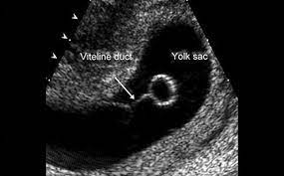 B 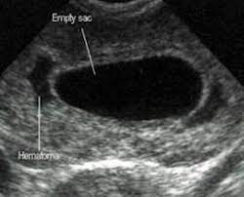

Determination of gestational age and assessment of fetal size and growth:
Up to approximately 20 weeks’ gestation the range of values around the mean for measurements of fetal length, head size and long bone length is narrow and hence assessment of gestation based on these measures is accurate. The crown–rump length (CRL) is used up to 13 weeks + 6 days, and the head circumference (HC) from 14 to 20 weeks’ gestation. The biparietal diameter (BPD) and femur length (FL) can also be used to determine gestational age.
Essentially, the earlier the measurement is made, the more accurate the prediction, and measurements made from an early CRL (accuracy of prediction 6 ± 5 days) will be preferred to a BPD at 20 weeks (accuracy of prediction 6 ± 7 days). In the latter part of pregnancy, measuring fetal abdominal circumference (AC) (Figure 4.7) and HC will allow assessment of the size and growth of the fetus and will assist in the diagnosis and management of fetal growth restriction (FGR).

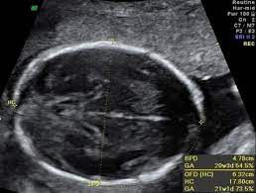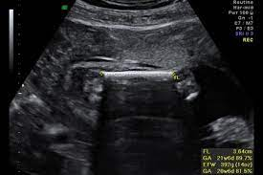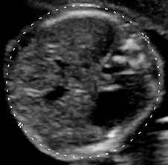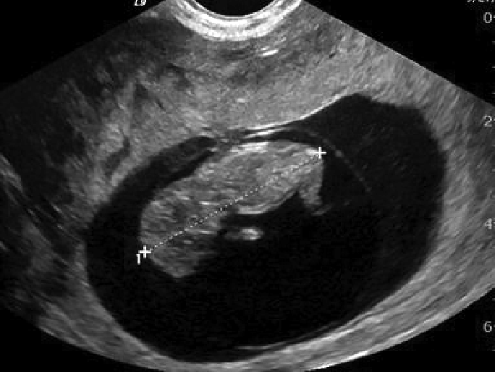

Multiple pregnancy:
Ultrasound is now the most common way in which multiple pregnancies are identified . In addition to identifying the presence of more than one fetus, it is used to determine the chorionicity of the pregnancy, which is important in stratifying the risk of particularly pregnancy complications. Monochorionic twin pregnancies (i.e. those who ‘share’ a placenta) are associated with an increased risk of pregnancy complications such as twin-to-twin transfusion syndrome and a higher perinatal mortality rate than dichorionic twin pregnancies. It is therefore clinically useful to be able to determine chorionicity early in pregnancy . The dividing membrane between monochorionic twins is formed by two layers of amnion and in dichorionic twins the dividing membrane consists of two layers of chorion and two of amnion. Dichorionic twin pregnancies therefore have a thicker dividing membrane than monochorionic twin pregnancies and this can be perceived qualitatively on ultrasound.
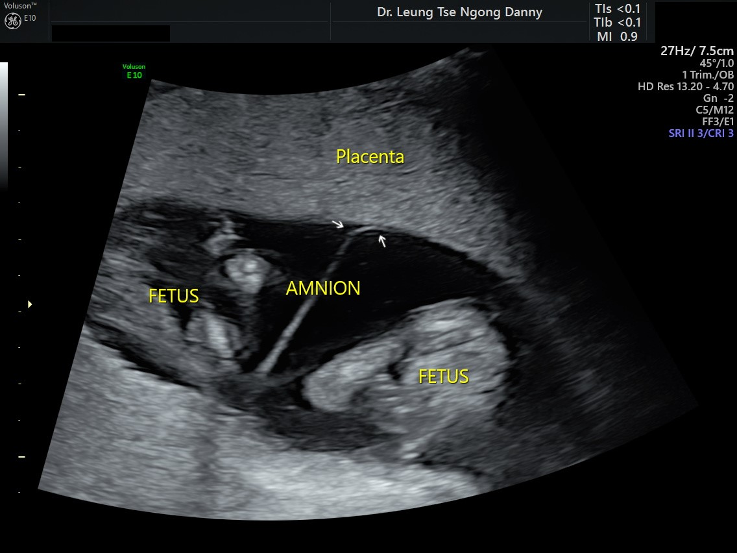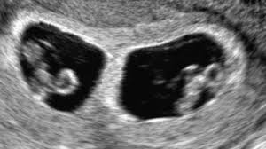
Another method of determining chorionicity in the first trimester uses the appearance of the septum at its origin from the placenta. On ultrasound, a tongue of placental tissue is seen within the base of dichorionic membranes and has been termed the ‘twin peak’ or ‘lambda’ sign . The optimal gestation at which to perform such ultrasonic chorionicity determination is 9–10 weeks.

Diagnosis of fetal abnormality:
Major fetal structural abnormalities occur in 2–3% of pregnancies and many can be diagnosed by an ultrasound scan at around or before 20 weeks’ gestation. Increasingly as ultrasound technology improves, these abnormalities are being detected at the first trimester ‘dating’ scan. Common examples include spina bifida and hydrocephalus, skeletal abnormalities such as achondroplasia, abdominal wall defects such as exomphalos and gastroschisis, cleft lip/palate and congenital cardiac abnormalities. When a fetal structural abnormality is detected, the woman may be referred to a fetal medicine specialist for further advice about prognosis and management.

Detection rates of between 40 and 90% have been reported at the 20-week ‘anomaly’ scan. This means that a ‘normal scan’ is not a guarantee of a normal baby. A number of factors can influence the success of detecting an abnormality. Some are very difficult to visualize or to be absolutely certain about. Some conditions, for example hydrocephalus, may not have been obvious at the time of early scans. Neuronal migration disorders that affect cerebral development may not manifest until the third trimester. Women should be informed of the limitations of routine ultrasound screening and that detection rates vary by the type of fetal anomaly, the woman’s body mass index and the position of the unborn baby at the time of the scan. The position of the baby in the uterus will influence visualization of organs such as the heart, face and spine. Repeat scans are sometimes required if visualization is a problem in anticipation that the fetus will be in a more accessible position.
Placental localization:
Placenta praevia, a placenta that is inserted wholly or in part into the lower segment of the uterus, can cause life-threatening haemorrhage in pregnancy. Ultrasonography has become indispensible in the localization of the site of the placenta. Ultrasonographic identification of the lower edge of the placenta to exclude or confirm placenta praevia as a cause for antepartum haemorrhage is now a part of routine clinical practice. The transvaginal approach, undertaken with caution, can be helpful in clearly identifying the lower placental edge if it is not seen clearly with an abdominal probe. At the 20 weeks scan, it is customary to identify women who have a low-lying placenta. At this stage, the lower uterine segment has not yet formed and most low-lying placentas will appear to ‘migrate’ upwards as the lower segment stretches in the late second and third trimesters. About 15–20% of women have a low-lying placenta at 20 weeks, and only 10% of this group will eventually be shown to have a placenta praevia.

Amniotic fluid assessment:
Ultrasound can be used to identify both increased and decreased amniotic fluid volumes. The fetus has a role in the control of the volume of amniotic fluid. It swallows amniotic fluid, absorbs it in the gut and later excretes urine into the amniotic sac. Congenital abnormalities that either structurally or functionally impair the fetus’s ability to swallow, for example oesophageal atresia or anencephaly, will result in an increase in amniotic fluid. Congenital abnormalities that result in a failure of urine production or passage, for example renal agenesis and posterior urethral valves, will result in reduced or absent amniotic fluid. FGR can be associated with reduced amniotic fluid because of reduced renal perfusion and hence urine output. Variation from the normal range of amniotic fluid volume calls for a further detailed ultrasound assessment of possible causes.
Assessment of fetal wellbeing:
Ultrasound can be used to assess fetal wellbeing by evaluating fetal movements, tone and breathing in the biophysical profile. Doppler ultrasound can be used to assess placental function and identify evidence of blood flow redistribution in the fetus, which is a sign of hypoxia.

Measurement of cervical length:
Evidence suggests that approximately 50% of women who deliver before 34 weeks’ gestation will have a short cervix at the midtrimester of pregnancy. Cervical length is best measured using a transvaginal probe that allows accurate identification of the internal and external os. Current National Institute for Health and Care Excellence (NICE) guidance (NICE Guidelines NG25: Preterm labour and birth) recommends serial cervical length assessment from 16 weeks’ gestation in those women with a history of spontaneous preterm birth or midtrimester loss.
Ultrasound schedule in clinical practice:
NICE recommends that all pregnant women should be offered scans at between 10 and 14 weeks’ and 18 and 21 weeks’ gestation. The first trimester scan is principally to determine gestational age, to detect multiple pregnancies and to determine NT as part of screening for Down’s syndrome. The 18–21-week scan primarily screens for structural anomalies, giving couples reproductive choice (e.g. termination of pregnancy vs. continuing with the pregnancy) and allowing antenatal care and delivery to be planned, including intrauterine therapy if available. Evidence suggests that routine ultrasound in early pregnancy appears to enable better gestational age assessment, earlier detection of multiple pregnancies and earlier detection of clinically unsuspected fetal malformation at a time when termination of pregnancy is possible. In uncomplicated pregnancies, scans are only performed after this stage in pregnancy if there is a clinical indication, such as concern about fetal growth or wellbeing, discussed later in the chapter. Additional ultrasound examinations, particularly for fetal growth and wellbeing, are offered to women who are identified as needing additional antenatal care , for example those who had problems during a previous pregnancy or who have pre-existing maternal disease.

Doppler investigation:
Waveforms can be obtained from the umbilical and fetal vessels and the maternal uterine artery. Data obtained from the umbilical artery provide indirect information about placenta function, whereas data from the fetal vessels provide information on the fetal response to hypoxia.
Umbilical artery:
Waveforms obtained from the umbilical artery provide information on placental resistance to blood flow and hence indirectly placenta ‘health’ and function. An infarcted placenta secondary to maternal hypertension, for example, will have increased resistance to flow.
So, with a normal pregnancy, blood will flow through the placenta without difficulty like water from a hose directed at the sponge and will pass straight through the sponge. In a diseased placenta the blood will reflect back from the high resistance placenta like water from a hose being bounced back from the wall at which it is directed. In the normal pregnancy, the normal constant forward flow of blood in diastole will be seen, but in the diseased placenta flow during diastole may be reduced, absent or even reversed . Reversed end-diastolic flow effectively means that during diastole, there is flow of fetal blood away from the placenta and back to the fetus.
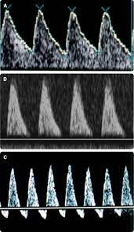

Fetal vessels:
Falling oxygen levels in the fetus lead to a redistribution of blood flow to ‘essential’ organs, such as the brain, heart and adrenal glands, from ‘nonessential’ organs where there is vasoconstriction. Several fetal vessels have been studied, and reflect this ‘centralization’ of flow, often called cerebral redistribution.
At the same time there is increased resistance in the fetal aorta reflecting compensatory vasoconstriction in the fetal body. Absent diastolic flow in the fetal aorta implies fetal acidaemia. Perhaps the most sensitive index of fetal acidaemia and incipient heart failure is demonstrated by increasing pulsatility in the central veins supplying the heart, such as the ductus venosus (DV) and inferior vena cava (IVC).
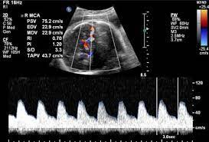

Uterine artery:
Doppler studies of the uterine artery during the first and early second trimester may be used to predict pregnancies at risk of adverse outcome, particularly preeclampsia. The proposed pathogenic model of pre-eclampsia is one of incomplete physiological invasion of the spiral arteries by the trophoblast, with a resultant increase in uteroplacental vascular resistance. This is reflected in the Doppler waveforms obtained from the maternal uterine artery circulation. Doppler ultrasound studies of the uterine arteries may demonstrate markers of increased resistance to flow including the diastolic ‘notch’ in the waveform in early diastole, thought to result from increased vascular resistance in the uteroplacental vascular bed. High resistance waveform patterns are associated with adverse outcomes, including pre-eclampsia, FGR and placental abruption. Sixty to seventy per cent of women at 20–24 weeks’ gestation with bilateral notched uterine arteries will subsequently develop one or more of these complications. Consequently, such pregnancies will require close monitoring of fetal growth rate and increased surveillance for the possible development of maternal hypertension and proteinuria.
Uterine artery Doppler evaluation at 20–24 weeks’ gestation can be used to stratify women with risk factors for a SGA baby, for example smoking, chronic hypertension, diabetes and vascular disease, previous SGA baby or stillbirth. Women with a normal uterine artery pulsatility index and normal waveform may be reassured that there is a low probability of an SGA birth. Serial ultrasound to assess fetal growth and umbilical artery Doppler for fetal wellbeing is recommended if the uterine artery Doppler assessment is abnormal.
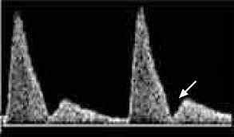
Cerebroplacental ratio:
The cerebroplacental Doppler ratio is a ratio of the pulsatility indices of the middle cerebral artery and the umbilical artery. It is emerging as an important predictor of adverse pregnancy outcome. Fetuses with an abnormal ratio that are appropriately grown for gestational age or have late-onset SGA (>34 weeks’ gestation) have a higher incidence of abnormal intrapartum CTG requiring emergency caesarean delivery, a lower cord pH and an increased admission rate to neonatal intensive care unit when compared with fetuses with a normal ratio. In fetuses with early-onset SGA (<34 weeks’ gestation), an abnormal ratio is associated with a lower birth weight, and an increased rate of adverse neonatal outcome and perinatal death when compared to a normal ratio.

Ultrasound and invasive procedures:
Ultrasound is used to guide invasive diagnostic procedures such as amniocentesis, chorion villus sampling and cordocentesis, and therapeutic procedures such as the insertion of fetal bladder shunts or chest drains. If fetoscopy is performed, the endoscope is inserted under ultrasound guidance. This use of ultrasound has greatly reduced the possibility of fetal trauma, as the needle or scope is visualized throughout the procedure and guided with precision to the appropriate place.

3D and 4D ultrasound:
Are mainly used as an adjunct to 2D ultrasound, either to interrogate fetal structures that may be difficult to visualize, such as the corpus callosum or fetal spine, or to demonstrate fetal structural abnormalities to the parents, for example cleft lip and palate.

Magnetic resonance imaging:
It provides significant improvement over ultrasound in tissue characterization. Ultrafast MRI techniques enable images to be acquired in less than 1 second to reduce the detrimental effect of fetal motion on image quality. Such technology has led to increased usage of fetal MRI, which provides multiplanar views, better characterization of anatomic details of, for example, the fetal brain, and information for planning the mode of delivery and airway management at birth. Fetal MRI is also being used to detect cerebral lesions after fetal interventions. For example, fetal brain MRI may be performed a few weeks after laser fetoscopic coagulation of placental anatomoses in twin-to-twin transfusion syndrome, to examine for acute cerebral ischaemic lesions.

