Assistant professor Dr Alaa Ibrahim
4th Class
2022
fertilization&implantation&early development of the placenta and fetal growth
Objective:
1. Understand the physiology of Fertilization, Implantation, Placental & Fetal Development.
2. Describe the early development of placenta and fetal growth
Fertilization: is the process of fusion of the spermatozoon with the mature ovum. It begins with sperm egg collision and ends with production of a mononucleated single cell called the zygote.
Its objectives are: (1) To initiate the embryonic development of the egg and (2) To restore the chromosome number of the species. Almost always, fertilization occurs in the ampullary part of the uterine tube.
The ovum, immediately following ovulation is picked up by the tubal fimbriae which partly envelope the ovary, especially at the time of ovulation. The ovum is rapidly transported to the ampullary part. The fertilizable life span of oocyte ranges from 12 to 24 hours whereas that of sperm is 48 to 72 hours.
Soon after the sperm fusion, penetration of other sperm is prevented by zona reaction (hardening) and oolemma block. Completion of the second meiotic division of the oocyte immediately follows, each containing haploid number of chromosomes (23, X). The bigger one is called the female pronucleus and the smaller one is called second polar body which is pushed to the perivitelline space. —
Head and the neck of the spermatozoon become male pronucleus containing haploid number of chromosomes (23, X) or (23, Y).
The male and the female pronuclei unite at the center with restoration of the diploid number of chromosomes (46) which is constant for the species. The zygote, thus formed, contains both the paternal and maternal genetic materials. Sex of the child is determined by the pattern of the sex chromosome supplied by the spermatozoon. If the spermatozoon contains ‘X’ chromosome, a female embryo (46, XX) is formed; if it contains a ‘Y’ chromosome, a male embryo (46, XY) is formed.
MORULA ;
After the zygote formation, typical mitotic division of the nucleus occurs by producing two blastomeres continue to divide by binary division through 4, 8, 16 cell stage until a cluster of cells is formed and is called morula, resembling a mulberry after spending about 3 days in the uterine tube enters the uterine cavity through the narrow uterine ostium (1 mm) on the 4th day in the 16-64 cell stage.
The central cell of the morula is known as inner cell mass which forms the embryo proper and the peripheral cells are called outer cell mass which will form protective and nutritive membranes of the embryo.
BLASTOCYST
The fluid passes through the canaliculi of the zona pellucida which separates the cells of the morula and is now termed blastocyst.
Zona hatching is the next step so that trophectoderm cells interact with endometrial cells and implantation occurs.
The cells on the outer side of the morula (polar) become trophectoderm and the inner cells (apolar) become inner cell mass by the mediation of epithelial cadherin (E-cadherin) (protein). Trophectoderm differentiates into chorion (placenta) and the inner cell mass into the embryo. Completely undifferentiated cells are called the pluripotent embryonic stem (ES) cells. ES cells are able to produce mature somatic cells of any germ layer (ectoderm, mesoderm and endoderm).
Implantation
occurs in the endometrium of the anterior or posterior wall of the body near the fundus on the 6th day which corresponds to the 20th day of a regular menstrual cycle. Implantation occurs through four stages e.g. apposition, adhesion, penetration and invasion.
penetration and invasion occur through the stromal cells in between the glands and is facilitated by the histolytic action of the blastocyst. the blastocystis burrowed more and more inside the stratum compactum of the decidua. Vacuoles appear in the advancing syncytium which fuse to form large lacunae.
the syncytial cells penetrate deeper into the stroma and erode the endothelium of the maternal capillaries. The syncytium by penetrating the vessels, Nutrition is now obtained by aerobic metabolic pathway from the maternal blood. The process is completed by 10th or 11th day which corresponds to D 24-25 from LMP, the blastocyst is covered on all sides by the endometrium (decidua). Just before implantation, the trophectoderm is further differentiated into an inner mononuclear cellular layer called cytotrophoblast or Langhans’ layer and an outer layer of multinucleated syncytium called syncytiotrophoblast.
Placenta and the fetal membranes are developed from the trophoblast. Local cytokines regulate the invasion of the cytotrophoblasts in the decidua.
THE DECIDUA
The increased structural and secretory activity of the endometrium that is brought about in response to progesterone following implantation is known as decidual reaction.
The fibrous connective tissues of the stroma become changed into epithelioid cells called decidual cells. The glands show marked dilatation and increased tortuosity with its lining epithelium. After the interstitial implantation of the blastocyst into the compact layer of the decidua, the different portions of the decidua includes:
(1) Decidua basalis or serotina— the portion of the decidua in contact with the base of the blastocyst, and becomes the maternal portion of the placenta (2) Decidua capsularis or reflexa — the thin superficial compact layer covering the blastocyst and (3) Decidua vera or parietalis — the rest of the decidua lining the uterine cavity outside the site of implantation.
The chorion is the outermost layer of the two fetal membranes (chorion and amnion). It consists of two embryonic layers — outer trophoblast and inner primitive mesenchyme.
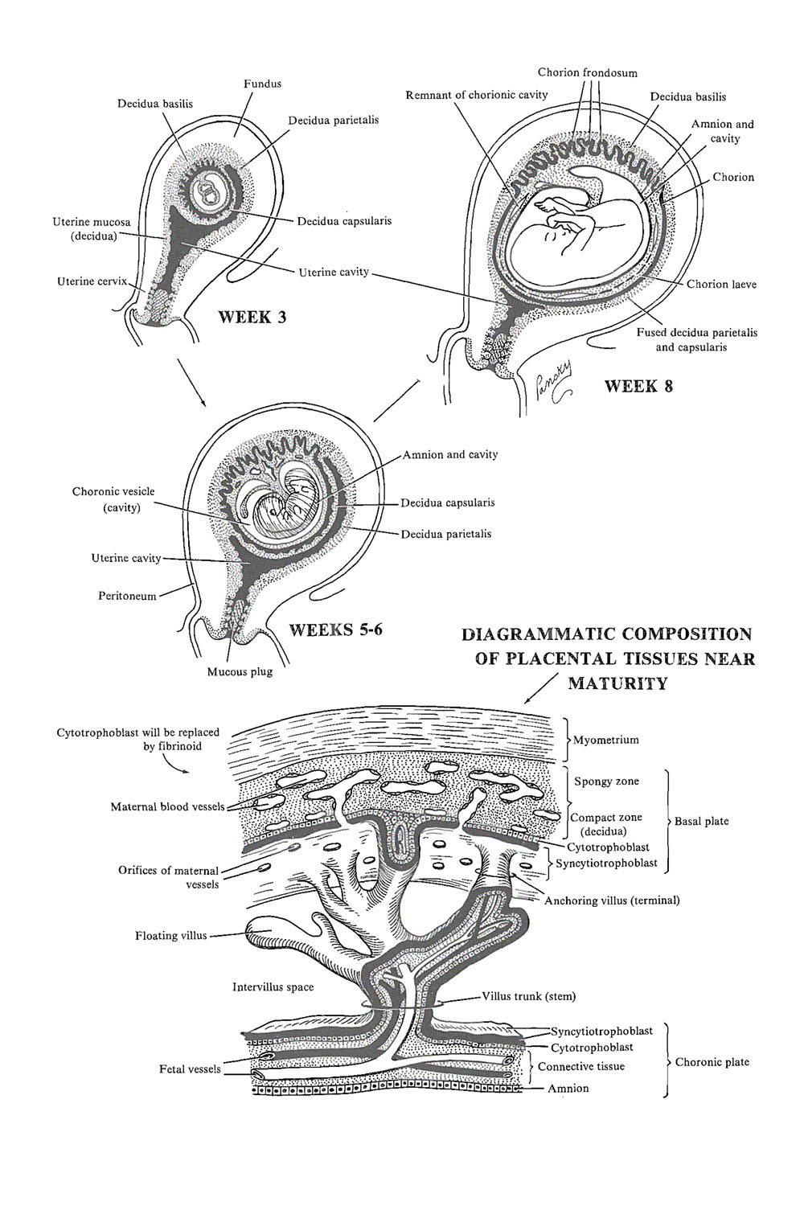

DEVELOPMENT OF INNER CELL MASS:
On the 8th day the embryoblast differentiates into bilaminar germ disc , which is connected with the trophoblast by mesenchymal condensation, called connecting stalk or body stalk which later on forms the umbilical cord.
Two cavities appear one on each side of the germ disc. On 12th postovulatory day, a fluid filled space appears between the ectodermal layer and the cytotrophoblast which is called amniotic cavity.
Formation of trilaminar embryonic disk: Fourteen days after fertilization, proliferation of ectodermal cells in the midline, leads to formation of primitive streak. Cells within the streak spread laterally between the ectoderm and endoderm as intraembryonic mesoderm.
Extraembryonic mesenchyme, derived from the trophoblast appears , Small cystic spaces (lacuna) now appear within it. There, the mesenchymal attachment persists to form body stalk. Umbilical cord develops from this body stalk.
The developing embryo bulges into the enlarged amniotic cavity. The yolk sac becomes partly incorporated into the embryo to form the gut.
During the embryonic stage which extends from the fourth to eighth week, individual differentiation of the germ layers and formation of the embryo folds occur. The embryo can be differentiated as human at 8th week.
ECTODERMAL LAYER: Central and peripheral nervous system, epidermis of skin with its appendages, pituitary gland, chromaffin organs, salivary glands; mucous lining of the nasal cavity, paranasal sinus, roof of the mouth etc.
MESODERMAL LAYER: Bones, cartilage, muscles, cardiovascular system, kidney, gonads, suprarenals, spleen, most of the genital tract; mesothelial lining of pericardial, pleural and peritoneal cavity etc.
ENDODERMAL LAYER: Epithelial lining of the gastrointestinal tract, liver, gallbladder, pancreas; epithelial lining of respiratory tract and most of the mucous membrane of urinary bladder and urethra; bulbourethral and greater vestibular glands etc

The fetal growth divided into:
(1)Ovular period or germinal period—which lasts for first 2 weeks following ovulation.
(2) Embryonic period—begins at 3rd week following ovulation and extends up to 10 weeks of gestation (8 weeks post conception).
(3) Fetal period begins after 8th week following conception and ends in delivery.
The chronology in the fetal period is henceforth expressed in terms of menstrual age and not in embryonic age.
GROWTH OF THE FETUS: Normal fetal growth is characterized by cellular hyperplasia followed by hyperplasia and hypertrophy and lastly by hypertrophy alone.
The fetal growth increases linearly until 37th week. It is controlled by genetic factor in the first half and by environmental factors in the second half of pregnancy.
The important physiological factors are: Race (European babies are heavier than Indians); Sex (male baby weighs > female); Parental height and weight (tall and heavier mother have heavier babies); Birth order (weight rises from first to second pregnancy) and Socioeconomic factors (heavier babies in social class I and II).
Fetal growth is predominantly controlled by IGF-1, insulin and other growth factors.
THE FETAL CIRCULATION:
The umbilical vein carrying the oxygenated blood (80% saturated) from the placenta, enters the fetus at the umbilicus and runs along the free margin of the falciform ligament of the liver.
In the liver, it gives off branches to the left lobe of the liver and receives the deoxygenated blood from the portal vein.
The greater portion of the oxygenated blood, mixed with some portal venous blood, short circuits the liver through the ductus venosus to enter the inferior vena cava (IVC) and thence to right atrium of the heart.
The terminal part of the IVC receives blood from the right hepatic vein. In the right atrium, most of the well oxygenated (75%) ductus venosus blood is preferentially directed into the foramen ovale by the valve of the inferior vena cava and crista dividens and passes into the left atrium. Here it is mixed with small amount of venous blood returning from the lungs through the pulmonary veins.
This left atrial blood is passed on through the mitral opening into the left ventricle. Remaining lesser amount of blood (25%), after reaching the right atrium via the superior and inferior vena cava (carrying the venous blood from the cephalic and caudal parts of the fetus respectively) passes through the tricuspid opening into the right ventricle (Fig. 4.1).

