The anatomy of female genital system
Overview
The main function of the female genital system is to ensure the fertilization of the ova and successfully implanted in the uterine cavity where it is grown to full fetus for 40 weeks. After due is over the uterus start the process of fetal delivery by developing rhythmic uterine contractions associated with the progressive passage of the fetus through the vaginal to be delivered through the introits. Thereafter the placenta and other product of gestation are sequentially delivered.

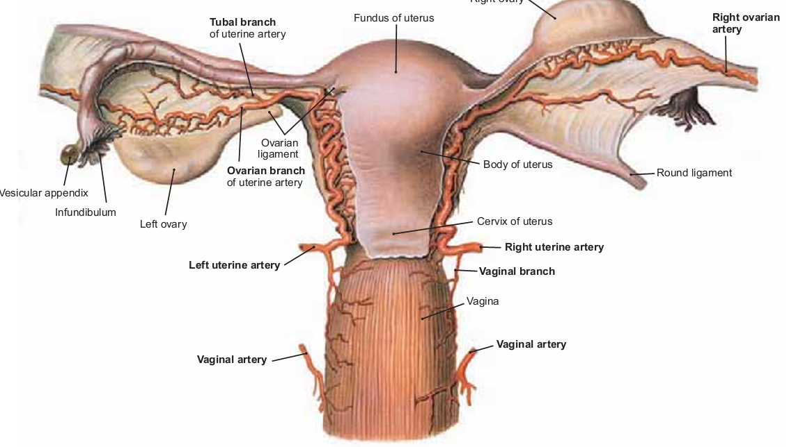
The female genital system consist of the following structure
- Ovaries
- Fallopian tubes
- Uterus
- Vagina
- External genita

The ovary

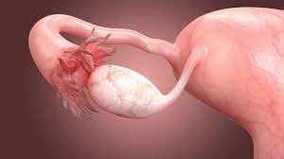

The ovary in human being is an oval shaped structure which is whit to grey in color. Roughly it measures 3-2-1 cm in diameters. The blood supply comes directly from the aorta and inferior vena cava via the ovarian vessels. It is suspended to the posterior abdominal wall by the suspensory ligament of the ovary through which the ovarian vessels pass. In addition it it is linked to the uterine body by the ovarian ligament which is situated below the Fallopian tube.

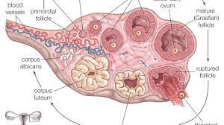
The ovarian surface is covered with single layer of columnar epithelium while the ovarian stroma is composed of connective tissue. In Menstruating women it may million of primordial ovarian follicles which are single ova surrounded by single layer of columnar epithelium. However in menstruating women any of the following structures may be present.
- Primordial ovarian follicles which are single ova surrounded by a single layer of simple columnar epithelium waiting to be stimulated by the pituitary gonadotrpins.
- Ovarian follicle which is usually present in the first half of the menstrual cycle. It is a cystic structure which contains clear fluid. The ova is usually enclosed in a clump of cells called the cumulus ooforus. The follicle arise from the primordial ovarian follicle under the effect of FSH from the pituitary.
- Corpus luteum is a solid yellowish structure which develops from the ovarian follicle after its rupture. It is mainly seen in the second half of menstruating cycle in premenopausal women. The cells are called theca – granulosa cells which secrets both estrogen and progesterone to mature the endometrial cavity. The maintenance of the corpus luteum is kept by both FSH and LH secreted from the pituitary gland.
- Corpus albicans are present more widely among older women and postmenopausal women. They simple represent those ovarian follicles which have failed to reach maturity or dying corpus luetum.

Fallopian tubes

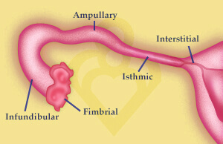

The Fallopian tubes arise from the mullerian system. It is simple a duct which connect the uterine cavity to the pelvic peritoneal cavity especially facing the ovary surface. The lining of the tube is composed of single layer of simple ciliated columnar epithelium which is surrounded by a thin layer of smooth muscle fibers which are arranged mostly in circular form. The serosa of the tubes comes from the upper most reflection of the broad ligament of the uterus. Under the influence of progesterone hormones the direction of ciliary movement is pushing the ova towards the uterine cavity. The Fallopian tubes consists of the following anatomical parts
- The interstitial part which is a small portion of the medial end of the tube where it opens into the uterine cavity.
- The isthmic part which is narrowest part of the Fallopian tubes in diameter and has minimal muscular layer in its wall.
- The ampullary part which has the maximum diameter of the tubes thickness due to the thick layer of the smooth muscle layer surrounding it
- The infunibular part which the terminal part of the Fallopian tube which opens into the pelvic cavity. This part has many moveable projections called the fambria which play a major role in picking up the released ovum from the ovarian surface forcing it to enter the tube towards the uterine cavity.

Uterus

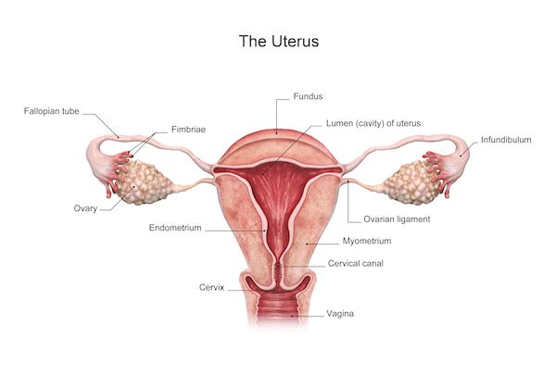
The uterus is a pear shaped muscular organ which has a narrow cavity. It is usually divided into 4 parts as follows
- The fundus which is the part of uterus above the Fallopian tube insertion
- The Body of the uterus which represents the major bulk of the uterine cavity and situated between the bladder and rectum
- The isthmus which is the narrowest part of the cavity and connects the body of the uterus to the cervix
- The cervix which a canal 2.5- 3 cm long and projects into the vagina
The blood supply of the uterus comes mainly from the uterine artery which a branch of the internal iliac artery. The venous drainage of the uterus is mainly through the uterine vein which a branch of the internal iliac vein.
The serosa of the uterus comes mainly from the broad ligament which a large reflection of the pelvic peritoneal layer covering the bladder, upper rectum, uterine body and Fallopian tubes.
The main bulk of the uterine body consist of smooth muscle fiber which are arranged in circular manner internally and longitudinal manner externally while the main bulk of the muscular layer consist of middle layer of oblique inter digitating muscle fibers which are mainly responsible for the uterine contractions during labor.
The nerve supply of the uterus comes mainly from the sacral plexus which supply mainly sympathetic nerve fibers to the uterus. While the inferior hypogatric nerve supply to a lower extent the parasympathetic nerve fibers to the uterine body.
In addition to the large broad ligament of the uterus it has the following pairs of ligaments
- The round ligament which arise below the junction of the Fallopian tubes insertion and run a long course to enter the internal inguinal ring and finally inserted into the labia majora.
- The uterosacral ligaments which is a pair of ligament connects the lower uterine body posterior to the surface of the sacrum
- The Cardinal ligament of the uterus which are big fan shaped layer of strong fibers which stretch from the pelvic side wall in each side and inserted into the isthmic part of the uterus. This ligament is the main ligament which holds the uterus in its position. Otherwise its damage can cause descent of the uterus into the vaginal canal or uterine prolapsed.

The cervix
The cervix is the lower portion of the uterus, an organ of the female reproductive tract. It connects the vagina with the main body of the uterus, acting as a gateway between them. Anatomically and histologically, the cervix is distinct from the uterus, and hence we consider it as a separate anatomical structure. The cervix is the lower portion of the uterus, an organ of the female reproductive tract. It connects the vagina with the main body of the uterus, acting as a gateway between them. Anatomically and histologically, the cervix is distinct from the uterus, and hence we consider it as a separate anatomical structure. The cervix performs two main functions:
- It facilitates the passage of sperm into the uterine cavity. This is achieved via dilation of the external and internal os.
- Maintains sterility of the upper female reproductive tract. The cervix, and all structures superior to it, is sterile. This ultimately protects the uterine cavity and the upper genital tract by preventing bacterial invasion. This environment is maintained by the frequent shedding of the endometrium, thick cervical mucus and a narrow external os.

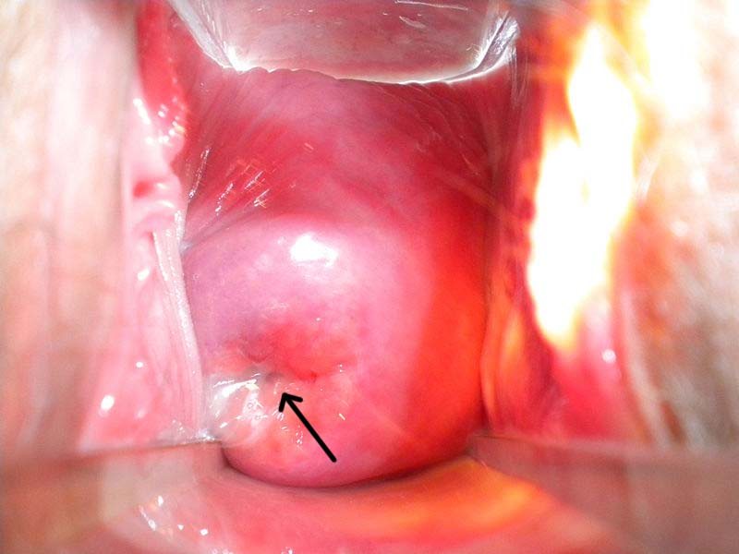

The vagina
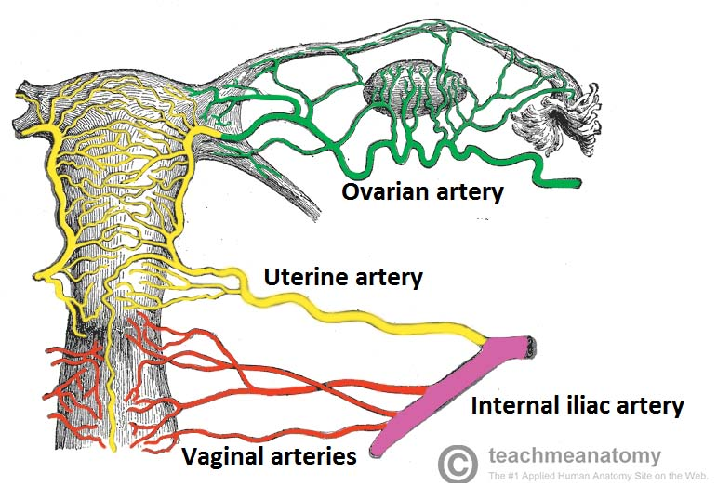

The vagina is a tube with fibromuscular anterior and posterior walls – these are normally collapsed and thus in contact with one another. The shape of the vagina is not a round tunnel. In. At the upper ending, the vagina surrounds the cervix, creating two domes (fornices or vaults): an anterior and a (deeper) posterior one. The posterior fornix is important as it acts like a natural reservoir for semen after intravaginal ejaculation. The semen retained in the fornix liquefies in the next 20-30 minutes, allowing for easier permeation through the cervical canal. The blood supply to the vagina comes mainly from the vaginal artery which is a large branch from the internal iliac artery. The vaginal veins come from pampiniform plexus of veins surrounding the vagina ultimately collecting into the uterine vaginal vein.
Histology of the Vagina
- Stratified squamous epithelium – this layer provides protection and is lubricated by cervical mucus (the vagina itself does not contain any glands).
- Elastic lamina propria – a dense connective tissue layer which projects papillae into the overlying epithelium. The larger veins are located here.
- Fibromuscular layer – comprising two layers of smooth muscle; an inner circular and an outer longitudinal layer.
- Adventitia – a fibrous layer, which provides additional strength to the vagina whilst also binding it to surrounding structures.

The vulva
The vulva (pudendum) refers to the external female genitalia. Its functions are threefold:
- Acts as sensory tissue during sexual intercourse
- Assists in micturition by directing the flow of urine
- Protects the internal female reproductive tract from infection.
Structures of the Vulva

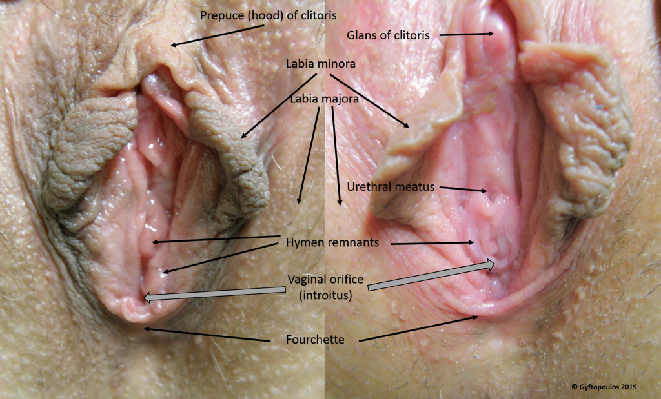
- The vulva is a collective term for several anatomical structures:
- Mons pubis – a subcutaneous fat pad located anterior to the pubic symphysis. It formed by the fusion of the labia majora.
- Labia majora – two hair-bearing external skin folds.
  - They extend from the mons pubis posteriorly to the posterior commissure (a depression overlying the perineal body).
  - Embryologically derived from labioscrotal swellings
- Labia minora – two hairless folds of skin, which lie within the labia majora.
  - They fuse anteriorly to form the hood of the clitoris and extend posteriorly either side of the vaginal opening.
  - They merge posteriorly, creating a fold of skin known as the fourchette.
  - Embryologically derived from urethral folds
- Vestibule – the area enclosed by the labia minora. It contains the openings of the vagina (external vaginal orifice, vaginal introitus) and urethra.
- Bartholin’s glands – secrete lubricating mucus from small ducts during sexual arousal. They are located either side of the vaginal orifice.
- Clitoris – located under the clitoral hood. It is formed of erectile corpora cavernosa tissue, which becomes engorged with blood during sexual stimulation. Embryologically derived from the genital tubercle

Vascular Supply and Lymphatics
The arterial supply to the vulva is from the paired internal and external pudendal arteries (branches of the internal iliac artery and femoral artery, respectively). Venous drainage is achieved via the pudendal veins, with smaller labial veins contributing as tributaries. Lymph drains to the nearby superficial inguinal lymph nodes.

Innervation

The vulva receives sensory and parasympathetic nervous supply from ilioinguinal nerve, genital branch of the genitofemoral nerve pudendal nerve, posterior cutaneous nerve of the thigh. The parasymathetic nerve supply somes from the nerves which supply the corpus spongiosum in the clitoris and the corpora carvernosa in both labia minora and comes mainly from s2,3 and 4.

