Parasitology Protozoa Lecture: Malaria-1
Dr. Azhar الفصل الثاني 2019-2020

Apicomplexa (Page number1-7)
apical complex= apicoplast
unicellular, spore-forming
exclusively parasites (i.e., no free-living)
Motile structures are absent except in certain gamete stages
Phylum Apicomplexa (Sporozoa)
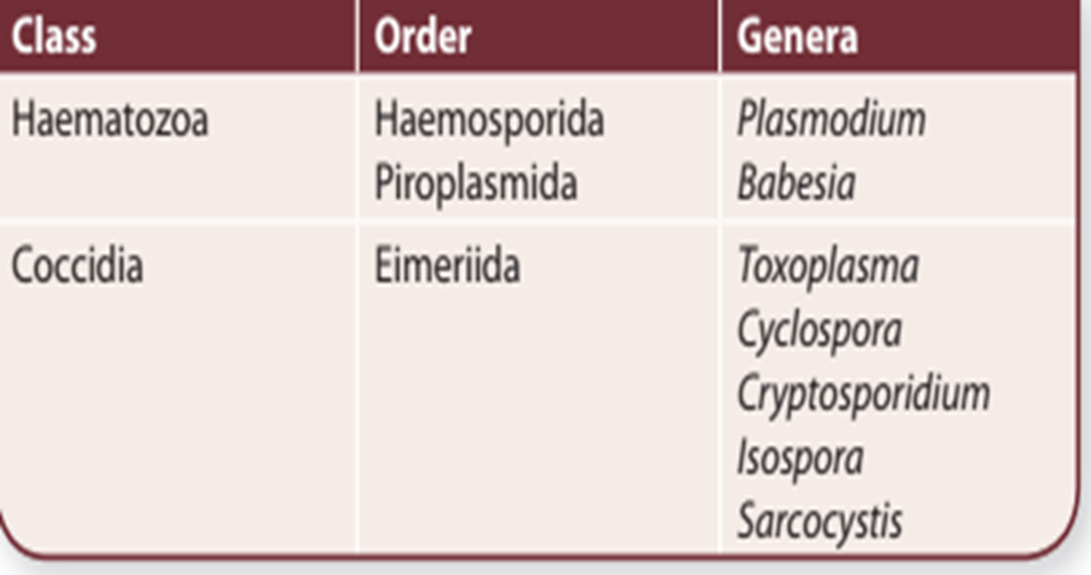
Complex life-cycle
sexual asexual
(sporogony &gametogony) (schizogony or merogony)

Malaria البرداء
- The cause of much human morbidity and mortality.
- Forty percent of the world's population lives in endemic areas.
- Malaria poses a serious barrier to economic progress in many developing countries.
- 300-500 million cases of clinical disease per year with 1.5-2.7 million deaths (90% Africa).
- Malaria is caused by members of the genus Plasmodium.
- Plasmodium species are apicomplexa and exhibit a heteroxenous life cycle involving a vertebrate host and an arthropod vector.
- Vertebrate hosts include: reptiles, birds, rodents, monkeys and humans.
- Plasmodium species are quite hosted specific and there are no zoonosis.
- Four distinct species infected humans: P. falciparum, P. vivax, P. ovale and P. malariae.
- The species differ in regards to their morphology, details of their life cycles, and their clinical manifestations.
- Mammalian Plasmodium species are transmitted by anopheline mosquitoes.
- increasing problem (re-emerging disease)
- resurgence in some areas
- drug resistance ( mortality)
Disease:
P. falciparum: (two-day cycle) malignant tertian malaria or falciparum malaria.
P. vivax: (two-day cycle) benign tertian or vivax malaria.
P. ovale: (two-day cycle) ovale tertian malaria or ovale malaria.
P. malariae: (three-day cycle) quatrain malaria.
Life cycle: 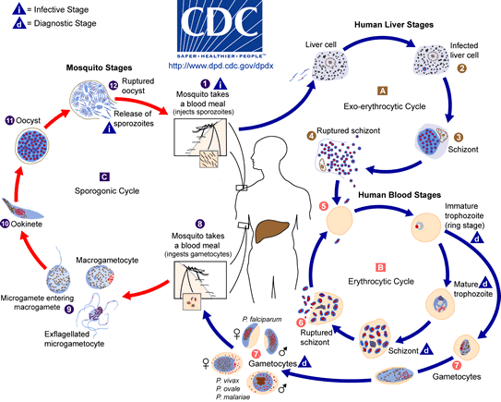
The malaria parasite life cycle involves two hosts. During a blood meal, a malaria-infected female Anopheles mosquito inoculates sporozoites into the human host. Sporozoites within 30-60 minutes will invade liver cells and mature into schizonts, which rupture and release merozoites in cycle of asexual reproduction (schizogony). (Of note, in P. vivax and P. ovale a dormant stage [hypnozoites] can persist in the liver and cause relapses by invading the bloodstream weeks, or even years later.) After this initial replication in the liver (exo-erythrocytic= pre-erythrocytic schizogony), the parasites undergo anther asexual multiplication in the erythrocytes (erythrocytic schizogony). Merozoites infect red blood cells and undergo a trophic period in which the parasite enlarges. The early trophozoite is often referred to as 'ring form' because of its morphology. Trophozoite enlargement is accompanied by an active metabolism including the ingestion of host cytoplasm and the proteolysis of hemoglobin incompletely into globin and iron porphyrin hematin (hemazon); the later is malaria pigment, a compound of hematin and protein. The ring stage trophozoites mature into amoeboid stage (mature trophozoite). The end of the trophic period is manifested by multiple rounds of nuclear division without cytokinesis resulting is a schizont. Merozoites bud from the mature schizont, also called a segmenter, and the rupture of the infected erythrocyte releasing merozoites. Invasion of erythrocytes reinitiates another round of the blood-stage replicative cycle. Some parasites differentiate into sexual erythrocytic stages (gametocytes). Blood stage parasites are responsible for the clinical manifestations of the disease. The gametocytes, male (microgametocyte) and female (microgametocyte), are ingested by an Anopheles mosquito during a blood meal. The parasites’ multiplication in the mosquito is known as the sporogonic cycle. While in the mosquito's stomach, the microgametes penetrates the macrogametes generating zygotes. The zygotes in turn become motile and elongated (ookinetes) which invade the midgut wall of the mosquito where they develop into oocysts . The oocysts grow, rupture, and release sporozoites, which make their way to the mosquito's salivary glands. Inoculation of the sporozoites into a new human host perpetuates the malaria life cycle.
In the life cycle there are two transfers stages: sporozoite (from mosquito to man) & gametocytes (from man to mosquito) and three invasive stages: Merozoite (invade erythrocytes of human), Sporozoite (invade salivary gland of mosquito & hepatocytes of human) &ookinete (invade epithelial cell of mosquito's stomach).
Prepatent period: is defined as the time between sporozoite inoculation and the appearance of parasites in the blood and represents the duration of the liver stage.
Incubation periods are defined as the time between sporozoite inoculation and the first appearance of clinical signs.
 | P. falciparium | P. vivax | P. ovale | P. malariae
Prepatent period | 6 days | 8 days | 9 days | 13 days
Incubation period | 12 days | 13-17 days | 13-17 days | 28-30 days
Differences between the species include:
- Minor life cycle variations
  - P. vivax and P. ovale exhibit the hypnozoite stage and can cause true relapses.
  - Trophozoite- and schizont-infected erythrocytes of P. falciparum sequester in the microvasculature and are not found in the peripheral circulation.
- Host erythrocyte preference
- P. vivax and P. ovale prefer reticulocytes (immature erythrocytes)
- P. malariae prefers senescent erythrocytes
- P. falciparum exhibits no preference
- Blood-stage morphology (see morphological differences).
- Disease and clinical manifestation (see below).

Morphological Differences
The blood-stage parasites of human Plasmodium species exhibit differences in their morphology and modify the host erythrocyte differently. These differences can be used to distinguish the four species.
- Ring stage: of all four species are very similar and difficult to distinguish. P. falciparum rings tend to be a little smaller and more numerous than the other species. The presence of a large number of rings in the absence of more mature stages, as well as multiply-infected erythrocytes, is highly suggestive of P. falciparum.
P. falciparum P. vivax P. ovale P. malariae Normal RBC
- Mature trophozoit: erythrocytes infected with P. vivax and P. ovale are enlarged and exhibit Schüffner's dots as the rings mature into mature trophozoites. The trophozoites of P. vivax are often amoeboid, whereas P. ovale tends to be more compact. The P. malariae trophozoite is very compact and extending across the diameter of the host and known as band form, the host erythrocyte is not enlarged.
P. falciparum P. vivax P. ovale P. malariae
- Mature schizont: asexual forms of Plasmodium spp. Schizonts of P. falciparum are rarely found in the peripheral circulation (sequestered in blood of viscera). The typical number of merozoites produced per schizont is: P. vivax 14-20 (up to 24), P. ovale 6-12 (up to 18), P. malariae 8-10 (up to 12), and P. falciparum 16-24 (up to 36).
P. falciparum P. vivax P. ovale P. malariae
(Sequestered) (14-20, up to 24) (6-12, up to 18) (8-10, up to 12)
- Gametocyte: P. falciparum exhibits crescent-shaped gametocytes whereas the other species are all round to oval. P. vivax and P. ovale gametocytes are in enlarged erythrocytes with Schüffner's dots and are difficult to distinguish from each other. P. malariae gametocytes do not modify the host erythrocyte. Gametocytes can be distinguished from trophozoites by their large size (nearly filling the erythrocyte) and a single nucleus. Mature microgametocytes (male gametes) tend to stain lighter than macrogametocytes (female gametes) and have a more diffuse nucleus.
Microgametocytes
Macrogametocytes
P. falciparium P. vivax P. ovale P. malariae
P. falciparium | P. malariae | P. ovale | P. vivax
Trophozoites (ring stage only) gametocytes(micro& macrogametocytes) other stages are sequestered in visceral blood | Trophozoites (ring, amoeboid) , schizonts (immature &mature) gametocytes(micro& macrogametocytes) | Trophozoites (ring, amoeboid) , schizonts (immature &mature) gametocytes(micro& macrogametocytes) | Trophozoites (ring, amoeboid) , schizonts (immature &mature) gametocytes(micro& macrogametocytes) | Stages in blood
36-48 hrs | 72 hrs | 48 hrs | 48 hrs | Schizogony cycle
Small, tow rings in RBC (multiple infection) | Compact, one ring in RBC | Small & large , one ring in RBC | Small & large , one ring in RBC | Ring stage
Irregular with Maurer's clefts. RBC non enlareged. | Compact within non enlarged RBC. | Compact within enlarged RBC. | Amoeboid with enlarged RBC. | Mature trophozoite
Normal size, Maurer's clefts. | Normal size, with Ziemann's dots. | Enlarged (oval in shape), pale, with schüffnr's dots. | Enlarged, pale, with schüffnr's dots. | Host cell RBC
Infects RBCs of all ages. | Infect senescent erythrocytes | Infect young RBCs | Infect young RBCs | Host erythrocyte preference
Rarely present (sequestered in visceral blood) | Oval or rounded, chromatin in fin or irregular clumps band form. | Irregular, chromatin in fin or irregular clumps | Irregular, chromatin in fin or irregular clumps | Immature schizont (segmenter)
(Sequestered in visceral blood), 16-24 (up to 36) merozoites. | Fill normal size RBC, 8-10(up to 12) merozoites. | Fill greatly enlarged RBC, 6-12(up to 18) merozoites. | Fill greatly enlarged RBC, 14-20(up to 24) merozoites. | Mature schizont
Crescent | Round to oval | Round to oval | Round to oval | Gametocyte

End of Protozoa Lecture

