Parasitology Protozoa Lecture: Malaria-2
Dr. Azhar الفصل الثاني 2019-2020
Malaria-2 (Page number1-10)
Pathogenesis and Clinical Manifestations
The pathology and clinical manifestations associated with malaria are almost exclusively due to the asexual erythrocytic stage parasites. Tissue schizonts (liver schizonts) and gametocytes cause little, if any, pathology. Plasmodium infection causes an acute febrile illness which is most notable for its periodic fever paroxysms occurring at either 48 or 72 hour intervals.
The severity of the attack depends on: 1. the Plasmodium species as well as other circumstances such as 2. The state of immunity and 3. The general health and nutritional status of the infected individual. The disease has a tendency to relapse (due to P. vivax, P. ovale or recrudesce (due to P. falciparum & P. malariae) over months or even years.
The prepatent period (represents the duration of the liver stage) and incubation periods (defined as the time between sporozoites inoculation and the onset of symptoms) vary according to species (see table in lecture 10).
Prodromal symptoms
All four species can exhibit non-specific prodromal symptoms a few days before the first febrile attack. These prodromal symptoms are generally described as 'flu-like' and include: headache, slight fever, muscle pain, anorexia, nausea and lassitude. The symptoms tend to correlate with increasing numbers of parasites. These prodromal symptoms will be followed by febrile attacks.
Febrile attacks (the malaria paroxysms)
These paroxysms will exhibit periodicities of 48 hours for P. vivax, & P. ovale, 36-48 hour periodicity for P. falciparum, and a 72-hour periodicity for P. malariae. Patients may also exhibit splenomegaly, hepatomegaly (slight jaundice), and hemolytic anemia during the period in which the malaria paroxysms occur.
The malarial paroxysm (see figure below) will usually last 4-8 hours and begins with a cold stage followed by hot stage which end by the sweating stage.
The cold stage: begins with sudden onset of chills in which the patient experiences an intense feeling of cold despite having an elevated temperature. This stage is characterized by a vigorous shivering. Lasts within 15-60 min
Immediately following this cold stage is the hot stage. The patient feels an intense heat accompanined by severe headache & dry burning skin. This stage lasts within 2-6 hours.
Next a period of profuse sweating (sweating stage) will ensue and the fever will start to decline. The patient is exhausted and weak and will usually fall asleep. Upon awakening the patient usually feels well, other than being tired, and does not exhibit symptoms until the onset of the next paroxysm. This stage lasts within 2-4 hours.

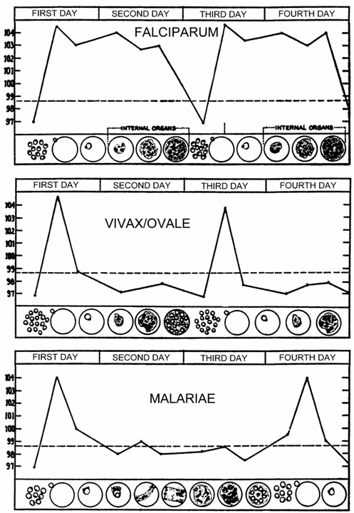

Malaria parasites tend to develop synchronously in the human host. In other words, all of the parasites within a host are at approximately the same stage (ie, ring, trophozoite, schizont) as they proceed through schizogony. The malarial paroxysm corresponds to the rupture of the infected erythrocytes and the release of merozoites (Figure above). Studies in P. vivax have demonstrated a correlation between fever and serum TNF-α (tumor necrosis factor-alpha) level. Presumably antigens or toxins are released when the infected erythrocyte ruptures and lead to the production of TNF-α and the febrile attacks.

Disease severity and duration
 | P. vivax | P. ovale | P. malariae | P.falciparum
Initial Paraoxysm Severity | Moderate to severe | Mild | Moderate to severe | Severe
Average Parasitemia (mm³) | 20,000 | 9,000 | 6,000 | 50,000-500,000
Maximum Parasitemia (mm³) | 50,000 | 30,000 | 20,000 | 2,500,000
Symptom Duration (untreated) | 3-8+ weeks | 2-3 weeks | 3-24 weeks | 2-3 weeks
Maximum Infection Duration (untreated) | 5-8 years | 12-20 months | 20-50+ years | 6-17 months
Anemia | ++ | + | ++ | ++++
Complications |  |  | renal | cerebral

P. falciparum (malignant tertian malaria =2 day cycle)
In contrast to the other three species, P. falciparum can produce serious disease with mortal consequences, due in part to:
- The high parasitemias associated with P. falciparum infections (due to high reproductive capacity of the parasite).
- Sequestration of P. falciparum, which is due to the cytoadherence of infected erythrocytes to endothelial cells in the blood vessels of deep tissues.
- The lack of preference for erythrocytes (infects RBCs of all ages).
- The high parasitemia and sequestration result in other complications associated with falciparum malaria, the most notable being anemia and cerebral malaria.
- Low liver (6 days) and blood (36-48 hrs) periodicities.
The anemia is due in part to the destruction of erythrocytes during blood-stage schizogony. Furthermore, non-infected erythrocytes are destroyed at higher rates during the infection and there is a decreased production of erythrocytes.

The sequestration of P. falciparum due to Cytoadherence protein which is expressed during the trophozoite and schizont stages and is formed as a result of parasite proteins exported to the erythrocyte membrane causing the blood cells to stick to the walls of small blood vessels of vital organs, especially brain, lung, gut, heart and placenta thereby sequestering the parasite from passage through the general circulation and the spleen. This "stickiness" is the main factor giving rise to hemorrhagic complications of malaria. High endothelial venules (the smallest branches of the circulatory system) can be blocked by the attachment of masses of these infected red blood cells. The blockage of these vessels causes symptoms such as in placental and cerebral malaria. In cerebral malaria the sequestrated red blood cells can breach the blood brain barrier possibly leading to coma. This Sequestration of P. falciparum, lead to minimize the removal of infected erythrocytes by the spleen, and increase the parasitemia rapidly.

P. vivax (benign tertian malaria = 2 day cycle): Patients infected with P. vivax, especially for the first time, can be quite ill. However, P. vivax rarely causes complications or results in death. Relapses can occur for several years.
P. ovale (ovale tertian malaria = 2 day cycle) is the most benign in that the paroxysms tend to be mild and of short duration and relapses seldom occur more than one year after the initial infection.
P. malariae (quartan malaria= three day cycle) generally produces a mild disease, but the initial paroxysms can be moderate to severe. It is the most chronic, though, and recrudescences have been documented several decades after the initial infection. This chronicity is sometimes associated with renal complications, which are probably due to the deposition of antigen-antibody complexes in the glomeruli of the kidney.

Relapse: following the termination of the primary attack (naturally or after treatment) and parasites may completely disappear from blood. In P. vivax relapse continue over 2-3 years before infection is terminated, while in P. ovale it rarely longer than one year.

Recrudescence: in P. falciparum and P. malariae a renewal clinical manifestations after weeks, months or years without re-exposure. This can be attributed to persistence of parasites in the blood at level too low to detect or to produce symptoms for 1 year in P. falciparum and for many years in P. malariae.

Other Features of malaria:

There is an increased activity of the reticuloendothelial system, particularly in the liver and spleen and thus their enlargement, as evidenced by macrophages with ingested infected and normal erythrocytes and hemozoin (malaria pigments).

Paroxysm may be accompanied by spleno-megaly, hepatomegaly (slight jaundice), hemolytic anemia

P. falciparum can be lethal in non-immune (like children)

Paroxysms become less severe and irregular as infection progresses

Semi-immune may exhibit little (1-2 days fever) or no symptoms.

Complications of malaria Except for P. falciparum, the pathology associated with malaria tends to be rather benign. Several severe complicatons can be associated with falciparum malaria with cerebral malaria being the most notable and a frequent cause of death.

Cerebral malaria
- severe complication of falciparum malaria
  - mortality of 30-50%
- a diffuse encephalopathy with loss of consciousness
  - severe headache followed by drowsiness, confusion and coma
  - consciousness ranges from stupor to coma
  - unresponsive to pain, visual, and verbal stimuli
  - convulsions frequently observed
  - onset can be gradual or sudden
- associated with sequestration in micro-vasculature of brain
Black water fever (hemoglobinuric fever)
Other complication of P. falciparum which it is characterized by repeated attacks of malaria that have been inadequately treated with quinine. Treatment with quinine for the first time may lead to massive destruction of infected and uninfected erythrocytes which lead eventually to passage of dark red or black urine.
Immunity:
- The malarial paroxysms will become less severe and irregular in periodicity as the host develops immunity.
- This immunity, is not a sterilizing immunity in that the infection persists longer than the symptoms and individuals can become reinfected.
- parasitemia does always cause disease (majority of persons living in areas of high endemicity will be parasitemic, but asymptomatic)
- 'Anti-disease immunity', antibodies against exo-antigens could neutralize their toxic effects.
- 'Anti-parasite immunity' in that parasitemia tends to be lower in persons previously exposed to malaria.
- Anti-parasite immunity could include antibodies that prevent merozoite invasion
Epidemiology of Malarial Parasites

P. vivax: most widespread, found in most endemic areas including some temperate zones.
P. falciparum: primarily tropics and subtropics.

P. malariae: similar range as P. falciparum, but less common and patchy distribution.
P. ovale: occurs primarily in tropical West Africa.

Stable or Endemic Malaria
- ~constant incidence over several years
  - includes seasonal transmission
- immunity and disease tolerance correlates with level of endemicity (especially adults)
Unstable or Epidemic Malaria
- periodic sharp increase in malaria
- little immunity
- high morbidity and mortality
Immunity:
- Immunity in malaria is strain specific.
- Humoral and cellular immunity occurs with multiple exposure.
- Cerebral malaria occur in non immune individuals in endemic areas.
- In P. vivax and P. ovale infections, relapse after a period of dormancy may result from periodic release of merozoites from liver (hypnozoites), owing to the lack of an immune response to the intracellular parasites.
- Innate, non acquired immunity to malaria is well demonstrated.
- Africans or African Americans lacking Duffy blood group antigen F (a-b) are immune to P. vivax because this genetic factor appears to be necessary for successful merozoite penetration of the human erythrocyte by this plasmodial species.
- Sickle cell hemoglobin inhibits growth of P. falciparum. This genetic factor is widespread in areas of Africa hyperendemic for falciparum malaria.

- Other red cell abnormalities such as glucose-6-phosphate dehydrogenase deficiency appear to be protective of the erythrocyte and there by reduce the severity of plasmodial infection .
- Currently three vaccination strategies are still being pursued:
- antisporozoite to prevent liver cell infection.
- antimerozoite to prevent red blood cell infection.
antigametocyte to block transmission.
- Children exposed to repeated infections in hyperendemic areas develop a high degree of immunity, although this immunity does not imply eradication of infection, but rather a balance between parasite and host.
- The failure to induce protective antibodies in vaccinated individuals led research investigators to focus on the role of CMI.

Diagnosis
- Symptoms: fever, chills, headache, malaise, splenomegaly and anemia as disease progresses.
- History of being in endemic area.
- microscopic demonstration of parasite in blood smear (distinguish species)
  - thick film: more sensitive
  - thin film: species identification easier
- repeat smears every 12 hours for 48 hours if negative
- Antigen detection ‘dipstick’ is also now available.
- Serological tests:
- IFAT
- ELISA
- PCR
Anti-Malaria Chemotherapy
- Causal Prophylaxis
  - prevent infection (i.e., liver stage, primaquine)
- Suppressive Prophylaxis
  - prevent clinical disease (i.e., blood stages, choloroquine)
- Treatment Therapy (or clinical cure)
  - relieve symptoms
  - eliminate blood stage parasites
- Curative Therapy (or radical cure)
  - eliminate parasites w/o regard to symptoms
- Anti-Relapse Treatment eliminate hypnozoites.
Mixed infections
In endemic areas it is not uncommon to find mixed infections with two or more species of malaria in the same individuals. Mixed infection with P. vivix & P. falciparum is the most common combination. The clinical picture may be atypical with bouts of fever occurring daily.
Distribution of Malarial Parasites
P. vivax
most widespread, found in most endemic areas including some temperate zones
P. falciparum
primarily tropics and subtropics
P. malariae
similar range as P. falciparum, but less common and patchy distribution
P. ovale
occurs primarily in tropical west Africa

Malaria in Iraq:
- In the past, malaria was highly endemic in Iraq.
- In 1957, the malaria eradication project was officially started in collaboration with WHO and UNICEF.
- Malaria control operations were very successful in its control in the area, but some resistant to DDT and malathion had developed in some parts in the country.
- Iraq is Malaria free since 2009.
- Mosquito males live for about a week, feeding on nectar and other sources of sugar. Females will also feed on sugar sources for energy, but usually require a blood meal for the development of eggs.

Control
- Reduce Human-Mosquito Contact
  - impregnated bed nets
  - repellants, protective clothing
  - screens, house spraying
- Reduce Vector
  - environmental modification
  - larvacides/insecticides
  - biological control
- Reduce Parasite Reservoir
  - diagnosis and treatment
  - chemoprophylaxis
Babesia
- is a protozoan parasite of the blood that causes a hemolytic disease known as Babesiosis.
- infecting cattle, livestock and domestic animals.
- People who contract Babesiosis suffer from malaria-like symptoms. As a result malaria is a common misdiagnosis for the disease.
- Babesia is a protozoan parasite of which Babesia microti and Babesia divergens are the two species to most frequently infect humans.
- Common names of the disease include Texas Cattle Fever, Red water Fever, and Tick Fever.
- The disease is asymptomatic or mild with flu-like symptoms.
- In cases of symptomatic infection, symptoms are characterized by irregular fevers, chills, headaches, general lethargy, pain and malaise.
- In severe cases, hemolytic anemia, jaundice, shortness of breath, and hemoglobinuria are documented due to the lytic effects of parasitic multiplication.
- Immunocompetent individuals with healthy spleens often recover without treatment.
- Splenoctomized patients are more susceptible to contracting the disease and the course of infection often ends fatally within 5 - 8 days of symptom onset.
- Parasitemia levels can reach up to 85% in patients without spleens compared to 1-10% in individuals with spleens and effective immune systems.
Transmission
- Babesia is spread through the saliva of a tick when it bites.
- At its nymphal stage, a tick will bite into the skin for a blood meal.
- The most common vector is hard tick, commonly known as a deer tick, is also the vector for other tick-associated illnesses such as Lyme disease.

Morphology
- Babesia enters erythrocytes at the sporozoite stage. Within the red blood cell, the sporozoite become cyclical and develop into a trophozoite ring.
- The trophozoites morph into merozoites, which have a tetrad structure coined a Maltese-cross form.
- The tetrad morphology is unique to Babesia and serves as a distinguishing feature from Plasmodium falciparum.
- Trophozoite and merozoite growth ruptures the host erythrocyte leading to the release of vermicules, the infectious parasitic bodies, which rapidly spread the protozoa throughout the blood.
Life cycle
- The life cycle of Babesia requires a biological stage in a rodent or deer host.
- To begin, the Ixodidae introduces the sporozoites into the rodent when taking a blood meal.
- Sporozoites enter erythrocytes in the blood and begin the cyclical development between trophozoites and merozoites.
- Rather than producing more trophozoites, some merozoites produce gametocytes.
- The tick host, Ixodidae, takes up the gametocytes when attached for a blood meal.
- The gametes are fertilized in the gut of the tick and develop into sporozoites in the salivary glands.
- The sporozoites are introduced into a human upon inoculation at the bite of an infected tick.
- Babesia can be diagnosed at the trophozoite stage and can be transmitted from human to human either through the tick vector or through blood transfusions.
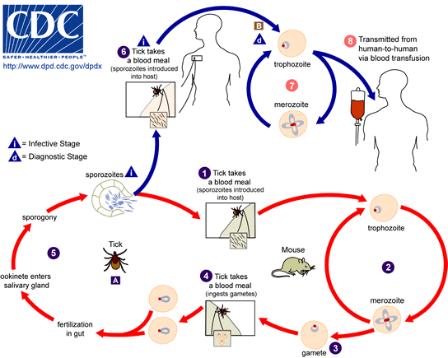
Diagnosis:
- Blood sample testing. It is important to pay specific attention to particular morphologies of Babesia in blood smears because its substantial similarity to the malarial parasite Plasmodium falciparum results in many patients suffering from Babesiosis being misdiagnosed.
- Indirect fluorescent antibody (IFA) test.
- Immunoblot (IB).
- PCR.
Treatment
- In many cases, patients spontaneously recover having only experienced mild symptoms undiagnosed as the disease.
- The standard treatment for symptomatic individuals was oral or intravenous Clindamycin with oral quinine.
- Oral atovaquone with oral azithromycin.
Control:
- Control vector (ticks).
- Splenectomized individuals are very susceptible to babesiosis and have a significantly higher fatality rate; hence, such persons should take special precautions against exposure.

End of Protozoa Lecture

