Parasitoloy
Protozoa Lecture: Blood &tissues flagellates-3
Dr. Azhar الفصل الثاني 2019-2020
Trypanosomes (Page number1-8)
3 species parasitize human:
- Trypanosoma brucei complex: T. rhodesiense &T. gambiense (Salivarian group develop in the salivary glands of the vector).
- T. cruzi (Stercorian group develop in the hind-gut of the vector, contain
leishmania- like amastigote in tissue).
- African Trypanosomiasis – 400,000 affected causing 50,000 to 70,000 deaths/year.
- American Trypanosomiasis – 11 million people affected causing 50,000 deaths/year.
Habitat
- Trypanosomes live in man and other vertebrate host. They are essentially a parasite of connective tissue, where they multiply rapidly and then invade regional lymph nodes, blood, and finally may involve CNS.
Life cycle of salivarian group trypanosomes:
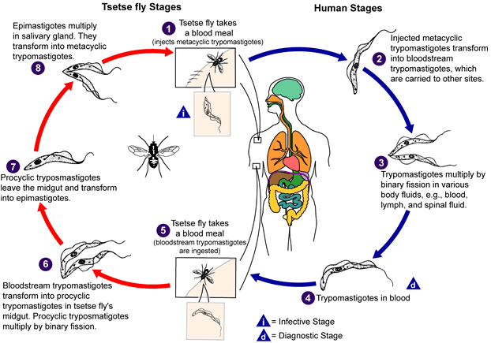
During a blood meal on the mammalian host, an infected tsetse fly (genus Glossina) injects metacyclic trypomastigotes into skin tissue. The parasites enter the lymphatic system and pass into the bloodstream. Inside the host, they transform into bloodstream trypomastigotes , are carried to other sites throughout the body, reach other blood fluids (e.g., lymph, spinal fluid), and continue the replication by binary fission . The entire life cycle of African Trypanosomes is represented by extracellular stages. The tsetse fly becomes infected with bloodstream trypomastigotes when taking a blood meal on an infected mammalian host (, ). In the fly’s midgut, the parasites transform into procyclic trypomastigotes, multiply by binary fission , leave the midgut, and transform into epimastigotes . The epimastigotes reach the fly’s salivary glands and continue multiplication by binary fission.
Transmission:
- Via vector – bite from the tse tse fly
- Mother to child infection (perinatal death)
- Blood transfusion
- Sexual contact
T. rhodesiense ( Rhodesian trypanosomiasis or East Africa sleeping sickness)
- Fatal disease.
- In human multiply in blood, lymph nodes, spleen & CNS.
- S-shape trypomastigote.
Pathogenesis
- Boil- like inflammatory reaction (subsides within 1-2ws.).
- Enter lymph node & cause inflammation with hyperplasia of the endothelial lining of the blood vessels cause death in a few months.
- Rarely cases survive long enough &the trypomastigote invade the CNS & produce signs called 3rd stage of T. gambiense (so called sleeping sickness).
- Headache, extreme weakness, rapid loss of weight.
- Death occurs within a year in untreated due to encephalomyelitis with mental deterioration & coma due to intercurrent infection.
Diagnosis:
- Thick blood smears or smears of aspirated fluid from lymph node or spinal fluid.
- IgM levels in serum or CSF.
- Serological tests (IFAT& ELISA).
Treatment:
- Suramin (toxic).
- Pentamidine.
Control:
- Control vector.
- Control reservoir host (game animals).
- Remove people from forested region.
T. gambiense: Gambian trypanosomiasis or African sleeping sickness
- Life cycle: Same as T. rhodesiense.
Parthenogenesis:
- Parasitemia.
- Lymphadenitis (occur in the posterior cervical triangle called winter bottom's sign).
- CNS involvement.
- Spleen & liver enlargement.
- Anemia.
- Sleeping sickness: patient falls' sleep while eating or standing, then coma, then death (intercurrent infection)
Systemic trypanosomiasis divided to:
- stage I disease:
In this stage, there is hepatosplenomegaly and lymphadenopathy, particularly in the posterior cervical region (Winterbottom’s sign).
Myocarditis develops frequently in patients with stage I disease and is especially common in T. rhodesiense infections. Hematological manifestations seen in stage I include anemia, moderate leukocytosis, and thrombocytopenia. High levels of immunoglobulin's mainly immunoglobulin (IgM) are a constant feature.
- Stage II disease: involves invasion of central nervous system. With the invasion of central nervous system, which occurs after several months, the ‘sleeping sickness’ starts. This is marked by increasing headache, mental dullness, apathy, and day time sleepiness. The patient falls into profound coma followed by death from asthenia.
Diagnosis:
- Blood or fluid smear.
- Cultivation.
- Animal inoculation.
Treatment & Control: Same as T. rhodesiense, but there is a prophylactic treatment of pentamidine once every 5-6 months.
Immune evasion – African Trypanosomes
- Trypanosome’s success = antigenic variation. Most of the parasites are effectively destroyed by the host's natural defenses, but some trypanosomes manage to evade the immune system by modifying their surface membrane, a process known as antigenic variation:
- Host makes specific IgM & IgG abs against protozoan Variant Surface Glycoprotein coat (VSG).
- Antigenic variation = switching major VSG -protective coat around protozoan.
- Successive waves of parasitaemia.
- Host’s abs neutralizes & kills ~ 99% original protozoan population.
- But a few tryponosomes switched VSGs - gained new antigenically distinct VSG coat.
- New population expressing new VSG coats.
- Immune system responds again & new abs kills 99% of trypanosome population.
- But VSG switches – undetectable - evade host immune response.
- Cycle continues = death of host.
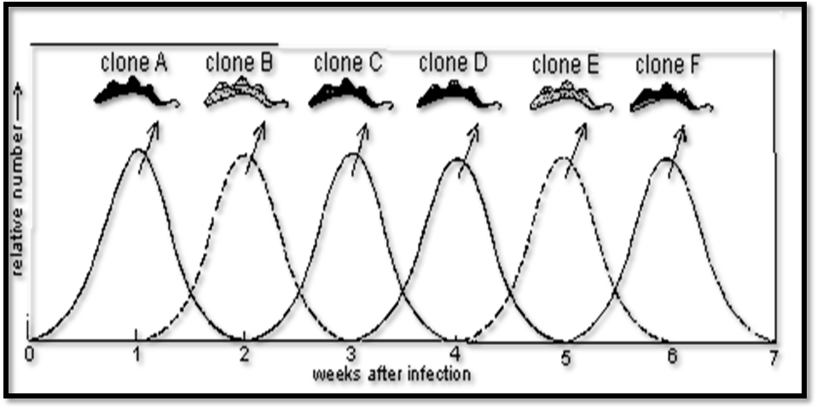
T. cruzi (Chaga`s disease or American trypanosomiasis)
- Stercorian group.
- Reservoir host: domestic & wild animals (cat, dogs & raccoons).
- Vector: triatomine bugs.
- 3 stages: trypomastigote (in blood stream c or s shaped), amastigote (invade MØ, smooth, cardiac & skeletal muscle) &transitional stage; epimastigote.
- Usually occur in children.
Note: T. rangeli harmless to man & animals, it overlaps with T. cruzi.
Transmission
- Mediated via vector of genus Triatomaalso known as “kissing bugs”
- Ingestion of food contaminated with parasites
- Blood transfusion
- Fetal transmission (13% stillborn deaths/year in Brazil)

Life cycle of T. cruzi:
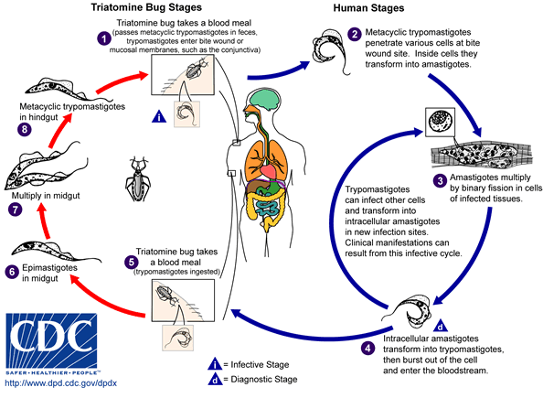
An infected triatomine bug vector (or “kissing” bug) takes a blood meal and releases metacyclic trypomastigotes in its feces near the site of the bite wound. Trypomastigotes enter the host through the wound or through intact mucosal membranes, such as the conjunctiva Inside the host, the trypomastigotes invade cells near the site of inoculation, where they differentiate into intracellular amastigotes . The amastigotes multiply by binary fission and differentiate into trypomastigotes, and then are released into the circulation as bloodstream trypomastigotes . Trypomastigotes infect cells from a variety of tissues and transform into intracellular amastigotes in new infection sites. Clinical manifestations can result from this infective cycle. The “kissing” bug becomes infected by feeding on human or animal blood that contains circulating parasites. The ingested trypomastigotes transform into epimastigotes in the vector’s midgut . The parasites multiply and differentiate in the midgut and differentiate into infective metacyclic trypomastigotes in the hindgut.
Trypanosoma cruzi can also be transmitted through blood transfusions, organ transplantation, transplacentally, and in laboratory accidents.
Pathogenesis:
Acute phase:
- Romana sign: Acute phase of the disease characterized by unilateral painless, erythematous palpebral edema, at times extending to the entire side of the face, most frequent sign in Chaga`s disease.
- Chagoma: less frequent sign in Chaga`s disease an erythematous, itching, painless infiltration of the dermis with central desquamation & rarely ulceration of the skin. It localized on exposed parts of the sleeping individual. It may last several weeks.
- Fever, Vomiting & diarrhea.
- Hepatosplenomegaly. Generalized lymphadenitis &edema.
- Muscular pain.
- Bronchitis, Myocarditis sometimes fatal.
- Anemia, leukocytosis with lymphocytosis.
- Increase of IgM levels.
Chronic Phases:
Starts 2 months after initial infection.
Indeterminate form: 60-70% of people with Chagas. Completely free of cardiac, gastrointestinal and neurological symptoms but 2-5% of patients convert to cardiac or digestive forms each year (reason not clear).
- Cardiac form:
  - 30-40% of people with Chagas. Induces arrhythmia, cardiac failure, thromboembolism, atrioventricular fibrillation, ventricular hypertrophy
- Digestive form:
  - 10% of people Megaoesophagus, 3%, megacolon and may be associated with cardiac form. Difficulty in swallowing, regurgitation, aspiration may cause pneumonia and death. Chronic constipation, fecal compacting causes perforation of the colon.

Diagnosis:
- Blood films in early infection (trypomastigote) or muscle biopsies (amastigote).
- In late stage of infection parasitemia is low so the diagnosis made by xenodiagnosis. Highly efficient – demonstrate low level of parasite in blood
Method:
A Laboratory bred winged bug is starved for 2 weeks then fed on suspected patient’s blood – 30 days later, it faeces & gut examined for trypanosomes.

- Serological tests (CF, IHA, IFAT & ELISA).
Treatment: Nifurtimox. Early stage (acute) followed by lifelong asymptomatic chronic stage.
Control: Same as others trypanosomes.

End of Protozoa Lecture

