Parasitology Protozoa Lecture: Blood &tissues flagellates-1
Dr. Azhar الفصل الثاني 2019-2020
(Page number1-8)
Hemoflagellates or blood and tissue flagellates :( Leishmania & Trypanosoma).
Objectives: at the end of these topics the student will be able to:

- Knowing &list the hemoflagellates members.
- Describe their stages & life cycles.
- Define their pathogenesis & manifestations.
- Determine the differences between each species.
- Describe their epidemiology & endemicity.
- Knowing which species is endemic in Iraq &why.
- List &define their methods of diagnosis & control measures.

KINETOPLASTIDS
- Kinetoplast
- Nucleus
- widespread parasites
KINETOPLAST
- located near base of flagellum
- initially believed to function in movement
- mitochondrial DNA
4 - Stages:
- Amastigote (Leishmania).
- Promastigote (Leptomonas).
- Epimastigote (Crithidia).
- Trypomastigote (Trypanosoma).
Differences between stages ???.
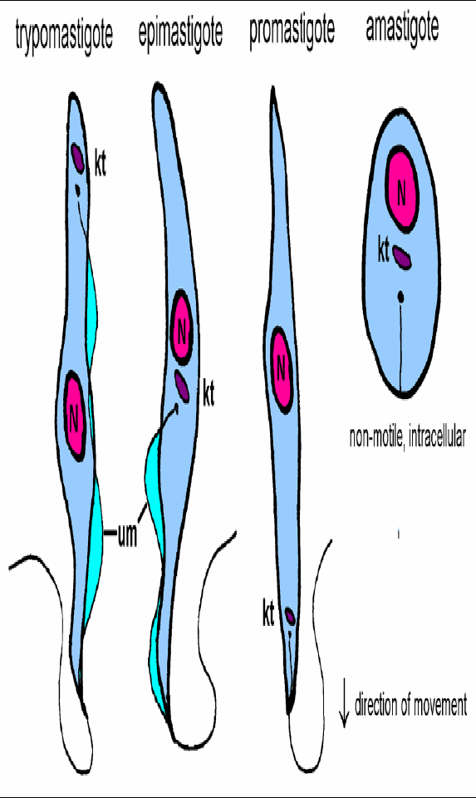
Diseases Causing by Kinetoplastids
• Leishmania species
leishmaniasis
• Trypanosoma brucei complex
African trypanosomiasis
• Trypanosoma cruzi
Chagas’ disease or American trypanosomiasis
Leishmania as a group: (Disease: leishmaniasis):
Leishmaniasis is a vector-borne disease that is caused by obligate intracellular protozoa of the genus Leishmania and transmitted by sandflies. The genus Lutzomyia transmitting Leishmania in the Americas (new world) and the genus Phlebotomus in the Old World. Most forms of the disease are transmissible only from animals (zoonosis), but some can be spread between humans (anthroponitic).
The parasite:
The genus Leishmania adopts two main morphological forms during their life-cycle: the amastigote, which divides within the cells of the vertebrate host and various types of promastigote, which are found in the gut lumen of the sandfly.
1-The amastigote (LD-bodies): This form is round or oval and measures 3-6 X 1.5-3 µm in diameter. It is intracellular and has a prominent, large eccentrically placed nucleus and a dark staining, bar-shaped structure called a kinetoplast is modified mitochondrion, which contains DNA. A delicate filament called axoneme near the kinetoplast.
2-Promastigote forms: various types of promastigote are found in the gut lumen of the sandfly and in culture.
Leishmaniasis as a disease

Cutaneous Leishmaniasis (CL) Visceral Leishmaniasis
(VL) (kala-azar)

Old World Leishmaniasis New World Leishmaniasis
L. tropica L. braziliensis complex
L. major L. mexicana complex
L. aethiopica

These species are differ species or subspecies of Leishmania. They differ clinically, epidemiologically, immunologically and biochemically. Diffuse leishmaniasis or leproid or keloid (many MØ with LD bodies, the host lacking CMI). Espundia and recidiva or lupoid leishmaniasis (relapsing cutaneous lesions with few or no amastigotes, in hypersensetive individuals).
Cutaneous leishmaniasis is the most common form of leishmaniasis. Visceral leishmaniasis is a severe form in which the parasites have migrated to the vital organs.
Classification
Leishmaniasis may be divided into the following types:
- Cutaneous leishmaniasis
- Mucocutaneous leishmaniasis
- Visceral leishmaniasis
- Post-kala-azar dermal leishmaniasis
- Viscerotropic leishmaniasis
Mode of transmission:
- Leishmaniasis is naturally transmitted by the bite of an infected ♀ sandfly.
- It can be transmitted directly from person to person through the sharing of needles (in HIV co-infection).
- Mechanical transmission through the flies.
- Sexual transmission has been reported, but is very rare.
Life cycle:
Leishmaniasis is transmitted by the bite of infected female phlebotomine or Lutzomyia sandflies. The sandflies inject the infective stage (i.e., promastigotes) from their proboscis during blood meals. Promastigotes that reach the puncture wound are phagocytized by macrophages and other types of mononuclear phagocytic cells. Progmastigotes transform in these cells into the tissue stage of the parasite (i.e., amastigotes) , which multiply by simple division (longitudinal binary fission) and proceed to infect other mononuclear phagocytic cells . Parasite, host, and other factors affect whether the infection becomes symptomatic and whether cutaneous or visceral leishmaniasis results. Sandflies become infected by ingesting infected cells during blood meals (, ). In sandflies, amastigotes transform into promastigotes, develop in the gut midgut and migrate to the proboscis.
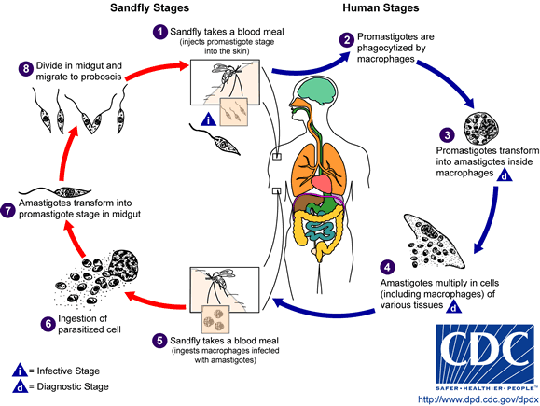
Leishmania-Macrophage Interactions
• entry is typical phagocytosis
• phagosome fuses with lysosome
• survival within phagolysosome
• parasite is resistant to hydrolytic activities
• shut down of respiratory burst
Old World Leishmaniasis: They are 3 or 4 Clinical forms of CL:
- Anthroponotic, dry, or urban type CL: This form, caused by Leishmania tropica, produces painless ulceration of the skin, often leading to disfiguring scars.
- Zoonotic, wet or rural CL: This form, caused by Leishmania major, is also painless when the lesions are uncomplicated.
- Leishmaniasis recidivans: This is a lupoid or tuberculoid chronic form which may last many years and responds little to treatment.
- Diffuse CL: Some persons infected with leishmania mexicana or leishmania aethiopica have a specific immune defect where they appear incapable of mounting a cellular response to Leishmania antigen.

Pathogenesis:
Promastigote (sand fly) Dermis MØ amastigote multiply destroy the cell & enter another one Necrotic center &the margins containing parasitized MØ +giant & plasma cells Macule Papule Lesion (breaks down)
Ulceration (2nd bacterial infection usually occur) Heal with Scar.

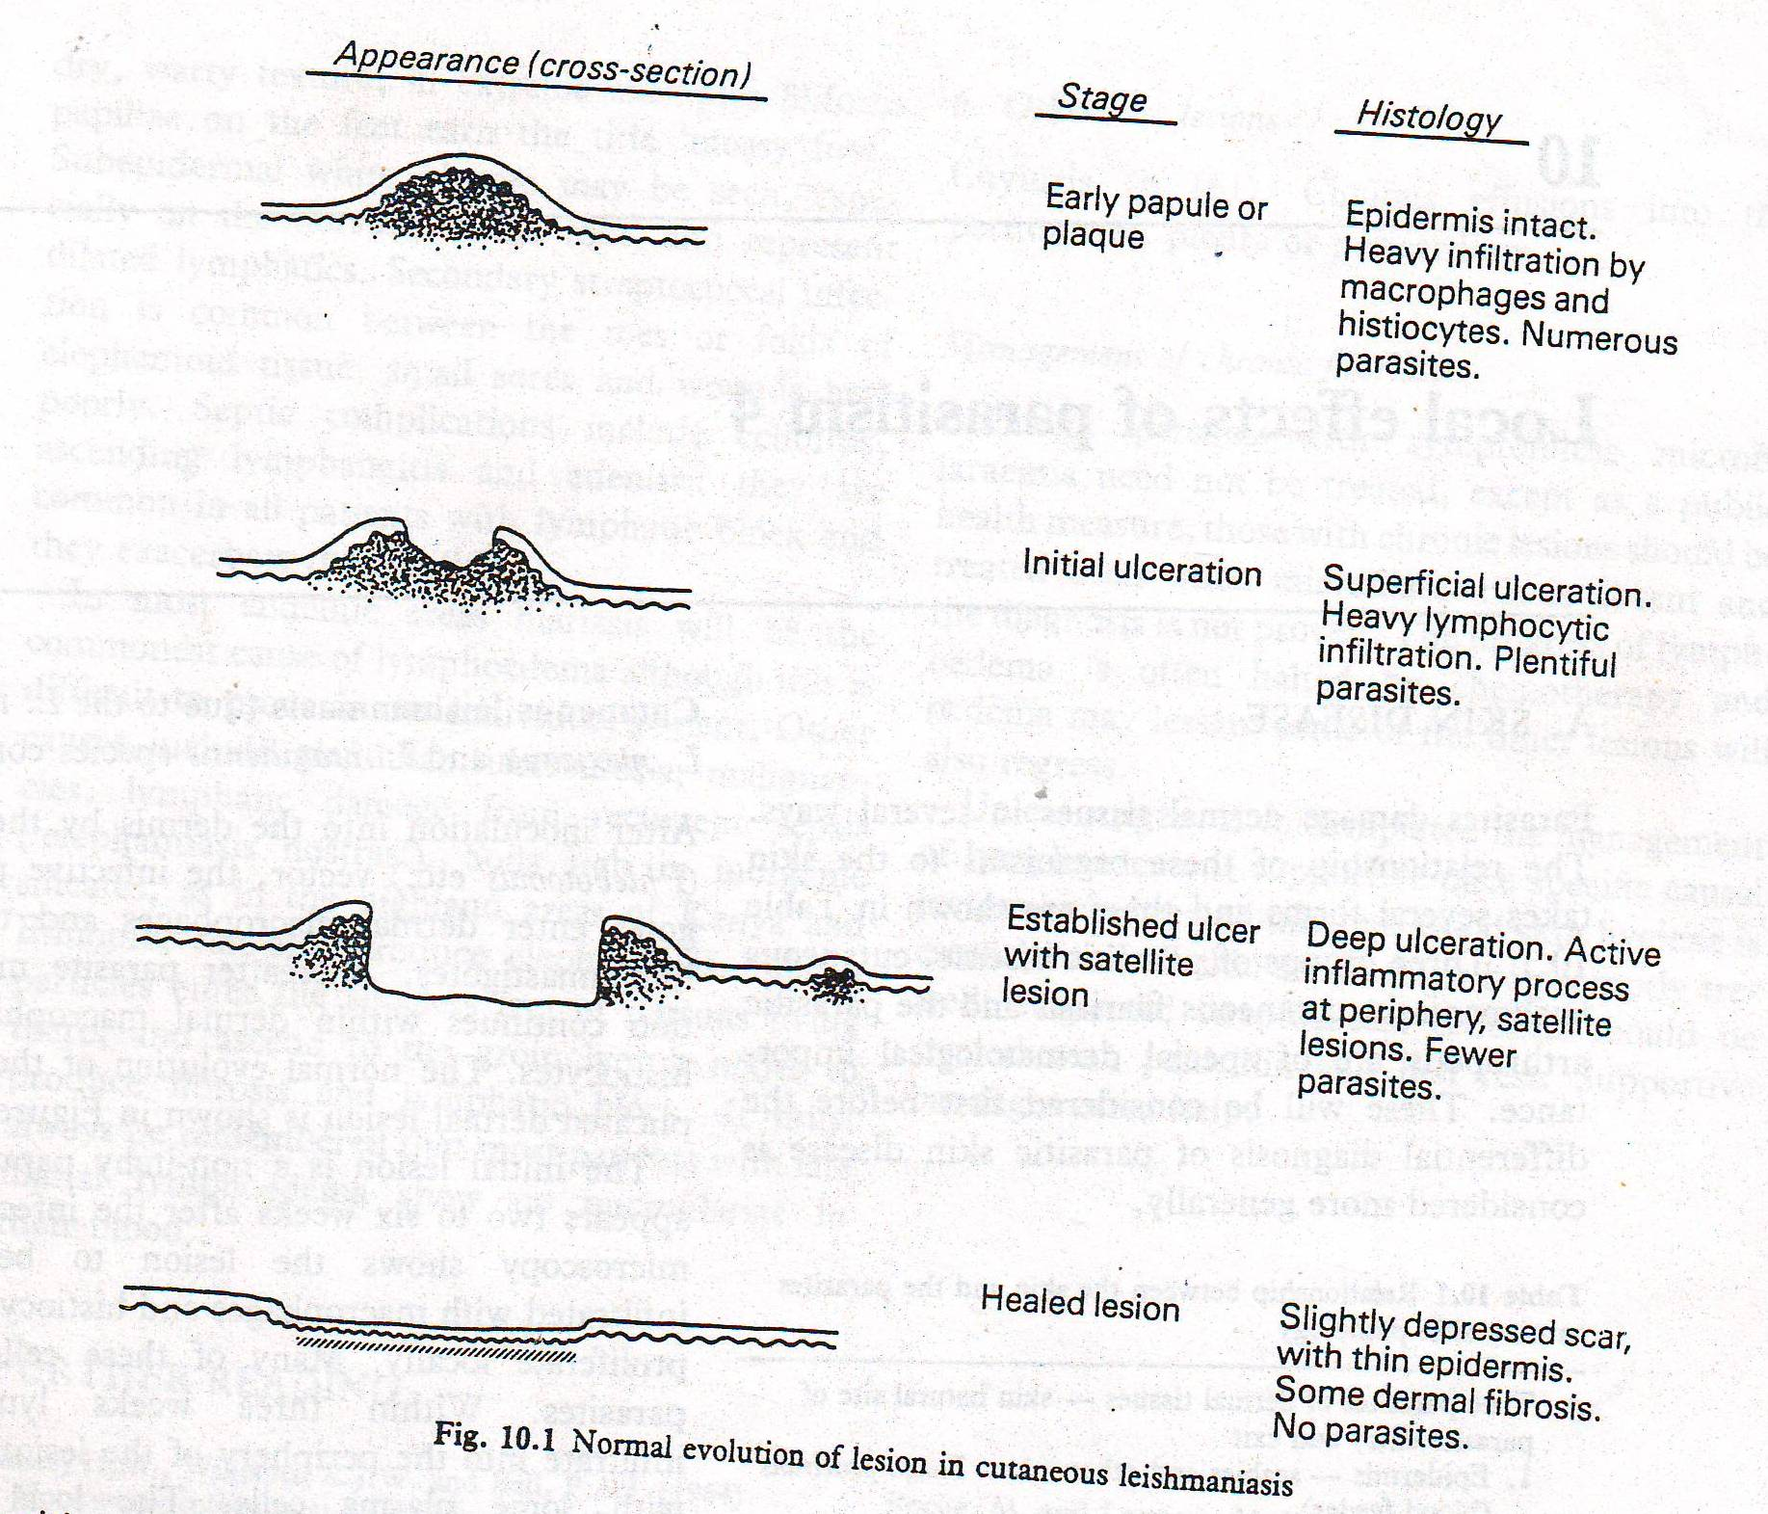

Dry type CL (Urban or Anthroponotic CL)
- Caused by L. tropica.
- Slow ulceration or may not occur.
- Little surrounding tissue reaction.
- Healing take more than a year.

Wet type CL (Rural or zoonotic CL)
- Caused by L. major.
- Early ulceration & often multiple.
- Greater degree of surrounding tissue reaction.
- Healing within 6 months.

- Incubation period=2 ws- 3ys (usually2-6ms)
- Infection is typically self-limiting, but complications may occur.
Diagnosis:
- Clinically
- Smear of aspirated material or skin scraping or biopsy from the margin of the ulcer (Gymea's, Leishman's or Wright's stain).
- Cultured of aspirated material or inoculated into hamsters.
- Leishmanin intradermal test.
- Serological tests (IFAT, ELISA, DAT…etc).
- DNA analysis (PCR).
Treatment:
- Pentavalent antimonials (Pentostame)I.M or locally.
- Cryotherapy.
Recidiva responds poorly to treatment.
2nd bacterial infection most be treated.
Epidemiology:
- Reservoir hosts: dogs & wild rodents.
- Vectors: Phlebotomus papatasi (mid & south Iraq) & P. sergenti (north Iraq). Mechanical transmission through the flies. Sexual transmission has been reported, but is very rare.
- Stable fly (Stomoxys) may transmit the disease from open ulcer mechanically.
- Infection gives live long immunity.
Control:
- Chemotherapy.
- Insecticides.
- Destroyed dogs.

CMI & Cutaneous Leishmaniasis

Diffuse or Anergic CL (L. aethiopica)
Reservoir host is hyrax.
Clinically 3 types:
- Lepromatoid (resemble to disseminated CL of the New World).
- Intermediate.
- Tuberculoid (lymphangitis &elephantiasis may occur).
- scaly, not ulcerated, nodules
- chronic and painless
- numerous parasites in lesions
- seldom heal despite treatment
- relapse frequently occur.
Treatment:
- Resistant to antimonial drugs.
- I.V. sodium stibogluconate.
- Amphotericin-B (toxic).
- Pentamidine isothionate.
End of Protozoa Lecture

