University of Mustansiriya Dr.Shatha AL-Khateeb
College of Medicine Lec.5(1-11)
Chemistry & Biochemistry Dept. 2019-2020

Vitamin C
Is a water soluble vitamin and easily destroyed by heat, alkali and storage .In the process of cooking,70% of vitamin C is lost.
The vitamin is easily oxidized to form dehydroascorbic acid (DHAA), and thus oxidation is readily reversible. Vitamin C is a generic name for all compounds that exhibit the same biologic activity as AA. Consequently, the term includes both AA and DHAA. The structure formula of vitamin C(Ascorbic acid) closely resembles that of carbohydrates.
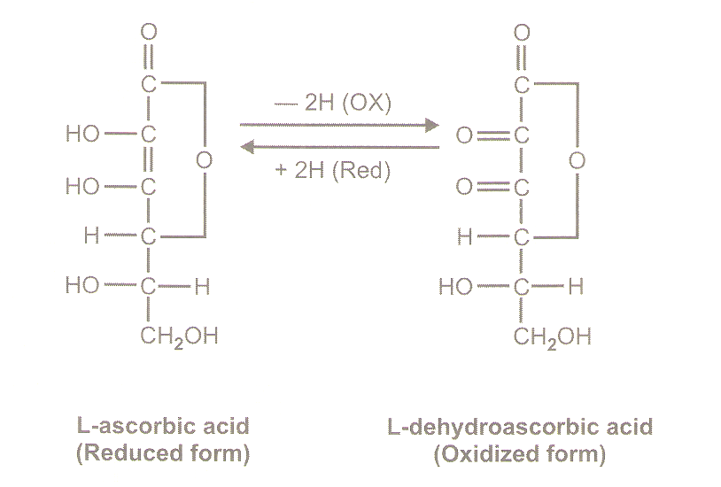
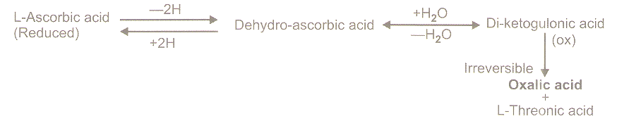

Most animals can synthesize ascorbic acid ,but human cannot synthesize ascorbic acid ,due to lack of the enzyme gluconolactone oxidase which is required for the synthesis of ascorbic acid. Thus ,humans have a dietary requirement of ascorbic acid.
Glucose →several steps→→→ Gluconolactone→→→→→→→→ Ascorbic acid
(Glucon↑↑olactone oxidase)
(Absent in human)
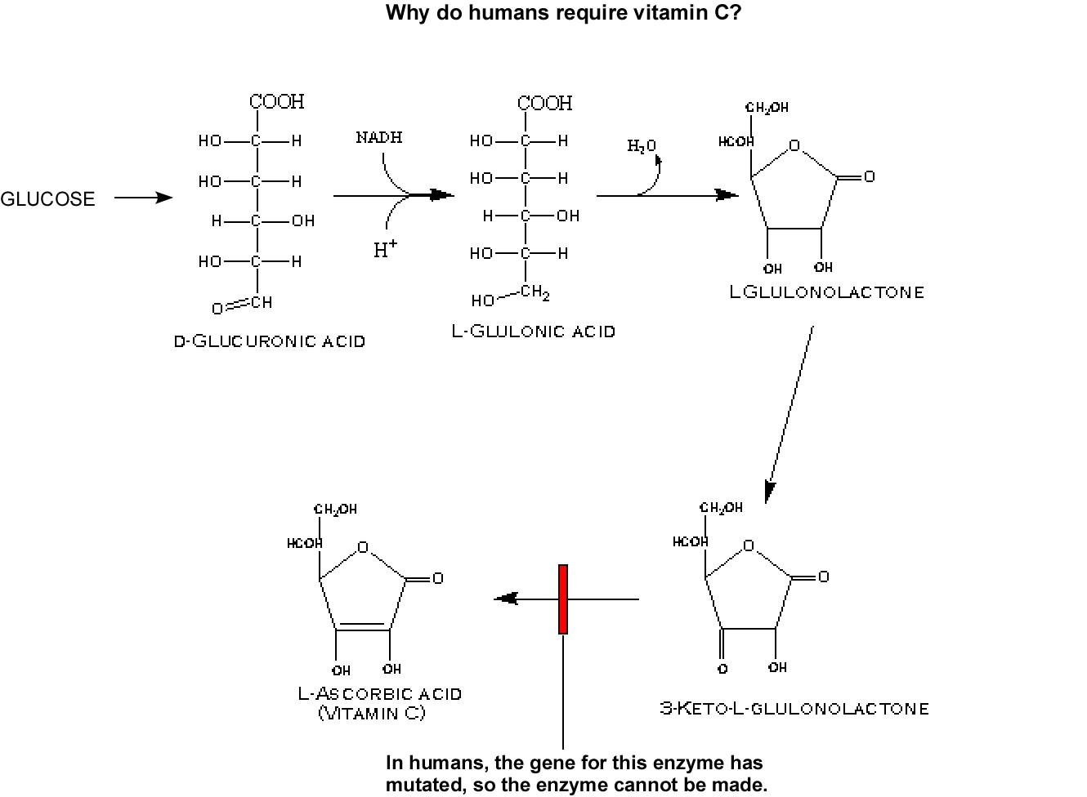
The name vitamin C always refers to the L-enantiomer of ascorbic acid and its oxidized forms. The opposite D-enantiomer called D-ascorbate has equal antioxidant power, but is not found in nature, and has no physiological significance.
Ascorbic acid is a weak sugar acid structurally related to glucose. In biological systems, ascorbic acid can be found only at low pH, but in neutral solutions above pH 5 is predominantly found in the ionized form, ascorbate. All of these molecules have vitamin C activity, therefore, and are used synonymously with vitamin C, unless otherwise specified.

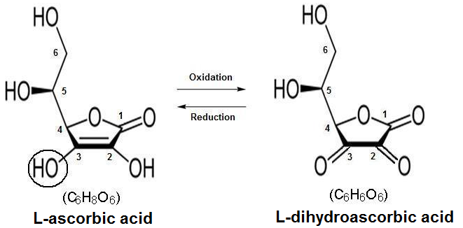

The oxidation-reduction (redox) reaction of vitamin C, molecular forms in equilibrium. L-dihydroascorbic acid also possesses biological activity, due to that in the body it is reduced to form ascorbic acid.
Sources
A wide variety of food exists that contains vitamin C, the best sources of vitamin C are citrus fruits and their juices. Fruits with high vitamin C content include, but are not limited to oranges, lemons, peaches, strawberries, bananas and grapefruit. A wide variety of other foods also contain sufficient quantities of vitamin C: Cabbage, broccoli, cauliflower, leaf lettuce, tomatoes, potatoes, and beans also have relatively high vitamin C content.

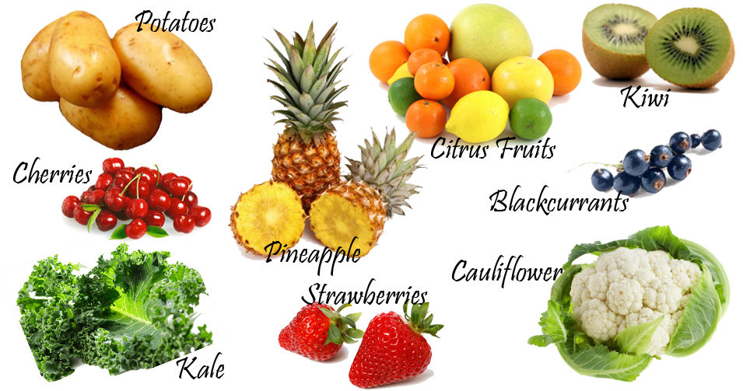
Biological significance
The biological role of ascorbate is to act as a reducing agent, donating electrons to various enzymatic and a few non-enzymatic reactions. The one- and two-electron oxidized forms of vitamin C, semidehydroascorbic acid and dehydroascorbic acid, respectively, can be reduced in the body by glutathione and NADPH-dependent enzymatic mechanisms. The presence of glutathione in cells and extracellular fluids helps maintain ascorbate in a reduced state.

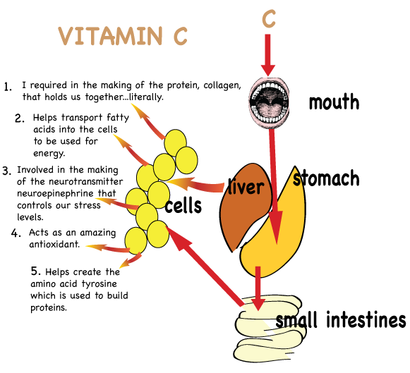

Absorption, transport, and excretion
Vitamin C does not require digestion prior to being absorbed into intestinal cells. There is active transport of the vitamin at the intestinal mucosal brush border membrane. Both ascorbate and dehydroascorbate are absorbed across the mucosa by carrier-mediated passive processes. Intestinal absorption of dehydroascorbate is carrier mediated, followed by reduction to ascorbate before transport across the membrane.
Prior to absorption, ascorbic may be oxidized to dehydroascorbate, which may be absorbed by facilitated diffusion. Although dehydroascorbic acid is absorbed in higher rate than ascorbate, the amount of dehydroascorbic acid found in plasma and tissues under normal conditions is low, as cells rapidly reduce dehyroascorbic acid to ascorbate.
Simple diffusion (may occur in stomach and small intestine) provides for vitamin C absorption with ingestion of higher amounts of the vitamin. Anion channels in some cells may mediate vitamin C diffusion faster than the transporters. From intestinal cells, ascorbate may diffuses through anion channels into extracellular fluid and enters plasma by way of capillaries.
Within intestinal cells: Dehydroascorbic acid is rapidly reduced back to ascorbic acid by enzyme dehydroascorbate reductase. Glutathione (GSH), which is required for the reduction of dehydroascorbate, is oxidized in process. Glutathione spares vitamin C and, in general, improves the antioxidant protection capacity of blood.
Absorption of ascorbate may be diminished in the presence of high intracellular glucose, which appears to interfere with ascorbate transporter. Unabsorbed vitamin C may be metabolized by intestinal flora. Ingesting large amounts of iron with vitamin C may result in oxidative destruction of vitamin C in digestive tract, yielding other products without vitamin C activity.
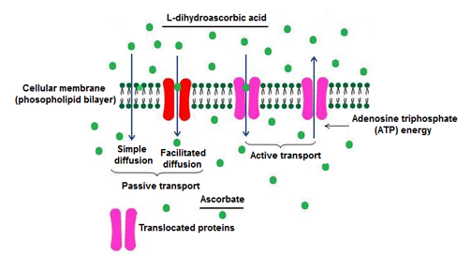
Shows the mechanism of absorption of vitamin C.
Passive absorption is dependent on a glucose transporter and active absorption is dependent on Na⁺.

Ascorbic acid is absorbed in the body by both active transport and simple diffusion. Sodium-Dependent Active Transport—Sodium-Ascorbate Co-Transporters (SVCTs) and Hexose transporters (GLUTs)—are the two transporters required for absorption. SVCT1 andSVCT2 import the reduced form of ascorbate across plasma membrane.
GLUT1 and GLUT3 are the two glucose transporters, and transfer only the dehydroascorbic acid form of Vitamin C. Although dehydroascorbic acid is absorbed in higher rate than ascorbate, the amount of dehydroascorbic acid found in plasma and tissues under normal conditions is low, as cells rapidly reduce dehydroascorbic acid to ascorbate. Thus, SVCTs appear to be the predominant system for vitamin C transport in the body.
SVCT2 is involved in vitamin C transport in almost every tissue, the notable exception being red blood cells, which lose SVCT proteins during maturation. "SVCT2 knockout" animals genetically engineered to lack this functional gene die shortly after birth, suggesting that SVCT2-mediated vitamin C transport is necessary for life.

Ascorbate concentrations over renal re-absorption threshold pass freely into the urine and are excreted. At high dietary doses (corresponding to several hundred mg/day in humans) ascorbate is accumulated in the body until the plasma levels reach the renal resorption threshold, which is about 1.5 mg/dL in men and 1.3 mg/dL in women. Concentrations in the plasma larger than this value (thought to represent body saturation) are rapidly excreted in the urine with a half-life of about 30 minutes. Concentrations less than this threshold amount are actively retained by the kidneys, and the excretion half-life for the remainder of the vitamin C store in the body thus increases greatly, with the half-life lengthening as the body stores are depleted. This half-life rises until it is as long as 83 days by the onset of the first symptoms of scurvy.
Function of vitamin C
1-Reverible oxidation –reduction.It can change between ascorbic acid anddehydroascorbic acid.
2-Hydroxylation of prolin and lysine.
Ascorbic acid is necessary for the post-translation hydroxylation of prolin and lysine residues,hydroxyprolin and hydroxyprolin are essential for the formation of cross links in the collagen.
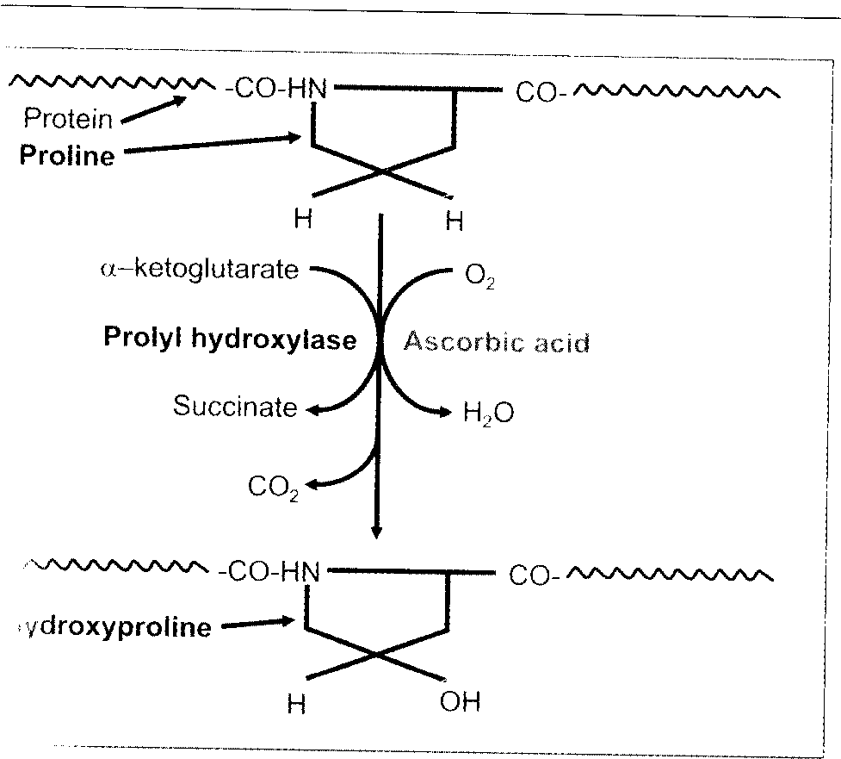

The role of Vitamin C in Collagen synthesis
Vitamin C is necessary for collagen synthesis. Collagen is a structural protein found in skin, bones, tendons, and cartilage. All collagen (n~19) have a triple helical structure. For the collagen molecule to aggregate into its triple-helix configuration selected proline residues must be hydroxylated forming hydroxyproline.
Requires di-oxygenase enzymes, reduced iron (Fe+2), ascorbate. Vitamin C role: During hydroxylation, iron cofactor in the enzymes is oxidized, (ferrous(2+) state ---- ferric (3+) state). Ascorbate is needed to function as a reductant thereby reducing iron back to its ferrous (2+) in prolyl and lysyl hydroxylases.
Collagen Synthesis Vitamin C may also influence mRNA levels needed for collagen synthesis.
Hydroxyproline and hydroxylysine are important contituents of mature collagen fibres. Precollagen molecules contain the amino acids proline and lysine.
They are hydroxylated by corresponding (hydroxylases) in presence of vitamin C, Fe++ and molecular O2.

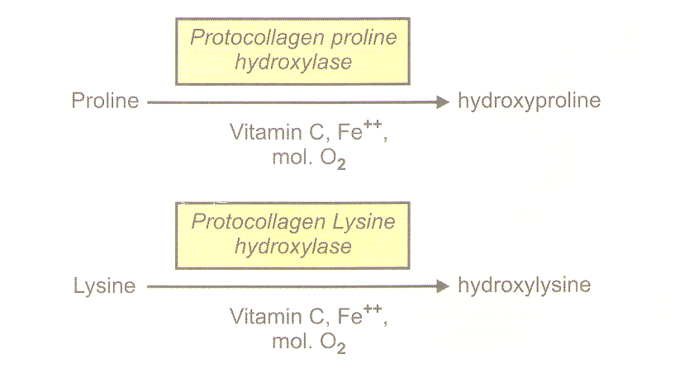

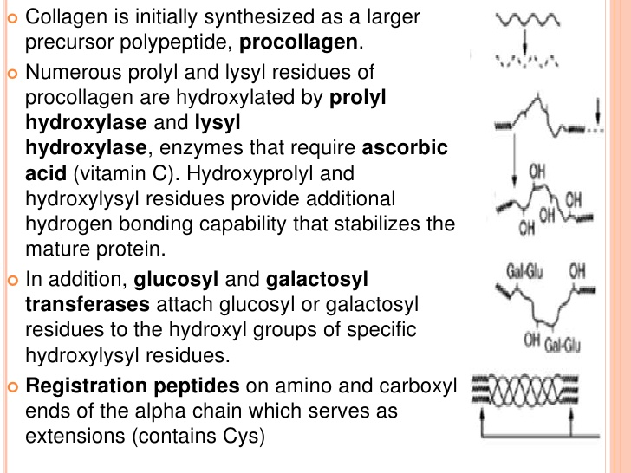
3-Tryptophan metabolism.
Ascorbic acid is necessary for the hydroxylation of tryptophan to 5- hydroxyl tryptophan , this is required for the formation of serotonin.
4-Tyrosine metabolism.
5-Iron metabolism:Ascorbic acid enhances the iron absorption from the intestine .Ascorbic acid reduces ferric iron to ferrous state, which is preferentially absorbed.
6-Hemoglobin metabolism.
7-Folic acid metabolism.
8-Steroid synthesis.
9-Phagocytosis.
10-Cataract: vitamin C is concentrated in the lens of eye; regular intake of ascorbic acid reduces the risk of cataract formation.
11-Anti-oxidant property.
The role of vitamin C as anti-oxidant property
Ascorbic acid is well known for its antioxidant activity, acting as a reducing agent to reverse oxidation in liquids. When there are more free radicals (reactive oxygen species, ROS) in the human body than antioxidants, the condition is called oxidative stress and has an impact on cardiovascular disease, hypertension, chronic inflammatory diseases, diabetes as well as on critically ill patients and individuals with severe burns.

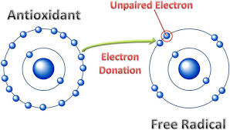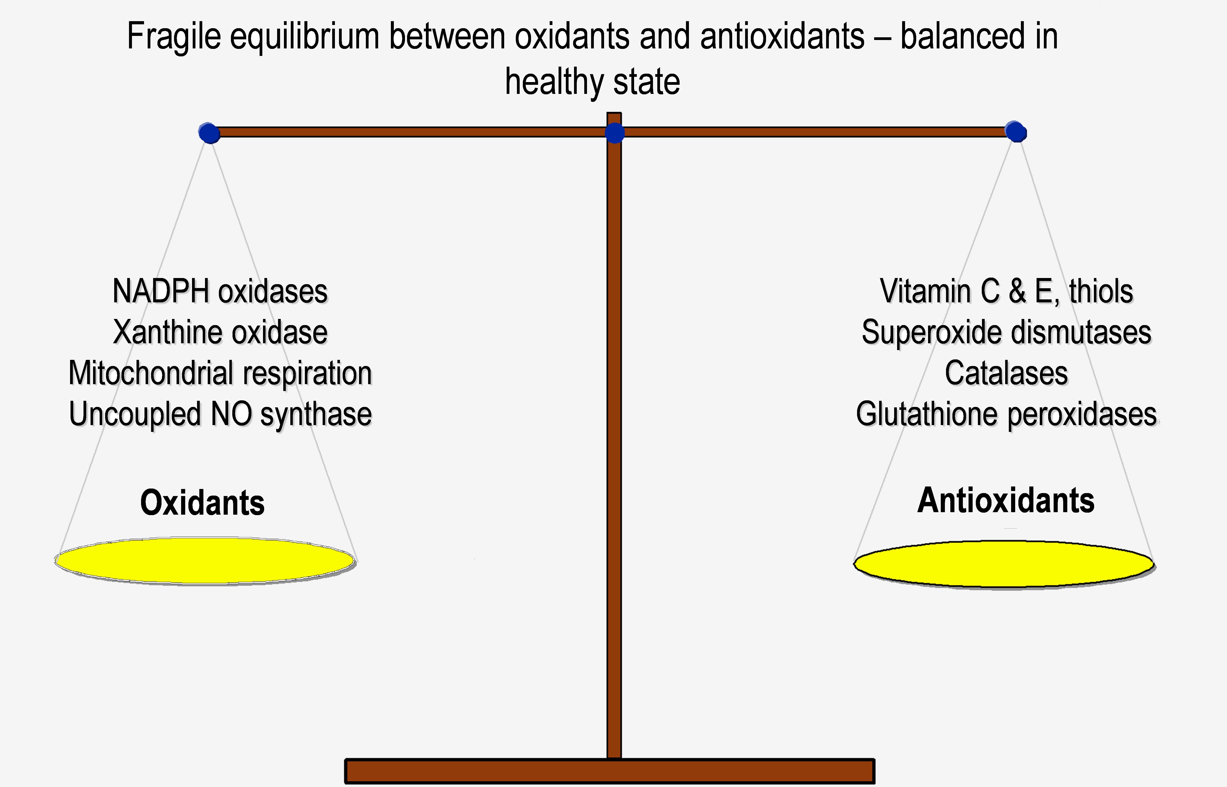
As an antioxidant, ascorbate will react with superoxide, hydrogen peroxide or the tocopheroxyl radical to form monodehydroascorbic acid and/or dehydroascorbic acid. The reduced forms are recycled back to ascorbic acid by monodehydroascorbate reductase and dehydroascorbate reductase using reducing equivalents from NAD (P) H or glutathione, respectively. Dehydroascorbate may decompose into tartrate and oxalate.
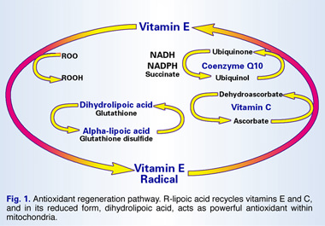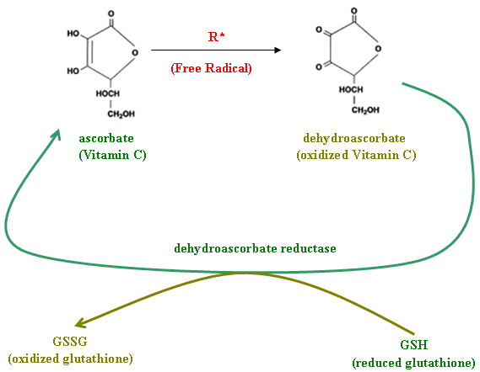
Dehydroascorbate and ascorbate free radicals can be regenerated by the enzyme semidehydroascorbate reductase. In the process, NADH is oxidized to NAD; the NAD/NADH cycle is a critical factor in many biochemical cascades and key to aerobic and anaerobic energy generation pathways. Another enzyme, dehydroascorbate reductase, also recovers ascorbate; in the process, reduced glutathione (GSH) is oxidized into glutathione (GSSG). The enzyme superoxide dismutase catalyzes the condensation of two superoxide molecules into the less reactive hydrogen peroxide (H₂O₂) and oxygen (O₂).
The enzyme catalase further helps the transformation of hydrogen peroxide into water (H₂O) and oxygen (O₂).
Role of vitamin C in cold
Taking good amounts of vitamin C could reduce the duration and severity of the common cold. It helps the body maintain healthy tissue, a strong immune system and protects against infection. Vitamin C reduces the incidence and severity of the common cold.
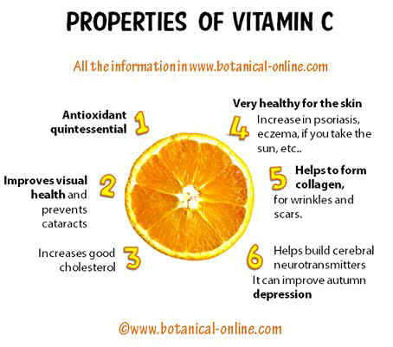
Deficiency
Scurvy is a vitaminosis resulting from lack of vitamin C, since without this vitamin, the synthesized collagen is too unstable to perform its function. Scurvy leads to the formation of brown spots on the skin, spongy gums, and bleeding from all mucous membranes. The spots are most abundant on the thighs and legs, and a person with the ailment looks pale, feels depressed, and is partially immobilized. In advanced scurvy there are open, suppurating wounds and loss of teeth and, eventually, death.
The human body can store only a certain amount of vitamin C, and so the body stores are depleted if fresh supplies are not consumed. The time frame for onset of symptoms of scurvy in unstressed adults switched to a completely vitamin C free diet, however, may range from one month to more than six months, depending on previous loading of vitamin C . Thus in Scurvy, failure of conversion of procollagen to collagen due to the failure of hydroxylation may lead to a rapid destruction of the collagen intermediates.
Symptoms of Scurvy are related to deficient collagen formation;
- Fragility of vascular walls leads to bleeding tendency.
- Poor wound healing.
- Deficiency of bone matrix causing osteoporosis.
- Poor healing of fractures.
- Anemia due to impaired erythropoiesis.
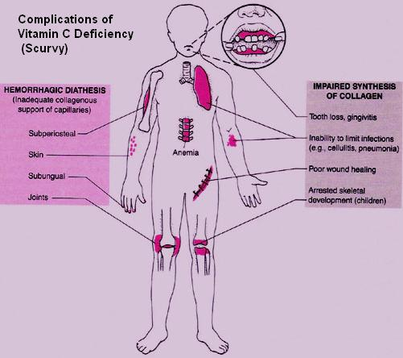

Immune system
Vitamin C is found in high concentrations in immune cells, and is consumed quickly during infections. It is not certain how vitamin C interacts with the immune system, it has been hypothesized to modulate the activities of phagocytes, the production of cytokines and lymphocytes, and the number of cell adhesion molecules in monocytes.

Vitamin C toxicity
Extremely safe, diarrhea appears as overdose of vitamin takes place, and may increase oxalate levels and renal oxalate calculi.

