University of Mustansiriya Dr.Shatha AL-Khateeb
College of Medicine Lec.7(1-8)
Chemistry &Biochemistry Dept. 2019-2020

Vitamin B2
Vitamin B2 is a water-soluble vitamin just like vitamin B1 and is also active in the breakdown of carbohydrate, protein and fat.( Molecular formula: C₁₇H₂₀O₆N₄)
Riboflavin, also known as vitamin B₂ is an easily absorbed colored micronutrient with a key role in maintaining health in humans and animals. It is the central component of the cofactors FAD and FMN, and is therefore required by all flavoproteins. It plays a key role in energy metabolism, and for the metabolism of fats, ketone bodies, carbohydrates, and proteins.
The name "riboflavin" comes from "ribose" (the sugar whose reduced form, ribitol, forms part of its structure) and "flavin", the ring-moiety which imparts the yellow color to the oxidized molecule (from Latin flavus, "yellow"). The reduced form, which occurs in metabolism along with the oxidized form, is colorless.
Riboflavin is best known visually as the vitamin which imparts the orange color to solid B-vitamin preparations, the yellow color to vitamin supplement solutions, and the unusual fluorescent-yellow color to the urine of persons who supplement with high-dose B-complex preparations (no other vitamin imparts any color to urine).
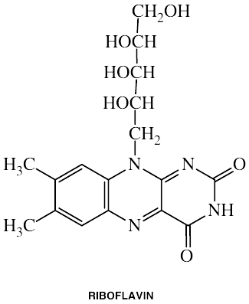

Riboflavin in food
Riboflavin is yellow or yellow-orange in color and in addition to being used as a food coloring, it is also used to fortify some foods. It is used in baby foods, breakfast cereals, pastas, sauces, processed cheese, fruit drinks, vitamin-enriched milk products, and some energy drinks.
Wheat bran, eggs, meat, milk, and cheese are important sources in diets containing these foods. Cereals grains contain relatively low concentrations of flavins.
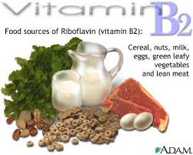
The milling of cereals results in considerable loss (up to 60%) of vitamin B₂.The enrichment of bread and ready-to-eat breakfast cereals contributes significantly to the dietary supply of vitamin B₂.
Riboflavin helps convert carbohydrates into ATP (adenosine triphosphate). The human body produces ATP from food, ATP produces energy as the body requires it. Simply, the compound ATP is vital for storing energy in muscles.
Chemistry of Vitamin B2
• Stable to heat, oxidation, and acid, riboflavin is soluble in water.
• Light and alkali destroy it.
• It should be noted that bottled milk (which has a relatively large amount of B2) loses a significant amount of B2 if it is left in the sunlight.

Nutrition and recommended dietary allowance (RDA)
The best way to get the daily requirement of essential vitamins is to eat a balanced diet that contains a variety of foods.
The estimated average requirement for adult men and women are 1.1 mg and 0.9 mg, respectively. Recommendations for daily riboflavin intake increase with pregnancy and lactation to 1.4 mg and 1.6 mg, respectively (1in advanced). For infants, the RDA is 0.3-0.4 mg/day and for children it is 0.6-0.9 mg/day.

Biological Active Forms

FMN flavin mononucleotide
FAD flavin Adenin dinucleotide

The active forms are reversible electron carriers in biological oxidation system, which are, in turn, oxidized by cytochromes.
They serve as prosthetic groups of oxidoreductase enzymes (flavoproteins).
If these enzymes contain one or more metals e.g. Fe or Mb as essential cofactor, they are known as metalloflavoproteins.
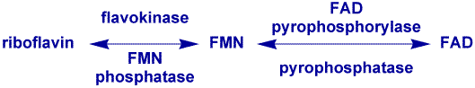

(FMN) and (FAD) function as coenzymes for a wide variety of oxidative enzymes and remain bound to the enzymes during the oxidation-reduction reactions. Flavins can act as oxidizing agents because of their ability to accept a pair of hydrogen atoms. Reduction of isoalloxazine ring (FAD, FMN oxidized form) yields the reduced forms of the flavoproteins (FMNH2 and FADH2).
The biological active forms, in which riboflavin serves as the prosthetic group (as coenzyme) of number of enzymes are the phosphorylated derivatives.

Two main derivatives are:
1-FMN (Flavin mononucleotide): in this the phosphoric acid is attached to ribityl alcoholic group in position 5.
(Flavin-Ribityl-PO4)

2-FAD (Flavin adenine nucleotide): It may be linked to an adenine nucleotide through a pyrophosphate linkage to from FAD. - (Flavin-ribityl-P-P-ribose-Adenine)

Thus, FMN and FAD are two coenzymes of this vitamin.
The acidic properties given by phosphoric acid group influence their capacity for combining with proteins apo-enzyme-forming flavor-proteins (Holoenzyme).
Thus:
Fp (Holoenzyme) = FMN ̸/ FAD (co-enzyme) + Protein (Apo-enzyme)

Fp) may also unite with metals like Fe and Mo thus forming Metallo-flavoproteins.

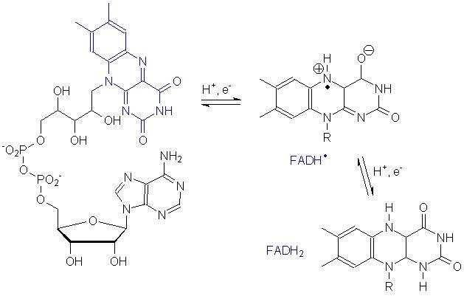

Mechanism of action as cofactors and flavoproteins
Flavoproteins exhibit a wide range of redox potential and therefore can play a wide variety of roles in intermediary metabolism. Some of these roles are:
- Flavoproteins play very important roles in the electron transport chain.
- Decarboxylation of pyruvate and α-ketoglutarate requires FAD.
- Fatty acyl CoA dehydrogenase requires FAD in fatty acid oxidation.
- FAD is required to the production of pyridoxic acid from pyridoxal (vitamin B₆).
- The primary coenzyme form of vitamin B₆ (pyridoxal phosphate) is FMN dependent.
- FAD is required to convert retinal (vitamin A) to retinoic acid.
- Synthesis of an active form of folate (5-methyl THF) is FADH2 dependent.
- FAD is required to convert tryptophan to niacin (vitamin B₃).
- Reduction of the oxidized form of glutathione (GSSG) to its reduced form (GSH) is also FAD dependent.

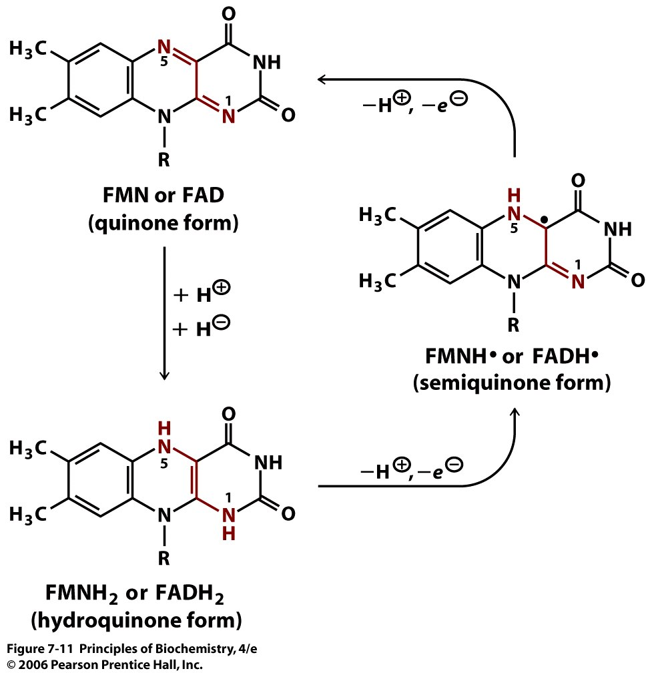
Metabolism
Riboflavin itself and flavin mononucleotides are absorbed from the proximal small bowel, where as flavin adenine dinucleotide must be degraded to flavin mononucleotide prior absorption.
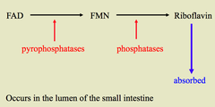
Absorption occurs mainly in the upper GI tract.
• Synthetic thyroid medication decreases absorption, but thyroid in general increases the absorption.
• Gastric acid is responsible for releasing B-2 from noncovalently bonding in foods so that it may be absorbed.
• Riboflavin is stored to some extent in the liver.
• Riboflavin is also found in high amounts in the retina of the eye.
Excretion

Mainly in free form, up to 50‰ as nucleotides in urine. Daily urinary excretion ( 0.1 to 0.4) mg(10-20‰ of intake).

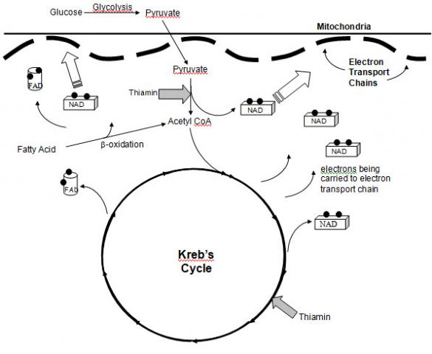

Blood Plasma Level:

Human blood plasma contains 2.5 to 4.0 µgm‰, two-third as FAD and bulk of reminder as FMN.
These values remain quite constant even in severe riboflavin deficiency. Thus determination of riboflavin in blood is not useful.
Deficiency
When dietary intake is poor, riboflavin deficiency is a significant risk because the human body excretes it continuously (it is not stored). Experts say that vitamin B2 deficiency is nearly always part of a general vitamin deficiency.
There are two types of riboflavin deficiencies:
- Primary riboflavin deficiency - the person's diet is poor in vitamin B2
- Secondary riboflavin deficiency - there is another reason. Perhaps the individual's intestines cannot absorb the vitamin properly, or the body cannot use it. It is also possible that it is being excreted too rapidly.
A shortage of this vitamin may manifest itself as cracks and sores at the corners of the mouth, eye disorders, inflammation of the mouth and tongue, and skin lesions. Sore tongue, chapped lips; mouth and throat infection; bloodshot eyes; sensitivity to light. Dermatitis, dizziness, hair loss, insomnia, light sensitivity, poor digestion, retarded growth, and slow mental responses have also been reported. Burning feet can also be indicative of a shortage.
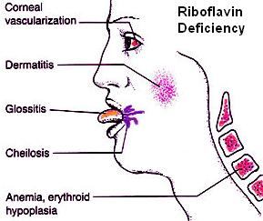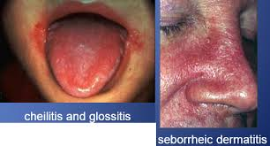

Assessment of riboflavin status
Biochemical tests are essential for confirming clinical cases of riboflavin deficiency and for establishing subclinical deficiencies. Among these tests:
- Erythrocyte glutathione reductase activity:
Glutathione reductase is a nicotinamide adenine dinucleotide phosphate (NADPH), a FAD-dependent enzyme, and the major flavoproteins in erythrocyte. The measurement of the activity coefficient of erythrocyte glutathione reductase (EGR) is the preferred method for assessing riboflavin status.
- Urinary riboflavin excretion:
Experimental balance studies indicate that urinary riboflavin excretion rates increase slowly with increasing intakes, until intake level approach 1.0 mg/d, when tissue saturation occurs. At higher intakes, the rate of excretion increases dramatically.Once intakes of 2.5 mg/d are reached, excretion becomes approximately equal to the rate of absorption .At such high intake a significant proportion of the riboflavin intake is not absorbed.
Clinical uses
Riboflavin has been used in several clinical and therapeutic situations. For over 30 years, riboflavin supplements have been used as part of the phototherapy treatment of neonatal jaundice. The light used to irradiate the infants breaks down not only bilirubin, the toxin causing the jaundice, but also the naturally occurring riboflavin within the infant's blood, so extra supplementation is necessary.
High dose riboflavin appears to be useful alone or along with beta-blockers in the prevention of migraine. Riboflavin has also been used as a muscle pain reliever.
Riboflavin in combination with UV light has been shown to be effective in reducing the ability of harmful pathogens found in blood products to cause disease. When UV light is applied to blood products containing riboflavin, the nucleic acids in pathogens are damaged, rendering them unable to replicate and cause disease.
Riboflavin and UV light treatment has been shown to be effective for inactivating pathogens in platelets and plasma, and is under development for application to whole blood. Because platelets and red blood cells do not contain a nucleus (i.e. they have no DNA to be damaged) the technique is well-suited for destroying nucleic acid containing pathogens (including viruses, bacteria, parasites, and white blood cells) in blood products.

