University of Mustansiriya Dr.Shatha AL-Khateeb
College of Medicine Lec.4(1-10)
Chemistry & Biochemistry Dept. 2019-2020

Vitamin K is a fat-soluble vitamin; it is not a single chemical substance but rather a family of chemically related substances that go by the general name of "vitamin K." (Phylloquinone; K1; Menaquinone; K2; Menadione; K3).Because it is a fat-soluble vitamin, so the body stores it in fat tissue and the liver.
Vitamin K
Types of Vitamin K:
1-Vitamin K1:
It is phylloquinone or phytonadione isolated from alfalfa leaves, also called Mephyton. It is light yellow oil.
2-Vitamin K2:
Known as farnoquinone,synthesized by bacteria ,it is also a yellow oil.
3-Vitamin K3:
Known as Menadione (the synthetic analogue of vitamin K) .It is three times more potent than natural varieties.
Two other forms are Menadiol and Menadioldiacetate.
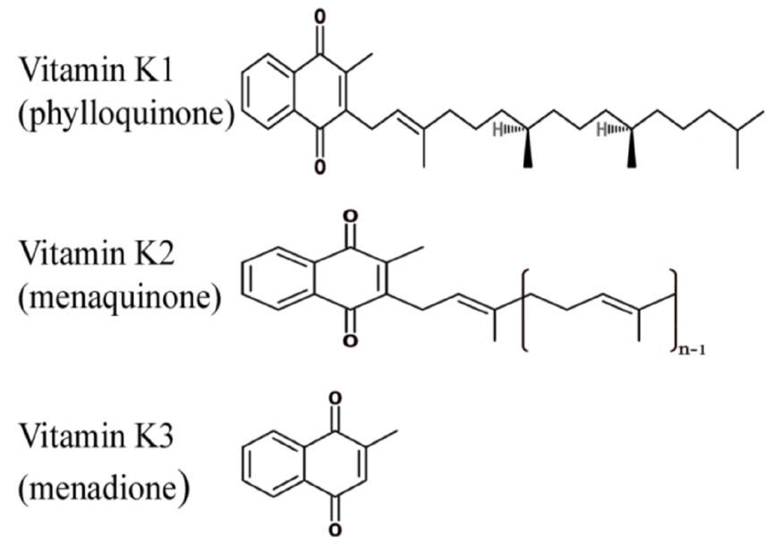
Three synthetic types of vitamin K are known: vitamins K₃, K₄, and K₅. Although the natural K₁ and all K₂ homologs have proven nontoxic, the synthetic form K₃ (Menadione) has shown toxicity.
Sources of Vitamin K
Vitamin K is found in spinach, lettuce, kale, cabbage, cauliflower, wheat bran, organ meats, cereals, some fruits, meats, dairy products, eggs.
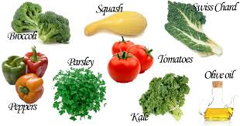

Vitamin K Synthesis
In addition to the absorption of vitamin K from the foods you eat, the body also obtains vitamin K from bacteria in the digestive tract. Specialized bacterial species within the large intestine generate relatively large amounts of vitamin K.
Diseases that disrupt the intestinal balance of bacteria can also prevent the proper synthesis and absorption of vitamin K, increasing the risk of a vitamin K deficiency. As a result, people suffering from intestinal disorders might take vitamin K supplements to prevent deficiency.
Newborn babies lack the intestinal bacteria to produce vitamin K and need a supplement for the first week. People on anticoagulant drugs (blood thinners) may become deficient in vitamin K, but should not change their vitamin K intake without consulting a physician because the effectiveness of the drug may be affected. People taking antibiotics may lack vitamin K temporarily because intestinal bacteria are sometimes killed as a result of long-term use of antibiotics. Also, people with chronic diarrhea may have problems absorbing sufficient amounts of vitamin K through the intestine and should consult their physician to determine if supplementation is necessary.
Metabolism
Absorption and transport
As a fat-soluble vitamin, the digestion and absorption of vitamin K relies on the absorption of fats and oils within the food. During the digestion process, the enzymes in the stomach and small intestine extract fats from the foods, and then absorb them for use within the body. The vitamin K from the foods is dissolved in this fat; the body absorbs vitamin K via fat droplets.
Vitamin K requires bile to be absorbed from the small intestine. It is carried through the bloodstream to the liver by lipoproteins. It can cross the placenta barrier and is available to the fetus.
Dietary vitamin K, mainly as phylloquinone, is absorbed chemically unchanged from the proximal intestine after solubilisation into mixed micelles composed of bile salts and the products of pancreatic lipolysis.
Metabolism of vitamin K occurs mainly in the liver. In the first step, vitamin K is reduced to its quinone form by a quinone reductase.
Reduced vitamin K is the form required to convert vitamin K dependent protein precursors to their active states. It acts as a cofactor to the integral membrane enzyme vitamin K-dependent gamma-carboxylase (along with water and carbon dioxide as co-substrates), which carboxylates glutamyl residues to gamma-carboxy-glutamic acid residues on certain proteins, activating them.
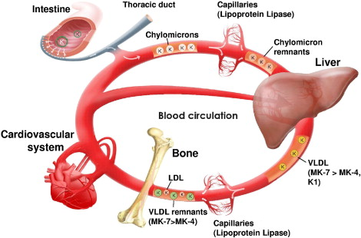
Each converted glutamyl residue produces a molecule of vitamin K epoxide, and certain proteins may have more than one residue requiring carboxylation. To complete the cycle, the vitamin K epoxide is returned to vitamin K via the vitamin K epoxide reductase enzyme, also an integral membrane protein. The vitamin K dependent proteins include a number of important coagulation factors, such as prothrombin. Thus, warfarin and other coumarin drugs act as anticoagulants by blocking vitamin K epoxide reductase.

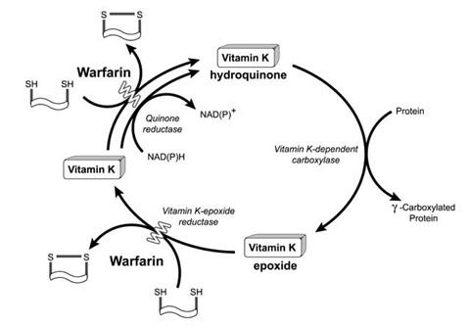
Once in the circulation, phylloquinone is rapidly cleared at a rate consistent with its continuing association with chylomicron and the chylomicron remnants which are produced by lipoprotein lipase hydrolysis at the surface of capillary endothelial cells. After an overnight fast, more than half of the circulating phylloquinone is still associated with triglyceride-rich lipoproteins, with the remainder being equally distributed between low-density and high-density lipoproteins.
Tissue stores and distribution
Human liver stores normally comprise about 90 percent menaquinones and 10 percent phylloquinone.
Other sites of storage may be adipose tissue and bone; both are known to be sites where vitamin K-bearing chylomicron and chylomicron remnants may be taken up.
Excretion
Vitamin K is extensively metabolized in the liver and excreted in the urine and bile.
Two major human excretion products have been identified: carboxylic acids with 5 and 7-carbon side chains that are excreted in the urine as glucuronide conjugates.
Vitamin K itself is too lipophilic to be excreted in the bile and the side chain-shortened carboxylic acid metabolites are not biologically active.
Physiologic Effects of Vitamin K
1-Blood Clotting.
Vitamin K controls the clotting mechanism of the blood because its action is directed at the precursor of prothrombin.
Prothrombin is activated to form thrombin, an enzyme which, in turn, converts fibrinogen to fibrin, the insoluble protein that solidifies the blood clot.
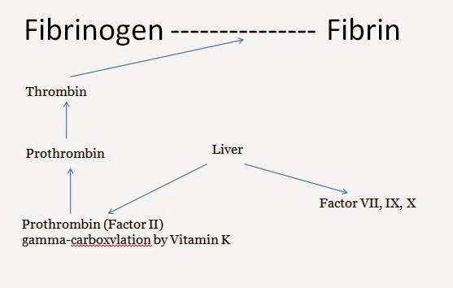

In this process a peptide is removed by proteolysis. Vitamin K is necessary for the maintenance normal levels of not only prothrombin (factor II) but also blood clotting factors VII, IX and X.
All these four blood clotting factors are synthesized in the liver as inactive precursors and the conversion to their active forms requires vitamin K.
Vitamin K converts the precursor protein preprothrombin to prothrombin by adding carbon dioxide to glutamic acid (an amino acid) in the protein.
This change imparts a calcium-binding capacity, which allows prothrombin to be changed to thrombin.

Vitamin K is first converted to its hydroquinone form in the liver microsomes by dehydrogenase using NADPH. It then functions as coenzyme for carboxylase
To become active, the glutamate residue on the inactive prothrombin precursor must acquire a carboxyl group to form a carboxylglutamate residue.
This carboxylation requires the cofactor vitamin K. The carboxylglutamate group can, in turn, bind a calcium ion to form the enzyme thrombin.

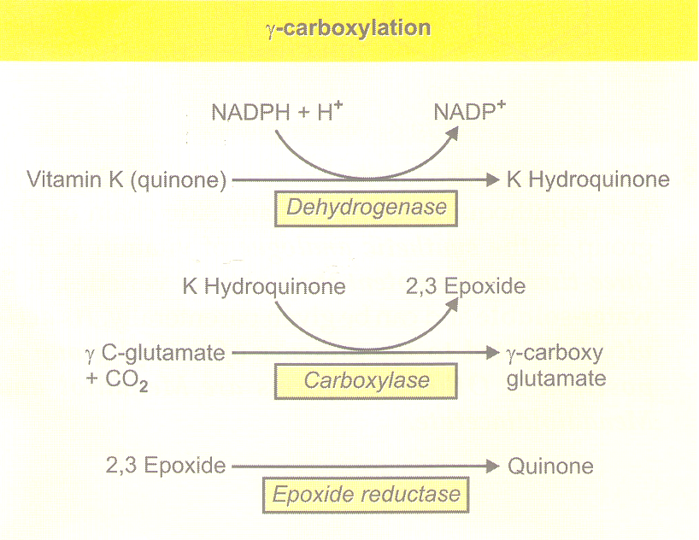
Vitamin K occurs in the liver as inactive vitamin K epioxide. A reductase (reducing enzyme) is required to change it back to its active state. There is speculation that coumarin works indirectly by inhibiting the reductase and, consequently, the vitamin K conversion, rather than by acting directly on thrombin or fibrin.
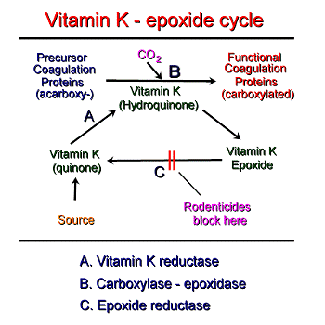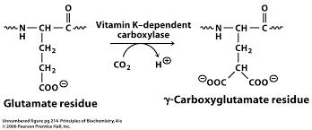
In the absence of vitamin K, no prothrombin is formed, resulting in a condition called hypoprothrombonemia. A deficiency in circulating prothrombin decreases the amount of thrombin available for coagulation and increases the body's tendency to hemorrhage following a blow or injury.
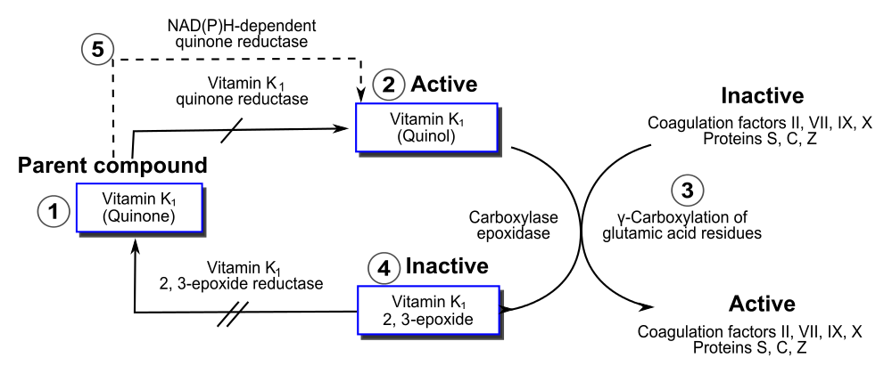
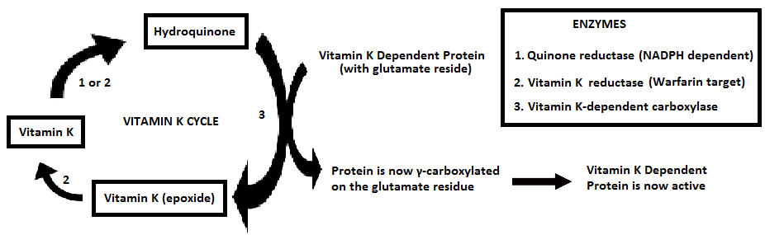
Other functions of Vitamin K are:
2-Bone health.
3-Calcification.
4-Antioxidant.
5-Anti-inflammatory.
6-Brain function.

Vitamin K2 also plays a crucial role in bone health, and may be critical for the prevention of osteoporosis. Osteocalcin is a protein produced by the osteoblasts (cells responsible for bone formation), and is utilized within the bone as an integral part of the bone-forming process. However, osteocalcin must be “carboxylated” before it can be effective. Vitamin K functions as a cofactor for the enzyme that catalyzes the carboxylation of osteocalcin.

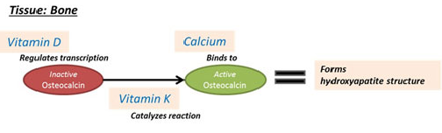

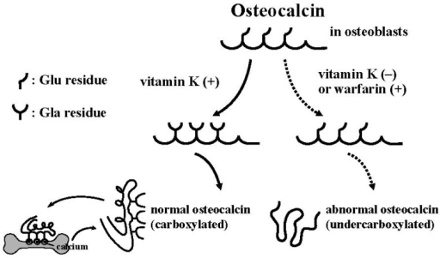

Vitamin K is a cofactor of γ-carboxylase, which converts three glutamic acid (Glu) residues in osteocalcin (OC) to γ-carboxyglutamic acid (Gla), and is thus essential for γ-carboxylation of OC . Without this modification, OC becomes undercarboxylated OC (ucOC), which lacks structural integrity and the ability to bind to the mineral hydroxyapatite . The carboxylation reaction is completed as an intracellular posttranslational event, and secreted OC cannot longer be carboxylated.
Impaired vitamin K nutritional status or warfarin use results in high concentrations of serum ucOC, resulting in an increased risk for fractures. Thus, vitamin K may play an important role in the prevention of fractures in postmenopausal women with osteoporosis.

The Vitamin K Cycle
As a cofactor to the carboxylase that generates gamma-carboxyglutamic acid, Vitamin K undergoes a cycle of oxidation and reduction that allows its reuse. The essential details of this cycle are:
- Vitamin K (usually K1) is reduced to vitamin KH2.
- Oxygenation of vitamin KH2 provides the energy to drive the carboxylation reaction, leading to formation of gamma-carboxyglutamic acid residues and vitamin K oxide.
- Vitamin K oxide is reduced by another reductase back to vitamin K, ready to enter another cycle. Anticoagulants such as Warfarin block the reduction of vitamin K oxide to vitamin K, explaining their antagonistic effects on this cycle.

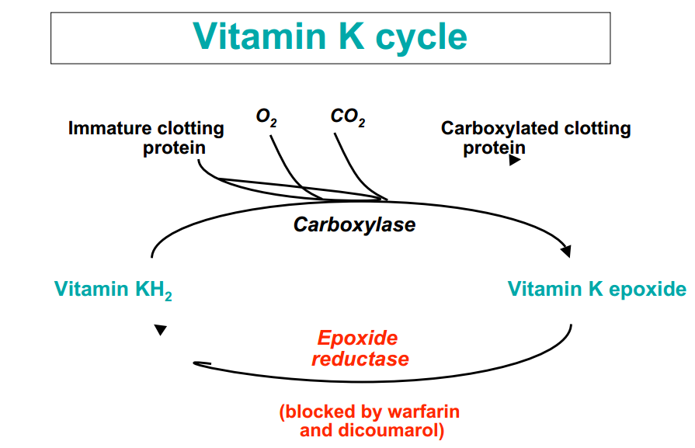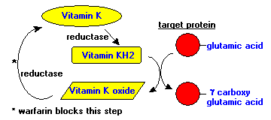

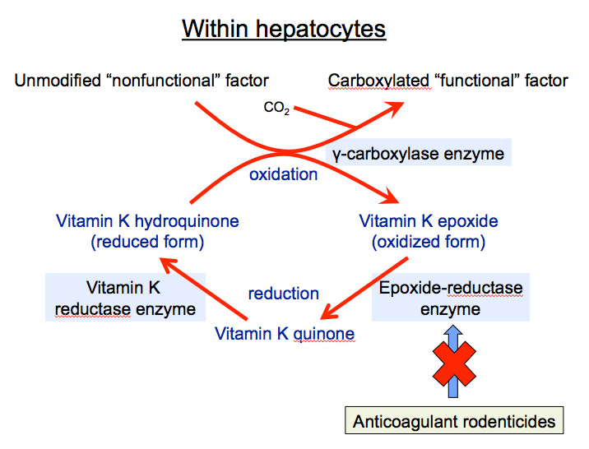

Vitamin K Deficiencies
Deficiency in vitamin K and resulting hemorrhagic disease can result from several situations:
- Poisoning with vitamin K antagonists: Coumarin derivatives such as Warfarin interfere with recycling of vitamin K and thereby lead to vitamin K deficiency.
- Fat malabsorption syndrome.
- Liver disease.
- Absence of vitamin K –synthesizing bacterial flora :
  - Broad spectrum antibiotics can destroy it. 2- Not fully developed in neonates (therefore vitamin K given prophylactically to all newborn).

Vitamin K plays an important role in the normal clotting of blood, and deficiency may lead to unexpected bleeding. Newborn babies generally have very low levels of Vitamin K at the time of their birth and build these reserves as they grow and develop.
To prevent this rare bleeding condition newborn babies are routinely given as a single injection of Vitamin K within 12 hours of their birth.

- Increased risk of fractures or reduced bone density may result from inadequate intake of vitamin K, due to its necessary role in production of bone proteins such as osteocalcin.

- Diagnosis
Vitamin K status is measured by the prothrombin time test. The normal prothrombin time is about 13 seconds. With vitamin K deficiency, the prothrombin time can be several minutes.

