University of Mustansiriya Dr.Shatha AL-Khateeb
College of Medicine Lec.2(1-11)
Chemistry &Biochemistry Dept. 2019-2020

Vitamin A
Vitamin A is a fat soluble vitamin; the active form is present only in animal tissue. The pro-vitamin, beta carotene is present in plant tissue. Beta carotene has two beta ionone ring connected by a polyprenoid chain.
One molecule of beta carotene can theoretically give rise to two molecules of vitamin A, but it may produce only one in biological system.
Retinol, retinal, retinoic acid, and related compounds are known as retinoid. Beta-carotene and other carotenoids that can be converted by the body into retinol are referred to as provitamin A (carotenoids). Hundreds of different carotenoids are synthesized by plants, but only about 10% of them are provitamin A carotenoids.
All forms of vitamin A have a beta-ionone ring to which an isoprenoid chain is attached, called a retinyl group. Both structural features are essential for vitamin activity. The orange pigment of carrots – beta-carotene – can be represented as two connected retinyl groups, which are used in the body to contribute to vitamin A levels. Alpha-carotene and gamma-carotene also have a single retinyl group, which give them some vitamin activity.
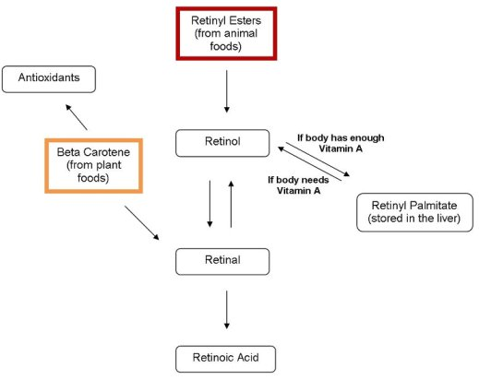
Vitamin A can be found in two principal forms in foods:
*Retinol, the form of vitamin A absorbed when eating animal food sources, is a yellow, fat-soluble substance. Since the pure alcohol form is unstable, the vitamin is found in tissues in a form of retinyl ester. It is also commercially produced and administered as esters such as retinyl acetate or palmitate.
*The carotenes alpha-carotene, beta-carotene, gamma-carotene; and the xanthophyll beta-cryptoxanthin (all of which contain beta-ionone rings), but no other carotenoids, function as vitamin A , which possess the enzyme required to convert these compounds to retinal.
Retinol is an active form of vitamin A. It is found in animal liver, whole milk, and some fortified foods.
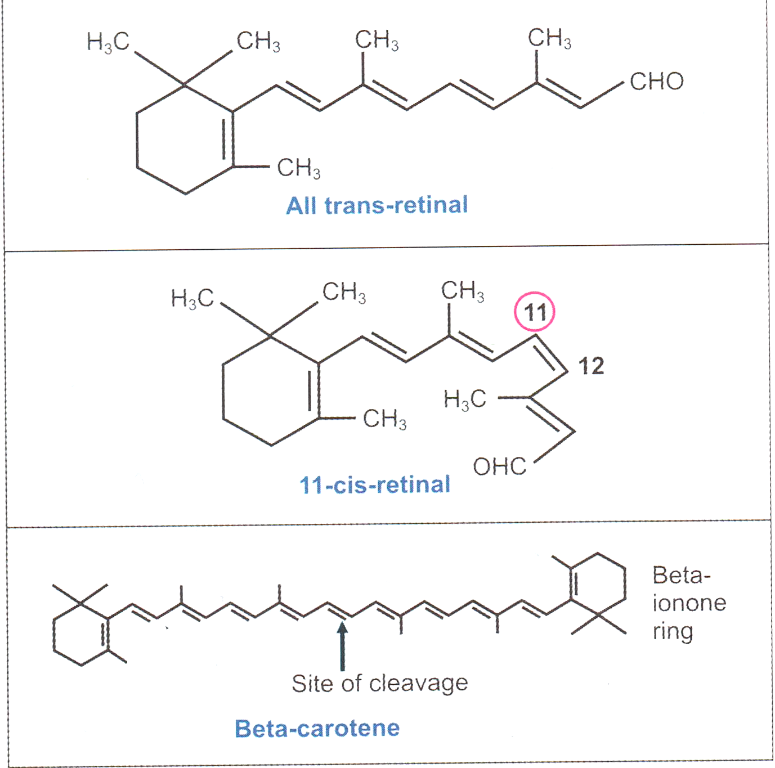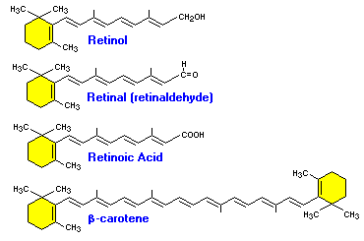

Sources
Retinol, the active form of vitamin A, is rarely found in foods. Instead, precursors to retinol, fatty acid retinyl esters, are found in the human diet. The esters are commonly found in foods of animal origin, such as egg yolks, liver, fish oil, whole milk and butter.

Plants can synthesize the carotenoids, but cannot convert them to retinoid; this process occurs in the human body. The carotenoids are red, yellow, and orange in color and substantial in number (over 400 types). It is estimated that only 10% of the pigments have "vitamin A activity", with beta-carotene having the greatest activity, followed by the alpha and gamma forms. Fruits and vegetables that appear bright orange or yellow in color are usually high in carotenoids. All green vegetables also contain substantial amounts of carotenoids, but the orange or yellow color is masked by chlorophyll .The wide variety of vitamin A precursors allows for adequate amounts of the vitamin in all diet types.

Vitamin A Metabolism

Vitamin A has three active forms (retinal, retinol and retinoic acid) and a storage form is (retinyl ester):

Retinyl ester ß → Retinol ß →Retinal → Retinoic acid

Circulating retinol is primarily bound to retinol-binding protein (RBP), and can enter and leave the liver several times per day in a process known as retinol recycling, which acts to relate the amount of retinol in circulation and protects cells from the damaging effects of free retinol or retinoic acid.
Retinol bound to a cellular RBP (CRBP or CRBP-II) can be esterified by the enzyme lecithin:retinol acyltransferase (LCAT), the resulting retinyl ester being stored primarily in liver stellate cells. LCAT provides a readily retrievable storage form of vitamin A, as well as regulating its availability for other pathways.
Absorption
Seventy to ninety percent of vitamin A from the diet is absorbed in the intestine. Greater than 90% of the retinol store within the body enters as retinyl esters that are subsequently found within the lipid portion of the chylomicron. Absorption of vitamin A is very rapid, with maximum absorption occurring two to six hours after digestion. Within the intestinal lumen the vitamin is incorporated into a micelle and absorbed across the brush border into the enterocytes. Within the enterocytes, precursors of vitamin A (carotenoids) are converted to active forms of the vitamin. The newly formed products and additional precursors are then packaged into chylomicron and readied for transport throughout the body.
Beta carotene is cleaved by a di-oxygenase,to form retinal .The retinal is reduced to retinol by an NADH or NADPH dependent retinal reductase present in the intestinal mucosa.
Intestine is the major site of absorption
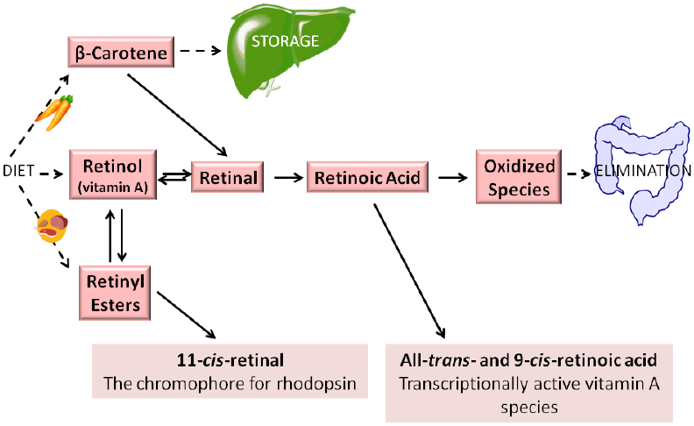
The absorption is along with other fats and requires bile salts. In biliary tract obstruction and steatorrhoea, vitamin A absorption is reduced.

Transport
1-After leaving the enterocytes chylomicron, which carry retinyl esters, carotenoids, and unesterfired retinol along with triglycerides, are circulated first through the lymphatic system and then through the general circulation.
2- Upon arriving at extra-hepatic cells chylomicron release triglycerides, however vitamin A remains within the chylomicron.
3-The vitamin A is then incorporated into a chylomicron remnant.
4-The chylomicron remnant then travels back to the liver where it is taken up and further metabolized or stored.
When needed retinol is mobilized from the liver and requires the use of a carrier for transport through the blood. Retinol-binding protein (RBP) is the specific carrier used to transport all-trans retinol in the plasma.
The all-trans isoform accounts for more than 90% of all plasma vitamin A . This specific carrier is manufactured and secreted by the parenchyma cells of the liver .Each mole of retinol released binds equivocally with RBP to form holo-RBP. This compound then binds with a molecule of transthyretin (TTR), formerly known as prealbumin.
This newly formed retinol-RBP-TTR complex is not filtered by the glamorous, but instead freely circulates throughout the plasma. Tissues are then able to take the retinol up as needed via cellular retinoid-binding protein.
Uptake by Tissues
The retinol-RBP complex binds to specific receptors on the retina,skin,gonads and other tissues.The RBP does not enter in the cell. Inside the cytoplasm of cells, vitamin binds to cellular retinoic acid binding protein (CRBP) and finally to hormone responsive elements(HRE),thus gene are activated.

Storage
Approximately 50 to 85% of the total body retinol are stored in the liver when vitamin A status is adequate. Retinol returning to the liver is re-esterified before storage. Because of this, over 90% of the retinol is stored in the form of retinyl esters. The retinol is stored in hepatic stellate (star-shaped) cells along with droplets of lipid .Thus constitutes the fat-soluble property of vitamin A. The size of stellate cells increase linearly with increasing retinol levels. Once hepatic stellate cells are saturated with all the retinol they can hold, hypervitaminosis can result.
The precursor to vitamin A,( beta-carotene) can be stored in adipose cells of fat depots throughout the body . Serum levels of beta-carotene are an indicator of recent intake and not body stores.

Excretion
The kidneys are the main paths of RBP and retinol excretion from the body. This is achieved manly via renal catabolism and glomerular filtration.

Metabolic functions
The Vitamin functions effectively in our body parts. It helps not just in the growth of our body but also in the proper functioning and movement of our body parts. This vitamin performs its part in wide numbers giving help to:
- For Vision.
- Gene Transcription.
- Increasing Bone Metabolic rate.
- Well being of skin and movement.
Vitamin A, and more specifically, retinoic acid, appears to maintain normal skin health by switching on genes and differentiating keratinocytes (immature skin cells) into mature epidermal cells.
- Antioxidant action.
- Collagen breakdown: Retinoic acid inhibits the enzyme collagenase and thus prevents the breakdown of collagen.
- Role of β- Carotene as an antioxidant: The antioxidant effect of beta-carotene is due to the stabilization of peroxide free radicals within the conjugated alkyl structure of beta-carotene.
The body synthesizes the essential nutrient retinol from vitamin A. Provitamin A is a form of vitamin A that the body derives from carotenoids like beta-carotene, alpha-carotene and beta-cryptoxanthin. The body transforms beta-carotene into retinol more efficiently than any other carotenoid.
The body converts retinol into retinoic acid, which supports cellular growth and cell differentiation throughout the body.

Vision
The Visual Cycle
The process of vitamin A in vision known as Rhodopsin cycle or Ward,s visual cycle.The photoreception in the eye is the eye is function of two specialized cell type located in the retina; -Roda and Cones.
Both rod and cones cells located in the retina contain a photoreceptor pigment in their membranes and vitamin A is a component of these pigments.
Retinol is transported to the retina via the circulation, where it moves into retinal pigment epithelial cells. There, retinol is esterified to form a retinyl ester that can be stored. When needed, retinyl esters are broken apart (hydrolyzed) and isomerizes to form 11-cis-retinol, which can be oxidized to form 11-cis-retinal.
11-cis-retinal can be shuttled to the rod cell, where it binds to a protein called opsin to form the visual pigment, rhodopsin (also known as visual purple). Absorption of a photon of light catalyzes the isomerization of 11-cis-retinal to all-trans-retinal and results in its release.
This isomerization triggers a cascade of events, leading to the generation of an electrical signal to the optic nerve. The nerve impulse generated by the optic nerve is conveyed to the brain where it can be interpreted as vision. Once released, all-trans-retinal is converted to all-trans-retinol, which can be transported across the interphotoreceptor matrix to the retinal epithelial cell to complete the visual cycle.
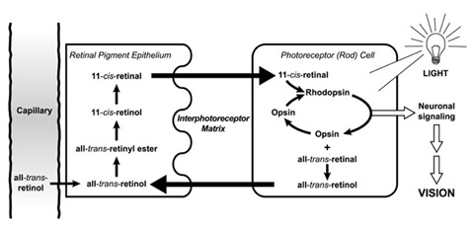
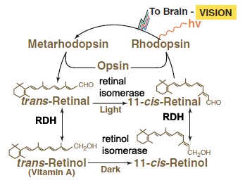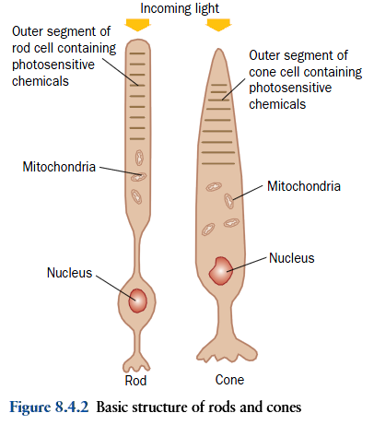
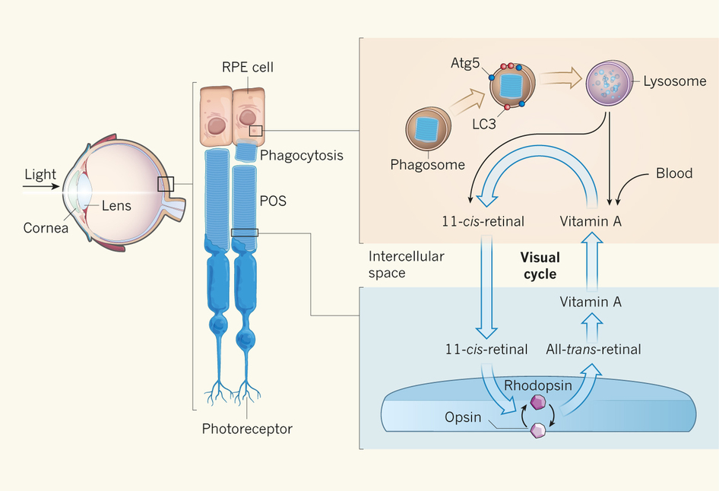
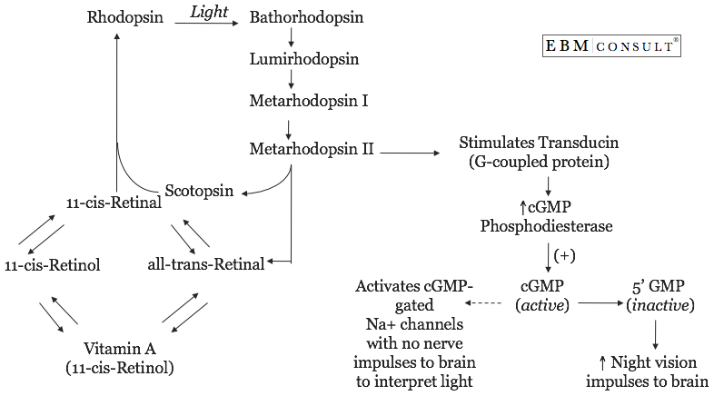
The role of vitamin A in the visual cycle is specifically related to the retinal form. Within the eye, 11-cis-retinal is bound to rhodopsin (rods) and iodopsin (cones) at conserved lysine residues. As light enters the eye, the 11-cis-retinal is isomerizes to the all-"trans" form.
The all-"trans" retinal dissociates from the opsin in a series of steps called photo-bleaching. This isomerization induces a nervous signal along the optic nerve to the visual center of the brain. After separating from opsin, the all-"trans"-retinal is recycled and converted back to the 11-"cis"-retinal form by a series of enzymatic reactions.

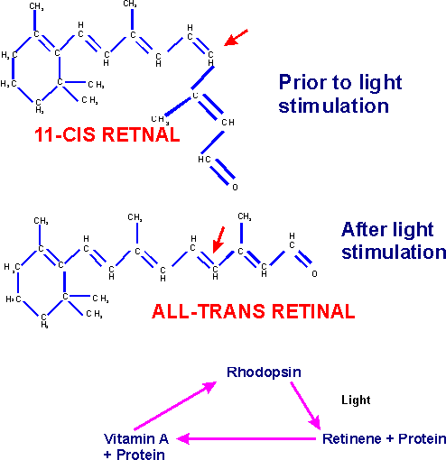
In addition, some of the all-"trans" retinal may be converted to all-"trans" retinol form and then transported with an interphotoreceptor retinol-binding protein (IRBP) to the pigment epithelial cells. Further esterification into all-"trans" retinyl esters allow for storage of all-trans-retinol within the pigment epithelial cells to be reused when needed.
The final stage is conversion of 11-cis-retinal will rebind to opsin to reform rhodopsin in the retina. Rhodopsin is needed to see in low light (contrast) as well as for night vision. It is for this reason that a deficiency in vitamin A will inhibit the reformation of rhodopsin and lead to one of the first symptoms, night blindness.
Transducin is a guanine-nucleotide binding protein (G protein), the structure and function of which is similar to those of G-protein that take part in hormonal signals across biological membranes.
Mechanism of action of transducin:
1-Photoactivated rhodopsin, metarhodopsin III, initiates guanine nucleotide amplification. It interacts with the α-subunit of trans ducine catalyzing the exchange of bound GDP for GTP.
2-When transducine binds to GTP; the α-subunit gets dissociated from β and γ –subunits, activating the transducine (Tα-GTP complex).
3-The activated transducine in turn activate phosphodiesterase (PDE) by binding to inhibitory γ –subunit and removing this. Thus activating the α, β subunit of PDE(PDE α β).
4-The activated PDE α β then catalyzes the hydrolysis of second messenger (cGMP) to 5-AMP, lowering the c-GMP level to the plasma membrane of the outer segment, causing the Na+ channels to close.
Thus in the dark, there are high level of c-GMP, which binds to the Na+ channels, causing them to open. While the opposite in the light, photo-activated rhodopsin, through transducine and phosphodiesterase, lowers the levels of c-GMP, thus closing the most of Na+ channels.
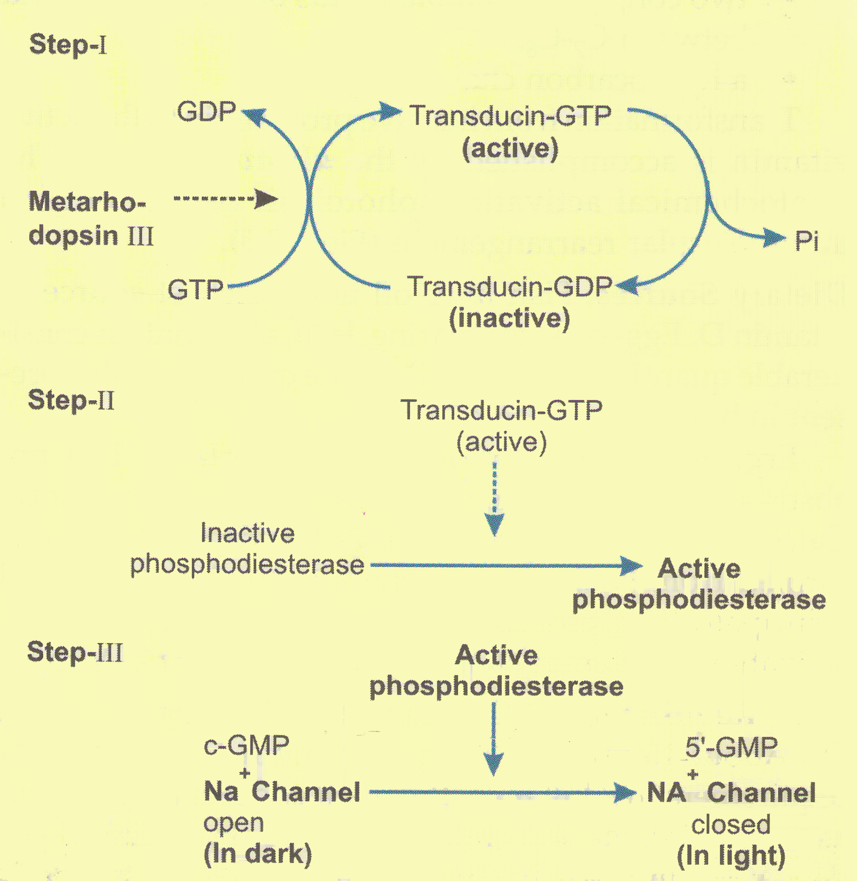
A second very important function of vitamin A involves retinoic acid. Acting as a hormone, retinoic acid first binds to retinoic acid receptors. The receptors then interact with specific nucleotide sequences of DNA. The interaction directly affects gene expression and transcription, which in turn control cellular development and body processes. For example, epithelial cells depend on retinoic acid for structural and functional maintenance.
Dark adaptation mechanism: When a person shifts from a bright light to a dim light, rhodopsin stores are depleted and vision is impaired . After few minutes rhodopsin is resynthesized and vision is improved ,called as dark adaptation and is increased in Vitamin-A deficiency.
Bleaching of rhodopsin :When exposed to light, the color of rhodopsin changes from red to yellow by a process known as bleaching .
Bleaching occurs in a few milliseconds and many unstable intermediates are formed during this process .
Deficiency:
Vitamin A deficiency can occur as either a primary or a secondary deficiency. A primary vitamin A deficiency occurs among children and adults who do not consume an adequate intake of provitamin A carotenoids from fruits and vegetables or preformed vitamin A from animal and dairy products. Early weaning from breast milk can also increase the risk of vitamin A deficiency.
Secondary vitamin A deficiency is associated with chronic malabsorption of lipids, impaired bile production and release, and chronic exposure to oxidants, such as cigarette smoke, and chronic alcoholism.
Vitamin A is a fat soluble vitamin and depends on micellar solubilization for dispersion into the small intestine, which results in poor use of vitamin A from low-fat diets. Zinc deficiency can also impair absorption, transport, and metabolism of vitamin A because it is essential for the synthesis of the vitamin A transport proteins and as the cofactor in conversion of retinol to retinal.
Due to the unique function of retinal as a visual chromophore, one of the earliest and specific manifestations of vitamin A deficiency is impaired vision, particularly in reduced light – night blindness. Other changes include impaired immunity (increased risk of ear infections, urinary tract infections, Meningococcal disease).
Causes for vitamin A deficiency
1-Decreased intake. 2-Obstructive jaundice causing defective absorption.
3-Cirrhosis of liver leading to reduced synthesis of RBP.
4-Severe malnutrition, where amino acids are not available for RBP synthesis.
5-Chronic nephrosis, where RBP is excreted through urine.

Assessment of deficiency
1-Dark adaptation test- it is the time required to adapt the eye to see objects in dim light,it is increased in vitamin A deficiency.
2-RBP (retinol-binding protein) level in serum is decreased.
3-Vitamin A in serum is decreased, it may be directly measured by spectrophotometry(has maximum absorption at 325 nm).

Normal blood level of vitamin A is 25 to 50 microgram / dl.

