University of Mustansiriya Dr.Shatha AL-Khateeb
College of Medicine Lec. 1(1-14)
Chemistry & Biochemistry Dept. 2019-2020

Vitamins
Vitamins are nutrients which are essential to life. They are organic compounds needed in small quantities, necessary for the healthy growth and maintenance of the body. Vitamins are found in all kinds of foods but, vegetables and fruits are particularly rich in vitamins.
The word organic means that the molecules of the substance contain the element carbon, the term also means that vitamins can be destroyed and become unable to perform their functions in our bodies, too much heat, and certain kinds of light, even oxygen can destroy some vitamins.
Discovery of vitamins started from observation of deficiency manifestations,e.g. Scurvy,Rickets,Beriberi,etc.
Vitamins are classified by their biological and chemical activity, not their structure Thus, each "vitamin" refers to a number of vitamer compounds that all show the biological activity associated with a particular vitamin. Vitamer is a term used to describe any of a number of compounds that possess a given vitamin activity and are sometimes inter-convertible to one another, as well.
Vitamins are classified into two categories based on their solubility: as either water-soluble or fat-soluble. In humans there are 13 vitamins: 4 fat-soluble (A, D, E, and K) and 9 water-soluble (8 B vitamins and vitamin. Many types of water-soluble vitamins are synthesized by bacteria.
Vitamins have diverse biochemical functions:
(1) Some have hormone-like functions as regulators of mineral metabolism (e.g., vitamin D), (2) Regulators of cell and tissue growth and differentiation (e.g., some forms of vitamin A). (3)Other function as antioxidants (e.g., vitamin E and sometimes vitamin C). (4)The largest number of vitamins (e.g., B complex vitamins) functions as precursors for enzyme cofactors, which help enzymes in their work as catalysts in metabolism. In this role, vitamins may be tightly bound to enzymes as part of prosthetic groups: For example, biotin is part of enzymes involved in making fatty acids. Vitamins may also be less tightly bound to enzyme catalysts as coenzymes, detachable molecules that function to carry chemical groups or electrons between molecules. For example, folic acid carries various forms of carbon group – methyl, formyl, and methylene – in the cell.
Vitamins differ from other organic food stuffs in that
1-They do not enter into tissue structures, unlike protein.
2- Do not undergo degradation for providing energy unlike carbohydrates and lipid.
3- Several B-complex vitamins play an important role as coenzymes in several energy transformation reactions in the body.

The same with hormones, vitamins differ from hormones in not being produced within the organism, and most of them have to be provided in the diet.
Characteristics of the vitamins are:
- Micronutrients.
- Do not supply energy.
- Do not contribute to body mass.
- Essential for metabolism.
- Lack results in deficiency disease.
Once growth and development are completed, vitamins remain essential nutrients for the healthy maintenance of the cells, tissues, and organs that make up a multicellular organism; they also enable a multicellular life form to efficiently use chemical energy provided by food it eats, and to help process the proteins, carbohydrates, and fats required for respiration.
Comparison of the two types of vitamins
 | Fat soluble vitamins | Water soluble vitamins
Solubility in fat | Soluble | Not soluble
Solubility in water | Not soluble | Soluble
Absorption | Along with lipids requires bile salts | Absorption simple(except vitamin B12)
Carrier proteins | Present | No carrier proteins(except vitamin B12)
Storage | Stored in liver | No storage(except vitamin B12)
Deficiency | Manifests only when stores are depleted | Manifests rapidly as there is no storage (except vitamin B12)
Toxicity | Hypervitaminosis may result | Unlikely ,since excess is excreted
Major vitamins | A,D,E and K | B,C

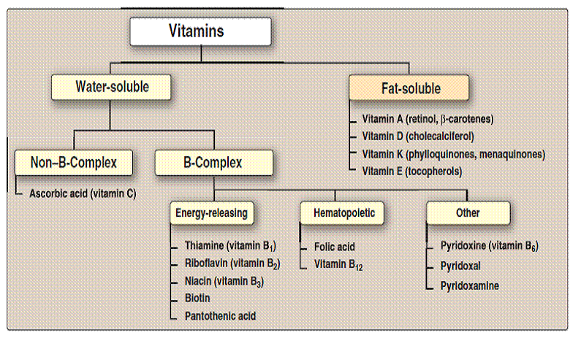

The differences between fat-soluble and water-soluble vitamins:
*Fat –soluble vitamin are stored in the liver and fatty tissues ,these are not readily excreted from the body such as ; vitamin A, vitamin E and vitamin K.
*Water –soluble vitamins travel in the blood and are stored in limited amounts, they are readily excreted from the body through urine such as ; vitamin C , vitamin B complex.
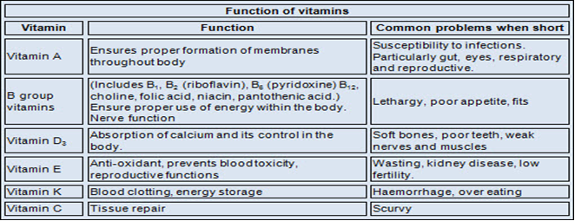

Deficiencies
Humans must consume vitamins periodically but with differing schedules, to avoid deficiency. The human body's stores for different vitamins vary widely; vitamins A, D, and B₁₂ are stored in significant amounts in the human body, mainly in the liver, and an adult human's diet may be deficient in vitamins A and D for many months and B₁₂ in some cases for years, before developing a deficiency condition. However, vitamin B₃ (niacin and niacinamide) is not stored in the human body in significant amounts, so stores may last only a couple of weeks. For vitamin C, the first symptoms of scurvy in experimental studies of complete vitamin C deprivation in humans have varied widely, from a month to more than six months, depending on previous dietary history that determined body stores.
In general, deficiency of vitamins may occur due to:
1-Reduced intake. 2-Impaired absorption. 3-Impaired metabolism.
4-Addetional requirements. 5-Increased losses.
Deficiencies of vitamins are classified as either primary or secondary:
A primary deficiency occurs when an organism does not get enough of the vitamin in its food.
A secondary deficiency may be due to an underlying disorder that prevents or limits the absorption or use of the vitamin, due to a "lifestyle factor", such as smoking, excessive alcohol consumption, or the use of medications that interfere with the absorption or use of the vitamin.
People who eat a varied diet are unlikely to develop a severe primary vitamin deficiency. In contrast, restrictive diets have the potential to cause prolonged vitamin deficits, which may result in often painful and potentially deadly diseases.

Side-effects and overdose
In large doses, some vitamins have documented side-effects that tend to be more severe with a larger dosage. The likelihood of consuming too much of any vitamin from food is remote, but overdosing (vitamin poisoning) from vitamin supplementation does occur. At high enough dosages, some vitamins cause side-effects such as nausea, diarrhea, and vomiting. When side-effects emerge, recovery is often accomplished by reducing the dosage.

Anti-vitamins
Anti-vitamins are chemical compounds that inhibit the absorption or actions of vitamins. For example, avidin is a protein in egg whites that inhibits the absorption of biotin. Pyrithiamine is similar to thiamine, vitamin B₁, and inhibits the enzymes that use thiamine.

Vitamin E
Vitamin E is one of four fat-soluble vitamins. It is a fat-soluble antioxidant that stops the production of reactive oxygen species formed when fat undergoes oxidation.
The vitamin is synthesized by plants, and has eight different isoforms (vitamers) divided into two classes of four vitamers each. Vitamin E is the generic term used for all of the compounds in this group. The vitamin can exist as two types of structures: the tocopherol and tocotrienol structures. Both structures are similar except the tocotrienol structure has double bonds on the isoprenoid units. There are many derivatives of these structures due to the different substituents possible on the aromatic ring at positions 5, 6, 7, and 8.
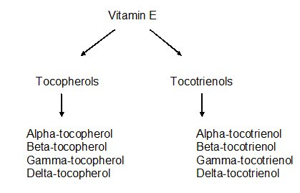
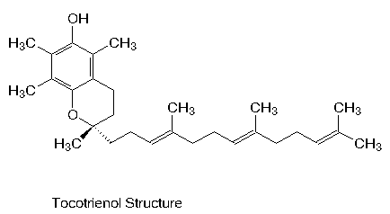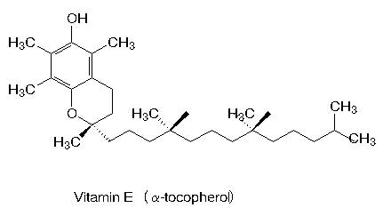
Forms
The eight forms of vitamin E are divided into two groups; four are tocopherol and four are tocotrienols. They are identified by prefixes alpha-, beta-, gamma-, and delta-. The synthetic form contains eight different stereoisomers and is called all-rac-α-tocopherol.
The tocotrienol share the same ring structure, but have an unsaturated tail.
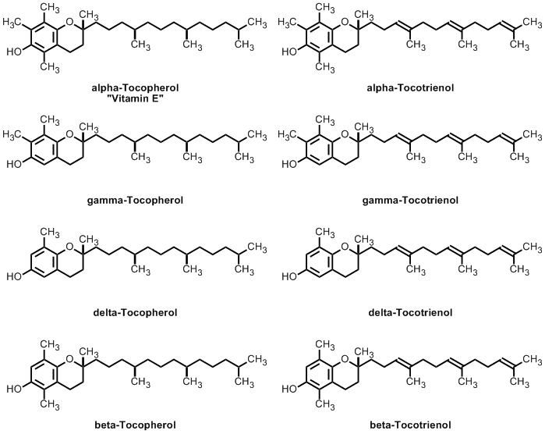
α-Tocopherol
α-Tocopherol is an important lipid-soluble antioxidant. It performs its functions as antioxidant by the glutathione peroxidase pathway and it protects cell membranes from oxidation by reacting with lipid radicals produced in the lipid peroxidation chain reaction. This would remove the free radical intermediates and prevent the oxidation reaction from continuing.
Tocotrienols

Tocotrienols are members of the vitamin E family. An essential nutrient for the body, vitamin E is made up of four tocopherols (alpha, beta, gamma, and delta) and four tocotrienols (alpha,beta, gamma, and delta). The slight difference between tocotrienols and tocopherols lie in the unsaturated side chain having three double bonds in its farnesyl isoprenoid tail. Tocotrienols are natural compounds found in select vegetable oils, wheat germ, barley, saw palmetto, and certain types of nuts and grains. This variant of vitamin E typically only occurs at very low levels in nature.
Comparison of Tocotrienol and Tocopherol
Tocotrienol are forms of natural vitamin E that can protect against brain cell damage, prevent cancer and reduce cholesterol. These biological characteristics, however, are not present in tocopherols due to their chemical structure.
The unsaturated side-chain in tocotrienols causes them to penetrate tissues with saturated fatty layers more efficiently making them ideal for anti-aging oral supplements and the skincare range. Tocotrienols are better able than tocopherols at combating oxidative stress of skin that had been exposed to UV rays of the sunlight.
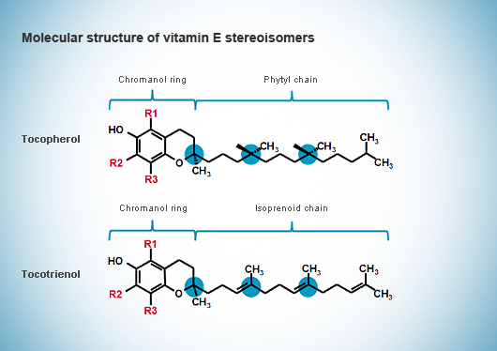
Molecular structure of vitamin E stereoisomers

Why is the natural form of vitamin E better than the synthetic form?
The difference is: availability. Natural vitamin E has roughly twice the availability of synthetic vitamin E. Most vitamins are produced as synthetic. Most of the vitamins used to make nutritional supplements (tablets, capsules, etc.) are synthetic. There is a difference in the molecule, in its potency and in the way it behaves in the body.
The natural form, is a single entity, in other words all the molecules are identical. By contrast, the synthetic dl-alpha-tocopherol is a mixture of 8 different molecular entities, known in the chemical jargon as "stereoisomers". Of these 8, only 1 is identical to the natural form, the other 7 do not exist in nature. Synthetic dl-alpha-tocopherol is not harmful, but its value to the body is only 1/2 of the natural.
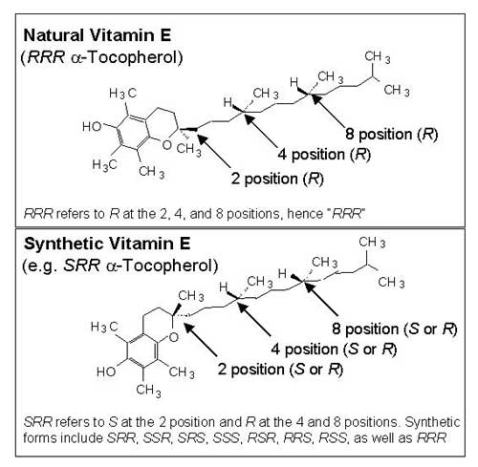
• Alpha-tocopherol it’s the most biologically active and widely used form in nature.

Sources
The natural form of the vitamin is synthesized only by plants and is found predominantly in plant oils. Vitamin E (tocopherol) is also present in high amounts within the chloroplast and therefore the leaves of most plants. In contrast, the tocotrienols are synthesized and found in the germ and bran sections of the plant. The fat-soluble property of vitamin E allows it to be stored within fatty tissue of animals and humans. Therefore a diet that includes meat supplies additional vitamin E. However, the amount of vitamin E obtained in a meat inclusive diet is less than the amount supplied by plant sources.
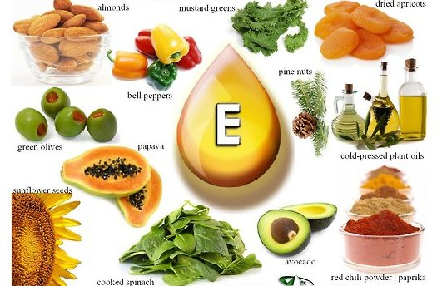
The plant chloroplast is the site of biosynthesis, and the aromatic amino acid tyrosine can be considered the basic precursor.
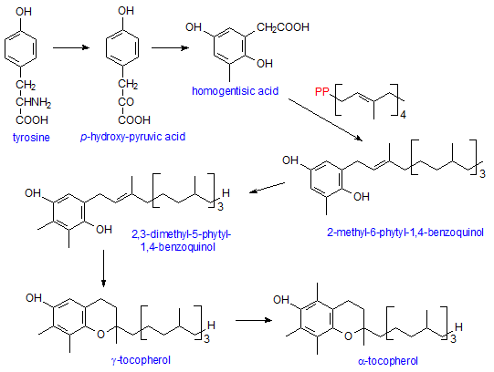

Metabolism

Absorption
The absorption of vitamin E in the intestinal lumen depends on the process necessary for the digestion of fats and uptake by the erythrocytes. In order to liberate the free fatty acids from the triglycerides the diet requires pancreatic esterases.
Bile acids, monoglycerides, and free fatty acids are important components of mixed micelles. Esterases are required for the hydrolytic unfolding of tocopherol esters, a common form of vitamin E in dietary supplements. Bile acids, necessary for the formation of mixed micelles. In patients with biliary obstruction, cholestasic disease of the liver, pancreatitis, or cystic fibrosis, a vitamin E deficiency presents as the result of malabsorption.
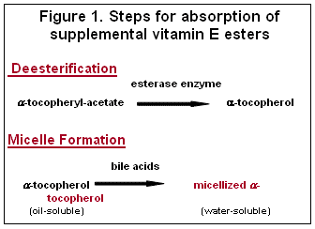

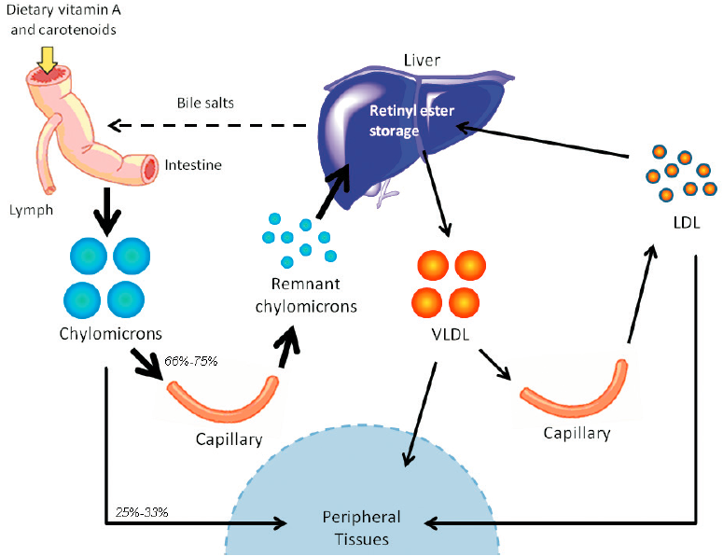

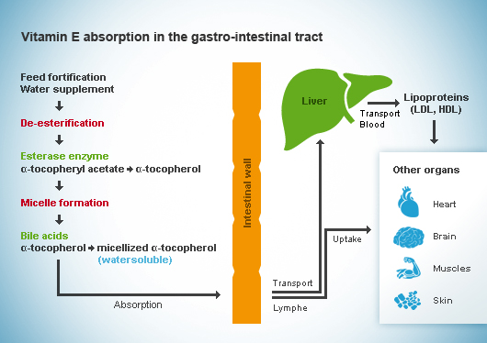

Storage
Vitamin E is a lipid soluble vitamin and therefore over 90% of total body vitamin E is found in the adipose tissue.

Excretion
Vitamin E is excreted mainly via bile, urine, feces, and the skin. The vitamin is oxidized and forms hydroquinone and then is conjugated to form glucuronate. Once formed the glucuronate can be excreted into bile or further degraded in the kidneys and excreted in the urine.
Functions of vitamin E
Vitamin E is integral part of cellular membranes whose main role is to defend the cell
against oxidation. Within cells and organelles (e.g. mitochondria) vitamin E is the first line of defense against lipid peroxidation. The vitamin also plays a very important function in
lending red blood cells (RBC) flexibility as they make their way through the arterial network.
1-Antioxidant. 2-Regulates oxidation reactions. 3-Cell-membrane stability. 4-Protect polyunsaturated fatty acids and vitamin A.
The primary role of vitamin E within the body is to function as an antioxidant. Vitamin E is considered to be the major chain breaking antioxidant in membranes.

Mechanism of action of antioxidants, vitamin E
Free radicals, such as superoxide, hydroxyl ions and nitric oxide all contain an unpaired electron. These radicals can have a negative effect on cells causing oxidative damage that leads to cell death. Antioxidants, such as vitamin E due to its lipid solubility is particularly important in protecting cell membranes, prevent cell damage by binding to the free radical and neutralizing its unpaired electron. For example, when vitamin E binds to ( OO· or O₂· ) absorbs a free radical, it is converted into a radical itself. The resulting tocopheroxyl radical is then reduced back to tocopherol by glutathione,vitamin C or other molecules. Thus the free hydroxyl group on the aromatic ring is responsible for the antioxidant properties. The hydrogen from this group is donated to the free radical, resulting in a relatively stable free radical form of the vitamin.
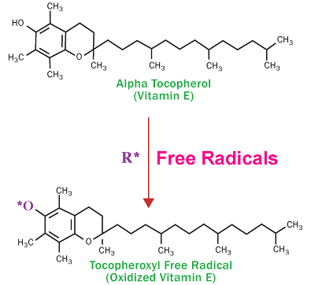

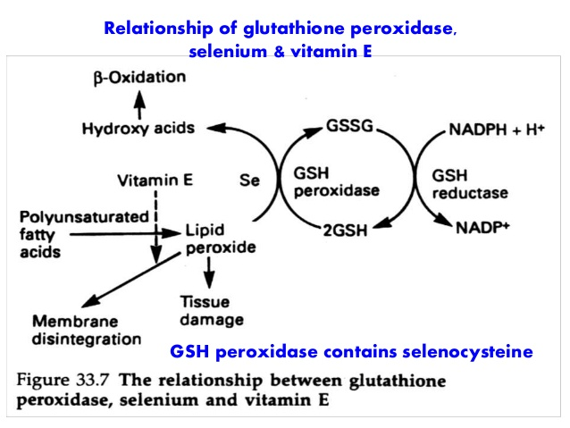

Antioxidants protect from ROS by:
- Scavenging them or rendering them inactive.
- Inhibiting excess ROS production.
- Promoting repair o f damaged tissues and cells.
One of the central components in the antioxidant cycle is vitamin E, a potent biological antioxidant that works to stabilize highly reactive free radicals in lipid (fatty) tissues and membranes (lipoproteins). In the process of quenching fatty free radicals, such as lipid peroxyl and lipid alkoxyl radicals, vitamin E becomes a free radical itself, though one that is far less reactive or damaging than the original radical.
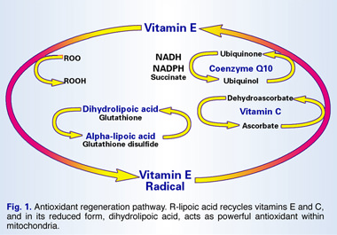

The vitamin E radical is then regenerated by vitamin C (ascorbic acid). This process recycles vitamin E from a radical back into an antioxidant again, but results in the formation of a new free radical in the form of unstable vitamin C. Vitamin C is next recycled by glutathione, a thiol (sulfur-containing compound). Up to this point vitamins E, C and glutathione work in concert to control free radicals and prevent cellular damage. But this is also an important stage where the antioxidant regeneration cycle runs into a limiting factor determined by the availability of glutathione.
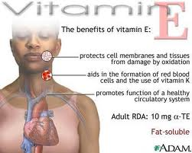
Deficiency
A deficiency of vitamin E is rare in humans. Vitamin E is present in many of the foods we eat on a daily basis, Wheat, Sunflower seeds, Hazelnuts, Soybean oil
Vitamin E deficiency causes neurological problems due to poor nerve conduction.
Deficiency can also cause anemia due to oxidative damage to red blood cells, retinopathy and impairment of the immune response.
Some symptoms of vitamin E deficiency are sometimes nerve degenerations in the hands and feet, muscle weakness, eventual blindness. Sometimes develop anemia, which is a lack of red blood cells.
The existence of a lack of vitamin E is rare. If this occurs, it is manifested in specific cases, that is, in the following three situations:
- Persons with a difficulty of absorbing or secreting bile or who suffer from fat metabolism-related disease (celiac disease or cystic fibrosis)
- Premature infants (with Very low birth weight, VLB) who weigh <1,500 grams at birth
- Persons with genetic abnormalities in alpha-tocopherol transporter proteins.

